 

Oral Histology

**Branchial Apparatus Formation**

Lecture 5

Prof. Dr. Muna Merza

Branchial apparatus consists of the branchial arches, branchial grooves or clefts and pharyngeal pouches.

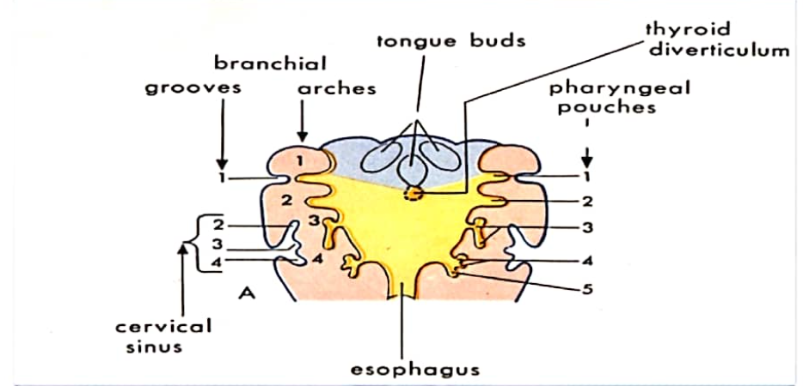

Branchial arches

Arches are six pairs of U-shaped stacked bilateral swellings of tissue appearing inferior

to the stomodeum and include the mandibular arch (FIRST branchial arch), which will form the lower face; each arch.

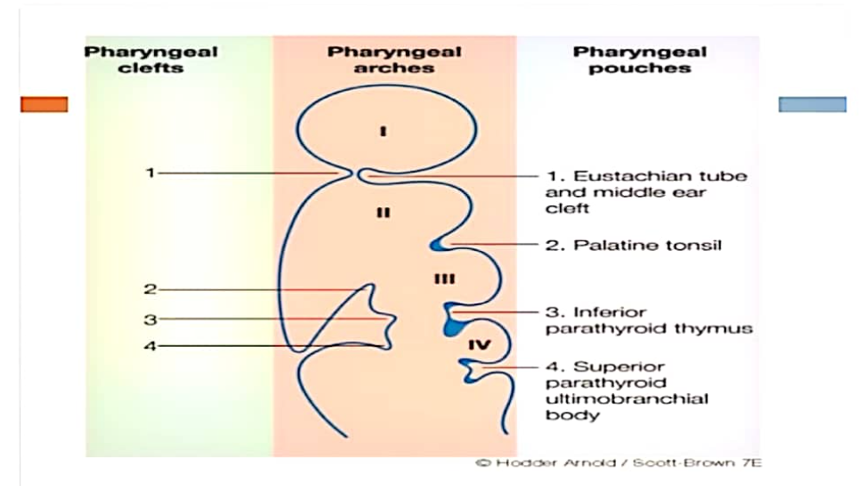

Second (hyoid) arch enlarges and grows so that by the sixth week it will overlap the third, fourth, and sixth arches and cover them.

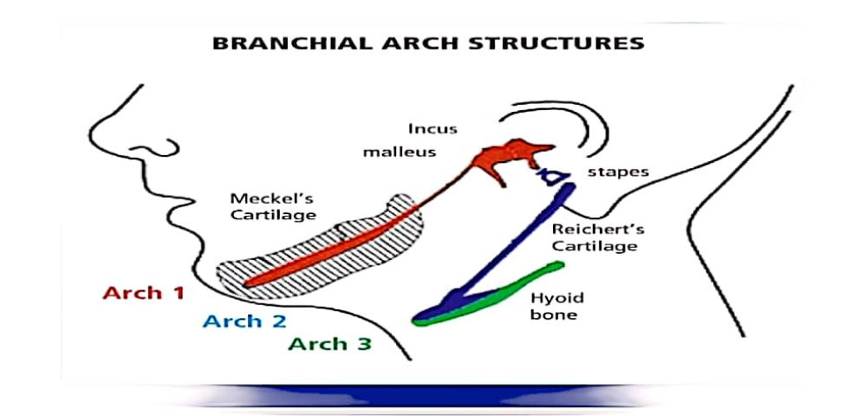

Branchial (pharyngeal) grooves Between neighbouring branchial (pharyngeal) grooves or clefts are noted on each side of the embryo; FIRST groove forms the external auditory meatus and mesenchyme of first and second arches, which are located on either side of this pharyngeal groove, will also give rise to the external ear.

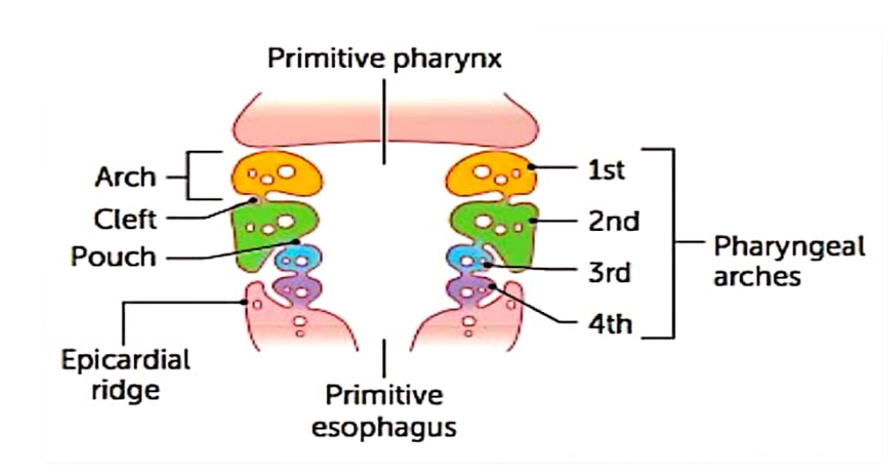

**Pharyngeal pouches**

Five well-defined pairs of pharyngeal pouches develop as endodermal envaginations form the lateral walls lining the pharynx and form different structures.

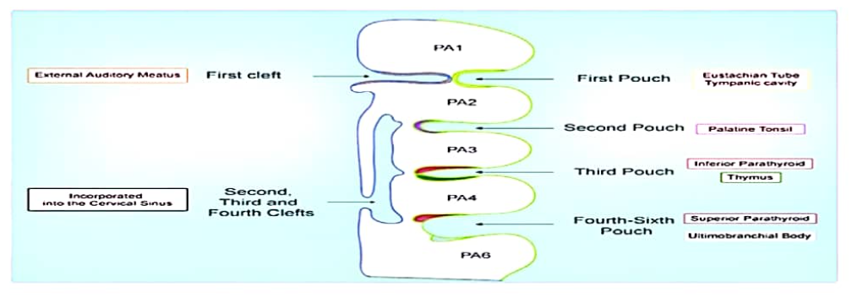

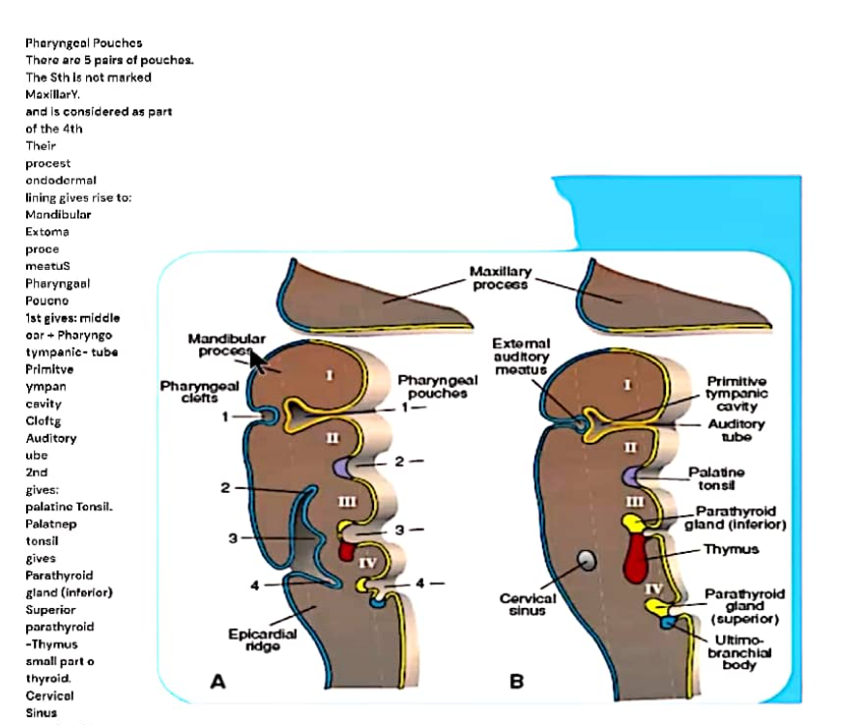

Development of the palate

Formation of the palate starts in the embryo during fifth week, takes place during several weeks of prenatal development, and is completed in twelfth week in the fetus formed from two separate embryonic structures, primary palate and secondary palate

