Lecture 3 Dental Equipment Technologies Dr.Muna Merza

**Conventional Centrifuge Casting machine**

**Casting machine:**

It is used in chromium cobalt and crown & bridge laboratory, for pouring all types of metal.

**Types of casting machine:**

1 Conventional Centrifuge casting machine.

2. Electric casting machine.

**Conventional Centrifuge Casting machine**

**Parts:**

1. Protective cover (Guard): is made from metal the inner surface from the pressured aspect that circle the tools to protect the pouring part in case of failure in pouring melting part go away in the sped rotation.
2. Base: is the support center, it must have high strength and located in a non-moving surface to avoid vibration or rotation during work, and it contains movement lock.
3. Balance arm: it is the arm that is faced with the crucible arm; connect with the base from one side and the other side stabilizes on its heavy bodies "contour weight". These heavy bodies increase according to the weight of the pouring ring in the other side. The importance of this arm to protect 2 arms in a balancing way.
4. Crucible arm: its high strength arm connects with a base from one side and with perpendicular support wall from the other side and anterior to the support wall there are 3 parts which are:

a. Cradle; is locating downward of the ring. the advantage of the cradle is to surround melting ring & the importance of melting crucible metal is to pour the metal that inside it.

b. Melting crucible metal: to locate the molten metal it should be made from the ceramic because no carbon contains the metal.

c. locks: are important to stabilities melting crucible metal and melting ring in their place and making sure they are not moving.

5- Pin: which contains the spring used to rotation the arm during the casting process.

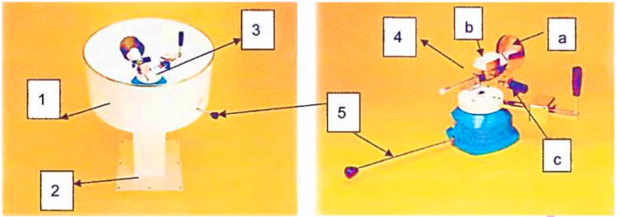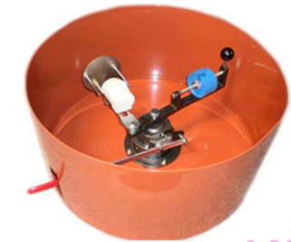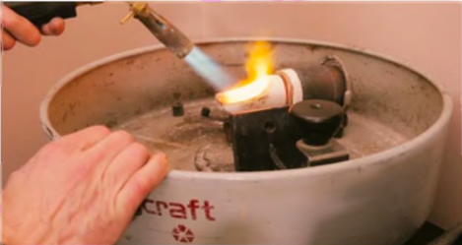

**Lecture 4 Electric and Induction Centrifuge Casting Machine**

**Electric and Induction Centrifuge Casting Machine:**

It is a modem centrifuge specially designed for centrifuge molding small metal parts for the dental prosthesis sector.

**Parts:**

A. Arm: parts of arm:

1- Balance arm: - it is the arm that is faced with the crucible arm; connect with the base from one side and the other side stabilizes on its heavy bodies "contour weight". These heavy bodies increase according to the weight of the pouring ring in the other side. The importance of this

arm to protect 2 arms in a balancing way.

2- Crucible arm: its high strength arm connects with a base from one side and with perpendicular support wall from the other side and anterior to the support wall there are 3 parts which are:

a. Cradle: is locating downward of the ring the advantage of the cradle is to surround melting ring &the importance of melting crucible metal is to pour the metal that inside it.

b. Melting crucible metal: to locate the molten metal it should be made from the ceramic because no carbon contains the metal.

c. Locks: are important to stabilities melting crucible metal and melting ring in their place and making sure that they are not moving.

B. Lid.

C. On switch.

D. Control panel**.**

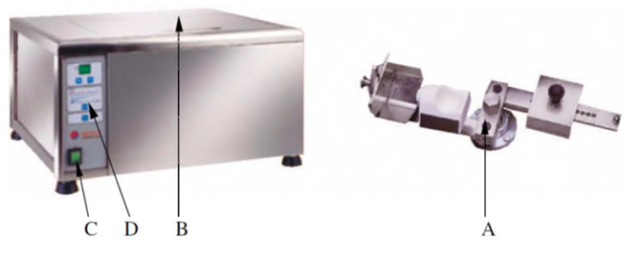

**Vestacast Centrifuge casting machine:**

Vestacast is a compact, easy to operate induction casting machine for melting and casting all dental alloys except titanium and titanium alloys.

This is the machine that uses the argon gas in the cycle electrical or the magnetic field bends the brow electrically.

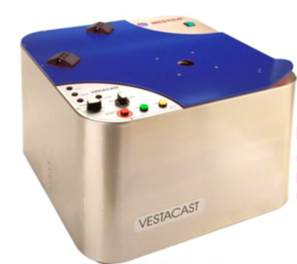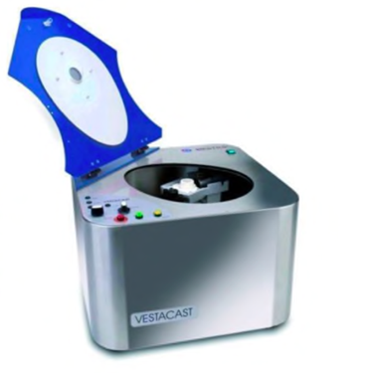

Parts:

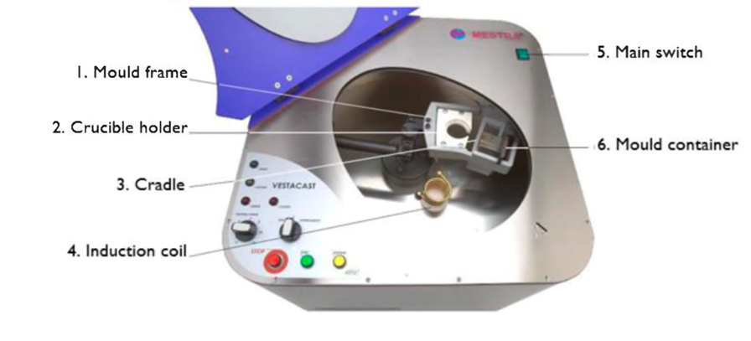

**Lecture 5 Ultrasonic Cleaning Machine and Mechanical Mixer (vacuum)**

**Ultrasonic Cleaning Machine:**

It is a device used to clean the metal by ultrasonic pulls with a cleaning solution that is either hot or cold, the machine consists of:

A. On-Off switch

B. Display

C. Up-Down keys

D. Heater resistor key

E. Lid

F. Waste pipe

G. Stainless steel basket

H. Glass vessel

İ. Glass vessel support

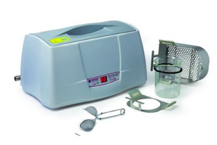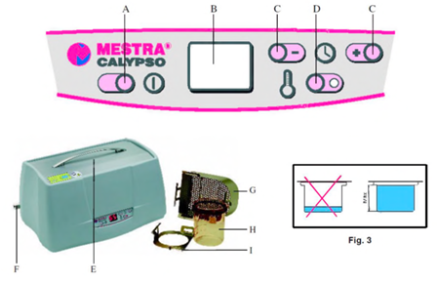

**” Liquid solution": is used in ultrasonic cleaners to dissolve or disperse the material to be removed from the dental restoration.

* There is special liquid for each type of alloy.

**Mechanical mixer device (vacuum-auto-mixing device):**

This device is used in the laboratory of the crown, bridge, and chromium cobalt for mixing gypsum product materials (plaster, stone, die stone, and investment material.)

With this equipment, the powder and liquid (water or special liquid) are mixed in a vacuum. The amount of air usually is reduced enough to obtain a smooth adaptation of the investment to the pattern vacuum investing often yield casting with the improved surface when compared with casting procedure from hand investment pattern.

It consists of:

1. Vacuum display. 2. Program display. 3. Up key

4. Down key 5. Parameter selection key. 6. Start/stop key.

7. No vacuum key. 8. Function display:

a. function key.

b. mixer only.

c. vacuum and mixer.

d. vacuum only.

9. Main switch. 10. The high-performance vacuum pump.

11. Mixing bowls in three sizes (small, medium, large bowl).

12. Led with mixing spatula.

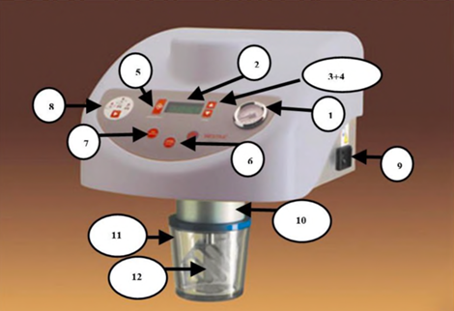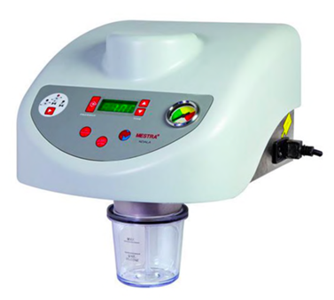

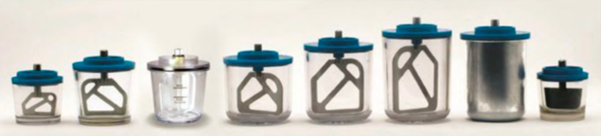

**Lecture 6 Sandblast Machine**

This device is used to remove oxides & debris of investment from metal that is used in partial denture (chrome-cobalt) & in crown and bridge. Use a sandblast which project by compressor air through a fine nozzle (tube) to clean the alloy using abrasive (sandblast) abrasive particle showing compressive air in agent to remove particle of investment this particle with different

size.

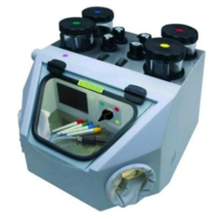

Parts:

A. Emery deposit vessel B. Vessel pressure control

C. Booth light switch D. External inlet tube

E. Rubber guard F. Vessel heat system switch

G. Vessel selection switchgear H. Fabric sleeve I. Fine nozzle.

