

**Ministry of Higher Education and Scientific Research Al- Mustaqbal University College Department of Chemical Engineering and petroleum Industrials**

**Mathematics II**

**2nd Stage**

**Lecturer: Rusul A. Hashim**

**Multiple Integrals**

# Integration of functions of one variable

We start by recalling the basics of integration with respect to a single variable. We have results such as:

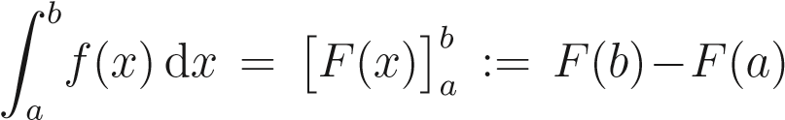

where *F* is an “antiderivative” or indefinite integral of *f*. (*f* = d*F/*d*x*.)

Z *λf*(*x*)d*x* = *λ*Z *f*(*x*)d*x,*

Z (*f*(*x*) + *g*(*x*))d*x* = Z *f*(*x*)d*x* + Z *g*(*x*)d*x.*

Useful techniques include:

* Integration by parts.
* Integration by substitution.
* Use of partial fractions.

Some specific integrals can be found on the formula sheet.

**Question 1.** Calculate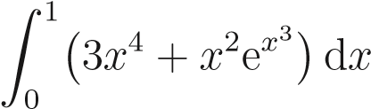.

**Solution.** This integral is designed to use a few different techniques! Firstly we can split the integral as

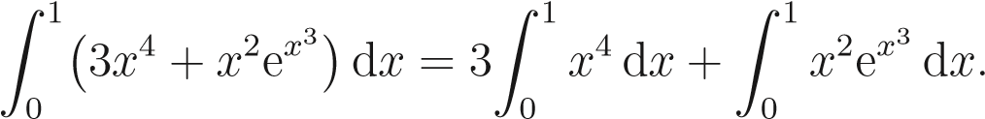

The first integral on the right-hand side is straightforward:

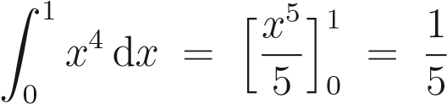*.*

To calculate the second integral on the right hand side we use integration by substitution; taking *u* = *x*3 we have d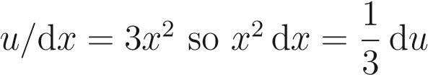. Therefore

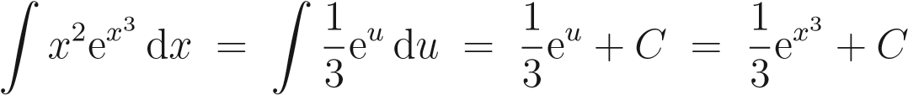*.*

The definite integral can then be computed as

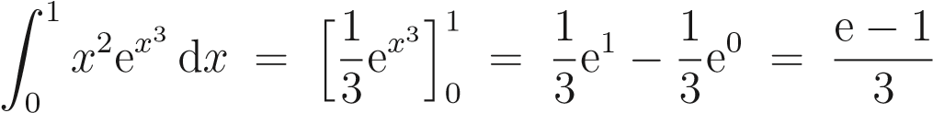*.*

Combining the above calculations we finally get

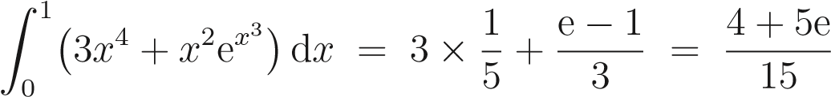*.*

One interpretation of an integral like this is the area under a graph: assuming that *f* is positive, the area of a strip of width d*x* and length *f* is *f* d*x* and then *A* = R*ab f*(*x*)d*x* is the total area between the *x* axis and the curve *y* = *f*(*x*) for *a < x < b*.

*y* = *f*(*x*)

*x*

*a*

*b*

*A*

More generally, if *f* represents the density of some quantity, *i.e.* it is the amount per unit length, *f* d*x* is the amount in a short length d*x* and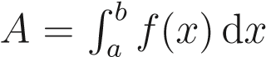 is the total amount between *x* = *a* and *x* = *b*.

# Integration of functions of two variables

Thinking of a single integral as giving an area, we might ask: what is the volume under a surface *z* = *f*(*x,y*) lying above a rectangle in the *x* - *y* plane, *a < x < b*, *c < y < d*? (We again take *f >* 0 for simplicity.)

First look at a small rectangle of length d*x* and width d*y*. Its area is d*A* = d*x* d*y*. Then the volume between that small rectangle and the surface is the height of the enclosed (aproximately) cuboidal region times the area: *f* d*A* = *f* d*x* d*y*.

*z* = *f*(*x,y*)

d

*y*

d

*x*

*f*

The volume between the *x* - *y* plane and the surface in the slab of width d*x* between *y* = *c* and *y* = *d* is then given by integrating with respect to 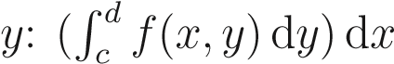. (In doing this integral, *x* is held fixed.) Finally, to get the total volume, we must integrate with respect to *x* from *a* to *b*:

volume =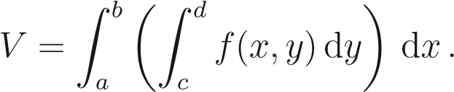 (7.1)

We usually abbreviate this double integral as

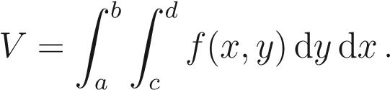 (7.2)

Noting that, for cases we’ll be considering at least, we could have integrated with respect to *x* first and then *y*, we also have

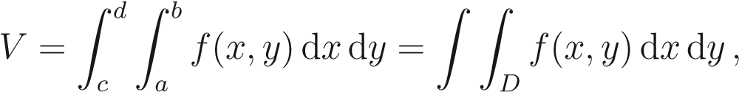 (7.3)

where *D* is our region of integration, here *D* is the rectangle *a < x < b*, *c < y < d*.

More generally if *f* once again represents some sort of density, *e.g.* mass per unit area in a sheet of metal, the double integral R R*D f*(*x,y*)d*x*d*y* is the total amount in the region *D*.

**Question 2.** CalculateZ (*xy*2 + *y*)d*y* d*x*. 4 3

2 1

**Solution.** Calculating the inner integral first gives

Z

*.*

Therefore

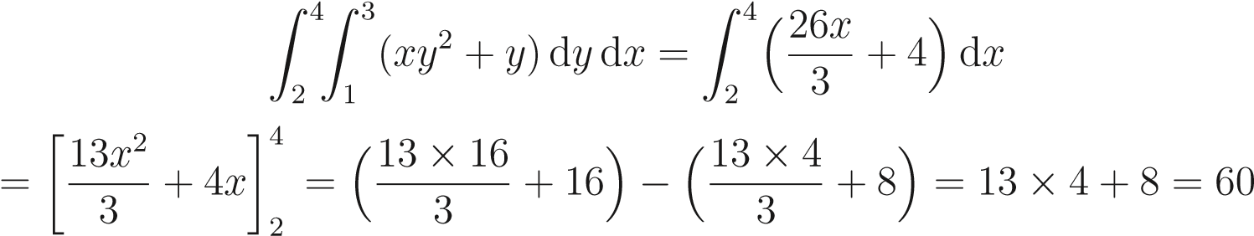*.*

**Question 3.** CalculateZ 2*xy* d*x*d*y*. 1 3

0 2

**Solution.** Calculating the inner integral first gives

Z

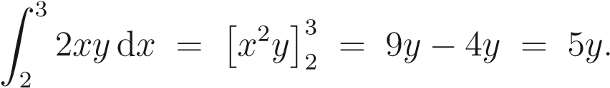

Therefore

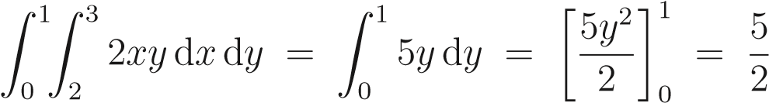*.*

3 1

**question** **4 .** For the double integral Z Z 2*xy*e*xy*2 d*y* d*x* the region of integration *D* is

2 0 the rectangle given by

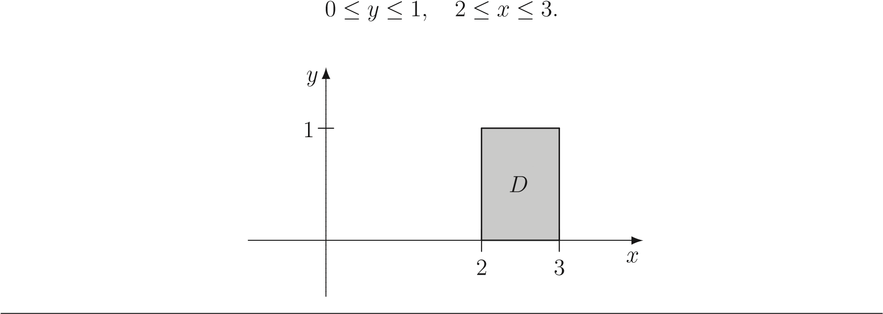

**Question 5 .** CalculateZ 2*xy*e*xy*2 d*y* d*x*. 3 1

2 0

**Solution.** Firstly consider the inner integral

Z

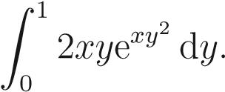

We will use integration by substitution for this integral; taking *u* = *xy*2 we have 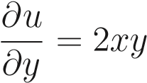so d*u* = 2*xy* d*y* and hence

Z 2*xy*e*xy*2 d*y* = Z e*u* d*u* = e*u* + *C* = e*xy*2 + *C.*

Thus

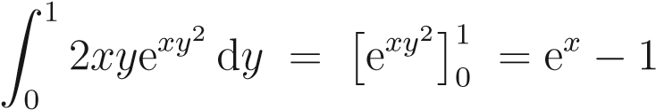*.*

It follows that

*.*

**Question 6 .** Let *D* be the rectangle given by

−1 ≤ *y* ≤ 0*,* 1 ≤ *x* ≤ 3*.*

Calculate ZZ (*x*2 + *y*)d*y* d*x*.

*D*

**Solution.** The region of integration is the following:

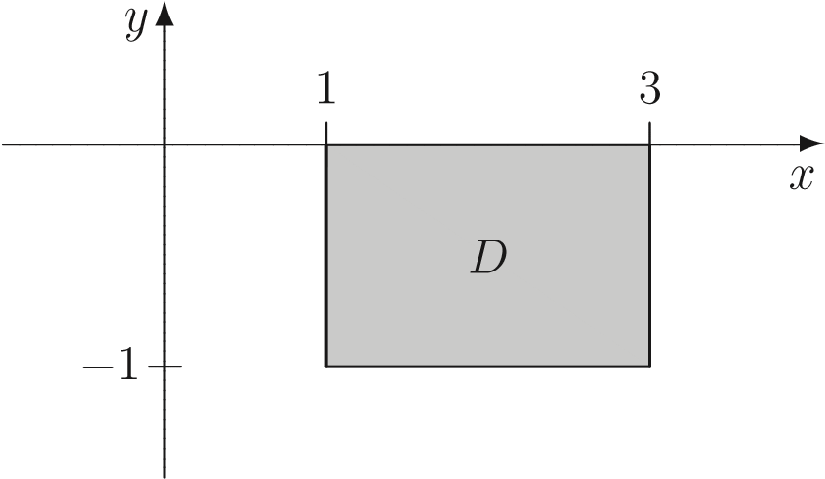

Now

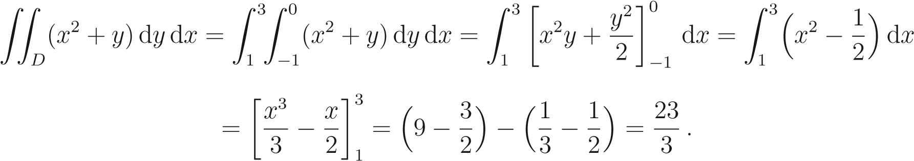

Of course a region of integration need not be rectangular. If *D* can be described by *g*(*x*) *< y < h*(*x*) for *a < x < b*, the (double) integral of *f*(*x,y*) over *D* will be

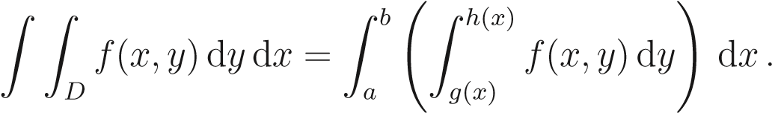

We can drop the brackets and simply write this as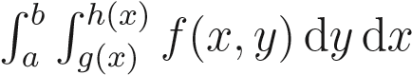.

**question** **7 .** Consider the region given by

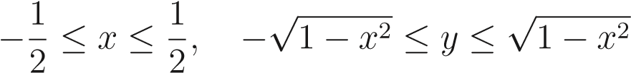*.*

This region is part of a disc.

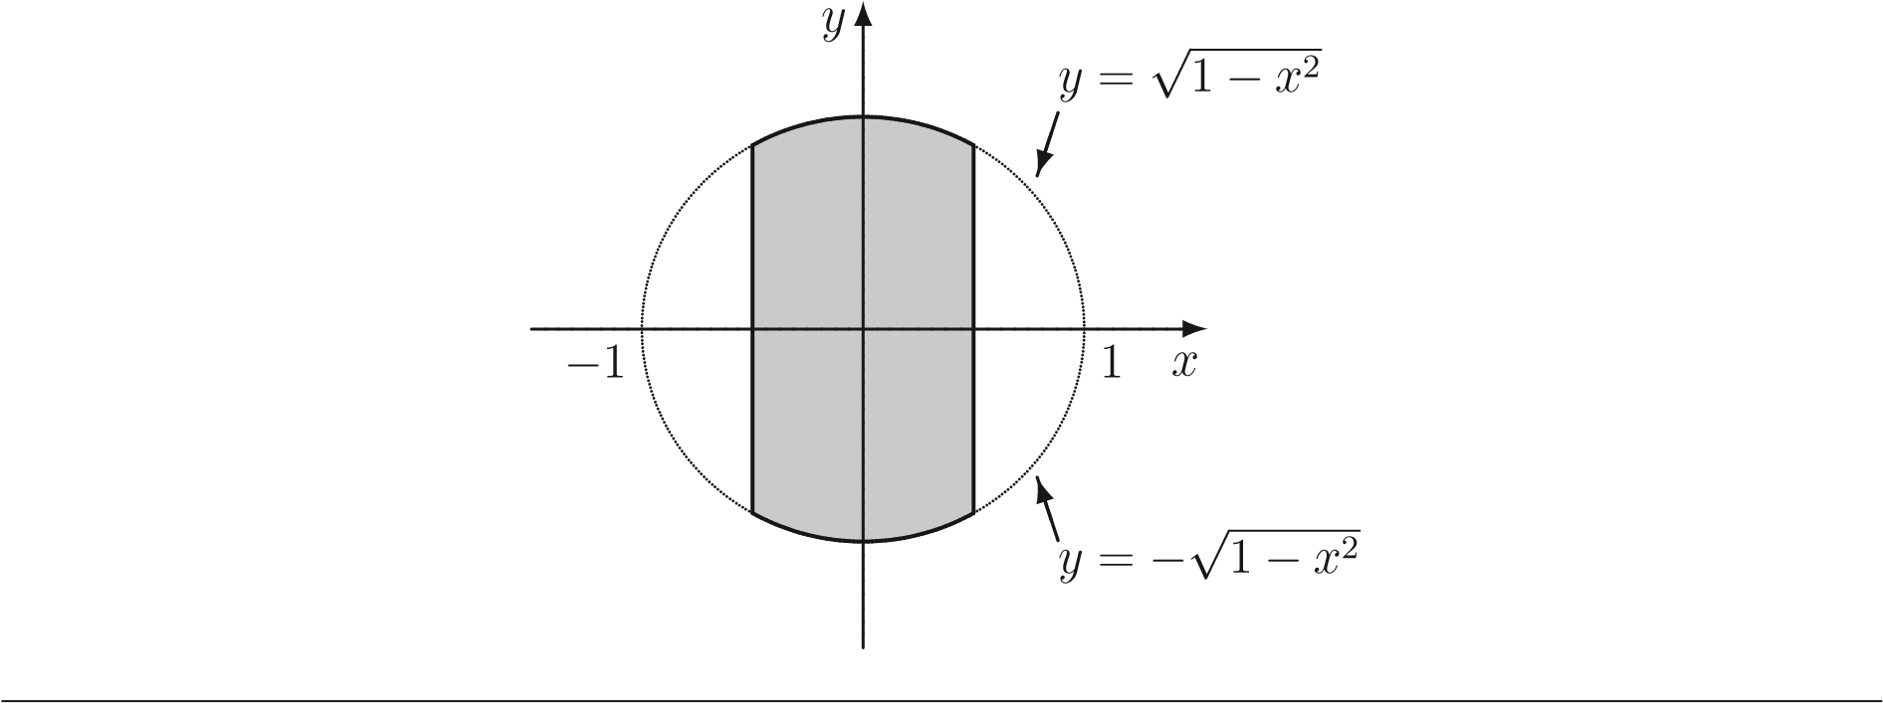

**question** 8**.** Consider the region *D*:

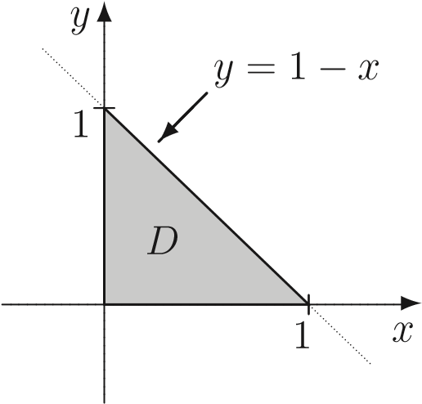

In this region we have 0 ≤ *x* ≤ 1 whilst, for a given *x*, 0 ≤ *y* ≤ 1 − *x*. Thus the region *D* is described by

0 ≤ *x* ≤ 1*,* 0 ≤ *y* ≤ 1 − *x.*

**Question 9 .** Calculate Z Z*D y* d*A* over the region *D* below:

**Solution.** In this region we have 0 ≤ *x* ≤ 1, whilst, for a given *x*, we have

√*x* ≤ *y* ≤ 1*.*

1

*y*

=

√

*x*

*x*

*y*

*D*

0 1

Therefore

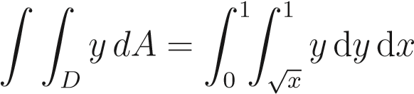*.*

Calculating the inner integral first gives

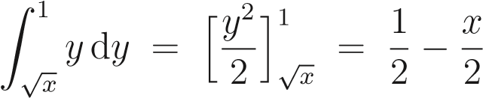*.*

Hence

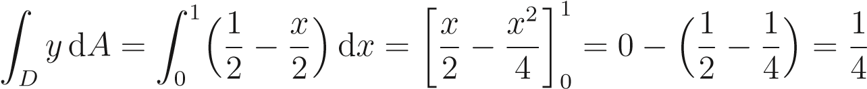 *.*

**question** **10.** Consider the region *D*:

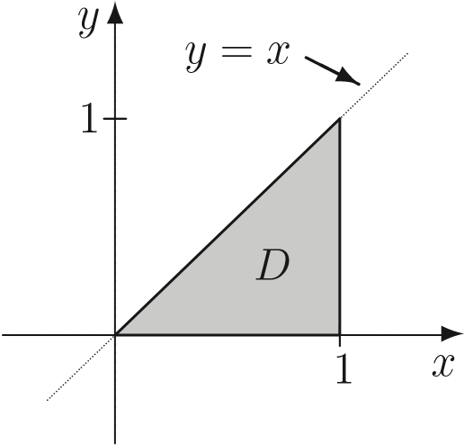

In this region we have 0 ≤ *y* ≤ 1, whilst, for a given *y*, *y* ≤ *x* ≤ 1.

**Question 1 1** Calculate**.** ZZ*D*(3 − *x* − *y*)d*A* where *D* is the region described in the previous question.

**Solution.** Recall that *D* is described by

0 ≤ *y* ≤ 1*, y* ≤ *x* ≤ 1*.*

Therefore 1 1

ZZ (3 − *x* − *y*)d*A* = Z0 Z*y* (3 − *x* − *y*)d*x*d*y.*

Now

 *.*

It follows that

*.*

# Interchanging the order of integration

As noted before, we can swap the order in which the order in which the integrals are carried out : R R*D f* d*y* d*x* = R R*D f* d*A* = R R*D f* d*x*d*y*. It is sometimes easier to calculate the value of a double integral doing the integrations in one order than the other.

**Example 7.6.** Consider the region *D* which lies between the line *y* = *x* and the parabola *y* = *x*2:

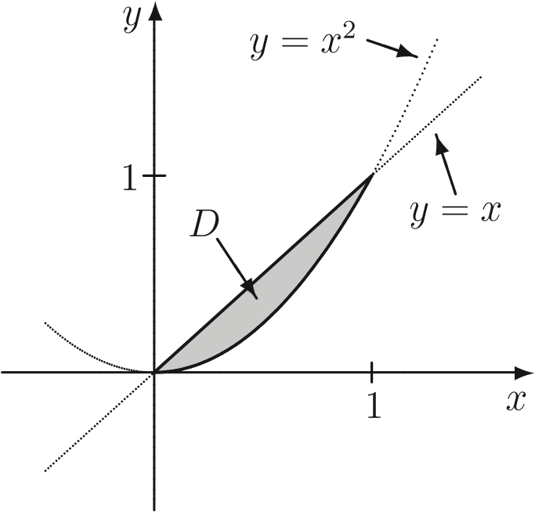

This region can be described by

0 ≤ *x* ≤ 1*, x*2 ≤ *y* ≤ *x.*

On the other hand, the parabola is also given by the equation *x* = √*y* so the region *D* can also be described by

0 ≤ *y* ≤ 1*, y* ≤ *x* ≤√*y.*

It follows that we have



**Question 1 .** Calculate ZZ e*y*2 d*A* where *T* is the triangular region with vertices (0*,*0),

(0*,*1) and (1*,*1): *T*

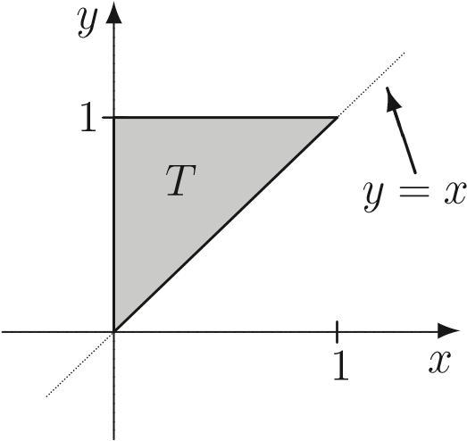

**Solution.** As a first attempt we may describe *T* by

0 ≤ *x* ≤ 1*, x* ≤ *y* ≤ 1*.*

It follows that

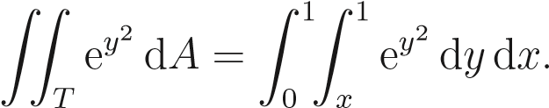

The inner integral is then

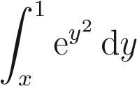

which can’t be evaluated very easily! We’ve got stuck!

As a second attempt let us describe *T* the other way; that is

0 ≤ *y* ≤ 1*,* 0 ≤ *x* ≤ *y.*

Then ZZ e*y*2 d*A* = Z Z e*y*2 d*x*d*y.* 1 *y*

*T* 0 0

Evaluating the inner integral first gives

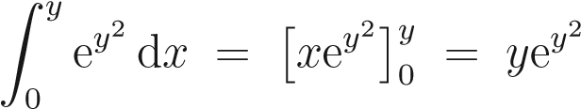*.*

It follows that

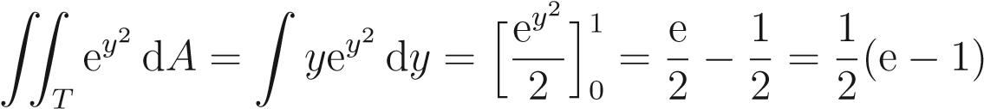*,*

where we used the substitution *u* = *y*2 to evaluate the integral.

**Note.** On evaluating a double integral *I* = R R*D f*(*x,y*)d*A* by doing the *y* integral first, *i.e.* taking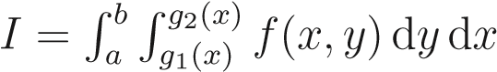, we integrate along vertical strips between the lower boundary, say *y* = *g*1(*x*), and the upper boundary, say *y* = *g*2(*x*) (this gives a result which generally depends upon *x*, but definitely does not depend on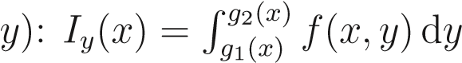.

We then total up the contributions of strips by integrating *Iy* from the lowest value of *x* taken in *D*, say *a*, to the largest, say *b* (see Fig. 7.1(i)): 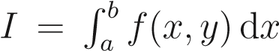. On the other hand, doing the *y* integral first, we take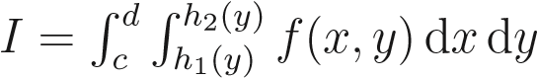, we integrate along horizontal strips between the left-hand boundary, say *x* = *h*1(*y*), and the right-hand boundary, say *x* = *h*2(*y*) (this gives a result which generally depends upon *y*, but definitely does not depend on 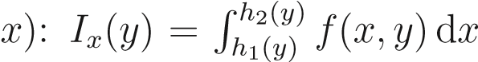. We then total up the contributions of strips by integrating *Ix* from the lowest value of *y* taken in *D*, say *c*, to the largest, say *d*

(see Fig. 7.1(ii)). (Either way, the final result does not depend on either *x* or *y*!)

(i) (ii)

2

*D*

*D*

*y*

*y*

*c*

*d*

*y*

=

*g*

1

(

*x*

)

*y*

=

*g*

2

(

*x*

)

*x*

=

*h*

(

*y*

)

*x*

=

*h*

2

(

*y*

)

*a b x x*

Figure 1: Different orders of integration over *D*.