|  |  |  |
| --- | --- | --- |
| **وزارة التعليم العالي والبحث العلمي**  **كلية المستقبل الجامعة**  **قسم/-هندسة تقنيات الحاسوب**  **مختبر/- اتصالات الرقمية** | | **رمز السجل :**  **تاريخ الإصدار:**  **رقم الإصدار:** |
| **المرحلة :الثالثة** |
| **سجل التجارب للعام الدراسي 2023 - 2024** | | |

***Experiment :1***

## *Pulse Amplitude Modulation & Demodulation (PAM)*

## [Pulse Amplitude Modulation & Demodulation (PAM) Trainer](http://www.tesca.in/uploads/products/images/pulse-amplitude-modulation-and-demodulation-pam-tr-1578-3320.jpg)

***Object:***

In this lab, you will learn how to perform the pulse amplitude modulation and demodulation and to calculate the modulation index for various modulating voltages.

***Features* & procedure :**

## The board consists of the following built-in parts: 1. ±9V D.C. at 100mA, IC regulated Power Supply internally connected 2. Variable frequency sampling pulse generator 3. Sine wave audio frequency modulating signal generator 4. PAM Modulator circuit based on an operational amplifier 5. PAM Demodulator circuit based on a point contact diode and an operational amplifier 6. Adequate no. of other electronic components 7. Mains ON/OFF switch, Fuse and Jewel light * The unit is operative on 230V ±10% at 50Hz A.C. Mains * Adequate no. of patch cords stackable from rear both ends 2mm spring loaded plug length ½ meter * Good Quality, reliable terminal/sockets are provided at appropriate places on panel for connections/ observation of waveforms * Strongly supported by detailed Operating Instructions, giving details of Object, Theory, Design procedures, Report Suggestions and Book References

***Theory*:**

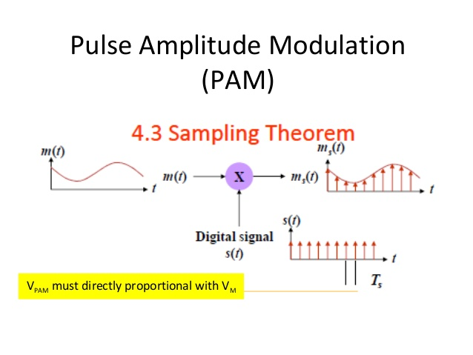

Audio frequency signals may travel long distances through over hade wire or underground cables it has been found that the message carrying capacity of these transmission lines increases if each individual message signal is translated from the audio frequency to a high frequency or what is commonly known as a carrier frequency .by suitably selecting the carrier frequency the resulting signal may also be made to transmit itself through space without the use of transition lines , this process by which an information of lower frequency distinguishable part of a higher frequency is known as MODULATION . the low frequency information is called the MODULATING SIGNAL whereas the high frequency is called the carrier wave very often the modulating signal is a complex waveform consisting of many frequencies with varying amplitude and phases . the carrier wave is on the other hand a single frequency wave of constant amplitude . the reverse process by which information is separated out from a modulated wave is known as detection or DEMODULATIOM.

***المناقشة والاستنتاجات :***



*PAM Model Graph*



*PAM Demodulation Model Graph*

***Demodulation:***

1. Connect the circuit as shown in tesca board .

2. Given the modulated output with AFO used to the input of the circuit.

3. Vary the potentiometer so that modulating signal is obtained.

4. Measure the amplitude of the signal and verify with that of the input.

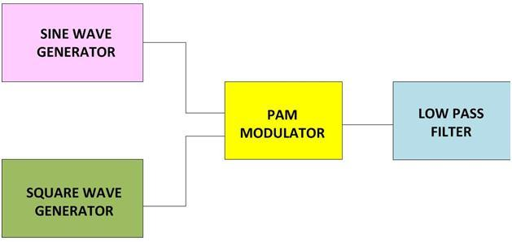

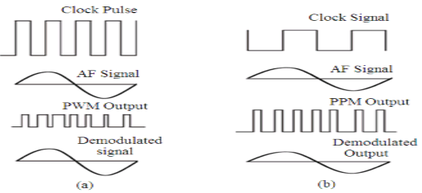

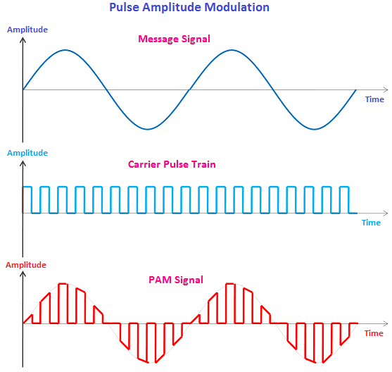

***POST LAB QUESTIONS:***

1. What is the process of sampling an analog signal at a high rate ?

2. Which multiplexing technique is used to transmit both digital and analog signals?

3. Why PAM is not preferable in digital transmission?

4. Which device is used to track PAM frequency variations in the clock recovery circuit ?

5. What kind of switches are commonly used in PAM multiplexers?