**How we connect the internet to the computer?**

There are three ways to connect the Internet to the computer

1. Operating the Internet through wireless.
2. Operating the Internet through dial-up.
3. Operating the Internet through the Ethernet port.
4. **Operating the Internet through wireless**

The Internet can be operated on the computer by connecting it to a wireless network, by following the steps: Verify that wireless is activated on the user’s computer. It can be turned on in some devices through the network button, while you must enter the network settings to turn it on in other devices.

step 2: Turn on Wi-Fi through your desktop we go to the taskbar, click on the Wi-Fi icon, and the following window appears. Figure 1

Search for the Wireless Network you want to connect to, with the router’s network name written on it.

Enter the password for the wireless network you want to connect to.

Wait until the computer is connected to the desired network, which usually takes several seconds. Verify the computer's connection to the Internet, by opening one of the Internet pages through the browser available on the computer.

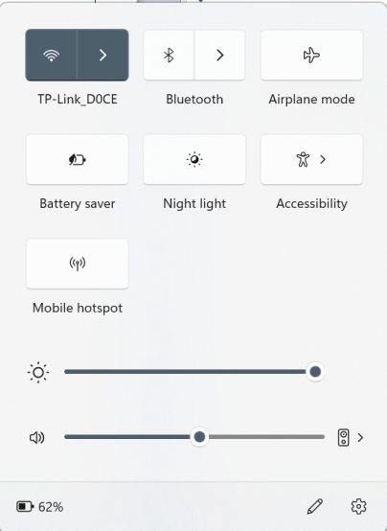

**Figure 1**

1. **Operating the Internet through dial-up**

The Internet can be operated on the computer by using the dial-up method, which is rarely used at this time. The following are the steps to turn on the Internet on a computer running Windows 10 via (Dial-Up):

* Make sure that there is Some equipment needed to complete the Internet operation; Such as having a private phone line to connect to the Internet through, having a modem in the computer, or purchasing an external one.
* Connecting the phone line to the modem.
* Connect the modem to the computer using cable Rj 11 .
* Go to the Internet option Through the control panel we choose Network and Sharing
* Click on the Set up a new connection or network button, then choose the Connect to the Internet option.
* Determine the type of connection you want to create, which here is dial-up.
* Adjust Internet connection settings by entering your phone number, username, and password. As in the following figure 2
* Open one of the Internet browsers available on the computer, and go to one of the websites; To check your Internet connection.

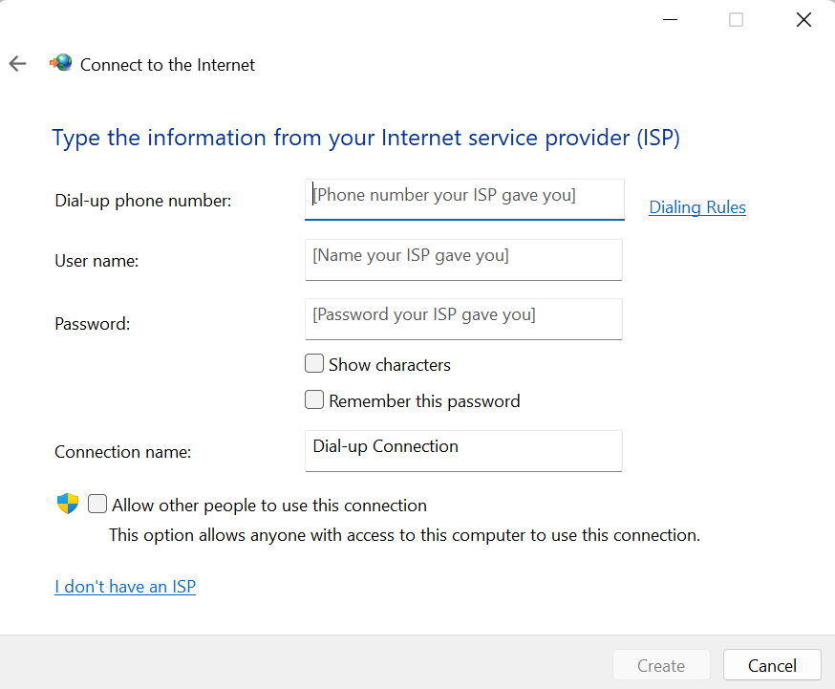

**Figure 2**

1. **Turn on the Internet through the Ethernet port**

The Internet can be operated on the computers by using the Ethernet port on the devices.

* Determine the location of the network port (Ethernet port) available on the computer. The location of this entrance varies depending on the type of computer. In laptop computers, it is located on the side of the device, while in desktop computers, it is located in the back.
* Insert one end of the network cable into the network port on the computer.
* Inserting the other end of the cable into one of the ports of the network device available to the user, such as a router, which must be connected to the Internet As in the following figure 3.
* Click on the network connection status icon appearing in the task bar of the computer, and you will be automatically connected to the Internet through the network without the need for any adjustment or settings.

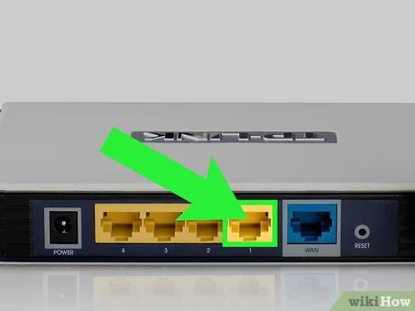

**Figure 3**