**GLP-F020**

**اسم القسم: هندسة تقنيات الأجهزة الطبية / اسم المختبر: الكترونيك القدرة / المرحلة : الثالثة / رمز المختبر:BL 404**

**سجل التجارب للعام الدراسي 23 20 - 24 20**

**رقم التجربة :-**  **Experiment No.1**

**اسم التجربة :** **Diode Characteristics**

**الغرض من التجربة :-** To study and plot the V-I characteristics of a diode. (Relationship between VAK and IA).

**الاجهزة والمعدات :-** 1. ST2712 board. 2. (2)DC Voltmeter. 3. DC Ammeter. 4. Diode 1N4007 (on board) 5. Potentiometer 5K(1/4W) 6. Resistance 1K(1/4W).

**طريقة العمل :**



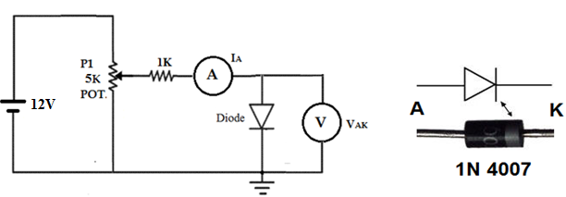

Figure (2) the practical circuit for forward Diode characteristics.

**النتائج القياسية:** Table (1) Results Obtained for forward characteristics of the Diode.

|  |  |  |  |  |  |  |  |
| --- | --- | --- | --- | --- | --- | --- | --- |
| VAK  (V) | 0.1 | 0.2 | 0.3 | 0.4 | 0.5 | 0.6 | 0.7 |
| IA  (mA) |  |  |  |  |  |  |  |

**المناقشة والاستنتاجات:**

**Discussion**

1. Comment about the obtained results ?
2. What is the benefit of (1 Ω, and 1kΩ ) resistances?
3. From AC and DC cct. results, determine Ploss(total) at peak current of the diode?

Note: Ploss(total) = Ploss(diode) + Ploss (of all the resistances in the circuit) .

1. By only the AVO meter, how can you know the terminals (A & K), drop voltage and the diode is working or not?
2. If the maximum current of the diode c/c cct. is (22 mA) can you determine the r.m.s voltage of the source?

|  |  |  |  |  |  |  |
| --- | --- | --- | --- | --- | --- | --- |
| **اليوم** | **التاريخ** | **الشعبة** | **العدد الكلي للطلبة** | **عدد الحضور** | **وقت المحاضرة** | **اسم و توقيع مدرس المادة** |
|  |  |  |  |  |  |  |
|  |  |  |  |  |  |  |
|  |  |  |  |  |  |  |