**Al-Mustaqbal University**

**Oral Medicine 5th stage/2023-2024**

**Lecture 3 Dr. Muayed Hashim**

Laboratory Investigation continue….

Hematological investigations

Blood investigations are clearly essential for the diagnosis of diseases such as leukemia, myeloma, or leucopenia which have oral manifestations, or for defects of hemostasis which can greatly affect management.

Blood investigations are also helpful in the diagnosis of other conditions such as some infections, and sore tongues or recurrent ulcerations which are sometimes associated with anemia.

The major components of the blood are plasma, red blood cells, white blood cells and platelets. Plasma is a yellowish liquid that contains the other components of the blood as well as many different substances. These include proteins, such as albumin, globulin and fibrinogen



Complete blood count (CBC)

- The blood count consisted of a Hb concentration, a white cell count and platelet count. other parameters such as MCV had to be mathematically calculated using the measured variables Hb, RBC and PCV.

The resultant CBC provides measured variables such as

Hb, PCV and RBC along with derived (mathematically) MCV, MCH and MCHC these machines also provide automated platelet counts and a 5-part differential WBC

Main parameters measured

Hb concentration.

Red Blood cell count (RBC). MCV.

MCH.

MCHC

Haematocrit (Hct) or PCV,

Red cell distribution width (RDW). White cell count.

WBC differential. Platelet count.

**Hemoglobin concentration (Hb)**

• Hemoglobin is the protein molecule in red blood cells that carries oxygen from the lungs to the body's tissues and returns carbon dioxide from the tissues back to the lungs.

• Hemoglobin is made up of four protein molecules (globulin chains) that are connected together.

Hemoglobin concentration (Hb)

• Units: g/dL or g/L

Defines anemia (Hb <lower limit of normal adjusted for age and sex).

Values differ between male and female since androgens drive RBC production and hence adult male has higher Hb, PCV and RBC than adult female,

Normal count 13-18 g/dl male, 11.5-16.5g/dl in female

•if increased Polycythemia

• Decreaseed Anemia

Red Blood cell count (RBC)

Normal red blood cells are round, flattened bi-concave disk shaped that are thinner in the middle than at the edges.

• The red blood cell count is an important test because the number of red blood cells (RBCs) can affect how much oxygen tissues receive.

• Fatigue and shortness of breath can be symptoms of either a low RBC count or a high RBC count.

• Certain medical conditions,dietary habits,

and medications can all affect RBC count.



a low RBC count, symptoms could include:

• fatigue

• shortness of breath

• feeling dizzy, weak, or lightheaded, particularly when change positions quickly

• increased heart rate

• headaches

• pale skin

a high RBC count, you could experience symptoms such as:

• fatigue

• shortness of breath

• joint pain

• tenderness in the palms of the hands or soles of the feet

• itching skin, sleep disturbance

• The normal RBC range for men four to six million cells per microliter.

• The normal RBC range for women who aren’t pregnant is 4.2 to 5.4 million cells per microliter.

• The normal RBC range for children is 4.0 to 5.5 million cells per microliter.

• Higher than normal (erythrocytosis ) if RBC count is higher than normal. This may be due to:

• congenital heart disease

• dehydration

• renal cell carcinoma ,pulmonary fibrosis

• polycythemia vera, a bone marrow disease that causes overproduction of RBCs and is associated with a genetic mutation

• When move to a higher altitude, RBC count may increase for several weeks .

**• Certain drugs, such as Gentamicin and methyldopa ,can also increase RBC count**. .

• A high RBC count may be a result of sleep apnea, pulmonary fibrosis, and other conditions that cause low oxygen levels in the blood.

• Performance-enhancing drugs such as protein injections and anabolic steroids can also increase RBCs.

• Lower than normal

**If the number of RBCs is lower than normal, it may be caused by:**

• Anemia

• bone marrow failure

• Erythropoietin deficiency, which is the primary cause of anemia in patients with chronic kidney disease

• Hemolysis, or RBC destruction caused by transfusions and blood vessel injury

• Internal or external bleeding

• Leukemia

• Malnutrition

• Multiple myeloma

• Nutritional deficiencies, including deficiencies in iron, copper, folate, and vitamins B-6 and B-12

• Pregnancy

• Thyroid disorders

• Certain drugs can also lower RBC count, especially:

1. chemotherapy drugs

2. chloramphenicol, for bacterial infections

**Mean cell volume (MCV)**

- is the average volume of red cells in a specimen. MCV is elevated or decreased in accordance with average red cell size; i e,

- low MCV indicates microcytic (small average RBC size)

- normal MCV indicates normocytic (normal average RBC size

-high MCV indicates macrocytic (large average RBC size).

Decease (microcytic) in iron def. anemia, Thalassemia Increase (macrocytic) in B12 or folate deficiency.

**Anemia** is a medical condition in which the red blood cell count or hemoglobin is less than normal. Anemia is caused by either a decrease in production of red blood cells or hemoglobin, or an increase in loss (usually due to bleeding) or destruction of red blood cells.

- Regardless of the cause of anemia, it needs to be treated. People with anemia typically feel tired and weak. They may also experience headaches, cold hands and feet, dizziness, and irregular heartbeats.

• **Anemia is caused essentially through two basic pathways:**

• A decrease in production of red blood cells or hemoglobin, or

• An increase in loss or destruction of red blood cells .

• A more common classification of anemia is based on the Mean Corposcular Volume (MCV) which signifies the average volume of individual red blood cells.

• If the MCV is low (less than 80), the anemia is categorized as microcytic anemia (low cell volume.)

• If the MCV is in the normal range (80-100), it is called a normocytic anemia (normal cell volume) .

• If the MCV is high, then it is called a macrocytic anemia (large cell volume).

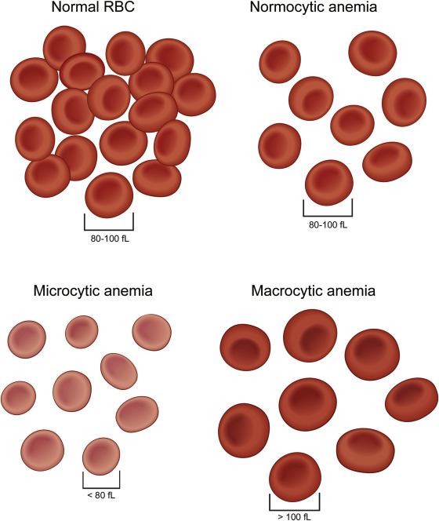

There are many types of anemia, including :

**1- Iron deficiency anemia**

Is a very common cause of anemia. This is because iron is major component of hemoglobin and essential for its proper function.

Chronic blood loss due to any reason is the main cause

As it depletes the body's iron stores to compensate for the ongoing loss of iron. Anemia that is due to low iron levels is called iron deficiency anemia.

Young women are likely to have low grade iron deficiency anemia because of the loss of blood each month through normal menstruation .This is generally without any major symptoms as the blood loss is relatively small and temporary.

* colon cancer or from stomach ulcers.
* Stomach ulcer bleeding may be induced by medications, even very common over-the-counter drugs such as aspirin and ibuprofen.
* In infants and young children, iron deficiency anemia is most often due to a diet lacking iron.

Interpretation of CBC may lead to clues to suggest this type of anemia.

For instance, iron deficiency anemia usually presents with low mean corpuscular volume (microcytic anemia), low hemoglobin (microcytic hypochromic anemia).

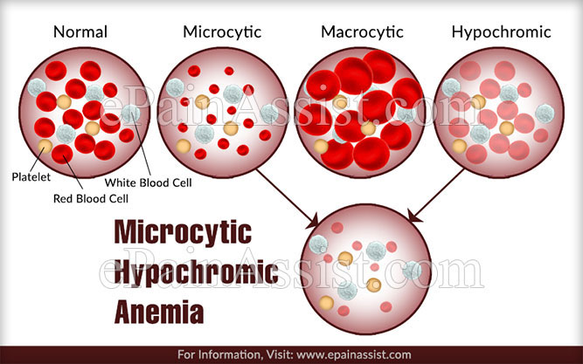

**2- Pernicious Anemia**

Condition in which the body can't make enough healthy red blood cells because it doesn't have enough vitamin B12.

People who have pernicious anaemia can't absorb enough vitamin B12 due to a lack of intrinsic factor (a protein made in the stomach). However, other conditions and factors can also cause vitamin B12 deficiency.

**Causes**

- A lack of intrinsic factor is a common cause.

-Some pernicious anemia occurs because the body's small intestine can't properly absorb vitamin B12 which may be due to the wrong bacteria in the small intestines;

-certain medicines;

- surgical removal of part of the small intestine;

-tapeworm infection .

- Strict vegetarians

- Long-term alcoholics.

This typically causes of macrocytic (large blood cell volume) anemia.

Vitamin B12, along with folate, is involved in making the heme molecule that is an integral part of hemoglobin.

Folate deficiency can be the cause of anemia as well.

This may also be caused by inadequate absorption, under-consumption of green, leafy vegetables, and also long-term heavy alcohol use

Signs and symptoms

Apart from the symptoms of anemia (fatigue, dizziness, etc.),

The vitamin B12 deficiency may also have some serious symptoms like Nerve damage, Neurological problems such as confusion, dementia, depression, and memory loss.

Symptoms in the digestive tract include nausea and vomiting, heartburn, abdominal bloating and gas, constipation or diarrhoea, loss of appetite, and weight loss .

An enlarged liver, A smooth, beefy red tongue

Infants who have vitamin B12 deficiency may have poor reflexes or unusual movements, such as face tremors.

**Treatment**

Pernicious anemia is treated by replacing the missing vitamin B12 in the body. People who have this disease may need lifelong treatment.

**3- Aplastic Anaemia**

Is a blood disorder in which the body's bone marrow doesn't make enough new blood cells.

This may result in a number of health problems including:

Arrhythmias, an enlarged heart, heart failure, infections and bleeding.

Aplastic anemia is a rare but serious condition. It can develop suddenly or slowly and tends to worsen with time, unless the cause is found and treated.

Causes

Damage to the bone marrow's stem cells causes aplastic anemia. In more than half of people who have aplastic anemia, the cause of the disorder is unknown .

A number of acquired diseases, conditions, and factors can cause aplastic anaemia including:

Toxins, such as arsenic, and benzene Radiation and chemotherapy Medicines such as chloramphenicol

Infectious diseases such as hepatitis, Epstein-Barr virus, cytomegalovirus, parvovirus B19, and HIV

Autoimmune disorders such as lupus and rheumatoid arthritis

Inherited conditions, such as Fanconi anemia.

**4- Hemolytic Anemia**

Is a condition in which red blood cells are destroyed and removed from the bloodstream before their normal lifespan is up. A number of diseases, conditions and factors can cause the body to destroy its red blood cells.

Haemolytic anemia can lead to various health problems such as fatigue, pain, arrhythmias, an enlarged heart and heart failure.

There are many types of haemolytic anemia's – some of which are inherited and others that are acquired.

**Inherited haemolytic anemia's include:**

Sickle cell anemia Thalassaemias Hereditary spherocytosis

Glucose-6-phosphate dehydrogenase (G6PD) deficiency Pyruvate kinase deficiency

**Acquired hemolytic anemia include:**

Autoimmune haemolytic anemia Drug-induced haemolytic anemia Mechanical haemolytic anemia

Certain infections and substances can also damage red blood cells and lead to haemolytic anaemia

**Signs and Symptoms**

The most common symptom of all anaemia is fatigue.

A low red blood cell count can also cause shortness of breath, dizziness, headache, coldness in hands or feet, pale skin, gums and nail beds, as well as chest pain .

Symptoms of haemolytic anaemia include Jaundice

Pain in the upper abdomen Leg ulcers and pain

A severe reaction to a blood transfusion

**Treatment**

Treatments for haemolytic anaemia include blood transfusions, medicines, plasmapheresis, surgery, blood and marrow stem cell transplants and lifestyle changes .People who have mild haemolytic anaemia may not need treatment, as long as the condition doesn't worsen. People with severe haemolytic anaemia usually need ongoing treatment.

**5- Thalassaemia**

Thalassaemias are inherited blood disorders which cause the body to make fewer healthy red blood cells and less haemoglobin.

The two major types of thalassaemia are alpha- and beta thalassaemia. The most severe form of alpha thalassaemia is known as alpha **thalassaemia major or hydrops fetalis,**

While the severe form of beta thalassaemia is known as **thalassaemia major or Cooley's anemia.**

Thalassaemias affect both males and females

. Severe forms are usually diagnosed in early childhood and are lifelong conditions.

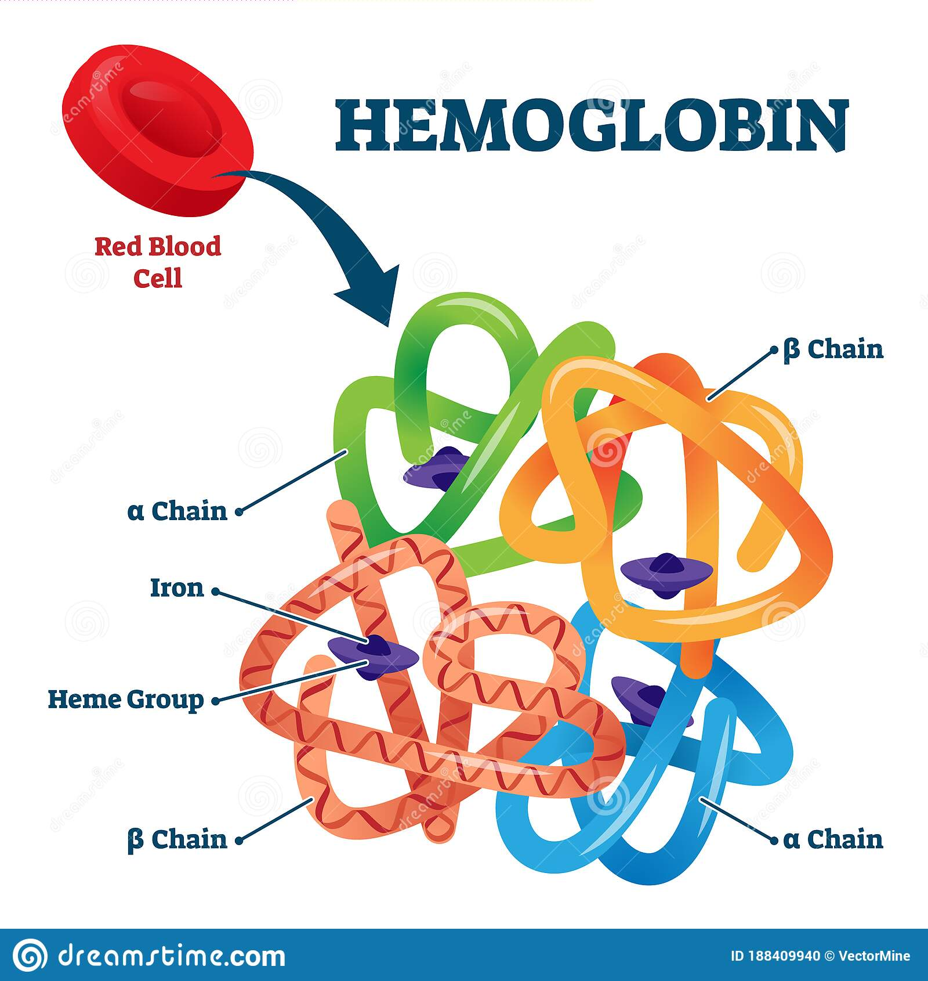

**Causes**

Haemoglobin in red blood cells has two kinds of protein chains: alpha globin and beta globin. If the body doesn't make enough of these protein chains, red blood cells don't form properly and can't carry enough oxygen.

Genes control how the body makes haemoglobin protein chains. When these genes are missing or altered, thalassaemias occur.

Thalassaemias are inherited disorders – they are passed on from parents to their children through genes. People who get abnormal haemoglobin genes from one parent but normal genes from the other are carriers. Carriers often have no signs of illness other than mild anaemia. However, they can pass the abnormal genes on to their children.

**Signs and symptoms**

Caused by a lack of oxygen in the blood stream. This occurs because the body doesn't make enough healthy red blood cells and haemoglobin. The severity of symptoms depends on the severity of the disorder:

Treatment

Treatment for thalassaemias depends on the type and severity of the disorder.

People who are carriers or who have alpha or beta thalassaemia need little or no treatment.

Three standard treatments are used to treat moderate and severe forms of thalassaemia, these include :

- Blood transfusions,

- iron chelation therapy, and

- folic acid supplements.

**6- Sickle Cell Anemia**

Is a serious disease in which the body makes sickle-shaped ("C"-shaped) red blood cells. Normal red blood cells are disk-shaped and move easily through blood vessels.

Red blood cells contain the protein haemoglobin .

Sickle cells contain abnormal haemoglobin that causes the cells to have a sickle shape which don’t move easily through the blood vessels they are stiff and sticky and tend to form clumps and get stuck in the blood vessels.

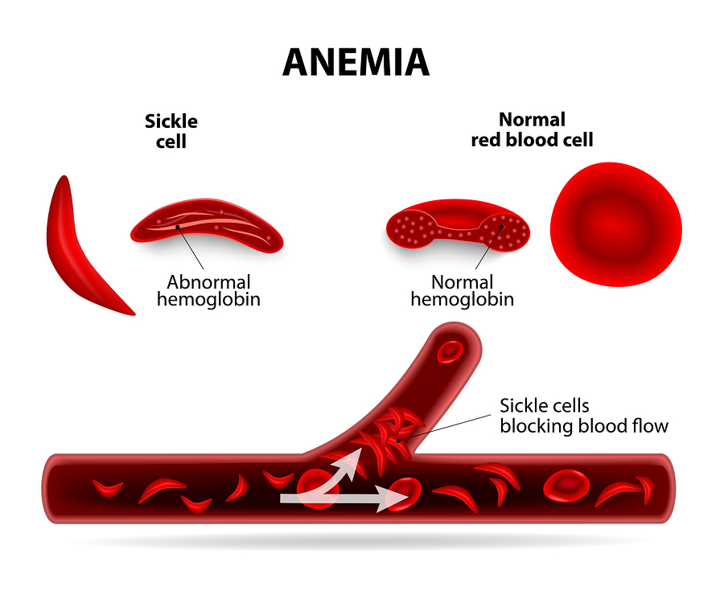

The clumps of sickle cells block blood flow in the blood vessels that lead to the limbs and organs. Blocked blood vessels can cause pain, serious infections, and organ damage .

In sickle cell anaemia, a lower-than-normal number of red blood cells occurs because sickle cells don't last very long. Sickle cells usually die after about 10 to 20 days and the body can't reproduce red blood cells fast enough to replace the dying ones, which causes anemia.

**Causes**

Sickle cell anemia is an inherited, lifelong disease. People who have the disease inherit two copies of the sickle cell gene – one from each parent.

Signs and Symptoms

The most common symptoms of sickle cell anemia are linked to anemia and pain .Sudden pain throughout the body is a common symptom of sickle cell anemia. This pain is called a "sickle cell crisis", and often affects the bones, lungs, abdomen, and joints.

**Treatment**

Sickle cell anemia has no widely-available cure. However, treatments can help relieve symptoms and treat complications.

The goals of treating sickle cell anemia are to relieve pain, prevent infections, eye damage and strokes, and control complications.

Bone marrow transplants may offer a cure in a small number of sickle cell anemia cases.

**Diagnosis of iron deficiency anemia**

1- CBC : Red blood cell size and color .With iron deficiency anemia, red blood cells are smaller and paler in color than normal (Microcytic, hypochromic)

Hematocrit .This is the percentage of blood volume made up by red blood cells. Normal levels are generally between 34.9 and 44.5 percent for adult women and 38.8 to 50 percent for adult men. These values may change depending on age .

Hemoglobin .Lower than normal hemoglobin levels indicate anemia.

2- Ferritin This protein helps store iron in the body, and a low level of ferritin usually indicates a low level of stored iron .

3- Total iron binding capacity

Total iron binding capacity (TIBC) is a blood test to see if there is too much or too little iron in blood. Iron moves through the blood attached to a protein called transferrin.

4- Serum iron test

• Normal value range is:

• Iron: 60 to 170 micrograms per deciliter (mcg/dL)

• TIBC: 240 to 450 mcg/dL

• Transferrin saturation: 20% to 50%

**Hematological investigation in bleeding disorders**

Several tests are available to screen patients for bleeding disorders and to help pinpoint the specific deficiency in general, screening is done in dentistry when the patient gives a history of a bleeding problem, a family member with a history of a bleeding problem, and/or when signs of bleeding disorders are found in the clinical examination.

The dentist can order the screening tests or the patient can be referred to a hematologist for screening

**Laboratory Tests**

There are a variety of laboratory tests that help identify deficiency of required elements or dysfunction of the phases of coagulation .

Tests to evaluate primary hemostasis involving platelets are the

platelet count and platelet function tests such as bleeding time (BT) and other new platelet function assays.

Tests to evaluate the status of coagulation function include:

prothrombin time (PT)/international normalized ratio (INR), PTT, thrombin time (TT), specific coagulation factor assays (e.g., F VII, F VIII, F IX, fibrinogen),

and coagulation factor inhibitor screening tests (blocking antibodies).

**Platelet count**

Normal platelet count ranges from 150,000 to 450,000 platelets per microliter of blood. Having more than 450,000 platelets is a condition called thrombocytosis;

having less than 150,000 is known as thrombocytopenia. You get your platelet number from a routine blood test called a complete blood count (CBC).

When a platelet count is below 50,000, bleeding is more serious if you're cut or bruised. If the platelet count falls below 10,000 to 20,000 per microliter, spontaneous bleeding may occur and is considered a life-threatening risk

Surgical or traumatic hemorrhage is more likely with platelet counts below 50,000/mm3.

It decrease in thrombocytopenia, leukemia & sever liver diseases

**Test of platelet function**

Bleeding time is a crude test of hemostasis. It indicates how well platelets interact with blood vessel walls to form blood clots. Bleeding time is used most often to detect qualitative defects of platelets. The bleeding time test is usually used on patients who have a history of prolonged bleeding after cuts, or who have a family history of bleeding disorders.

The normal bleeding time is between 2-7 minutes. The normal clotting time in a person is between 8-15 minutes. By understanding the time taken for blood to clot, it can be determined if the person has haemophilia or von Willibrand's disease

The most common techniques used for determination of the bleeding time are:

**The Duke method and the Ivy method**

According to the Duke method, the ear lobe is incised with a lancet, and the blood is blotted every 30 seconds until the bleeding ceases

Normal range is between 1 and 6 minutes and is considered significantly prolonged when greater than 15 minutes. Normal for the Duke method is three minutes.

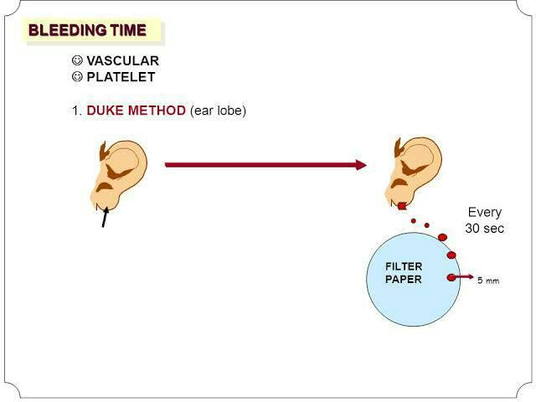

Diseases that cause prolonged bleeding time include:

-Thrombocytopenia ,

- Disseminated intravascular coagulation( DIC)

- Aspirin and other cyclooxygenease inhibitors can prolong bleeding time significantly.

While warfarin and heparin have their major effects on coagulation factors, an increased bleeding time is sometimes seen with use of these medications as well

**PROTHROMBIN TIME (PT ) AND INTERNATIONAL NOMALIZED RATIO (INR )**

The PT and INR tests evaluate the extrinsic and common coagulation pathways, screening for the presence or absence of fibrinogen (F I), prothrombin (F II), and Fs V, VII, and X.

It's most common use is to measure the effects of coumarin anticoagulants and reduction of the vitamin K-dependent. Additionally,

The PT is used to measure the metabolic aspects of protein synthesis in the liver

The normal range of PT is approximately **11 to 13 seconds.**

INR, is a way of standardizing the results of the prothrombin time test, or PT, which measures the time it takes for blood to clot

• The international normalized ratio ranges between **( 0.8 and 1.1 )** for a person who is not taking anticoagulant medication, and 2.0 to 3.0 for people taking warfarin and other blood- thinning drugs

**THROMBIN TIME (TT)**

• The TT is used specifically to test the ability to form the initial clot from fibrinogen and is considered normal in the range of 9 to 13 seconds.

• Additionally, it is used to measure the activity of heparin, or other paraproteins that inhibit conversion of fibrinogen to fibrin.

Fibrinogen can also be specifically assayed and should be present at a level of 200 to 400 mg/dL.

**Diabetes Mellitus (DM)**

Prediabetes" — blood glucose levels that are higher than normal but not yet high enough to be diagnosed as diabetes.

There are several tests to diagnose diabetes. Each test usually needs to be repeated on another day to diagnose diabetes.

**1- Fasting plasma glucose:**

Tthis test is used to measure the blood glucose after at least 8 hour without eating, this test is used to Detect DM ,pre diabetes , and it is the most reliable.

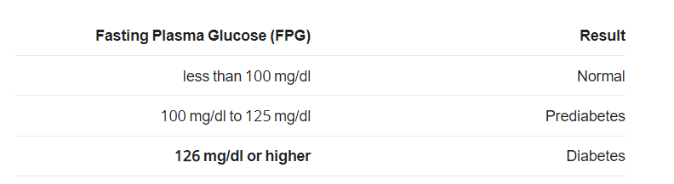

**2- Random plasma glucose test:**

Used to detect the blood glucose without regard to When patient ate the last meal, this test, along with an assessment of symptoms, **is used to Dx DM but not pre-DM.**

positive test result should be confirmed by repeating the fasting plasma glucose test or the oral glucose tolerance test on a different day .

**3-Oral Glucose Tolerance test (OGTT) :**

This can be a useful test in the diagnosis of:

1- Pre-diabetes

2- Gestational diabetes in pregnant women

3-Insulin resistance

4- Reactive hypoglycemia

It is used for the Dx of type 2DM, it is still commonly used for Dx of gestational DM, the patient should fasts over night (at least 8 but not more than 16 hours) then firstly the fasting plasma glucose is tested, after this test person receive 75 grams of glucose(or 1.75 gm per Kg body weight). Blood samples will be collected at timed intervals of 1, 2 hr.

Blood samples may also be taken as soon as 30 minutes to more than 2 hours after drink the glucose

In patient with DM, glucose levels rise higher than normal (< 140 mg/dL  ) and fail become back down as a fast .

Oral glucose tolerance depends on a number of factors including:

The ability of the intestine to absorb glucose, the power of the liver to take up and store glucose, the capacity of the pancreas to produce insulin, the amount of "active" insulin it produces, and the sensitivity of the cells in the body to the action of insulin.

• The oral Glucose tolerance test (OGTT),usually used for Dx Gestational DM (It is checked 4 or 5 times During the test if twice abnormal so Gestational DM

• It is prediabetes if the results of oral glucose tolerance test are 140 to 199 mg/dL (2 hours after the beginning of the test).

A blood glucose level of 200 mg/dL (11.1 mmol/L) or higher may indicate diabetes

Gestational diabetes   
if your blood glucose level is higher than 140 mg/dL   
 after the one-hour test, your doctor will recommend the three-hour test.   
If your blood glucose level is higher than 190 mg/dL after the one-hour test, you'll be diagnosed with gestational diabetes.

**5- The hemoglobin A1c (HbA1c )**

**It measures the percentage of hemoglobin in the blood that has glucose attached to it, reflecting the average blood sugar levels over the past two to three months**

The sugar in your blood is called glucose. When glucose builds up in your blood, it binds to the hemoglobin (glycated hemoglobin )in your red blood cells. The A1c test measures how much glucose is bound.

If your [glucose levels](https://www.webmd.com/diabetes/guide/blood-glucose) have been high over recent weeks, your hemoglobin A1c test will be higher.

The normal hemoglobin A1c test is between 4% and 5.6%.

Hemoglobin A1c levels between 5.7% and 6.4% indicate increased risk of diabetes,

and levels of 6.5% or higher indicate diabetes.

• One advantage of using HbA1c for diagnosis is that the test does not require a fasting blood sample

People who have [diabetes](https://www.webmd.com/diabetes/default.htm) need this test regularly to see if their [levels](https://www.webmd.com/diabetes/guide/blood-glucose) are staying within range. It can tell if you need to adjust your [diabetes](https://www.webmd.com/diabetes/diabetes-health-check/default.htm) medicines. The A1c test is also used to diagnose [diabetes](https://www.webmd.com/diabetes/diabetes-health-check/default.htm).

the goal for people with diabetes is a hemoglobin A1c less than 7%. The higher the hemoglobin A1c, the higher the risks of developing complications related to diabetes

People with diseases affecting hemoglobin, such as [anemia](https://www.webmd.com/a-to-z-guides/understanding-anemia-basics), may get misleading results with this test. Other things that can affect the results of the hemoglobin A1c include [supplements](https://www.webmd.com/vitamins-and-supplements/lifestyle-guide-11/default.htm) such as [vitamins](https://www.webmd.com/vitamins-and-supplements/lifestyle-guide-11/vitamin-expert) C and E and high [cholesterol levels](https://www.webmd.com/cholesterol-management/guide/understanding-numbers). [Kidney disease](https://www.webmd.com/a-to-z-guides/understanding-kidney-disease-basic-information) and [liver](https://www.webmd.com/digestive-disorders/picture-of-the-liver) disease may also affect the test.

