

Oral Histology

Development and Growth of Teeth

Lecture 6

Prof. Dr. Muna Merza

Development and Growth ofTeeth

Two or three weeks after the rupture of the buccopharyngeal membrane, when the embryo is about 6 wecks old, certain areas of basal cells of the oral ectoderm leads to the formation of the Primary epithelial band which is a band of epithelium that has invaded the underlying ectomesenchyme along each of the horseshoe-shaped future dental arches
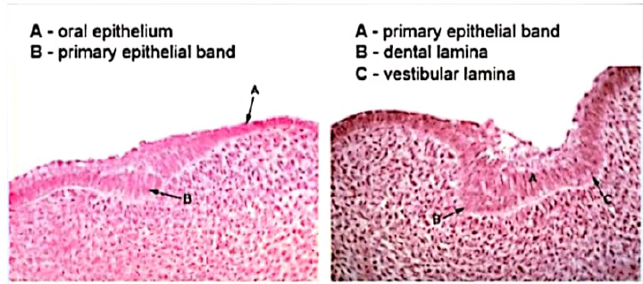
At about 7th week the primary epithelial band divides into an inner (lingual) process called Dental lamina and an outer (buccal) process called Vestibular lamina. The dental laminae serve as the primordium for the ectodermal portion of the deciduous teeth.
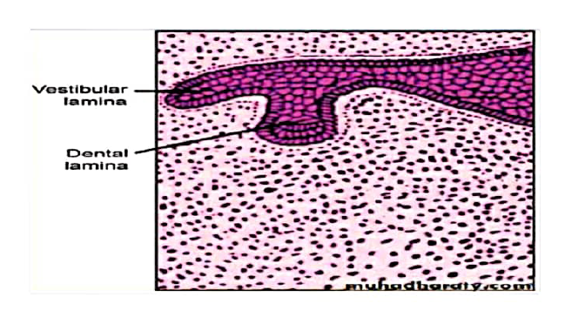

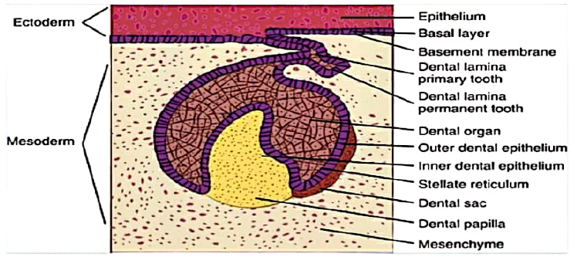

The development of the first permanent molar is initiated at the fourth month in utero. The second molar is initiated at about the first year after birth, the third molar at the fourth or fifth years, The distal proliferation of the dental lamina is responsible for the location of the germs of the permanent molars in the ramus of the mandible and the tuberosity of the maxilla. The successors of the deciduous teeth develop from a lingual extension of the free end of the dental lamina opposite to the enamel organ of each deciduous tooth
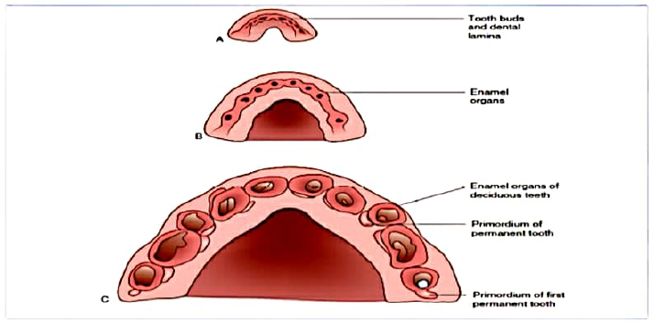

DEVELOPMENTAL STAGES
Tooth development is divided into several morphologic 'stages' and are called the bud, cap, and bell stages.
1.Bud Stage
The epithelium of the dental laminae is separated from the underlying ectomesenchyme by a basement membrane, round or ovoid swellings at 10 different points, corresponding to the future positions of the deciduous teeth. These are the primordia of the enamel organs, the tooth buds.

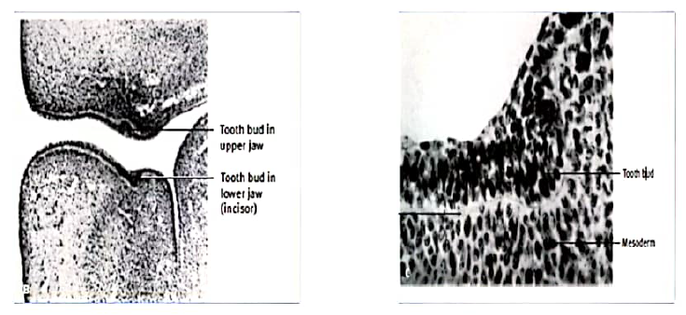

In the bud stage, the enamel organ consists of peripherally located low columnar cells and centrally located polygonal cells. Many cells of the tooth bud and the surrounding mesenchyme undergo mitosis. As a result of the increased mitotic activity and the migration of neural crest cells into the area ,the ectomesenchymal cells surrounding the tooth bud condense.
The area of ectamesenchymal condensation immediately subjacent to the enamel organ is the dental papilla.
The condensed ectomesenchyme that surrounds the tooth bud and the dental papilla is the dental sac.
2.Cap Stage: As the tooth bud continues to proliferate with unequal growth in different parts of the tooth bud leads to the cap stage, which is characterized by a shallow invagination on the deep surface of the bud. The peripheral cells of the cap stage are cuboidal, cover the convexity of the cap, and are called the outer enamel epithelium. The cells in the concavity of the cap become tall, columnar cells and represent the inner enamel epithelium
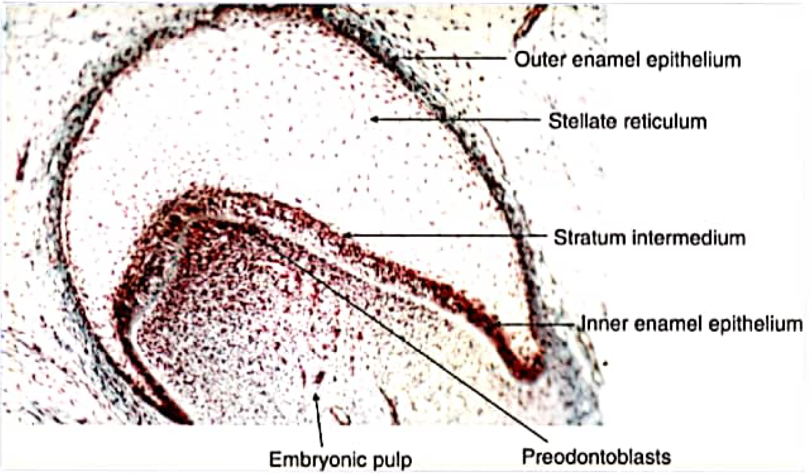
Stellate reticulum
Polygonal cells located in the center of the epithelial enamel organ, between the outer and inner enamel epithelia.
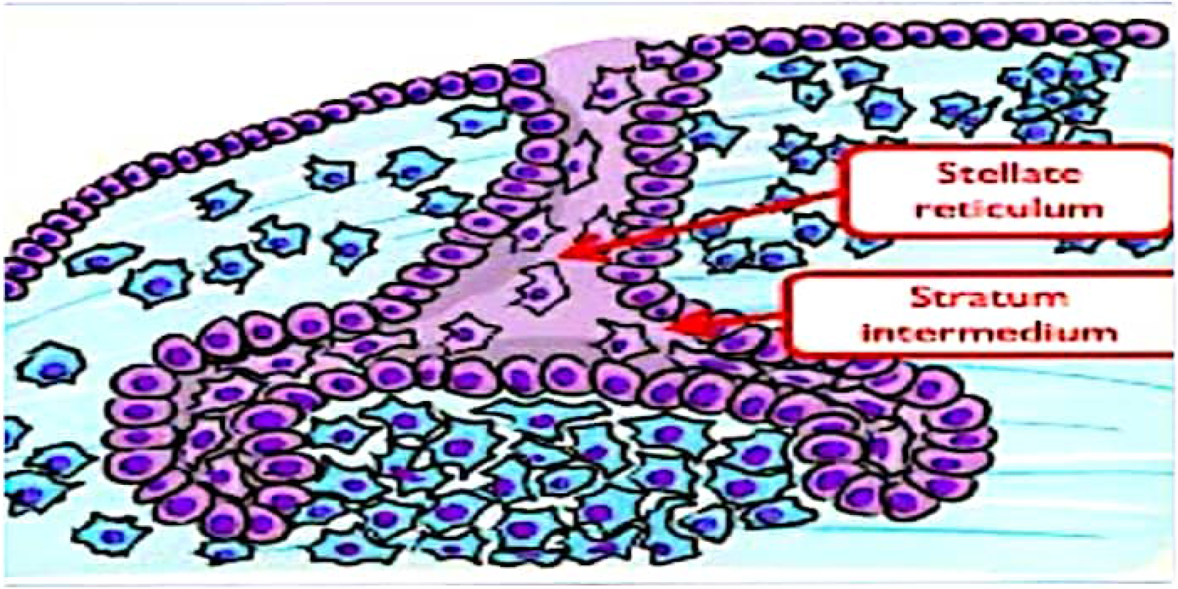
Dental papilla
The ectomesenchyme (neural crest cells) that is partially enclosed by the invaginated portion of the inner enamel epithelium proliferates and condenses to form the dental papilla, which is the formative organ of the dentin and primordium of the pulp.
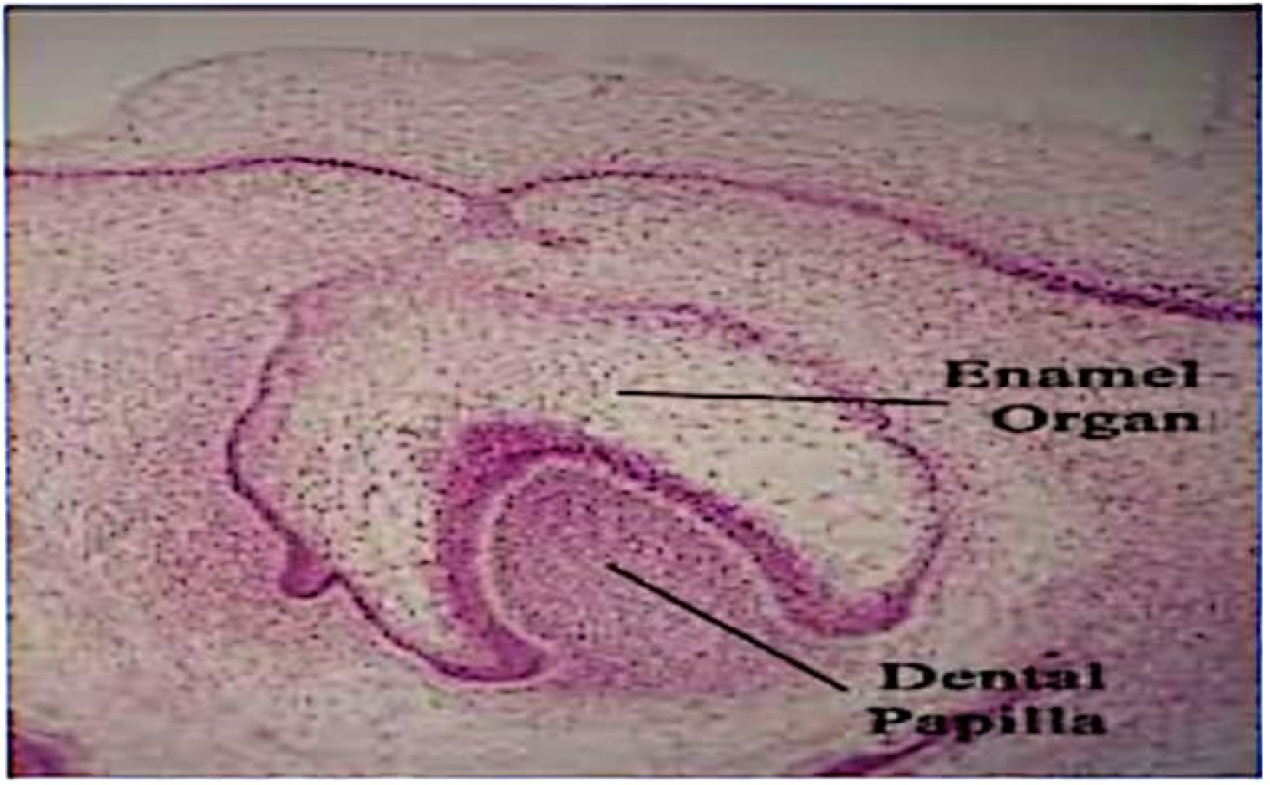

Dental sac (dental follicle)A marginal condensation in the ectomesenchyme surrounding the enamel organ and dental papilla forming a denser and more fibrous layer develops,which is the primitive dental sac.
