# Radiology

**Lec. 3 Biological effects of radiation**

**Types of radiation**

1. Non-Ionizing Radiation: Radiation that does not have sufficient energy to dislodge orbital electrons. ex.: microwaves, ultraviolet light, lasers, radio waves, infrared light, and radar.
2. Ionizing Radiation: Radiation that has sufficient energy to dislodge orbital electrons. ex.: alpha particles, beta particles, neutrons, gamma rays, and x- rays.

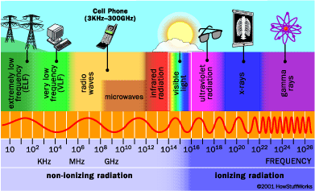

## Fig. 1: types of radiation

All the atoms in human body has electrical stability when x- ray photon strikes a – ve electron in the atom of living subjects (tissues) it displace the electron leaving the atom electrically unbalance so the atom ionized such process called (ionization), this ionized atom has a strong tendency to seek its stability by accepting a –ve electron from somewhere else and by doing so a new chemical is form and the cell of which the atoms and molecules are parts can be altered. So that the basic effects of ionization are Molecular alteration and creation of new chemicals.

**Radiation biology (radiobiology):** is the study of the effects of ionizing radiation on living systems.

# Effects of ionizing radiation ( consequence of radiation absorption)

Radiation acts on living systems through direct and indirect effects

1. **Direct action:** When the energy of a photon ionizes biologic macromolecules, the effect is termed direct. Those effects alter the biological molecules making them differ structurally and functionally from the original molecules, the consequence is a biological change in the irradiated organism.

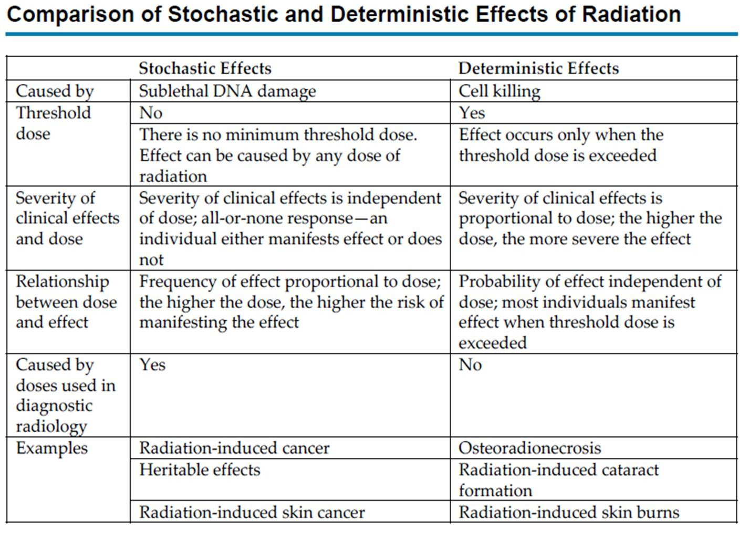

1. **Indirect action:** It happened by interaction of photons with water molecules.

Ionizing radiation initiates a complex series of chemical changes in water, collectively referred to as **radiolysis of water** . the initial series of interactions of x ray photon with water produce hydrogen **H** and hydroxyl **OH** free radicals that interact with biological macromolecules making these molecules have different chemical and biological properties than the original molecules. Also x- radiation can alter the chemical composition of hormones enzymes and other body secretions make them partially or totally ineffective.

## What are the stochastic and deterministic effects of radiation ?? الجدول للاطلاع

## Biological effect of radiation is of two type summarized in the following table:

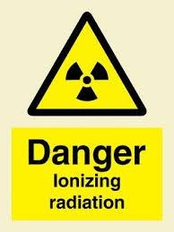

Fig. 2: ionizing radiation symbol

# Radio sensitivity of tissues and organs

Body tissues differ in their susceptibility to ionizing radiation. Cells are most sensitive to radiation when they are immature, undifferentiated, and rapidly dividing. As cells mature and become specialized they are less sensitive to radiation. If cells are more oxygenated, they are more susceptible to radiation damage which is known as **oxygen** **enhancement ratio.**

The following tissue and organs are **listed in order to their susceptibility to x-ray**:

1. high radio sensitivity: lymphoid organs , Blood forming tissues (bone marrow), intestines , stem cells, lymphocyte and reproductive cells
2. intermediate radio sensitivity: Young or growing bone, Growing cartilage, glandular tissue , salivary glands , kidney, liver, lungs and epithelium of alimentary canal.
3. low radio sensitivity: Skin , muscle and optic lens.
4. the least effect seen in nerve tissue and adult bone.

The response of cells, Tissues and organs to irradiation depends on:

* 1. **Dose**: The severity of damage seen in irradiated tissues or organs depends on the amount of radiation received.
  2. **Dose Rate:** The term dose rate indicates the rate of exposure. For example, a total dose of 5 Gy may be given at a high dose rate (5 Gy/min) or a low dose rate (5 mGy/min). Exposure of biologic systems to a given dose at a high dose rate causes more damage than exposure to the same total dose given at a lower dose rate.
  3. **Oxygen** : The radio-resistance of many biologic systems increases by a factor of 2 or 3 when irradiation is conducted with reduced oxygen (hypoxia).

The presence of dissolved oxygen, as in the normal tissue, will significantly modify the free radical formed during water radiolysis. In the presence of oxygen; hydrogen peroxide **H2O2** and hydroperoxyl **HO2** free radicals are formed .Both hydroperoxyl radicals and hydrogen peroxide are oxidizing agents that can significantly alter biologic molecules and cause cell destruction. They are considered to be major toxins produced in the tissues by ionizing radiation.

**للاطلاع) المعادلات)X ray photon + H2O -------------- H + OH free radical**

**H +O2-------------HO2** (hydroperoxyl)

**HO2 +HO2 ----------------H2O2** (hydrogen peroxide) **+O2**

* **ALARA principle (The law of radiation protection) A**s **L**ow **A**s **R**easonably **A**chievable: Radiographs should only be taken at the minimum dosage with reasonable information, so the benefit from radiograph should be weighed against the radiation dose and then decide to take radiograph or not.

# Latent period:

Is a period of time interposed between exposure and clinical symptoms such period varies with the dose. So the more is sever dose the shorter is the latent period. sometimes the latent period is as long as 25 years for some minimum doses.

# Protection of patients from x-ray:

# *Radiographic screening for the purpose of detecting disease before clinical examination should not be performed. Clinical examination, taking patient history, review of any prior radiograph, caries risk assessment and consideration of both dental and general health needs should precede radiographic examination.* (ADA 2012). So for patient protection we should :

# 

1. Using faster (film speed) because the faster the film the less is the amount of radiation required to produce a radiographic image so it need less exposure time.
2. Collimation: - this done by collimating device to prevent the un necessary beam divergence, especially rectangular collimator.

3. Filtration:- in order to absorb the long wave length X-ray photons (soft radiation)

which have no diagnostic value.

4. Exposure and developing techniques: - in order to prevent exposure of patient to much more radiation, we should know the exposure time for each segment of the jaw. So for anterior teeth the exposure time is 0.36 seconds for premolars is 0.40 seconds while for molars is 0.50 seconds.

* exposure time required for child and old people may have be decreased as much as 50% while exposure time required for dense and thick objects may have to be doubled. Also the film should be probably processed following manufacturer recommendation because one of the major causes of unnecessary patient exposure is the practice of overexposing film to compensate underdevelopment.

5. Source to Skin Distance:-

we have 2 standard cone length (8and 16 inches). With a longer cone , the x ray beam is less divergent, reducing the exposed tissue volume.

Using long cone reduces exposure by 10 to 25 percent compared with short cone, also we should avoid closed end cone due to great scattered radiation.

6. Protective apron and thyroid collar: - sheet of lead used to cover chest and reproductive areas of the patient so must be used in pregnant and young adult also thyroid collar used for protection of thyroid gland. (lead apron used by operator also for protection).

7. Using intensifying screen in extraoral film to reduce radiation dose to patients.

8. Using digital radiography that provide greater dose reduction than E\F speed film

# Protection of operator:

Operator received secondary radiation and generally workers in X-ray clinic should not receive more than 5 rem of whole body radiation each year.

Operator received 3 types of radiation

* 1. Scattered radiation from the patient (the most common).
  2. Primary beam if he stands in its path.
  3. Leakage radiation from the tube head.

**To minimize the exposure of operator:**

1. **Position**: operator must stand behind the patient because the head of the patient will absorb scattered radiation operator must stand with an angle of 90 - 135˚ to the radiation beam because in this area we have less scattered radiation.
2. **Barrier**: it interpose between the source of radiation and the operator it is the most effective method of providing safety to the operator and barrier is made of lead or concert or barium plaster of 1/16 inch. The barrier should contain a leaded glass window so the operator can monitor the patient during exposure.
3. **Distance**: the intensity of radiation inversely proportional to the distance (inverse square law) so it's recommended for him to stand 6 feet (2 mm) from the patient.

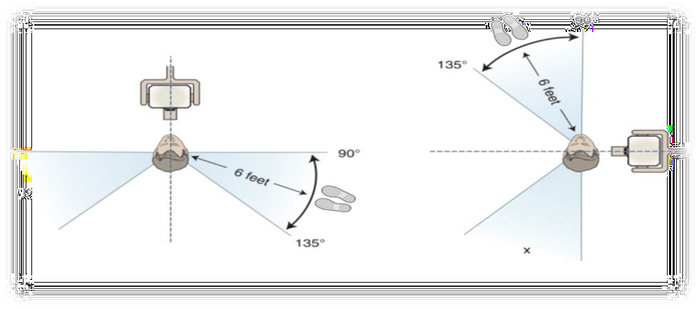

**Fig 3: * position and distance rule: if no barrier is available, the operator should stand at least 6 feet from the patient, at an angle of 90 to 135 degrees to the central ray of the x-ray beam when the exposure is made**.**مطلوب** **حفظ** **مهم**

# Film badges

 Persons who work in dental radiography should wear personal dosimeter (film badge) to monitor exposure level and calculating accumulative dose. The film badge contain a strip of AL2O3 which is sensitive to radiation in addition it contains metal filter and a small radiographic film in a plastic frame. It used for 1 – 3 months before being processed for monitoring of dose received by operator.



Fig 4: film badge