 

**Dentinogenesis**

**&**

**Dentin structure**

Prof. Dr.Muna Merza

Lecture 8

The dentin ranges in thickness from 3 to 10 mm or more. Dentin showed variation in thickness between the sexes, it was thicker in boys than girls of similar age group and this increased during puberty. Dentin thickness varied not only from tooth to tooth but also in different surfaces of the same tooth. The buccal surfaces showed maximum thickness, followed by lingual, and there was no difference in thickness between mesial and distal surfaces. 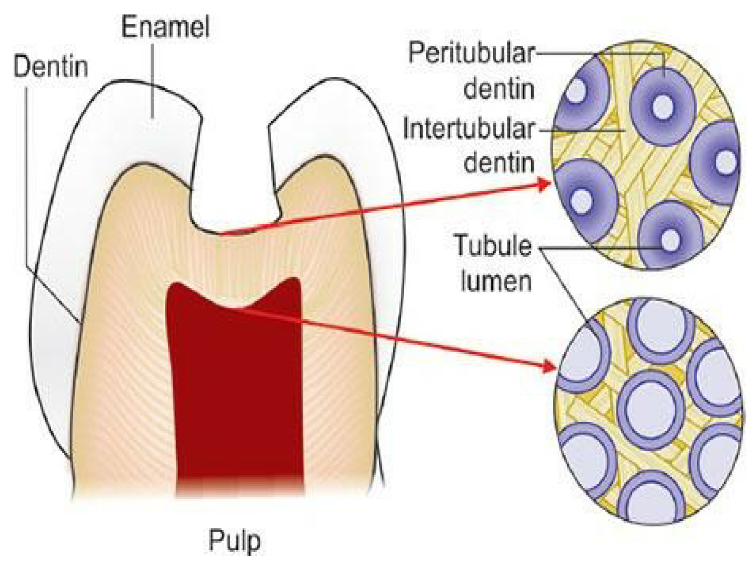

The dentinal tubules have lateral branches throughout dentin, which are termed canaliculi or microtubules.

A few odontoblastic processes extend through the dentinoenamel junction into the enamel for several millimeters. These are termed enamel spindles.

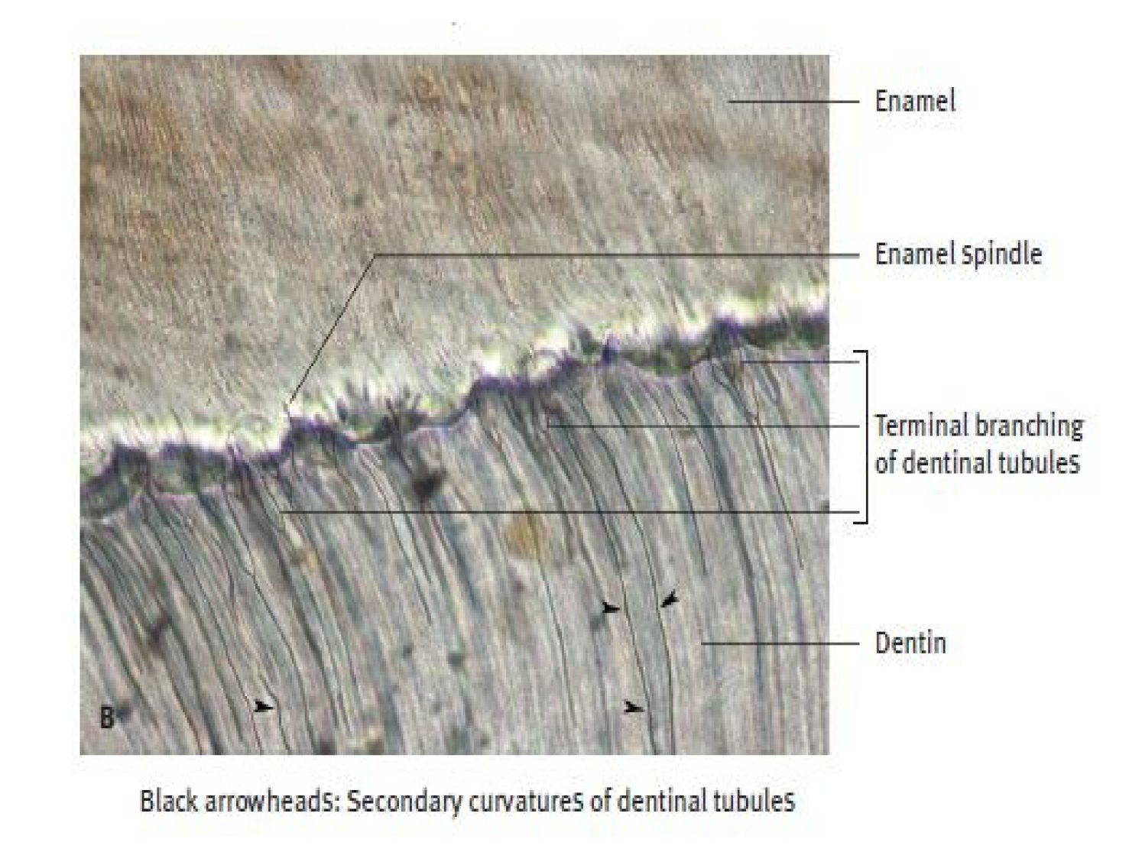

**Peritubular dentin**

The dentin that immediately surrounds the dentinal tubules is termed peritubular dentin. This dentin forms the walls of the tubules in all but the dentin near the pulp. It is more highly mineralized (about 9%) than the dentin present between the tubules (the intertubular dentin). Peritubular dentin differs from intertubular dentin by its matrix composition. The crystal arrangement appears to be similar.

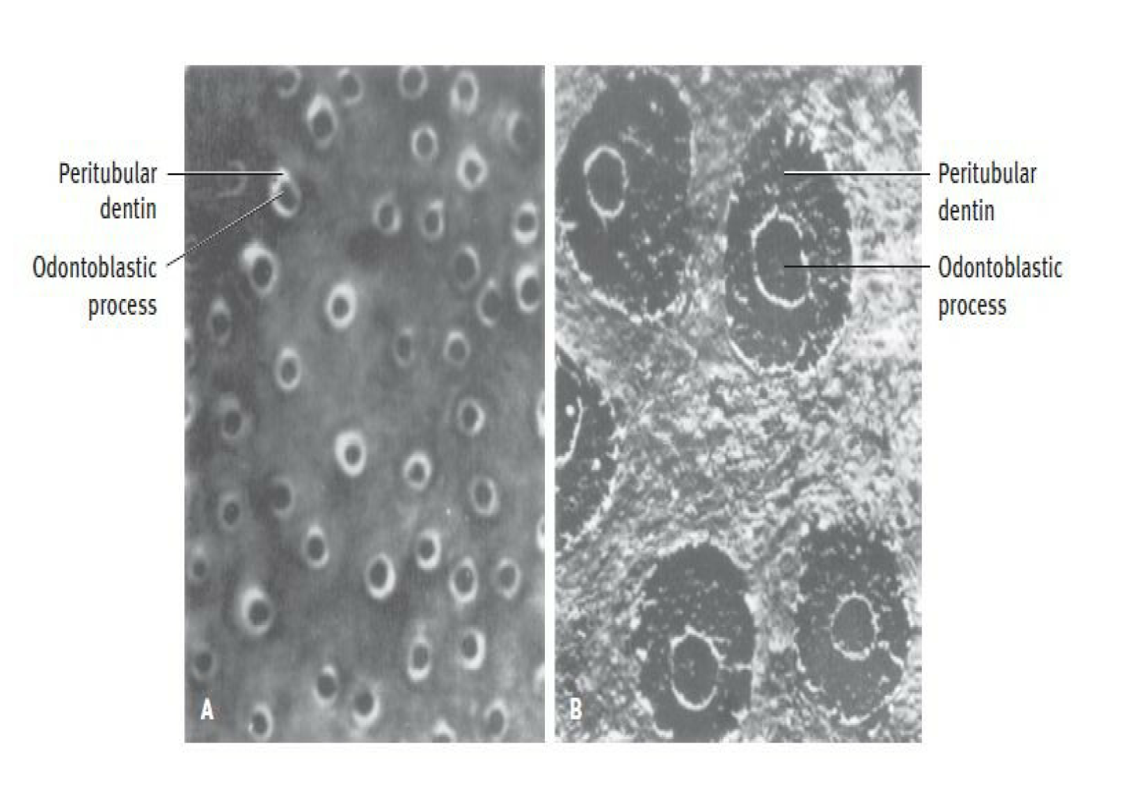

**Intertubular dentin**

The main body of dentin is composed of intertubular dentin. It is located between the dentinal tubules or between the zones of peritubular dentin. Although it is highly mineralized, this matrix, like bone and cementum, is retained after decalcification, whereas peritubular dentin is not. About one half of its volume is specifically collagen fibers, which are randomly oriented around the dentinal tubules.

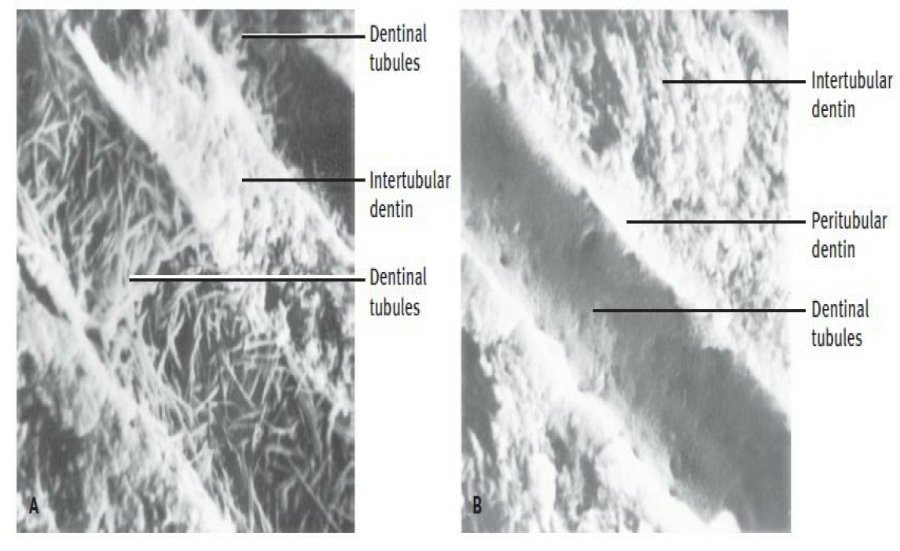

**Predentin**

The predentin is located always adjacent to the pulp tissue and is 2 to 6 μm wide, depending on the extent of activity of the odontoblast. It is not mineralized . The predentin appears to be pale staining than the mineralized dentin . As the collagen fibers undergo mineralization at the predentin-dentin junction, the predentin becomes dentin .

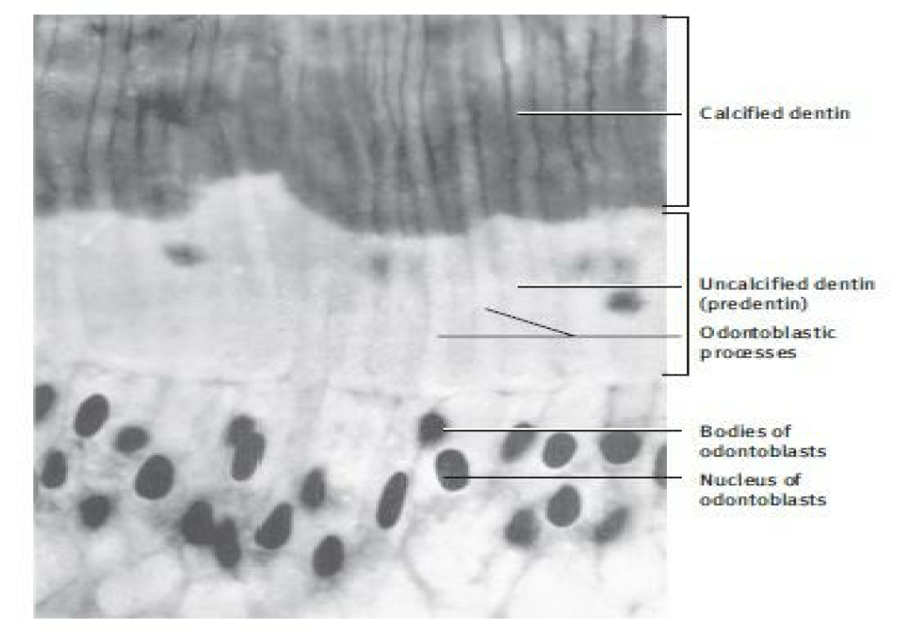**Differences between mentle dentin and predenrtin**

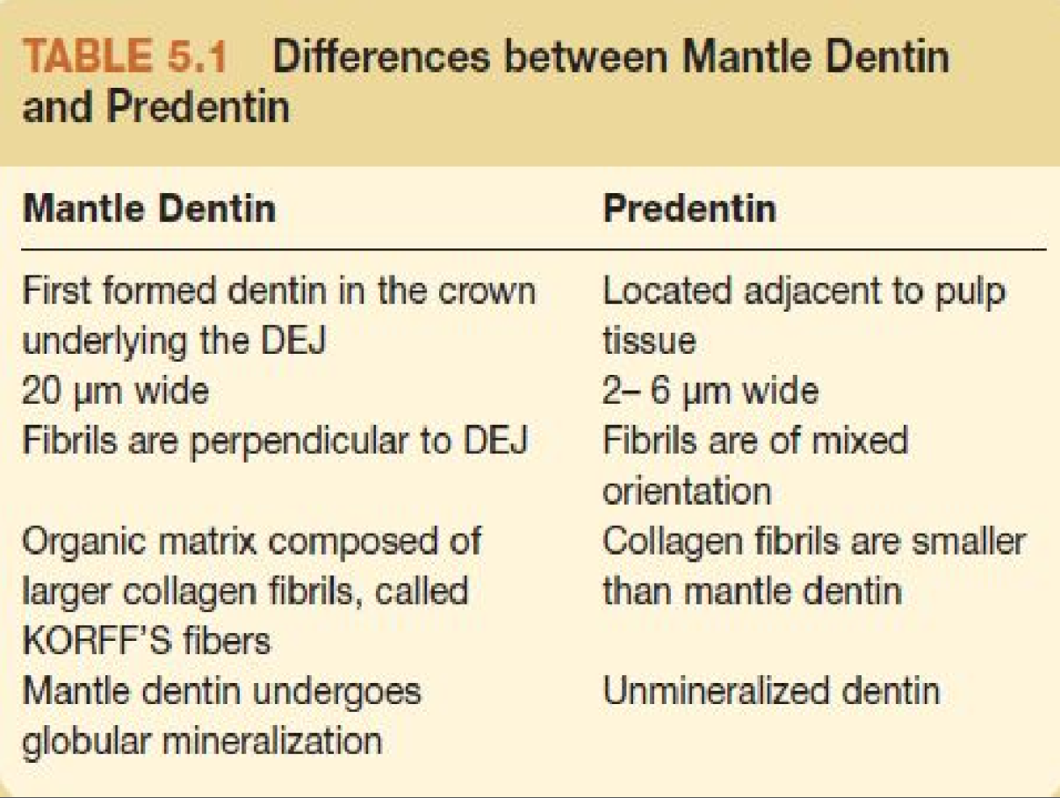

**Types of Dentin**

**1. PRIMARY DENTIN:**

Dentin which is formed before root completion is known as primary dentin. The primary dentin are of two types— mantle dentin and the circumpulpal dentin.

Mantle dentin is the name of the first-formed dentin in the crown underlying the dentinoenamel junction. This zone below the DE junction is soft and thus provides a cushioning effect to the tooth. It is thus the outer or most peripheral part of the primary dentin and is about 20 μm thick.

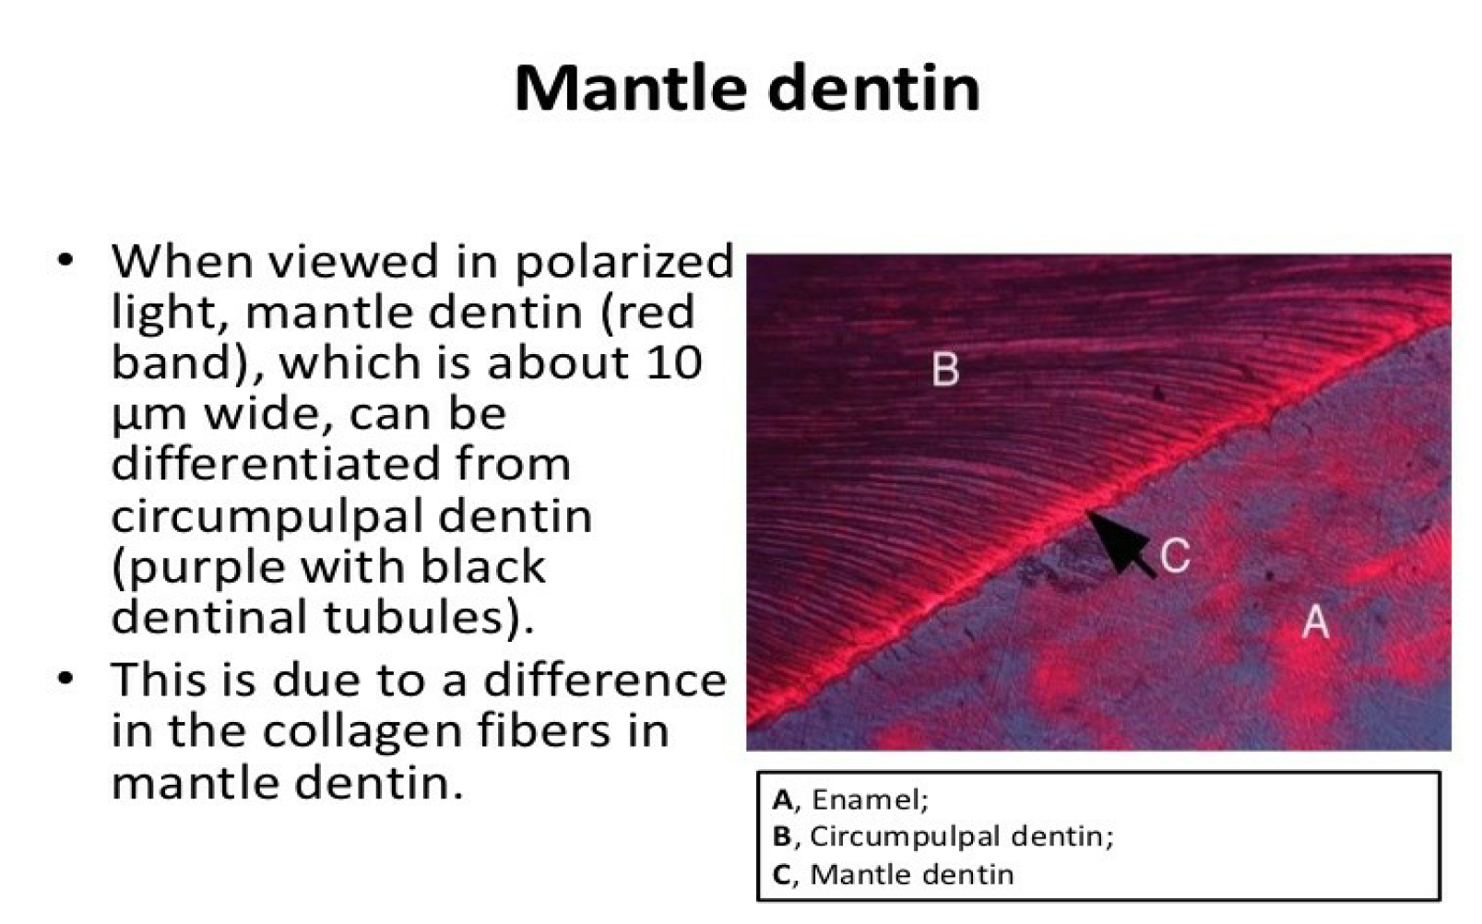

The fibrils formed in this zone are perpendicular to the dentinoenamel junction, and the organic matrix is composed of larger collagen fibrils than are present in the rest of the primary dentin (circumpulpal dentin). The larger diameter collagen fibers (0.1 – 0.2 μm in diameter) and are known as von Korff’s fibers.

Compared to circumpulpal dentin, mantle dentin is less mineralized. Mantle dentin also has fewer defects than circumpulpal dentin. Mantle dentin undergoes globular mineralization whereas the circumpulpal dentin mineralizes either by globular or linear pattern.

Circumpulpal dentin Forms the remaining primary dentin or bulk of the tooth. The collagen fibrils in circumpulpal dentin are much smaller in diameter (0.05 um) and are more closely packed together compared to the mantle dentin. The circumpulpal dentin may contain slightly more minerals than mantle dentin.

**2. SECONDARY DENTIN**

Secondary dentin is a narrow band of dentin bordering the pulp and representing that dentin formed after root completion. This dentin contains fewer tubules than primary dentin. There is usually a bend in the tubules where the primary and secondary dentin interface. Many believe that secondary dentin is formed more slowly than primary dentin and that it looks similar to primary dentin but contains fewer tubules.

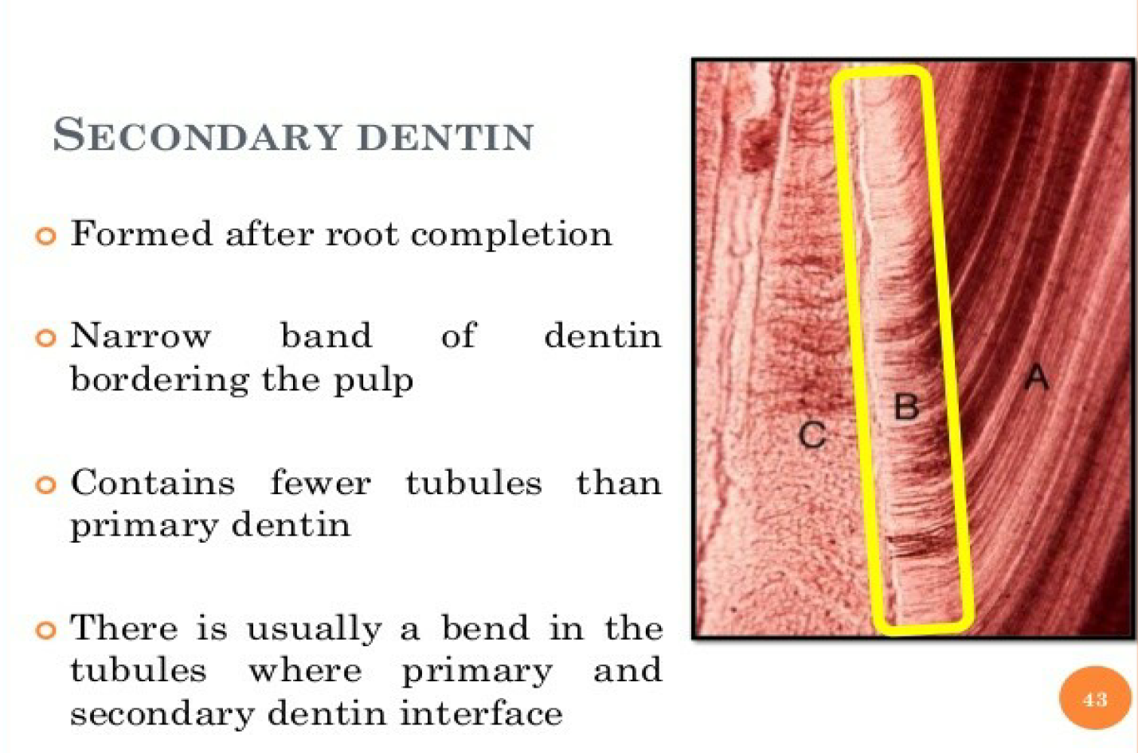

Secondary dentin is not formed uniformly and appears in greater amounts on the roof and floor of the coronal pulp chamber, where it protects the pulp from exposure in older teeth. The secondary dentin formed is not in response to any external stimuli, and it appears very much like primary dentin.

**3.TERTIARY DENTIN**

Tertiary dentin is reparative, response, or reactive dentin. This is localized formation of dentin on the pulp-dentin border, formed in reaction to trauma such as caries or restorative procedures. If by extensive abrasion, erosion, caries, or operative procedures the odontoblast processes are exposed or cut, the odontoblasts die or survive, depending on the intensity of the injury. If they survive, the dentin that is produced is known as reactionary or regenerated dentin.

Those odontoblasts that are killed are replaced by the migration of undifferentiated cells arising in deeper regions of the pulp to the dentin interface. It is believed that the origin of the new odontoblast is from cells in the cell-rich zone or from undifferentiated perivascular cells deeper in the pulp. The newly differentiated odontoblasts then begin deposition of reparative dentin.

This action to seal off the zone of injury occurs as a healing process initiated by the pulp, resulting in resolution of the inflammatory process and removal of dead cells. The hard tissue thus formed is best termed reparative dentin although the terms tertiary dentin, response, or reactive dentin are also used. Reparative dentin is characterized as having fewer and more twisted tubules than normal dentin.

It is due to the irregular nature of the dentinal tubules, these types of dentin are also referred to as irregular secondary dentin, in order to differentiate from the regular secondary dentin formed not as a result of any external stimuli.

