

Al-Mustaqbal University

College of Health and Medical Technologies

Radiological Techniques Department

**Magnetic Resonance Imaging**

First Semester

**Lecture 7,8 : Pulse sequences and Image Contrast**

By

Dr. Mohanad Ahmed Sahib

MSc. Ph.D. Radiology technology

Assistant lecturer

M. A. Mohammed

MS.C. Theoretical Nuclear Physics

2023/2024

**Introduction:**

There are many different pulse sequences available, and each is designed for a specific purpose. **The image weighting, contrast and quality** is determined by the **type of pulse sequence** we use.

MRI Technion students need to know pulse sequences for several reasons, including: **Performing MRI exams**: **Pulse sequences are the fundamental building blocks of MRI exams**, and MRI students need to understand pulse sequences to perform MRI exams effectively.

**Interpreting MRI results**: Pulse sequences determine **the contrast and resolution of MRI images**, and MRI students need to understand pulse sequences to interpret MRI results accurately Optimizing MRI parameters: Pulse sequences can be optimized by adjusting various parameters, such as **repetition time (TR) and echo time (TE), to improve image quality and reduce scan time Keeping up-to-date with MRI technology:** MRI technology is constantly evolving, and MRI students need to keep up-to-date with the latest advances in pulse sequences and MRI technology to provide the best possible care for their patients.

Overall, MRI Technion students need to know pulse sequences to perform **MRI exams effectively, interpret MRI results accurately, optimize MRI parameters, and keep up-to-date with MRI technology**. Pulse sequences can be learned through MRI tech programs, continuing education courses, and on-the-job training. It is important for MRI students to stay up-to-date with the latest MRI technology and pulse sequences to provide the best possible care for their patients.

**PULSE SEQUENCES**

**Types**

**1. Spin echo (SE) pulse sequences**

a. Conventional spin echo (CSE) pulse sequence

b. Fast spin echo (FSE) pulse sequence

**2. Inversion recovery (IR) pulse sequences**

a. STIR (short inversion recovery)

b. FLAIR (fluid attenuated inversion recovery)

**3. Gradient echo (GE) pulse sequences**

a. Coherent gradient echo pulse sequence

b. Incoherent gradient echo pulse sequence

**4. Steady state free precession (SSFP)**

**5. Ultrafast imaging**

**6. Echo planar imaging**

**Conventional Spin Echo (CSE) Pulse Sequence**

In this pulse sequence, a 90° excitation RF pulse is given followed by 180° rephasing RF pulse.

**Uses**

• These are the most commonly used pulse sequences

• May be used for almost every examination

• Produce optimum signal-to-noise ratio (SNR) and contrast-to-noise ratio (CNR)

• T1, T2 and proton density weighting is possible

**Advantages**

• Good image quality

• True T2 weighting is possible.

**Disadvantages**

• Scan times are relatively long

• More RF power deposition in the body



**Fig .(1): Schematic illustration of spin echo pulse sequence**

**Fast Spin Echo (FSE) Pulse Sequence**

In this type of pulse sequence, 90° excitation RF pulse will be delivered followed by several 180o rephasing RF pulses. In conventional spin echo (CSE), **only one line of K-space is filled per TR**. So the CSE takes longer scan time. But in fast spin echo **several lines of K-space will be filled per TR**. Because of this reason, *the scan times are reduced in fast spin echo*. The number of lines of K-space filled per TR is referred to as **Turbo Factor (tf) (or) echo train**  **length (ETL). More the ETL, less the scan time** .

**Uses**

• Can be used as an alternative to spin echo

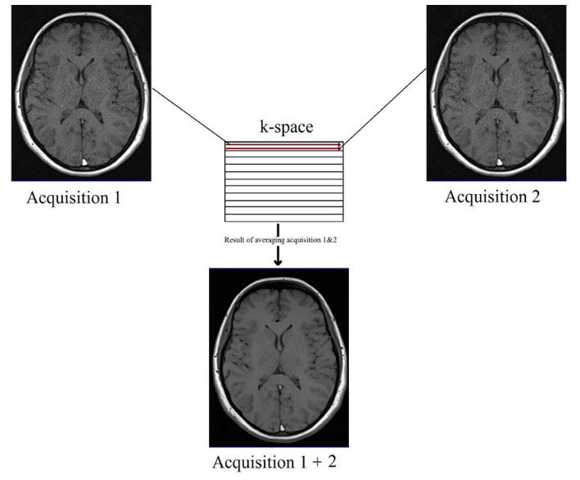• Reduction in the scan time compared to conventional spin echo.

**Advantages**

• Scan times are greatly reduced

• High resolution matrices and multiple NEX can be used

• Improved image quality.

**Disadvantages**

• Fat remains bright on T2 weighted images

****• Image blurring may result



**Fig .(2): Schematic illustration of fast spin echo**

**Inversion Recovery (IR) Pulse Sequences**

These pulse sequences use **180° inverting RF pulse followed by 90° excitation RF pulse after certain time [Inversion Time (IT) or Time from Inversion (TI)].** Depending on the **TI value**, we can classify the IR sequences into:

**1. Short inversion recovery (STIR)**

**2. Fluid attenuated inversion recovery (FLAIR)**

If we apply 180° inverting RF pulse, the NMV (net magnetic vector) will be inverted through 180° into full saturation. When we remove the inverting pulse, the NMV begins to relax back to Bo (static external magnetic field)

A 90° excitation pulse is then applied at a time from the 180° inverting pulse known as the TI time (Time from Inversion). **The contrast of the image depends on the TI value** (Fig. 3&4).

**These sequences are used to generate heavily T1 weighted images bringing large difference between fat and water.**



**Advantages**

• Produces heavily T1 weighted images

• Very good signal-to-noise ratio (SNR).

**Disadvantage**

• Long scan times.

**STIR (Short Inversion Recovery) Pulse Sequence**

**This sequence is used to suppress the fat signal from the anatomy of interest.** **Here we use a TI value that corresponds to the time it takes fat to recover from full inversion to the transverse plane so that there is no longitudinal magnetization corresponding to fat.** When the 90° RF excitation pulse is applied, the fat is flipped 90o to 180°, so there will not be any fat signal. It will suppress the fat in STIR. Generally, a TI value of **around 100-200 ms is used**. This TI value may slightly vary depending on the field Strength. Fig 3 Fig 4

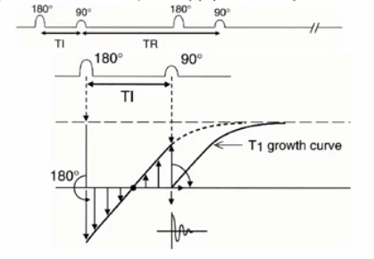

**Uses :** Used to suppress the fat signal in T1 weighted image.

**Disadvantage:** Should not be used with contrast enhancement.

**FLAIR (Fluid Attenuated Inversion Recovery)**

It is another variation in the IR pulse sequence which uses a TI value around **2000 ms.** Usually, this sequence is used to suppress the signal from CSF containing areas.



**Gradient Echo (GE) Pulse Sequences**

**These sequences use variable flip angles and lesser repetition time (TR).** The gradients are used to rephase the protons. We can apply the gradients quickly to Fig (6) rephase the protons (unlike 180° rephasing pulses in spin echo which takes some time to apply) (Figs 6 and 7). **Because of the quicker application of gradients and reduced repetition time and smaller flip angles, the scan times are greatly reduced in gradient echo pulse sequences.** With **this sequence, we can get T1 weighting, proton density weighting and T2* weighting**.



Fig.(7): Image obtained with gradient echo pulse sequence .blood vessels appear bright on gradient echo pulse sequences



Fig.(8): schematic illustration of gradient echo pulse sequences.

Since the gradient does not compensate for magnetic field inhomogeneities, we will get T2* weighting (Fig. 8).

**Uses**

* Can be used to produce T1, proton density and T2*weighting
* Very minimal scan times
* Can be used for single slice breath hold acquisitions in abdomen and dynamic contrast enhancement
* Since these sequences are flow sensitive, can be used for MR angiography/MR myelography
* Less RF deposition into the body, i.e. less specific absorption rate (SAR).

**Disadvantages**

* Less signal-to-noise ratio when compared to SE pulse sequences
* True T2 weighting is not possible (T2* contrast rather than true T2)
* More work for the gradients
* More noise to the patient.

**Steady State**

In this state, **the selected TR will be shorter than the T1 and T2 times of the tissues**. In this state, there will be coexistence of both longitudinal and transverse magnetization. Most gradient echo sequences use the steady state.

Generally, flip angles **of 30° to 45° with TR of 20 to 50** ms favours the steady state.

Depending on the residual transverse magnetization in phase (or) out of phase GE pulse sequences are classified into:

1. Coherent (in phase) gradient echo pulse sequence

2. Incoherent (out of phase) gradient echo pulse sequence.

**Coherent (in phase) Gradient Echo Pulse Sequences**

These sequences use a variable flip angle excitation pulse followed by a **frequency encoding gradient rephasing to produce a gradient echo**. Here the steady state is maintained by selecting a **TR shorter than the T1 and T2 times of the tissues.** In this sequence, **the tissue with long T2 values appear with high signal intensity.**

**Uses**

* Increased T2* Dependence
* Very fast scans
* Preserves the transverse signal
* Good for angiography
* Can be acquired in a volume acquisition.

**Disadvantages**

* More gradient noise to the patient
* Poor SNR in 2D acquisitions compared to spin echo.
* More magnetic susceptibility.

**Incoherent (Spoiled) Gradient Echo Pulse Sequences**

These pulse sequences begin with a **variable flip angle excitation pulse and use frequency encoding gradient rephasing to give a gradient echo**. These sequences spoil (or) dephase the residual transverse magnetization so that its effect on image contrast is minimal.

**Uses**

• Increased T1 weighting

• Spoils the transverse signal

• Only the longitudinal signal contributes to the next RF pulse

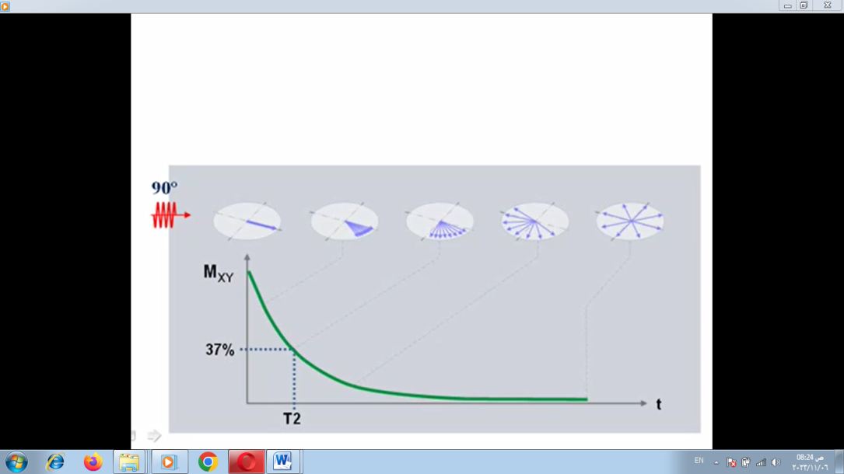• Good SNR in volume acquisition

• Can be acquired in 2D (or) volume

• Breath holding is possible.

**Disadvantages**

• Decreased SNR in 2D

• Loud gradient noise

**Steady State Free Precession (SSFP)**

These sequences are used to attain more T2 weighting. In this sequence the steady state is maintained.

**Advantages**

• True T2 weighting is achieved

• Can be acquired in volume or 2D

**Disadvantages**

• Loud gradient noise

• Poor image quality

**Ultrafast Sequences**

* These sequences use coherent (or) incoherent gradient echo pulse sequences
* Only a portion of the RF pulse is used
* Only a portion of the echo is read

Because of the above reasons, the scan time is drastically reduced.

**Echoplanar Imaging (EPI)**

* The fastest scan acquisition modes in MRI are **the EPI and the gradient echo pulse sequences.**
* In echoplanar imaging all the lines of K-space will be filled in one shot. **This is called single shot EPI (SS-EPI).**
* If the echoes are generated by multiple 180° pulses, this is termed as **spin echo echoplanar imaging (SE-EPI).**
* If the gradients are used for the purpose of rephasing in EPI, then this **sequence is called GE-EPI.**
* GE-EPI and SS-EPI are faster than SE-EPI.
* **SS-EPI sequences are more prone to artifacts such as chemical shift, distortion and blurring.**
* **In EPI the image may contain more T2* weighting which can be minimized by using 180° inverting pulse before excitation pulse.**

**Uses**

• Improved cardiac and abdominal imaging

• Used in perfusion weighted imaging

• Useful in real time and interventional MR-guided procedures.

**PERFUSION WEIGHTED IMAGING (PWI)**

This is a type of dynamic MR imaging by using **GRE (or) EPI sequences** with contrast enhancement to study the uptake of contrast medium by the lesion. **This technique can be used in abnormalities of brain, pancreas, liver and prostate.**

**DIFFUSION WEIGHTED IMAGING (DWI)**

In this type of MR imaging either **GRE (or) EPI sequences** are used to demonstrate the areas with restricted diffusion of extracellular water such as **infarcted tissue**. High signal intensity appears at the area of restricted diffusion. DWI is mainly useful in brain to differentiate salvageable and non salvageable tissue after brain stroke.

**FUNCTIONAL MRI (FMRI)**

**It is a dynamic MR imaging Technique that acquires images of the brain during stimulus and also at rest**. Then the two sets of images are subtracted to demonstrate functional brain activity. This technique is called BOLD (blood oxygenation level dependent). **At the activated areas of brain, there will be increased signal intensity.**

fMRI is useful in evaluating the brain activity in **the disorders of epilepsy, stroke and behavioural problems.**

**MAGNETIZATION TRANSFER (MT) CONTRAST**

This is a technique used to suppress the background tissue thereby increasing the conspicuity of vessels and certain disease processes. MT contrast is useful in **diagnosing hemorrhage, AIDS, multiple sclerosis and also to improve contrast in TOF-MRA images by suppressing background tissue.**

**MAGNETIC RESONANCE ANGIOGRAPHY (MRA)**

**MRA is a technique which allows us to acquire the images with high signal from flowing nuclei and low signal from stationary nuclei.** This technique will allow us to see the blood vessels more clearly than surrounding. Generally, **GRE pulse sequences are used to show flowing vessels as bright.**

There are two types of MRA techniques available. They are:

**1) Time of flight (TOF-MRA and**

**2) Phase-contrast MRA (PC-MRA).**

**Time of Flight MRA (TOF-MRA)**

This technique commonly uses **incoherent GRE pulse sequences** in conjunction with TR and flip angle combinations that saturate background tissue but **allowing moving spins to show high signal intensity.** This technique is used in demonstrating **arterial and venous flow in head, neck and peripheral vessels.**



**Phase Contrast MRA (PC-MRA)**

This technique usually **uses coherent GRE sequences**. It provides excellent background suppression. But the scan times with PC-MRA are longer than the scan times of GE pulse sequences are flow sensitive hence used for MRA (magnetic resonance angiography).



**Pretest:**

1. **Compare between spine echo sequences and fast spin sequences?**
2. **Mention the types of sequences and explain three of them?**