**University of Al-Mustaqbal / College of Nursing**

**Fourth Year Students / Family and Community Health Nursing**

**Lecture 6**

**FAMILY HEALTH SERVICES**



**Definition of Family:**

Family refers to a social system composed of two or more persons who are joined by bonds of sharing and emotional closeness and who identify themselves as being part of the family.

**Definition of Family Health:**

Family Health refers to the health status of a given family at a given point in time. It includes all the attitudes, beliefs, knowledge, and habits that families use to obtain, sustain, or regain maximum health

**Definition of Family Health Promotion**: It can be defined as-

“The process by which families work to improve or maintain the physical, mental, social, emotional and spiritual well-being of the family unit and its members”.

**Types of Families**

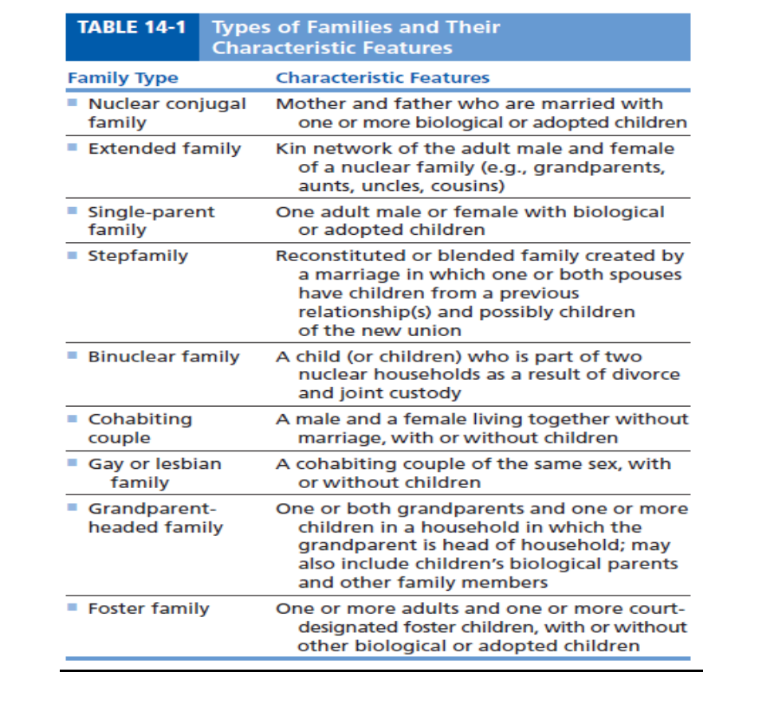

**Theoretical Approaches to Family Nursing**

**1.** Systems Models

**2**. Family Development Models

**3**. Structural-Functional Models

**Family Systems Models**

− System is defined as " **a complex of elements in interaction**"

− System: The family (focal system).

− The "elements" that make up a system are also known as **Subsystems.**

− **Subsystems**:(Family member).

− **Suprasystem**: Influences external to the family (interacting systems)

**Family System Goals:**

**1-** Maintenance of a steady state

**2**- System growth

**Family Development Models**

Families pass through a series of developmental stages in which they must accomplish certain family developmental tasks.

**Stage I - Single Young Adult**

− Accept self-responsibility

− Differentiate self from family of origin

− Develop intimate peer relationships

− Develop a career and financial independence

**Stage II - New Couple**

− Achieve commitment to the new relationship

− Form the marital relationship

− Realign relationships with families and friends

**Stage III - Family with Young Children**

− Adjust the marriage to the presence of children

− Distribute childrearing, household, and financial tasks

− Develop new relationships with family members (parenting and grand parenting)

**Stage IV - Families with Adolescents**

− Adapt to growing independence of adolescent family members

− Adjust to increasing frailty of own parents

− Change parent-child relationships

− Address marital and career issues

**Stage V - Launching Children and Moving on**

− Accept multiple entries and exits from family structure

− Renegotiate the marital dyad

− Adapt relationships to accommodate in-laws and grandchildren

− Deal with disability and death of one’s own parents

**Stage VI - Families in Later Life**

− Accept the change in generational roles

− Maintain function

− Explore new roles

− Assure support for middle and older generations

− Deal with the death of others and one’s own approaching death

**Structural-Functional Models**

− A structural-functional approach to family nursing is based on the principles that all families possess structure designed to allow them to perform specific functions.

− The **two basic concepts** of a structural-functional approach are:

1. **Structure:** Is the pattern of organization of the interdependent parts of a whole.

− Family members and family interaction patterns related to roles, values, communication patterns, and power structure.

− **Family structure:** may be assessed and identified by means of a family **genogram and ecomaps**.

− **A genogram** is a diagram of a family tree incorporating information regarding family members and their relationships over at least three generations.

− **An ecomaps** a visual representation of relationships both within and outside family

− Family structural elements affect the family’s ability to carry out socially recognized family functions.

1. **Function**: One of a group of related actions that lead to accomplishment of specific goals.

**Family Functions Goals**

**1**. **Affective** • Meet the emotional needs of family members.

**2**. **Socialization**  • Educate family members as contributing members of society.

• Instill family attitudes and values in members.

**3. Reproductive** • Ensure survival of family and society.

• Regulate sexual activity.

• Provide for sexual satisfaction.

**4.** **Economic**  • Provide financial resources sufficient to meet family needs.

**5**. **Provision of needs** • Meet family members' needs for food, shelter, clothing, health care, etc.

**Assessing Family Health:**

1. **Biophysical Considerations**

− Family members’ age and maturational level

− Family members’ physical health status

− Genetic inheritance

1. **Psychological Considerations**

− Communication patterns

− Family relationships

− Emotional strengths

− Coping abilities

− Childrearing practices

− Family goals

1. **Physical Environmental Considerations**

− Home environment

− Safety hazards

− Neighborhood

1. **Sociocultural Considerations**

− Roles

− Culture & Religion

− Employment and income

− Education level

− Community relationships and resources

1. **Behavioral Considerations**

− Consumption patterns

− Rest and sleep

− Exercise and leisure

− Safety practices

1. **Health System Considerations**

− Family response to illness

− Use of health care services

− Health insurance status

**Families at Risk:**

Families and children can be find themselves as 'at-risk' when they experience violence, unemployment, drug abuse, single-parenthood, teen pregnancy or mental illness. When a child from an at-risk family grows up, they can fall into the same negative behavior patterns as their parents.

**High Risk Factors in the Family**

In relationships, **risk factors** include parents who use drugs and alcohol or who suffer from mental illness, child abuse and maltreatment, and inadequate supervision. In this context, parental involvement is an example of a protective factor. **In communities, risk factors** include neighborhood poverty and violence.

**Ethical Principles Related to Care of Families:**

**1**. Individualization of client care.

**2**. Respect of diverse values.

**3**. Active family participation.

**4**. The family's right of self-determination.

**5**. Confidentiality.

**6.** Maintenance of therapeutic focus.