**University of Al-Mustaqbal / College of Nursing  
Fourth Year Students / Community Health Nursing Course  
  
Introduction to Community Health Nursing**

**Lecture 1**

**THE CONCEPT OF COMMUNITY-**

A community is a collection of people who share some important features of their lives.

* Sharing common interests (e.g., a community of farmers).
* Living under the same laws and regulations (e.g., a prison community).
* The function of any community includes collective sense of belonging and their shared identity, values, norms, communication, and common interests and concerns.
* Vulnerable population are groups and communities at a higher risk for poor health as a result of the barriers they experience to social, economic, political and environmental resources, as well as limitations due to illness or disability.

Although many believes that health and illness are individual issues, evidence indicates that they also are community issues. The spread of the HIV pandemic, nationally and internationally, is a dramatic and tragic case in point So , Communities can influence the spread of disease, organize ways to combat outbreaks of infectious disease, and promote members practices that contribute to individual and collective health.

Many different professionals work in community health to form a complex team-

* Physicians,
* Social workers,
* Physical therapists,
* Nutritionists, and
* Others

**Public Health-** Is the science and art of preventing disease, prolonging life, and promoting health and efficiency through **organized community efforts** through providing environmental sanitation, control of communicable infections, education about personal hygiene, organization of medical and nursing services to ensure early diagnosis and treatment of disease, and development of the social machinery to ensure that everyone have adequate standard of living for the maintenance of health, so organizing these efforts may help to enable every citizen to realize his birthright of health and longevity.

**Community Health-**  Is a field of practice, seeks to provide organizational structure, a broad set of resources, and the collaborative activities needed to accomplish the goal of an optimally healthy community.

**Community Health Nursing-** Is a specialized practice. It combines all basic elements of professional clinical nursing with public health and community practice applied for promoting and preserving the health of populations.

**Community Based** - Used to describe an activity that is **organized and takes place locally: Example- nurse provide sick care in community settings.**

**Community Focused**- It means being more **focused on how you can support and care for your community than being more focused on how they can come to your setting.**

One of the challenges that community health practice faces is to remain responsive to the community’s health needs. As a result, **its structure is complex; numerous health services and programs are currently available or will be developed.**

**Examples** are health education, family planning, accident prevention, environmental protection, immunization, nutrition, early periodic screening and developmental testing, school programs, mental health services, occupational health programs, and the care of vulnerable populations.

**Populations and Aggregates-**

**Population-**  A distinct group of individuals, whether that group comprises a nation or a group of people with a common characteristic.

**Aggregate-** It is a collection of people who happen to be at the same place at the same time but who have no other connection to one another.

**Examples:**

* The people gathered in a restaurant on a particular evening are an example of an aggregate, not a group.
* Aggregate can be identified by virtue of setting( those enrolled in a well-baby clinic
* Demographic characteristics (women)
* Health status ( smokers, hypertension)

**CONCEPTS OF HEALTH-**

**Wellness**- Is the process of moving towered integrating human functioning and maximizing potential. Can be measured in terms of quality of life.

**Well-being**- A state of positive health or a person's perception concerning positive health.

**Illness-** Is a state of being relatively unhealthy.

There are many levels and degrees of wellness and illness, Because health involves a range of degrees from optimal health at one end to total disability or death at other.

**High Level Wellness**- (Optimal Health)

**Good Health**- Normal health (the state of being vigorous and free from bodily or mental disease).

**Total Disability** - Inability to engage in any substantial gainful activity by reason of any medically determinable physical or mental .

**Death-** The permanent ending of vital processes in a cell or tissue**.**

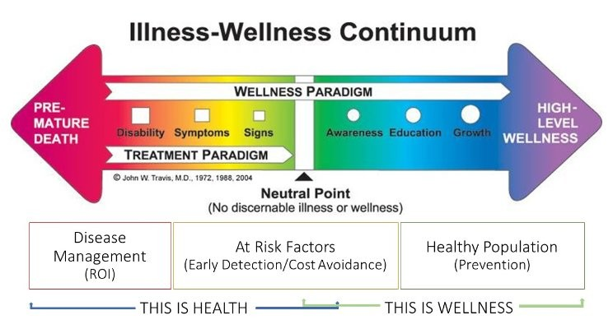

**ROI – Return on Investment ( ( المردود الربحي**

**OBJECTIVES OF COMMUNITY HEALTH NURSING-**

1. To increase capability of individuals, families, groups and communities to deal with their own health and nursing problems

2. To strengthen community resources.

3. To control and counteract environment.

4. To prevent and control communicable and non-communicable diseases.

5. To provide specialized services for mothers, children, adults, workers, elderly handicapped and eligible couple etc.

6. To conduct research and contribute to the further refinement and improvement of community health nursing practice

7. To supervise, guide and help health personnel in carrying out function effectively.

8. To participate in preparing health personnel to function in community for community health care services.

**Philosophy Of Community Health Nursing-**

**Philosophy of community health nursing** is a philosophy of providing care that is characterized by **collaboration, continuity of care, client and family responsibility for self-care, and preventive health care.**

**Community-based nursing** focuses on an **individual and is family-centered in orientation community t**hat provide (disease prevention, health protection, and maintenance, and health promotion). so, the **community health nursing called imperial for others nursing field.**

**Following Ideas and Beliefs-**

1. Philosophy of individual’s right of being healthy.

2. Philosophy of working together under a competent leader for the common good.

3. Philosophy that people in the community have potential for continued development and are capable of dealing with their own problems if educated and helped.

4. Philosophy of socialism.

5. Health is believed to be one of the rights of all human beings nationally and internationally.

**COMPONENTS OF COMMUNITY HEALTH PRACTICE-**

These **components are**

**(1) Promotion of health,**

**(2) Prevention of health problems,**

**(3) Treatment of disorders,**

**(4) Rehabilitation**

**(5) Evaluation**

**(6) Research**

**CHARACTERISTICS OF COMMUNITY HEALTH NURSING-**

**Characteristics of community health nursing** are particularly salient to the practice of this specialty:

**(1) It is a field of nursing;**

**(2) It combines public health with nursing;**

**(3) It is population focused;**

**(4) It emphasizes prevention, health promotion, and wellness;**

**(5) It uses aggregate measurement and analysis;**

**(6) It involves inter-professional collaboration..**

**Principles of Community Health Nursing (CHN)-**

1. The recognized **need of individuals, families and communities** is a primary purpose to apply public health measures within the framework of the total CHN effort.

2. Knowledge and understanding of the objectives and policies of the agency facilities goal achievement.

3. CHN considers the family as the unit of service.

4. CHN integrated health education and counseling as vital parts of functions.

5. Periodic and continuing evaluation provides the means for assessing the degree to which CHN goals and objectives are being attained. **Clients are involved** in the appraisal of their health program through consultations, observations..

6. Continuing staff education programs and providing quality services to client are essential to upgrade and maintain sound nursing practices in their setting.

7. Maintenance of accurate records is a vital responsibility of community health nursing as these are utilized in studies and researches and as legal documents.

**Scope of Community Health Nursing-**

**1. Home Care**

**2. Nursing Care**

**3. MCH & family Planning**

**4. School Health Nursing**

**5. Mental Health Nursing**

**6. Rehabilitation Services**

**7. Geriatric Health Nursing**

**Community Health Nurses have Seven Major Roles for CHN Practice -**

• **Clinician**- The community health nurse provides care along the entire range of the wellness-illness continuum; however, promotion of health and prevention of illness are emphasized. Skills in observation, listening, communication, counseling, and physical care are important for the community health nurse.

• **Educator**- As educators, nurses seek to facilitate client learning on a broad range of topics. They may act as consultants to individuals or groups, hold formal classes, or share information informally with clients or nurse who teaches and prepares licensed practical nurses (LPN) and registered nurses (RN) for entry into practice positions

• **Manager-** Given the opportunity to acquire the operational, financial, and management skills essential to their success – and the success of their organization.

**Advocate-** Community health nurse as advocate is **to help clients find out what services are available,** which ones they are entitled to, **and how to obtain these services**. A second goal is **to influence change and make the system more relevant and responsible to clients' needs.**

• **Collaborator-** Collaboration with clients, other nurses, physicians, social workers, physical therapists, nutritionists, attorneys, secretaries, and other colleagues is part of the role of the community health nurse leader

**• Researcher**- Systematic investigation, collection, and analysis of data to enhance community health practice research in community health

• **Leader-** The community health nurse directs, influences, or persuades others to effect change that will positively affect people's health.