Digital Signal Processing (DSP) Lab
Exp.3 Generating Unit impulse Sequence & Unit step sequence using ones & zeros functions
- Generating Unit impulse Sequence's(n)=1 ; n=0
MATLAB code:
n=-10:1:10
impulse=[zeros(1,10),ones(1,1),zeros(1,10)]
figure(1)
stem(n,impulse,'k','linewidth',2)
title('Generating Unit impulse Sequence')
xlabel('Amplitude')
ylabel('time')
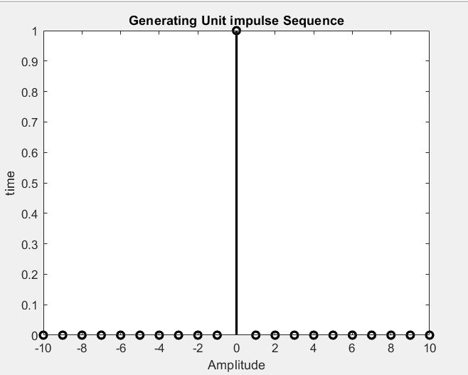

%%%%%%%%%%%%%%%%%%%%%%%%%%%%%%%%
n=-5:1:20
impulse=[zeros(1,5),ones(1,1),zeros(1,20)]
figure(2)
stem(n,impulse,'b','linewidth',2)
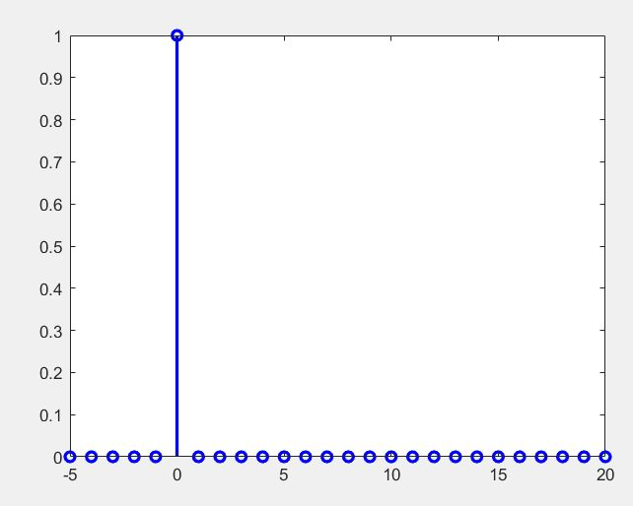

- Generating Unit step Sequence
MATLAB code:
n=-8:1:10
step=[zeros(1,8),ones(1,11)]
figure(3)
stem(n,step,'b','linewidth',2)
title('Generating Unit step Sequence')
xlabel('Amplitude')
ylabel('time')

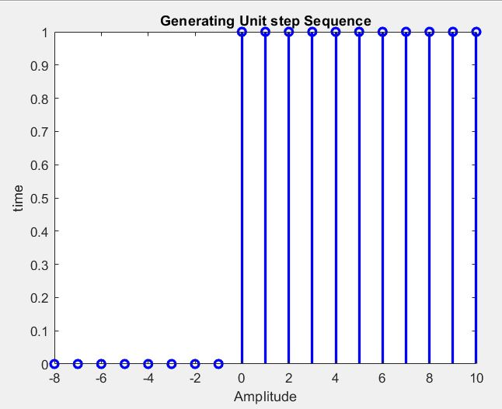

%EX//Plot the following sequence using unit step sequence
x(n)={-2,0,3,0,0,5,1,1,-4}?
clear all
n=0:1:8
step=[-2*ones(1,1),zeros(1,1),3*ones(1,1),zeros(1,2),5*ones(1,1), ones(1,2),-4*ones(1,1)]
figure(4)
stem(n,step,'b','linewidth',3)
xlabel('Amplitude')
ylabel('time')
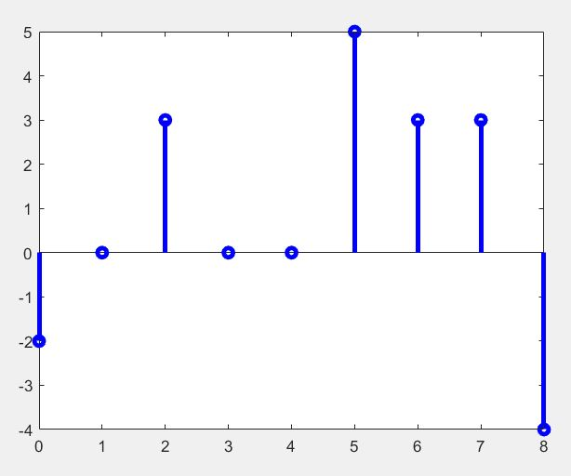
Discussion:
Plot the following sequence using the unit step sequence
x(n)={-3,-3,[3],2,2,5,1,1,-2}?
Find & plot the following sequence using ones & zeros functions
- x(n)=2n[u(n)-u(n-3)] .
- X(n)= S(n)+2S(n-1)+3S(n-2)+4S(n-3)

