**Transformers MCQS 2**

**1- **

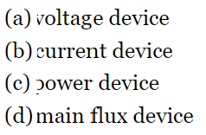

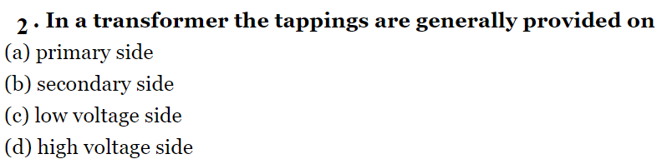

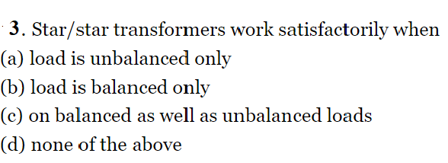

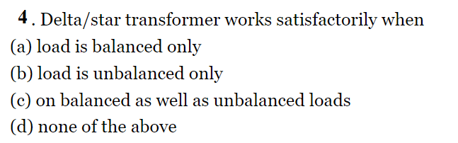

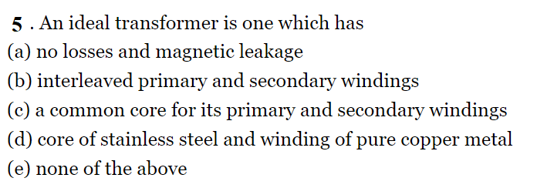

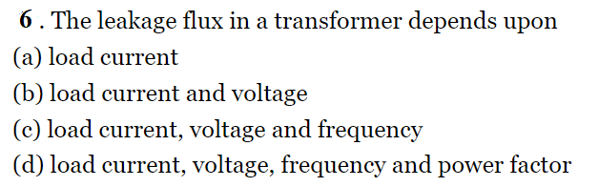

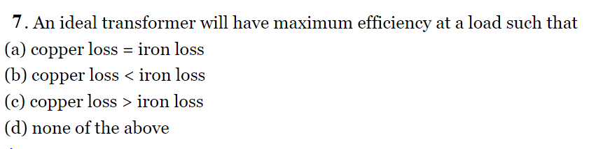

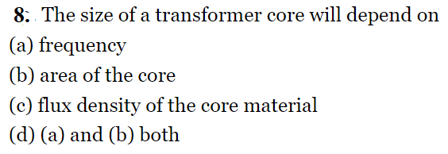

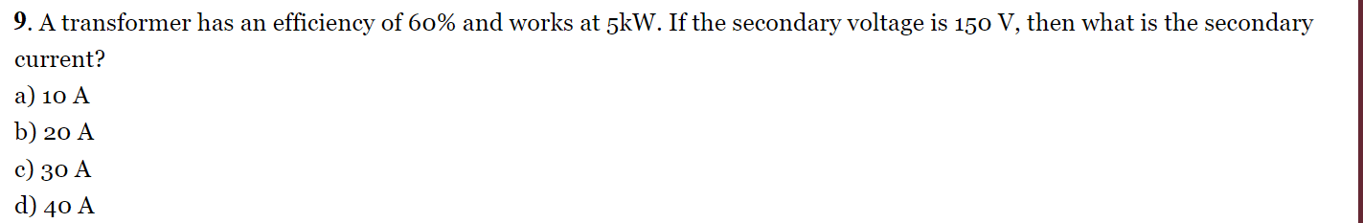

**10- A three-phase transformer have a (11000/400 V) voltage ratio. Turn ratio for delta-star connection is**

**a-20**

**b-40**

**c-50**

**d-30**