

**Chemistry lectures /4**

**By**

**Prof. Dr. Hadi Yasir Al-Janabi**

**Lecture / 4 Chemical bonds**

Types of chemical bonds including covalent, ionic, metallic and hydrogen bonds. Chemical bonds hold molecules together and create temporary connections that are essential to life

**Introduction**

Living things are made up of atoms, but in most cases, those atoms aren’t just floating around individually. Instead, they’re usually interacting with other atoms (or groups of atoms).

For instance, atoms might be connected by strong bonds and organized into molecules or crystals. Or they might form temporary, weak bonds with other atoms that they bump into or brush up against. Both the strong bonds that hold molecules together and the weaker bonds that create temporary connections are essential to the chemistry of our bodies, and to the existence of life itself.

Why form chemical bonds? The basic answer is that atoms are trying to reach the most stable (lowest-energy) state that they can. Many atoms become stable when their [valence shell](https://www.khanacademy.org/science/biology/chemistry--of-life/electron-shells-and-orbitals/a/the-periodic-table-electron-shells-and-orbitals-article) is filled with electrons or when they satisfy the octet rule (by having eight valence electrons). If atoms don’t have this arrangement, they’ll “want” to reach it by gaining, losing, or sharing electrons via bonds

**Ions and ionic bonds**

Some atoms become more stable by gaining or losing an entire electron (or several electrons). When they do so, atoms form **ions**, or charged particles. Electron gain or loss can give an atom a filled outermost electron shell and make it energetically more stable.

**Forming ions**

Ions come in two types. **Cations** are positive ions formed by losing electrons. For instance, a sodium atom loses an electron to become a sodium cation,  Negative ions are formed by electron gain and are called **anions**. Anions are named using the ending “-ide”: for example, the anion of chlorine is called chloride.

When one atom loses an electron and another atom gains that electron, the process is called **electron transfer**. Sodium and chlorine atoms provide a good example of electron transfer.

Sodium (Na) only has one electron in its outer electron shell, so it is easier (more energetically favorable) for sodium to donate that one electron than to find seven more electrons to fill the outer shell. Because of this, sodium tends to lose its one electron, forming Na+.

Chlorine (Cl), on the other hand, has seven electrons in its outer shell. In this case, it is easier for chlorine to gain one electron than to lose seven, so it tends to take on an electron and become Cl−.

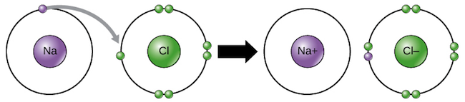

Sodium transfers one of its valence electrons to chlorine, resulting in formation of a sodium ion (with no electrons in its 3n shell, meaning a full 2n shell) and a chloride ion (with eight electrons in its 3n shell, giving it a stable octet).

When sodium and chlorine are combined, sodium will donate its one electron to empty its shell, and chlorine will accept that electron to fill its shell. Both ions now satisfy the octet rule and have complete outermost shells. Because the number of electrons is no longer equal to the number of protons, each atom is now an ion and has a +1 (Na+) or –1 (Cl−) charge.

**Covalent bonds**

Another way atoms can become more stable is by sharing electrons (rather than fully gaining or losing them), thus forming **covalent bonds**. Covalent bonds are more common than ionic bonds in the molecules of living organisms.

For instance, covalent bonds are key to the structure of carbon-based organic molecules like our DNA and proteins. Covalent bonds are also found in smaller inorganic molecules, such as H2O, CO2 and O2. One, two, or three pairs of electrons may be shared between atoms, resulting in single, double, or triple bonds, respectively. The more electrons that are shared between two atoms, the stronger their bond will be.

As an example of covalent bonding, let’s look at water. A single water molecule, H2O consists of two hydrogen atoms bonded to one oxygen atom. Each hydrogen shares an electron with oxygen, and oxygen shares one of its electrons with each hydrogen:

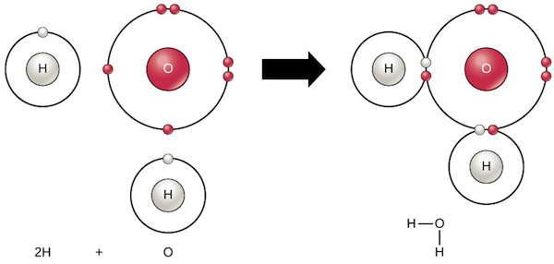

Hydrogen atoms sharing electrons with an oxygen atom to form covalent bonds, creating a water molecule

The shared electrons split their time between the valence shells of the hydrogen and oxygen atoms, giving each atom something resembling a complete valence shell (two electrons for H, eight for O). This makes a water molecule much more stable than its component atoms would have been on their own.

**Polar covalent bonds**

There are two basic types of covalent bonds: polar and nonpolar. In a **polar covalent bond**, the electrons are unequally shared by the atoms and spend more time close to one atom than the other. Because of the unequal distribution of electrons between the atoms of different elements, slightly positive (δ+) and slightly negative (δ–) charges develop in different parts of the molecule.

In a water molecule (above), the bond connecting the oxygen to each hydrogen is a polar bond. Oxygen is a much more **electronegative** atom than hydrogen, meaning that it attracts shared electrons more strongly, so the oxygen of water bears a partial negative charge (has high electron density), while the hydrogens bear partial positive charges (have low electron density).

In general, the relative electronegativities of the two atoms in a bond – that is, their tendencies to "hog" shared electrons – will determine whether a covalent bond is polar or nonpolar. Whenever one element is significantly more electronegative than the other, the bond between them will be polar, meaning that one end of it will have a slight positive charge and the other a slight negative charge.

**Nonpolar covalent bonds**

**Nonpolar covalent bonds** form between two atoms of the same element, or between atoms of different elements that share electrons more or less equally. For example, molecular oxygen is nonpolar because the electrons are equally shared between the two oxygen atoms.

Another example of a nonpolar covalent bond is found in methane (CH4). Carbon has four electrons in its outermost shell and needs four more to achieve a stable octet. It gets these by sharing electrons with four hydrogen atoms, each of which provides a single electron. Reciprocally, the hydrogen atoms each need one additional electron to fill their outermost shell, which they receive in the form of shared electrons from carbon. Although carbon and hydrogen do not have exactly the same electronegativity, they are quite similar, so carbon-hydrogen bonds are considered nonpolar.

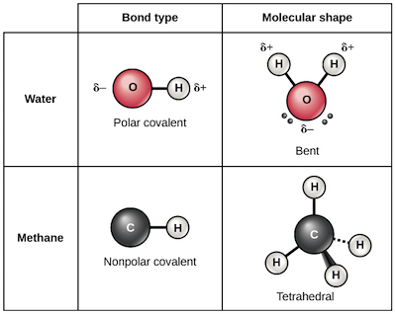

Table showing water and methane as examples of molecules with polar and nonpolar bonds, respectively

**Metallic Bond?**

‘Metallic bond’ is a term used to describe the collective sharing of a sea of valence electrons between several positively charged metal ions.

Metallic bonding is a type of chemical bonding and is responsible for several characteristic properties of metals such as their shiny lustre, their malleability, and their conductivities for heat and electricity.

Both metallic and covalent bonding can be observed in some metal samples. For example, covalently bonded gallium atoms tend to form crystal structures that are held together via metallic bonds. The mercurous ion also exhibits metallic and covalent bonding.

The factors that affect the strength of a metallic bond include:

* Total number of delocalized electrons.
* Magnitude of positive charge held by the metal cation.
* Ionic radius of the cation

An illustration describing the way electrons are delocalized over a rigid lattice of metal ions in a metallic bond is provided below.

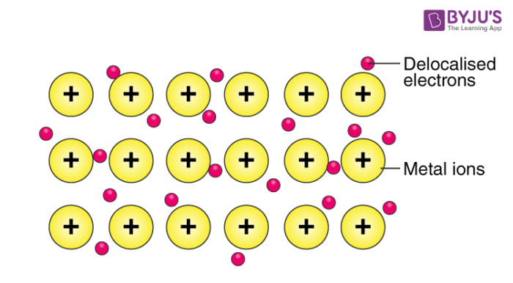

Metallic bonds are not broken when the metal is heated into the melt state. Instead, these bonds are weakened, causing the ordered array of metal ions to lose their definite, rigid structure and become liquid. However, these bonds are completely broken when the metal is heated to its boiling point.

**Example – Metallic Bonding in Sodium**

The [electron configuration](https://byjus.com/chemistry/electron-configuration/) of sodium is 1s22s22p63s1; it contains one electron in its valence shell. In the solid-state, metallic sodium features an array of Na+ ions that are surrounded by a sea of 3s electrons. However, it would be incorrect to think of metallic sodium as an ion since the sea of electrons is shared by all the sodium cations, quenching the positive charge.

An illustration describing the metallic bonding in sodium is provided below.

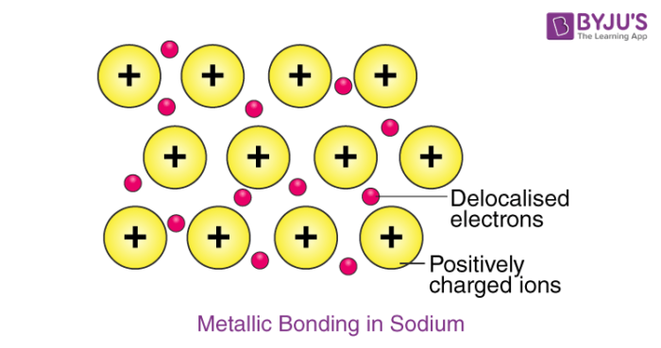

The softness and low melting point of sodium can be explained by the relatively low number of electrons in the electron sea and the relatively small charge on the sodium cation. For example, metallic magnesium consists of an array of Mg2+ ions. The electron sea here contains twice the number of electrons than the one in sodium (since two 3s electrons are delocalized into the sea). Due to the greater magnitude of charge and the greater electron density in the sea, the melting point of magnesium (~650oC) is significantly higher than that of sodium. A simplified model to describe metallic bonding has been developed by Paul Drüde called the 'Electron Sea Model'. Based on the low ionization energies of metals, the model states that metal atoms lose their valence electrons easily and become cations. These valence electrons create a pool of delocalized electrons surrounding the cations over the entire metal.

Metallic solids, such as crystals of copper, aluminum, and iron. are formed by metal atoms, and all of them exhibit high thermal and electrical conductivity, metallic luster, and malleability. Many are very hard and quite strong. Because of their malleability (the ability to deform under pressure or hammering), they do not shatter and, therefore, make useful construction materials. The melting points of metals vary widely. Mercury is a liquid at room temperature, and the alkali metals melt below 200 °C. Several post-transition metals also have low melting points, whereas the transition metals melt at temperatures above 1000 °C. These differences reflect differences in the strength of metallic bonding amongst the metals.

Hydrogen Bonds

Covalent and ionic bonds are both typically considered strong bonds. However, other kinds of more temporary bonds can also form between atoms or molecules. The weak bond often seen in biology is hydrogen bond. Not to be overly dramatic, but without hydrogen bond, life as we know it would not exist! For instance, hydrogen bonds provide many of the life-sustaining properties of water and stabilize the structures of proteins and DNA, both key ingredients of cells.

In a polar covalent bond containing hydrogen (e.g., an O-H bond in a water molecule), the hydrogen will have a slight positive charge because the bond electrons are pulled more strongly toward the other element. Because of this slight positive charge, the hydrogen will be attracted to any neighboring negative charges. This interaction is called a **hydrogen bond**.

Hydrogen bonds are common, and water molecules in particular form lots of them. Individual hydrogen bonds are weak and easily broken, but many hydrogen bonds together can be very strong.