* Lecture 2
* Atom,Atomic number,Mass number,Atomic mass and Isotops
* The atom is the basic unit of matter and serves as our starting point for the study of chemistry. The atom is composed of the subatomic particles protons, neutrons, and electrons. Scientists have studied atoms for hundreds of years and have developed a number of different models to describe them, as experimental technology has improved and new discoveries have been made. Chemists currently use the quantum mechanical model of the atom.

In this unit, we explore the structure and properties of atoms. We also study some of the basic tenets of quantum mechanics, and how quantum mechanics describes atomic structure. Finally, we learn about the structure and organization of the periodic table of the elements.

* + Upon successful completion of this unit, you will be able to:
    - list the properties of protons, neutrons, and electrons;
    - define isotopes and use isotopic abundance data to calculate average atomic mass for a given element;
    - define atomic number and atomic mass and describe how they apply to isotopes;
    - use Avogadro's number to convert between the number of particles and moles;
    - explain the wave-particle duality of light;
    - describe the Bohr model of the hydrogen atom;
    - list the four quantum numbers and describe their significance: and
    - describe the structure and organization of the periodic table.

Atoms and Elements

Let's begin by discussing elements. You are probably familiar with many elements, such as sodium, oxygen, and helium, from everyday life. Elements correspond to the symbols you see listed on the periodic table. All atoms are made of the subatomic particles protons, neutrons, and electrons.

Protons and neutrons exist in the nucleus, or the high-density center of the atom. Electrons exist as an electron cloud around the nucleus.

* + - Protons are positively charged
    - Neutrons are not charged
    - Electrons are negatively charged

Different elements are defined by the number of protons in the nucleus. For example, all hydrogen atoms have one proton in their nucleus. All helium atoms have two protons in their nucleus.

The Nuclear Atom and Atomic Mass

As stated above, we define the elements by their number of protons. We define the atomic number, Z, as the number of protons in an atom. For a neutral atom (not a charged ion), the number of electrons must equal the number of protons. However, the number of neutrons can vary within atoms of a given element.

Atoms of the same element with different numbers of neutrons are called isotopes. Most elements have multiple isotopes. For a given isotope, we define the mass number, A, as the atomic number plus the number of protons. We can write this as A = Z + N where A is mass number, Z is atomic number, and N is number of neutrons.

Read this section, which explains how we write atomic symbols with atomic numbers and mass numbers.

When we see the mass of an element on the periodic table, we are seeing the weighted average of the masses of all isotopes of that element. Then read the section "Isotopic Mixtures and Abundances" near the bottom of the page. This section describes how to determine the average atomic mass of an element if we know the isotope masses and their relative abundance. Try the practice problems to do these types of calculations yourself.

The Nuclear Atom

The precise physical nature of atoms finally emerged from a series of elegant experiments carried out between 1895 and 1915. The most notable of these achievements was **Ernest Rutherford's** famous 1911 **alpha-ray scattering experiment**, which established that:

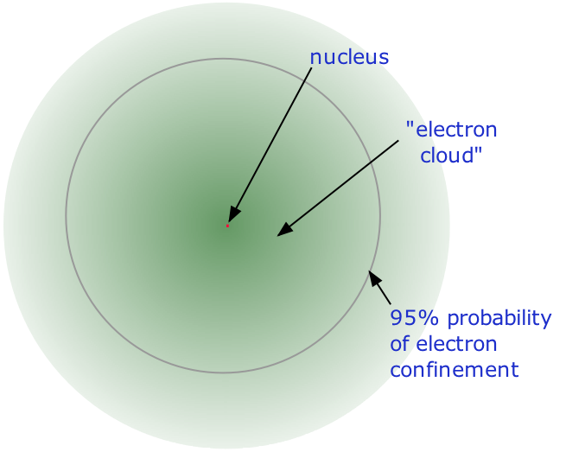

* Almost all of the **mass** of an atom is contained within a tiny (and therefore extremely dense) **nucleus** which carries a positive electric charge whose value identifies each element and is known as the **atomic number** of the element.
* Almost all of the **volume** of an atom consists of empty space in which electrons, the fundamental carriers of negative electric charge, reside.

The extremely small mass of the electron (1/1840 the mass of the hydrogen nucleus) causes it to behave as a **quantum particle**, which means that its location at any moment cannot be specified; the best we can do is describe its behavior in terms of the probability of its manifesting itself at any point in space. It is common (but somewhat misleading) to describe the volume of space in which the electrons of an atom have a significant probability of being found as the **electron cloud**. The latter has no definite outer boundary, so neither does the atom. The radius of an atom must be defined arbitrarily, such as the boundary in which the electron can be found with 95% probability. Atomic radii are typically 30-300 pm.

Mass Number

This is just the sum of the numbers of protons and neutrons in the nucleus. It is sometimes represented by the symbol **A**, so

**A = Z** + **N**

in which **Z** is the atomic number and **N** is the **neutron number**.

Nuclides and Their Symbols

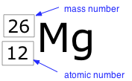

term **nuclide** simply refers to any particular kind of nucleus. For example, a nucleus of The atomic number 7 is a nuclide of nitrogen. Any nuclide is characterized by the pair of numbers (**Z ,A**). The element symbol depends on **Z** alone, so the symbol 26Mg is used to specify the mass-26 nuclide of manganese, whose name implies **Z**=12. A more explicit way of denoting a particular kind of nucleus is to add the atomic number as a subscript. Of course, this is somewhat redundant, since the symbol Mg always implies **Z**=12.

Isotopes are Nuclides Having the Same Atomic Number

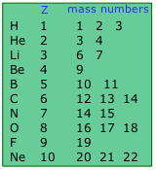

nuclides of the same element (and thus with identical atomic numbers) but different neutron Two numbers (and therefore different mass numbers) are known as **isotopes**. Most elements occur in nature as mixtures of isotopes, but twenty-three of them (including beryllium and fluorine, shown in the table) are monoisotopic. For example, there are three **natural isotopes** of magnesium: 24Mg (79% of all Mg atoms), 25Mg (10%), and 26Mg (11%); all three are present in all compounds of magnesium in about these same proportions.

Approximately 290 isotopes occur in nature.

The two heavy isotopes of hydrogen are especially important – so much so that they have names and symbols of their own:

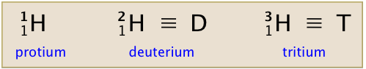

Deuterium accounts for only about 15 out of every one million atoms of hydrogen. Tritium, which is radioactive, is even less abundant. All the tritium on the earth is a by-product of the decay of other radioactive elements.