***Curriculum Vitae***

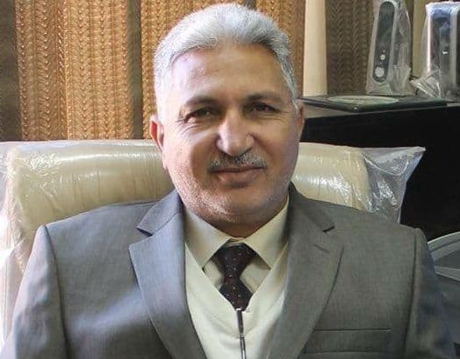

**PERSONAL INFORMATION:**

**Name:** Jaber Hameed Majeed

**Birthday:** 1 st. Jun. /1961 Baghdad.

**Nationality:** Iraqi.

**Marital Status:** Marred.

**Address:** Iraq / Baghdad.

**Contact:** mobile: +964 7716099709

E-mails: Officially;

30085@uotechnology.edu.iq

**Education:**

* B.Sc. in Electronics and communication Engineering/ University of Belgrade/ Serbia 1985.
* M.Sc. in Short Communications Engineering/ University of Belgrade/ Yugoslavia 1988.

**Current Position:**

1. Academic Lecturer at Department of Electrical Engineering. University of Technology. Iraq.
2. Electrical Engineering Department Board Decision 2012-2014
3. Electronic Engineering Branch Board Decision 2015-20118

**Biography**

Born in Baghdad, Iraq in 1961. He received his B.Sc and M.Sc degrees in 1985 and 1987 respectively from University of Belgrade, Serbia. Since 2007 he is a Lecturer at the University of Technology, Iraq. The field of interest is Communication and Electronic Engineering, Digital Electronics.

**Certifications & Awards:**

* Several **Certificates** from the reviewed journals.
* Several certificates from, international conferences, workshops and different events.
* Several Acknowledgment certificates from the chancellor of the University of Technology.
* Many Acknowledgment certificates from the Head of the department of Electrical Engineering, University of Technology.

**Scientific Specialization:**

* Electronics and Microelectronics
* Digital Electronics Systems

**Qualifications:**

* Professional in Electronic workbench (Multisim) software.
* Professional in Microsoft Office and Power Point Design.
* Very good in XILINEX software and FBGA

**Experiences and Practical Work:**

* I worked for a long time in the Construction Industries / Baghdad - Design Department (1990-2002). Where he works as a supervisor of maintenance work for electronic devices.
* I Worked in the Baghdad Tower Company, supervising, implementing and rehabilitating the electrical system, control systems, protection and fire systems for several banks affiliated with Rafidain Bank.
* Rehabilitation of the electrical system and installation of generators for several schools in Baghdad Governorate.
* From 2007 as a lecturer at the university of technology-Department of electronics- Baghdad. Where I gave a lecture in electronic engineering and digital. In additional a chief on the follows laboratories
  1. Communications Laboratory.
  2. Electronics Laboratory.
  3. Basic Electrical Circuits Laboratory.
  4. Digital Electronics Laboratory.
* With deep experience in the maintenance and repair capabilities of:

1. Deep expertise in the design and maintenance of the power supplies blocks.

2. Deep expertise in the design and maintenance of alarms and control circuits that are used in factories and homes.

**Languages:**

* Arabic-Mother Language.
* English.
* Serbian
* Croatian
* Bosnian