# Lecture 8 :

# Relations

# Order Pair:

# Product of Sets:

# 

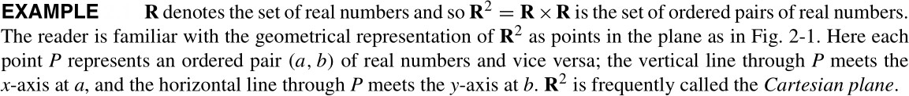

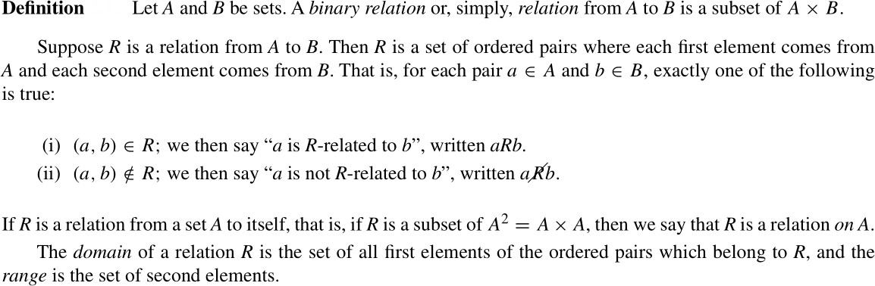 **Relation**

**Example** :

Let *A* (1,2,3) and *B* *{x ,y ,z}* , and let *R*={(1,*y),(1,z),(3,y)}.* Then *R* is a relation from *A* to *B*  since *R* is a subset of *A×B*. With respect to this relation ,

*1Ry , 1Rz ,3Ry* but *1Rx , 2Rx ,2Ry ,2Rz ,3Rx ,3Rz*

That is *R*={ (1, y), (1, z), (3,y )}

The domain of R is { 1 ,3} and the range is { y,z}

Another examples :

*S*= { (2,y), (2,z), (3,y) ,(3,z)}

*T*={(1,z)}

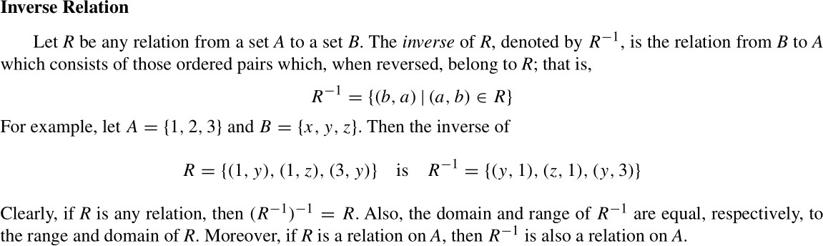

# Pictures of Relations on Finite Sets

Suppose *A* and *B* are finite sets. One ways of picturing a relation *R* from *A* to *B*

is to write down the elements of *A* and the elements of *B* in two disjoint disks, and then draw an arrow from *a* ∈ *A* to *b* ∈ *B* whenever *a* is related to *b*. This picture will be called the *arrow diagram* of the relation.

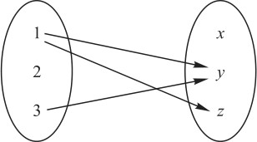For example, see for *R* (1, *y*),(1, *z*),(3, *y*)}.

# Types of Relations:

Here we discusses a number of important types of relations defined on a set *A*.

# Reflexive Relations

A relation *R* on a set *A* is reflexive if *aRa* for every *a* є *A*, that is, if (*a*, *a*) є *R* for every *a* є *A*. Thus *R* is not reflexive if there exists *a* є *A* such that (*a, a*) є *R*

# Example

Consider the following five relations on the set

*A* = {1, 2, 3, 4}:

R1 = {(1, 1), (1, 2), (2, 3), (1, 3), (4, 4)}

R2 = {(1, 1)(1, 2), (2, 1), (2, 2), (3, 3), (4, 4)}

R3 = {(1, 3), (2, 1)}

R4 = Ø, the empty relation

R5 = *A*×*A*, the universal relation

Since *A* contains the four elements 1, 2, 3, and 4, a relation *R* on *A* is reflexive if it contains the four pairs (1, 1), (2, 2), (3, 3), and (4, 4). Thus only R2 and the universal relation

R5 = *A*×*A* are reflexive. Note that R1, R3, and R4 are not reflexive since, for example, (2, 2) does not belong to any of them.

# Symmetric Relations

A relation *R* on a set *A* is symmetric if whenever *aR b* then *bRa*, that is, if whenever (*a, b*) є *R* then (*b, a*) є R.

A relation *R* is not symmetric if there exists *a, b* є *A* such that (*a, b*) є *R* but (*b, a*)  *R*.

# Example

Consider the following five relations on the set

*A* = {1, 2, 3, 4}:

R1 = {(1, 1), (1, 2), (2, 3), (1,3),(4,4)}

R2 = {(1, 1)(1, 2), (2, 1), (2, 2), (3, 3), (4, 4)}

R3 = {(1, 3), (2, 1)}

R4 = Ø , the empty relation

R5 = *A*×*A*, the universal relation

A relation R1 is not symmetric since (1, 2) є R1 but (2, 1)  R1. R3 is not symmetric since (1, 3) є R3 but (3, 1)  R3.

The other relations are symmetric.

# Antisymmetric Relations

A relation *R* on a set *A* is antisymmetric if whenever *aRb* and *bRa* then *a* = *b*, that is, if *a*  *b and aRb* then *b* *R a*.

Thus, *R* is not antisymmetric if there exist distinct elements *a* and *b* in *A* such that *aRb* and *bRa*.

# Example

Consider the following five relations on the set

*A* = {1, 2, 3, 4}:

R1 = {(1,1), (1, 2), (2, 3), (1, 3), (4, 4)}

R2 = {(1, 1)(1, 2), (2, 1), (2, 2), (3, 3), (4, 4)}

R3 = {(1, 3), (2, 1)}

R4 = Ø, the empty relation

R5 = *A*×*A*, the universal relation

A relation R2 is not antisymmetric since (1, 2) and (2, 1) belong to R2, but 1  2. Similarly, the universal relation R3 is not antisymmetric. All the other relations are antisymmetric.

# Remark

The properties of being symmetric and being antisymmetric are not negatives of each other. For example, the relation *R* = {(1, 3), (3, 1), (2, 3)} is neither symmetric nor antisymmetric. On the other hand, the relation *R*′ = {(1, 1), (2, 2)} is both symmetric and antisymmetric.

**Transitive Relations**

A relation *R* on a set *A* is transitive if whenever *aRb* and *bRc* then *aRc*, that is, if whenever (*a, b*), (*b, c*) ∈ *R* then (*a, c*) ∈ *R*.

Thus *R* is not transitive if there exist *a, b, c* ∈ *R* such that (*a, b*), (*b, c*) ∈ *R* but (*a,c*) ∈  *R*.

**Example**

Consider the following five relations on the set

A = {1, 2, 3, 4}:

R1 = {(1, 1), (1, 2), (2, 3), (1, 3), (4, 4)}

R2 = {(1, 1)(1, 2), (2, 1), (2, 2), (3, 3), (4, 4)}

R3 = {(1, 3), (2, 1)}

R4 = ∅, the empty relation

R5 = A×A, the universal relation

The relation R3 is not transitive since (2, 1), (1, 3) ∈ R3 but (2, 3) ∈ R3. All the other relations are transitive.

**Equivalence Relations**

Consider a nonempty set *S*. A relation *R* on *S* is an equivalence relation if *R* is reflexive, symmetric, and transitive.

That is, *R* is an equivalence relation on *S* if it has the following three properties:

1. For every *a* ∈ *S*, *aRa*.
2. If *aRb*, then *bRa*.
3. If *aRb* and *bRc*, then *aRc*.

**Examples 1**

The relation “=” of equality on any set *S* is an equivalence relation; that is:

1. *a* = *a* for every *a* ∈ *S*.
2. If *a* = *b*, then *b* = *a*.
3. If *a* = *b*, *b* = *c*, then *a* = *c*.