***AL- Mustaqbal University***

**Optometry Department**

**Lec.6**

Optical Instruments

assistant teacher

MCS

**Ali Hadi Al-Hussainy**

*2023-2024*

***Test charts and trial case and frame***

Case Lens Trial

It is a case that contains a set of lenses that are used by trial and error in order to correct refractive errors. These lenses are different in type and power.

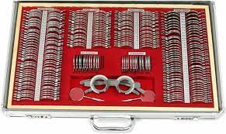

The case is divided into three groups of examination lenses:

1- Concave spherical lenses (negative): which are used in the treatment of myopia (nearsightedness).

2- Convex spherical lenses (positive): which are used in the treatment of hypermetropia (farsightedness) and presbyopia.

3- Negative and positive cylindrical lenses: which are used to treat astigmatism, and differ from the other by the presence of two red lines on both ends of the lens to determine the axis of the lens.

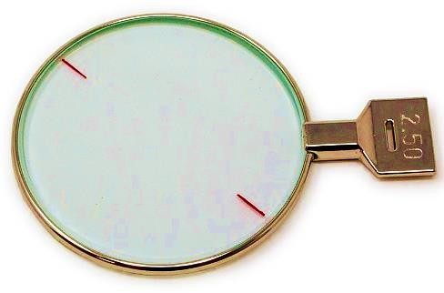

lens Auxiliary

**Prism lens: prismatic lenses are used in some cases of squint, which leads to diplopia, and the base of the prismatic lens is thicker than the apex.**

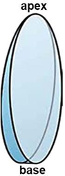

**Jackson cross-cylinder lens: It is a type of special cylindrical lens, also called Jackson lens. It consists of two cylindrical lenses of different in sign, equal in power and orthogonal. It is used to check for astigmatism and to adjust the degree and axis of the cylindrical lens.**

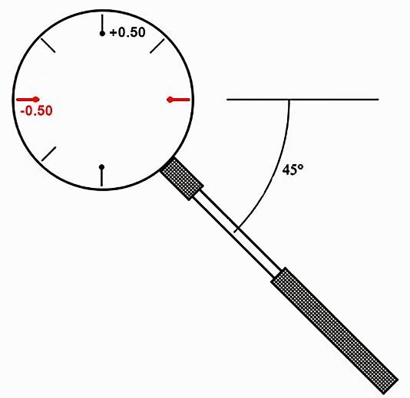

**Maddox rod lens**

**It is a glass lens consisting of parallel cylindrical lines that have several colors, including red, green and transparent, it used to subjectively detect and measure a latent, manifest, horizontal or vertical heterophoria for near and distance.**

**The purpose of the cylindrical lines is that they convert the point light source into a bright line, and through the direction of the cylinders we can obtain a horizontal or vertical bright line to evaluate the squint on both axes.**

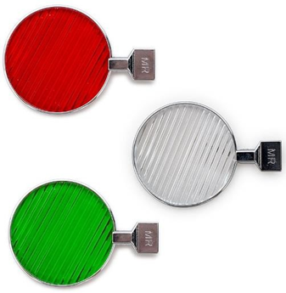

**Pinhole lens**

**It is a black, opaque circular disc, in its center there is a hole ranging in diameter (1-2 mm) to reduce the amount of peripheral light entering the eye, and it is used to find out the cause of poor vision, so that the vision improves with it, which means that the cause is a refractive error, and if the vision does not improve with it, it means that the cause is an organic eye disease.**

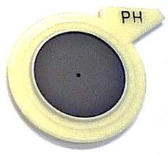

**Stenopaic slit lens**

**It is a black circular disc containing a linear slit of width (0.50-1.00 mm) and length (15 mm), to allow light to pass through. It is used to determine astigmatism by rotating it (horizontal and vertical) after placing spherical test lenses, and asking the patient in which direction the vision is clearer.**

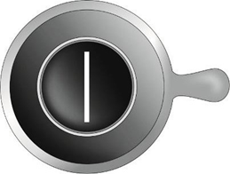

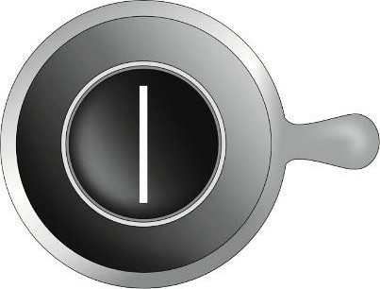

**Occlude lens**

**It is a black circular disk and is used as a covering for the eye when examining the other eye.**

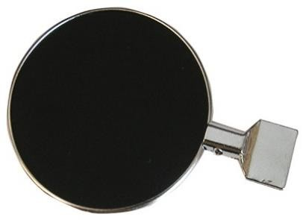

**Red/Green filter lens**

They are red and green colored lenses and have no optical power. They are used in binocular vision tests. They are also used to check over-correction and under-correction of refractive error.

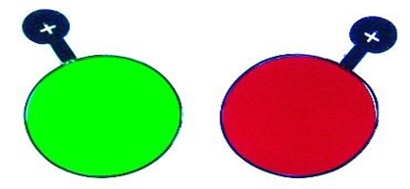

Frame Trial

Is a frame intended for testing visual acuity by placing all test and additional lenses in it, and its parts are as follows.

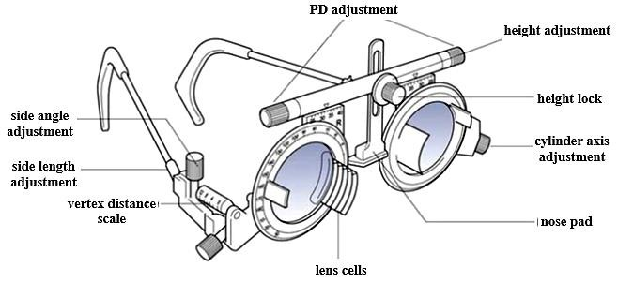

***THANK YOU***