

Optical instruments

Risk of transmission of infection in lenses

M.Sc

Ali Hadi Ahussaini



**Contact lenses**

Contact lenses are thin, clear plastic disks you wear in your eye to improve your vision. Contacts float on the tear film that covers your cornea.

Like eyeglasses, contact lenses correct vision problems caused by refractive errors.



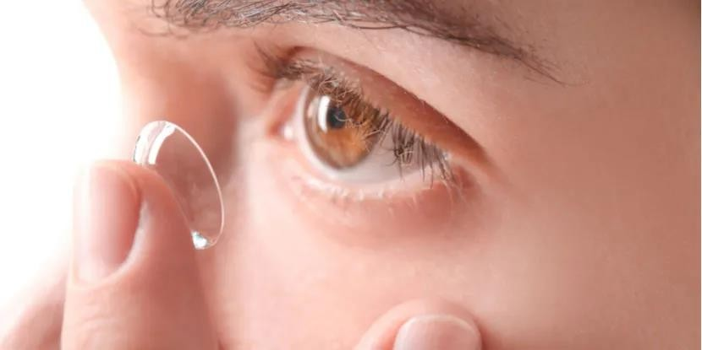

# Eye infections from contact lenses



There are a number of things that can cause a contact lens-related infection. Some causes of infection may include:

* Using extended-wear lenses.
* Sleeping in your contact lenses.
* Having microbes build up under the lens.
* Herpes virus.
* Bacteria, fungi, or parasites.
* Not keeping lenses or cases clean, or reusing or topping off contact lens solution.



**The most common eye infection**

Keratitis is the most common eye infection from wearing contact lenses. It is when the cornea becomes infected.

In some cases, it can scar the cornea, affecting your vision. If the cornea is severely scarred, a corneal transplant may be needed to eliminate damage from the eye infection and have clear vision again.

# The signs of an eye infection from contact lenses



Symptoms of contact lens–related infections include:

* + blurry vision.
  + Unusual redness of the eye.
  + Pain in the eye.
  + Tearing or discharge from the eye.
  + Being extra sensitive to light.
  + Feeling like there is something in your eye.
  + Some contact lens-related eye infections can cause serious vision loss or even blindness.

# How do you avoid eye infections from contact lenses



1. Rub
2. Rinse
3. Replace
4. Rest
5. Renew
6. Reserve

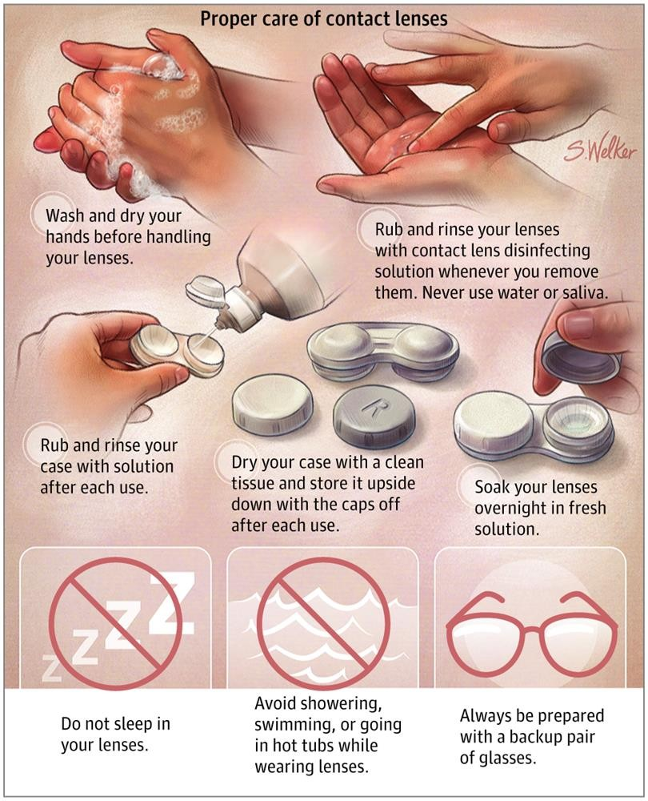



**Diagnostic contact lens**

These are the corneal or scleral contact lenses that serve as a locator for intraocular foreign bodies. There is an electrode which scans calm and active potentials of the cornea and conjunctiva.

This serves as a diagnosis of diseases of the retina.



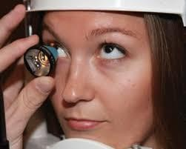 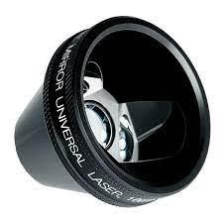



**Diagnostic indication**

* Gonioscopy.
* Electroretinography.
* examination of fundus in case of irregular Corneal Astigmatism
* Fundus Photography
* Goldmann’s3 Mirror Examination