**___________________________________________________Lecture 8: Blood Film Preparation**

***Principle:***

1. Blood film enables us to evaluate WBC, RBC, and PLT **morphology**,
2. Also, to perform **differential** WBC count,
3. Estimation of WBC and platelets counts.
4. Blood films are made on glass microscopic slides.

***Sample:*** EDTA anticoagulated venous whole blood

**Procedure:**

1- Use clean standard size glass slides (3 inch x 1 inch = 7.5 cm x

2.5 cm), wiped from dust just immediately before use.

2- Place a small drop of well mixed anticoagulated whole blood, in

the center line of the slide, about 1.5 to 2 cm from one end, with

the aid of a capillary tube.

3- Immediately, without delay, with the aid of a second clean slide

with uniform smooth edges (**spreader slide**), with a 30 –40 degrees angle, move back so blood drop will spread along the edge of the spreader slide.

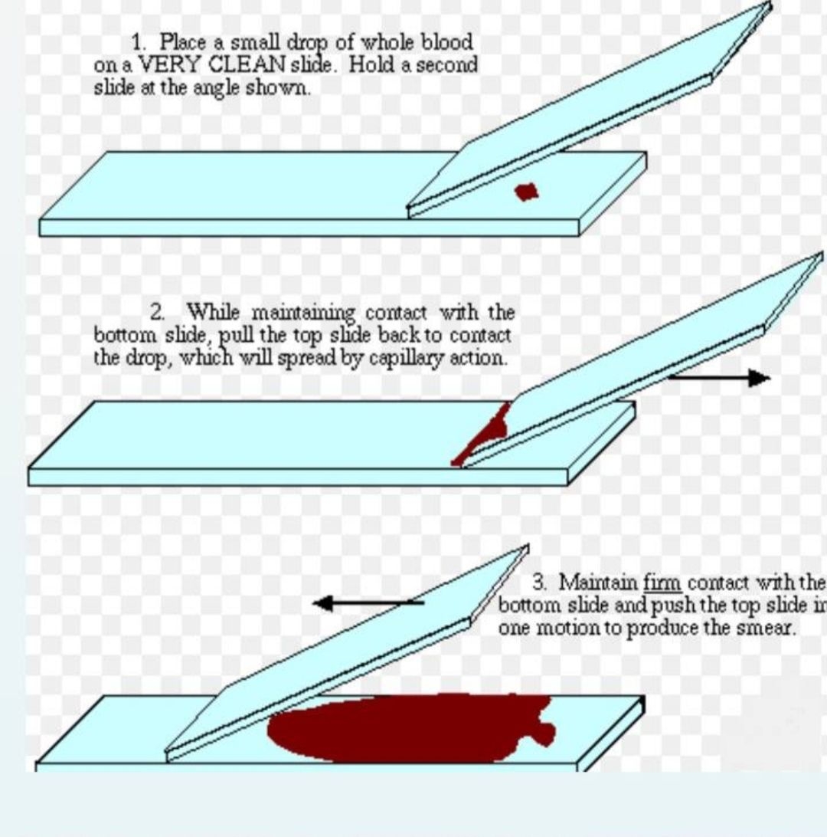

**(Figure 1 blood smear preparation)**

**Blood films are stained with one of the Romanovsky stains, which are universally used for staining blood films**

**Romanovsky stains** dependent on two staining components:

* **Azure B** (the basic dye) and
* **Eosin Y** (the acidic dye).

**Other factors which affects the staining results include :**

**1**) Staining time ,  **2**) Ratio of Azure B to Eosin Y,  **3**) pH of the staining solution

|  |
| --- |
| ***Romanovsky stains include:***   Giemsa Stain   Wright’s Stain   Leishman Stain   May-Grünwald Stain  ***The widly used and popular Romanovsky stains*** *:*  ➢Leishman Stain  ➢Wright’s Stain  **Leishman Stain Procedure:** |

1- Cover the blood film with 8-10 drops of Leishman’s stain for 1-2 min.

2- Dilute the stain with an equal volume of distilled water (DW) and mix by gentle rocking then leave it for 10 min.

3- Wash with (DW).

4- Drain and dry in the air at room temperature.

5- Clean the back of the slide and examine it microscopically.

**A well spread blood film should have the following characteristics (Fig.2):**

1. Lateral edges 2. An adequate zone of morphology 3. Straight feature-edge. 4. Adequate length.

The zone of morphology is the area of the film where the RBCs barely touch each other (Fig.3), this is appropriate area for carrying out blood film examination.

**Preparing a good quality smear depends on three main factors:**

1- The size of the drop of blood.

2- The angle applied to spreader.

3. The speed and steadiness in pushing the spreader.

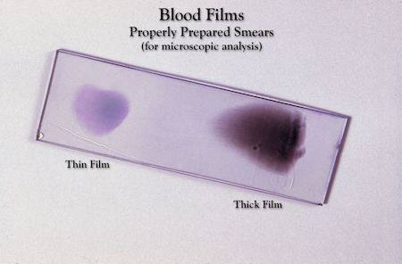

**(Figure 2 well spread blood smear)**



**A B**

**Figure (3): a: Zone of morphology.** The RBCs are well separated from each other. **b:** Thick film with no zone of morphology (RBCc are crowded).

***Notes ON This Technique :***

* Before preparing the films, you must check that blood samples are **free from clots**
* Films can be **labeled** with patient’s name and /or Lab. No. on the thick end of the film itself, after being dried, by using a pencil.
* With **anemia** (low Hct, reduced viscosity), the spreading angle

should be **greater**, to avoid running off the slide.

* With polycythemia (high Hct, increased viscosity), the spreading

angle should be **less**, to avoid short, too thick films.

* With **large** blood drops, **increase** the spreading angle.
* With **small** blood drops, **decrease** the spreading angle.

***Sources Of Errors In Staining:***

1. Stain Precipitate: May obscure cell details .Filter the stain before use.
2. pH of the buffer or water:

*  Too acidic pH causes too pinkish slides.
* Too basic pH causes too bluish slides

1. Improper stain timing may result in faded staining or altered colors:

* Too long staining time causes too blue slides (overstaining).
* Too short staining time causes too red slides.

1. Forced drying may alter color intensities and/or distort cell

morphology.

1. Non-stain related errors:
2. EDTAcauses **crenation** of the cells after blood collection.
3. Severely anemic blood samples causes slower drying

(before staining) due to **excessive plasma**.