**_ Lecture 6 : Manual and automated RED BLOOD CELL (RBC’s) COUNT**

**The RBC counting:** The count of red blood cells, is the number of red blood cells in mmᶟ of whole blood.

**RBC count - Normal Values :**

* + Men: 4.5-6.2 × 106/mm3
  + Women: 4.0-5.5 × 106/mm3
  + at birth: 4.0-6.0 × 106/mm3
  + 3 years – 10 years: 4.0-5.0 × 106/mm3

**The RBC counting performed :**

1. Manually by Heamocytometer or
2. The blood cells automatic analyzer (Part of CBC ;group of tests)

**Importance**  **OF RBCS counting** :

RBCs count less or more than normal , It is a screen test anemia or polycythemia

1. **Rbc count using Haemocytometer :**

**Materials:**

* Venous blood mixing with EDTA or capillary blood with heparin
* Improved neubauer's counting chamber withCoverslips
* RBC pipette and RBC Diluting solution (Hayem's Fluid ), the purpose of this fluid: its isotonic solution diluted blood, prevent lysis and blood sedimentation)
* Compound Microscope

**Principle:** The blood is diluted 200 time with RBCs diluting fluid (1\200) in practice (20ul blood and 4 ml dilution).

**Procedure:**

1. Draw blood by micropipette 20 ul.
2. Mix the blood with diluting fluid 4ml.
3. Mix the contents in glass tube for 2 min.
4. Introducing the sample into the Neubauer chamber (10ul from mixture).
5. To count the RBCs the microscope must be switched to 40X objective
6. Count RBCs from R marked 5 squares
7. Rbcs count in*10.000 cells of blood

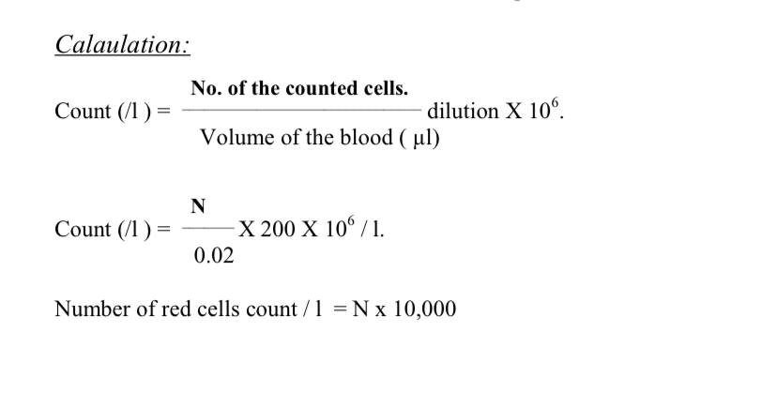****

**Causes of decreased RBC count:**

|  |
| --- |
| * Impaired red blood cell (RBC) production * Increased RBC destruction (hemolytic anemia's) * Blood loss * Fluid overload (hemodilution) |

**Causes of high red blood cell count:**

* High altitudes , Hypoxia, Smoking, Dehydration
* Polycythemia vera (often a hereditary problem)
* Congestive heart disease, Certain lung diseases
* Erythropoietin doping by athletes to boost their performance
* Some types of anemia has high RBC count such as β-thalassemia

**Physiological effect on Rbc count: -**

1-age 2-sex 3-Activity 4-nutrition 5-pregnancy 6-brest feeding 7-psychological Emotions

**2. Automated Red blood cell count:**

Electronic counter is based on the principle of aperture impedance method.