**Dr.salim kareem hajwal**

|  |
| --- |
| **Population Characteristics** |
| **Definition:** Qualities and characterization of various types of populations within a social or geographic group, with emphasis on demography, health status, and socioeconomic factors. |

**The population has the following characteristics**:

**1. Population Size and Density:**

Total size is generally expressed as the number of indi­viduals in a population.

**Population density** is defined as the numbers of individuals per unit area or per unit volume of environment.

Since, the patterns of dispersion of organisms in nature are different population density is also differentiated into crude density and ecological density.

**a. Crude density:**

It is the density (number or biomass) per unit total space.

**b. Ecological density or specific or economic density:**

It is the density (number or biomass) per unit of habitat space i.e., available area or volume that can actually be colonized by the population.

**2. Population dispersion or spatial distribution:**

Dispersion is the spatial pattern of in­dividuals in a population relative to one another. In nature, due to various biotic interactions and influence of abiotic factors, the following three basic population distributions can be observed:

**(a) Regular dispersion:**

Here the individuals are more or less spaced at equal distance from one another. This is rare in nature but in common is cropland. Animals with territorial behaviour tend towards this dispersion.

**(b) Random dispersion:**

Here the position of one individual is unrelated to the positions of its neighbours. This is also relatively rare in nature.

**(c) Clumped dispersion:**

Most populations exhibit this dispersion to some extent, with individuals aggregated into patches interspersed with no or few individuals. Such aggregations may result from social aggregations, such as family groups or may be due to certain patches of the environment being more favourable for the population concerned.

**3. Age structure:**

In most types of populations, individuals are of different age. The pro­portion of individuals in each age group is called age structure of that population. The ratio of the various age groups in a population determines the current reproductive status of the popu­lation, thus anticipating its future. From an ecological view point there are three major ecological ages in any population. These are, pre-reproductive, reproductive and post reproductive. The relative duration of these age groups in proportion to the life span varies greatly with different organisms.

**Age pyramid:**

The model representing geometrically the proportions of different age groups in the population of any organism is called age pyramid. According to Bodenheimer (1938), there are following three basic types of age pyramids.

**(a) A pyramids with a broad base (or triangular structure):**

It indicates a high percentage of young individuals. In rapidly growing young populations birth each successive generation will be more numerous than the preceding one, and thus a pyramid with a broad base would result (Fig. A).

**(b) Bell-Shaped Polygon:**

It indicates a stationary population having an equal number of young and middle aged individuals. As the growth rate becomes slow and stable, i.e., the pre-  
reproductive and reproductive age groups become more or less equal in size, post-reproductive group remaining as the smallest (Fig. B).

**(c) An urn-shaped structure:**

It indicates a low percentage of young individuals and shows a declining population. Such an un-shaped figure is obtained when the birth rate is drastically reduced the pre-reproductive group dwindles in proportion to the other two age groups of the population. (Fig. C).

**[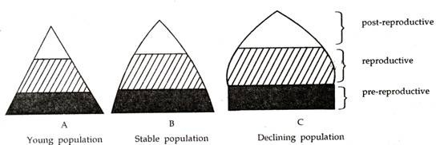](http://cdn.yourarticlelibrary.com/wp-content/uploads/2014/01/clip_image00247.jpg)**