**College of Nursing**

**Community Health Nursing Specialty**

**Homelessness and Health**

**Dr.salim hajwal**

**Homelessness**

* is a life-change traumatic event that creates major stress in any person’s life, regardless of age.

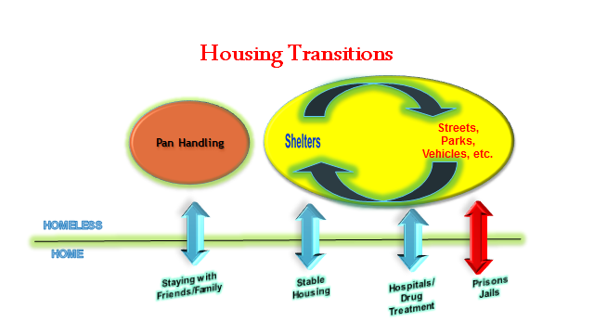

**Homelessness in the Iraq**

The causes of **homelessness in Iraq** are different. In 2007, the [**United nations**](https://en.wikipedia.org/wiki/United_Nations)estimated that **16% of the Iraqi population** have run away their homes because of the [**conflict**](https://en.wikipedia.org/wiki/Iraq_War).

**Why do people become homeless?**

* **Individual Risk Factors**
* Substance abuse
* Mental illness
* Childhood family environment
* Lack of job skills
* **Social Problems**

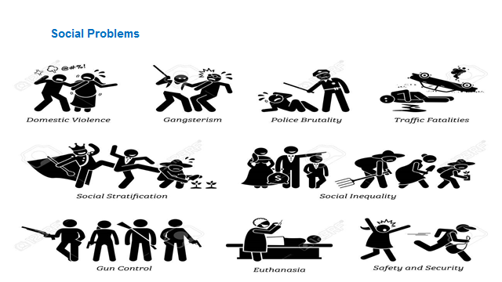

**Leading Causes of Mortality among Homeless People**

* Injuries
* Drug Overdose
* Suicide
* HIV/AIDS
* Cancer
* Heart Disease

**Principles of Clinical Care for Patients who are Homeless**

* Patient-centered care(Trust & listening)
* Acute vs. Chronic (unmanaged) vs. Chronic (managed) conditions
* Collateral history from clinicians and pharmacists
* Promote continuity of care
* Understand the person’s life situation

**Resources to combat homelessness by**

**Public sector**

* Needs included emergency shelter, transitional housing, job training, primary health care, education, and housing.
* The goal of Housing First is to prevent homelessness or to rapidly rehouse individuals who have become homeless

**Private Sector**

The private sector has made a concerted effort to organize communities in the battle against homelessness. These organized efforts are carried out at the national, state, and local level to positively impact the problem of homelessness in communities across the nation.