Epidemiology in Community Health Care

**Dr.salim hajwal**

**The content**

* Introduction
* The goals of epidemiology
* Historical roots of epidemiology
* Epidemic and pandemic
* Concepts basic to epidemiology
* Causality
* Immunity
* Natural history of a disease or health condition
* Sources of information for epidemiologic study
* Methods in the epidemiologic investigative process
* Conducting epidemiologic research
* Summary
* Reference

**Introduction**

Epidemiology is “concerned with the distribution and determinants of health and diseases, morbidity, injuries, disability, and mortality in populations.

It is a specialized form of scientific research that can provide health care workers, including community health nurses, with a body of knowledge on which to base their practice and methods for studying new and existing problems.

The term is derived from the Greek words epi (upon), demos (the people), and logos (knowledge):

**Epidemiologists ask such questions as the following:**

◆ What is the occurrence of health and disease in a population?

◆ Has there been an increase or decrease in a health state over the years?

◆ Does one geographic area have a higher frequency of disease than another?

◆ What characteristics of people with a particular condition distinguish them from those

without the condition?

◆ What factors need to be present to cause disease or injury?

◆ Is one treatment or program more effective than another in changing the health of

affected people?

◆ Why do some people recover from a disease and others do not?

**The goals of epidemiology are to :**

* Determine the extent of disease in a population.
* Identify patterns and trends in disease occurrence.
* Identify the causes of disease.
* Evaluate the effectiveness of prevention and treatment options.(1)

With knowledge **the scale** and **nature** of human health problems , can be

solutions to prevent disease and contributing to the improved health of the population.

Epidemiology **offers** community health nurses a specific methodology for assessing the health of aggregates. and it **provides** a frame of reference for investigating and improving clinical practice in any setting.

**Historical Roots Of Epidemiology**

* The roots of epidemiology can be traced to Hippocrates, a Greek physician who lived from about 460 to 375 BCE and who is sometimes referred to as the first epidemiologist.
* Hippocrates and other members of the Hippocratic School believed that disease not only affects individuals but also affects the masses.

This was one of the earliest associations of the occurrence of disease with lifestyle

and environmental factors, specifically geographic location . (4)

* Not until the late 19th century however, did modern epidemiology come into existence.

**Epidemic and pandemic**

* An **epidemic** refers to a disease occurrence that clearly exceeds the normal or expected frequency in a community or region. In past centuries, epidemics of **cholera**, **bubonic** **plague**, and **smallpox** swept through community after community, killing thousands of people, changing the community structure, and altering the lifestyle of people.
* When an epidemic, such as **the bubonic plague** (also called pneumonic plague or the Black Death) or **acquired immunodeficiency syndrome** (AIDS), is worldwide in distribution, it is called a **pandemic**.
* **Epidemic** and **pandemic** diseases clearly prompted the development of epidemiology as a science. Epidemiology became a branch of medical science through its concern with massive waves of infectious diseases. (5)

**Concepts Basic To Epidemiology**

* The science of epidemiology depends on certain basic concepts and principles to analyze and understand patterns of occurrence among total health conditions.

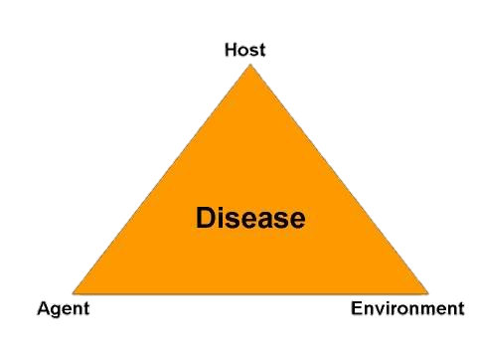

**Host, Agent, and Environment Model:**

Through their early study of infectious diseases, epidemiologists began

to consider disease states generally in terms of the epidemiologic triad,

or the host, agent, and environment model. Interactions among these

three elements explained infectious and other disease patterns.

**Host**

The host is a susceptible human or animal who harbors and nourishes a disease-causing agent. Many physical, psychological, and lifestyle factors influence the host’s susceptibility and response to an agent.

* **Physical factors** include age, sex, race, and genetic influences on the host’s vulnerability or resistance.
* **Psychological factors**, such as outlook and response to stress, can strongly influence host susceptibility.
* **Lifestyle factors** also play a major role. Diet, exercise, sleep patterns, and healthy or unhealthy habits all contribute to either increased or decreased vulnerability to the disease-causing agent.

The concept of **resistance** is important for community health nursing practice. People sometimes have an ability to resist pathogens called **inherent resistance**.

Typically, these people have inherited or acquired this characteristics that make them less vulnerable.

**Agent**  
An agent is a factor that causes or contributes to a health problem or condition. Causative agents can be factors that are present e.g.,( bacteria that cause tuberculosis) or factors that are lacking e.g.,( lack of iron in the body that cause anemia.

**Environment**

The environment refers to all the external factors surrounding the host that might influence vulnerability or resistance.

* **The physical environment** includes factors such as geography, climate, weather, safety of buildings, water and food supply, and presence of animals, plants, insects, and microorganisms that have the capacity to serve as reservoirs (storage sites for disease-causing agents) or vectors (carriers) for transmitting disease.
* **The psychosocial environment** refers to social, cultural, economic, and psychological influences and conditions that affect health, such as access to health care, cultural health practices, poverty, and work stressors, which can all contribute to disease or health.

**Causality**

**Causality:** refers to the relationship between **a cause** and **its effect**.

A purpose of epidemiologic study has been to discover causal relationships, so as to understand why conditions develop and offer effective prevention and protection. Over the years, however, as scientific knowledge of health and disease has expanded, epidemiology has changed its view of causality.

***Chain of Causation***

As the scientific community’s thinking about disease causation and the tripartite model (host-agent-environment) grew more complex, epidemiologists began to use the idea of a chain of causation.

* The chain begins by identifying the reservoir (where the causal agent can live & multiply).
* With plague, that reservoir may be other humans, rats, squirrels, and a few other animals.
* The infected **humans** with malaria, are **the major reservoir** for the parasitic agents, although certain **nonhuman** primates also **act as reservoirs** .
* Next, the agent must have a **portal of exit** from the reservoir, as well as some **mode of transmission**.

For example, the bite of an Anopheles mosquito provides a portal of exit for the malaria parasites, which spend part of their life cycle in the mosquito’s body; the mosquito in this case is the mode of transmission. (2)

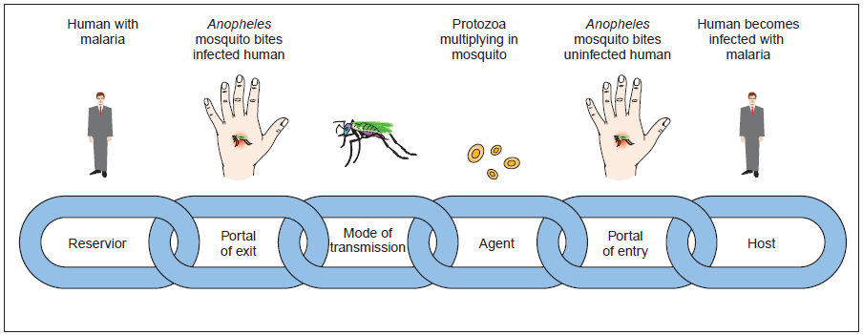

**Immunity**

**Immunity:** Immunity refers to a host's ability to resist a particular infectious disease-causing agent. This occurs when the body forms antibodies and lymphocytes that react with the foreign antigenic molecules and render them harmless.

**Passive Immunity:** refers to short-term resistance that is acquired either naturally or artificially.

* Newborns, through maternal antibody transfer, have natural passive immunity that lasts about 6 months . artificial passive immunity is attained through inoculation with a vaccine that gives temporary resistance.

**Active Immunity:** is long-term and sometimes lifelong resistance that is acquired either naturally or artificially.

* Naturally acquired active immunity comes through host infection. That is, a person who contracts a disease often develops long-lasting antibodies that provide immunity against future exposures. Artificially acquired active immunity is attained through vaccine inoculation.

**Natural History of a Disease or Health Condition**

* Any disease or health condition follows a progression known as its natural history; this refers to events that occur before its development, during its course, and during its conclusion.
* This process involves the interactions among a **susceptible host**, the **causative agent**, and **the environment**.
* The natural progression of a disease occurs in two phases include four stages – two stages referred to as pre-pathogenesis (before the delectability of the disease or condition) and two referred to as pathogenesis (while the disease or condition is present ).
* The natural progression of a disease occurs in four stages as they affect a population: susceptibility, preclinical disease, clinical disease ,and resolution.

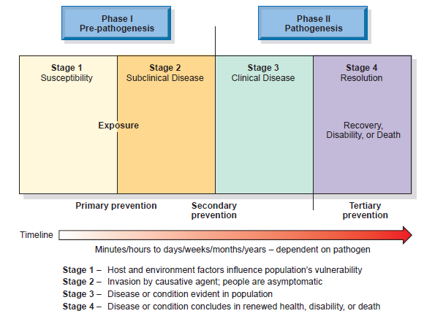

**Sources Of Information For Epidemiologic Study**

Epidemiologic investigators may draw data from any of three major sources: existing data, informal investigations, and scientific studies.

**1-Existing Data:**

A variety of information is available nationally, by state, and by section, such as county, region, or area. This information includes vital statistics, census data, and morbidity statistics on certain communicable diseases. Local health departments often can provide these data on request.

* Vital Statistics
* Census Data
* Reportable Diseases
* Disease Registries
* Environmental Monitoring
* National Center for Health Statistics
* Health Surveys

**2-Informal Observational Studies:**

**3-Scientific Studies:**

**Methods In The Epidemiologic Investigative Process**

The goals of epidemiologic investigation are to identify the causal mechanisms of health and illness states and to develop measures for preventing illness and promoting health.

Epidemiologists employ an investigative process that involves a sequence of three approaches that build on one another: descriptive, analytic, and experimental studies.

**Descriptive Epidemiology**

**Analytic Epidemiology**

* ***Prevalence Studies***
* ***Case-control Studies***
* ***Cohort Studies***

**Experimental Epidemiology**

**Descriptive epidemiology** includes investigations that seek to observe and describe patterns of health in a population.

For example, a community health nurse might seek to learn

**how many children in a school have been immunized for measles**.

**how many home births occur each year in the county.**

**how many cases of STDs have occurred in the city in the past month**,

At this stage in the epidemiologic investigation, the researcher seeks to establish the occurrence of a problem. Data from descriptive studies suggest hypotheses for further testing.

Descriptive studies almost always involve some form of broad-based quantification and statistical analysis such as : Counts & Rates & Computing Rates.

**Analytic epidemiology**

A second type of investigation, analytic epidemiology, exceed description or observation and seeks to identify associations between health problem and its possible causes.

**Analytic studies** tend to be more specific than **descriptive studies** in their focus. They test hypotheses or seek to answer specific questions and can be retrospective or prospective in design. Analytic studies fall into three types:prevalence studies & Case-control studies & Cohort studies.

* **prevalence studies:**  it is describes patterns of occurrence, It may examine **causal factors**, from the same point in time and in the same population.

**Incidence** :is the number of new cases of the condition over a specified

period of time.

**Prevalence** :is the number of cases of the condition at a particular point in

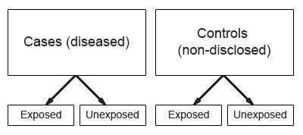 time.

* **Case-control studies:** A case-control study compares people who have a health or illness condition (number of cases with the condition) with those who lack this condition (controls).

**Cohort studies:** is a group of people who share a common experience in a specific time period. Examples are a group of the elderly or the employees of an industry.

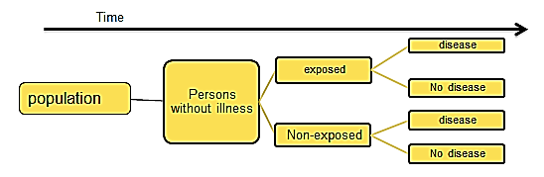

**Experimental Epidemiology**

**Experimental epidemiology** follows and builds on information gathered from descriptive and analytic approaches.

* It is used to study epidemics, the etiology of human disease, the value of preventive and therapeutic measures, and the evaluation of health services . (6)
* In an experimental study, the investigator actually controls or changes the factors suspected of causing the health condition under study, then observes what happens to the health state. In human populations, experimental studies should focus on disease prevention or health promotion rather than testing the causes of disease, which is done primarily on animals.

**Conducting Epidemiologic Research**

**Use the seven-step research process when conducting an epidemiologic study.**

1. Identify the problem.

2. Review the literature.

3. Design the study.

4. Collect the data.

5. Analyze the findings.

6. Develop conclusions and applications.

7. Disseminate the findings.

**Summary**

Epidemiology is the study of the distribution and determinants of health, health conditions, and disease in human population groups. It shares with community health nursing the common focus of the health of populations. It is a specialized form of scientific research that can provide public health professionals with a body of knowledge on which to base their practice and methods for studying new and existing problems. To understand epidemiology, one must first understand some basic epidemiologic concepts: the host, agent, and environment model; causality; immunity; the natural history of disease or health conditions; risk; and prevention strategies.

Community health nurses can use three sources of information when conducting epidemiologic investigations: **existing epidemiologic data**, **informal investigations,** and **carefully designed scientific studies.**

Epidemiology employs three investigative approaches:

descriptive studies, analytic studies, and experimental studies.

Although studies can be either retrospective or prospective, some merely describe existing conditions (descriptive studies) , whereas others seek to explain causes (analytic studies).

(Experimental studies) seek to confirm causal relationships identified in descriptive and analytic studies.

Analytic studies can be of three types: prevalence, case-control, or cohort. In practice, all these types of studies often become combined in various ways.

They also make use of quantitative concepts such as **count**, **prevalence** **rate**, **incidence** **rate**, **mortality rate**, and **morbidity (sickness) rates**.

**Reference**

1. Aschengrau, A., & Seage, G.R. (2008). *Essentials of epidemiology*

*in public health*, 2nd ed. Sudbury, MA: Jones and Bartlett Publishers, P:33.

1. Heymann, D.L. (Ed.). (2004). *Control of communicable diseases manual,* 18th ed. Washington, DC: American Public Health Association.
2. Judith A. Allender, Cherie Rector, Kristine D. Warner. **,** *(2010) Community health nursing : promoting and protecting the public’s health,* 7th ed. *Lippincott Williams & Wilkins*, P: 172- 197.
3. Lawson, A.B., & Williams, F.L.R. (2001). An introductory guide to disease mapping. Chichester, UK: John Wiley & Sons.
4. Theilmann, J., & Cate, F. (2007). A plague of plagues: The problem of plague diagnosis in Medieval England. *Journal of Interdisciplinary* *History, 37*, 371–393.
5. Valanis, B. (1999). *Epidemiology in health care,* 3rd ed. Stamford, CT: Appleton & Lange.