**Experiment No.6**

**IGBT**

**Characteristics and Switch**

**Experiment No.6 IGBT Characteristics and switch**

**Objective :**

To display and study the V-I characteristics of an IGBT on the oscilloscope, and examine its operation as a switch.

**Apparatus used:**

1. ST2712 board. 2. Oscilloscope. 3. Function generator. 4. DC Voltmeter. 5. Diode.

6. LED. 7. Potentiometer 5KΩ(1/4w). 8. Resistances 1KΩ(1/4w) , and 10 Ω(1/2W).

**Theory :**

The **insulated gate bipolar transistor** or **IGBT** is a three-terminal [power semiconductor device](http://en.wikipedia.org/wiki/Power_semiconductor_device), noted for high efficiency and fast switching. It switches electric power in many modern appliances: electric cars, trains, variable speed refrigerators, air-conditioners and even stereo systems with [switching amplifiers](http://en.wikipedia.org/wiki/Switching_amplifier).

In order to combine the low forward voltage drop of the power BJT and the high input impedance of the power MOSFET, the IGBT is invented as a new power device.

The structure of the IGBT is the combination of the P+ layer added to the MOSFET structure. As such, IGBT is easier to drive, and it combines the advantages of MOSFET’s faster switching speed and power BJT’s lower conduction loss. IGBT is a useful device in that it overcomes the shortfall of MOSFET in that it is not suitable for high voltage, high current applications due to its high conduction loss, while IGBT has the advantage over power BJT, which has limitations in high frequency applications due to its switching speed.

Symbol and V-I characteristics of an IGBT is shown in figure (1). Referring to its characteristics The IGBT has the high input impedance and high-speed characteristics of a MOSFET with the conductivity characteristic (low saturation voltage) of a bipolar transistor. The IGBT is turned on by applying a positive voltage between the gate and emitter and, as in the MOSFET, it is turned off by making the gate signal zero or slightly negative. The IGBT has a much lower voltage drop than a MOSFET of similar ratings.

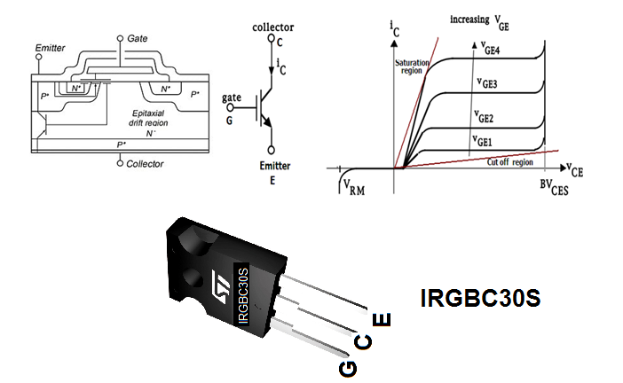

Figure (1) Symbol and characteristics of an N-channel IGBT.

### IGBT as a Switch

IGBTs are commonly used as electronic switches, both for high-power applications such as [switched-mode power supplies](http://en.wikipedia.org/wiki/Switched-mode_power_supply) and for low-power applications such as [logic gates](http://en.wikipedia.org/wiki/Logic_gates).

The circuit of the IGBT as switch is just like that of the BJT as switch.

In any switching circuit, values of input voltage would be chosen such that the output is either completely off, or completely on. The transistor is acting as a switch, and this type of operation is common in [digital circuits](http://en.wikipedia.org/wiki/Digital_circuits) where only "on" and "off" values are relevant.

**PART I. IGBT characteristics.**

**Procedure:**

1. Connect the circuit as shown in figure (3).
2. Set the oscilloscope as follows:

* X-Y mode.
* Channel 1 at 5 V/Div on the collector.
* Channel 2 at 0.1 V/Div.on the emitter.

3.Switch ON the power supply of the board.

4.Vary VGE by using the 5K pot. for the values as shown in table (1) and record IC and VCE for each value. Also display the characteristics on the oscilloscope for each value and plot all the characteristics in the same graph paper.

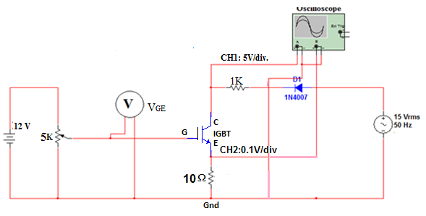

Figure (2) the practical circuit to plot the IGBT characteristics on the oscilloscope.

Table (1) results obtained for a IGBT characteristics

|  |  |  |  |  |  |
| --- | --- | --- | --- | --- | --- |
| Region | Cut Off | Active | | | Saturation |
| VGE(V) | 0 | 5.2 | 5.4 | 5.5 | 5.8 |
| VCE(V) |  |  |  |  |  |
| IC(mA) |  |  |  |  |  |

**PART II. IGBT as a Switch.**

**Procedure:**

1. Connect the circuit diagram as shown in figure (4).
2. Adjust the oscilloscope as follows:

CH1. at 5 V/div. the first state on the o/p1 then on the o/p2.

CH2 at 5 V/div. on the function generator.

Put the selector on the dual mode .

Press chopper .

Put time on the 5 msec/div. with 30 Hz ,

and 0.2 msec/div. with 1KHz .

1. Adjust the duty cycle and the frequency of the square wave for the function generator built in on ST2712 board as shown in the figure for duty cycle of 50%. and frequency of 30 Hz. Note the blanking operation of the LED also sketch the wave forms displayed on the oscilloscope.
2. Vary the frequency of the function generator at 1KHz and display both the input signal (ch.1) and the output signal (ch2). Sketch the signal displayed on the oscilloscope. You can notice the ON-OFF operation clearly.

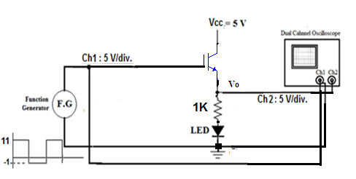

Figure (3) Experiment setup for IGBT as switch.

**Discussion.**

1. Comment on the results ?
2. Compare between the (IGBT,MOSFET & BJT).
3. What is the best Q-point you choose for good amplification?
4. If you have three practical applications, the first with [ high power & low frequency], the second with [low power & high frequency], and the third with [ high power & high frequency], what is the device which you choose with each application, and why ?
5. Find (RCE & Ploss(total)) at each step of the Table(1)?