|  |  |  |
| --- | --- | --- |
| **وزارة التعليم العالي والبحث العلمي**  **كلية المستقبل الجامعة**  **قسم/هندسة تقنيات الحاسوب**  **مختبر/أسس الاتصالات** | | **رمز السجل :**  **تاريخ الإصدار:**  **رقم الإصدار:** |
| **المرحلة : الثانية** |
| **سجل التجارب للعام الدراسي 2023-2024** | | |

**Experiment no. 2**

**HIGH PASS FILTERS**

A High Pass Filter is the exact opposite to the low pass filter circuit as the two components have been interchanged with the filters output signal now being taken from across the resistor

Where as the low pass filter only allowed signals to pass below its cut-off frequency point, ƒc, the passive high pass filter circuit as its name implies, only passes signals above the selected cut-off point, ƒc eliminating any low frequency signals from the waveform. Consider the circuit below.

## The High Pass Filter Circuit

## C:\Users\HP\Desktop\11111111.PNG

## In this circuit arrangement, the reactance of the capacitor is very high at low frequencies so the capacitor acts like an open circuit and blocks any input signals at VIN until the cut-off frequency point ( ƒC ) is reached. Above this cut-off frequency point the reactance of the capacitor has reduced sufficiently as to now act more like a short circuit allowing all of the input signal to pass directly to the output as shown below in the filters response curve.

### Frequency Response of a 1st Order High Pass Filter

## C:\Users\HP\Desktop\111111.PNG

The Bode Plot or Frequency Response Curve above for a passive high pass filter is the exact opposite to that of a low pass filter. Here the signal is attenuated or damped at low frequencies with the output increasing at +20dB/Decade (6dB/Octave) until the frequency reaches the cut-off point ( ƒc ) where again R = Xc. It has a response curve that extends down from infinity to the cut-off frequency, where the output voltage amplitude is 1/√2  = 70.7% of the input signal value or -3dB (20 log (Vout/Vin)) of the input value.

Also we can see that the phase angle ( Φ ) of the output signal LEADS that of the input and is equal to +45o at frequency ƒc. The frequency response curve for this filter implies that the filter can pass all signals out to infinity. However in practice, the filter response does not extend to infinity but is limited by the electrical characteristics of the components used.

The cut-off frequency point for a first order high pass filter can be found using the same equation as that of the low pass filter, but the equation for the phase shift is modified slightly to account for the positive phase angle as shown below.

Cut-off Frequency and Phase Shift

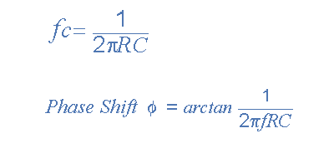

The circuit gain, Av which is given as Vout/Vin (magnitude) and is calculated as:

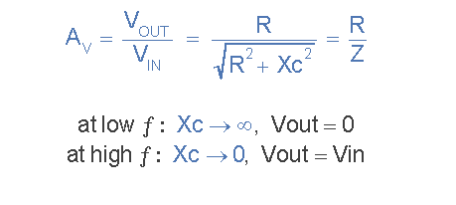

## Second-order High Pass Filter

Again as with low pass filters, high pass filter stages can be cascaded together to form a second order (two-pole) filter as shown.

### Second-order High Pass Filter

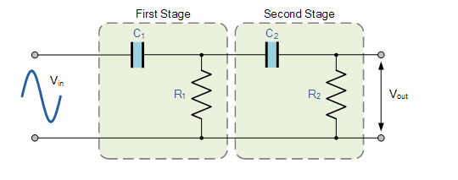

The above circuit uses two first-order filters connected or cascaded together to form a second-order or two-pole high pass network. Then a first-order filter stage can be converted into a second-order type by simply using an additional RC network, the same as for the 2nd-order low pass filter. The resulting second-order high pass filter circuit will have a slope of 40dB/decade (12dB/octave).

As with the low pass filter, the cut-off frequency, ƒc is determined by both the resistors and capacitors as follows.

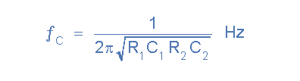

In practice, cascading passive filters together to produce larger-order filters is difficult to implement accurately as the dynamic impedance of each filter order affects its neighboring network. However, to reduce the loading effect we can make the impedance of each following stage 10x the previous stage, so R2 = 10*R1 and C2 = 1/10th of C1.

Inductive Model of a First Order High Pass Filter As the frequency at the input increases, the impedance of the inductor increases. Hence, the low frequency signals pass through the inductor and all the voltage is seen across the output at higher frequencies.

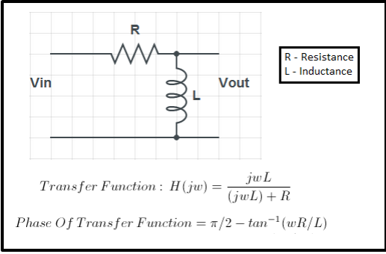

Second Order High Pass Filter A second order high pass filter blocks low pass frequencies more effectively due to the presence of two energy storing elements (capacitor and inductor).

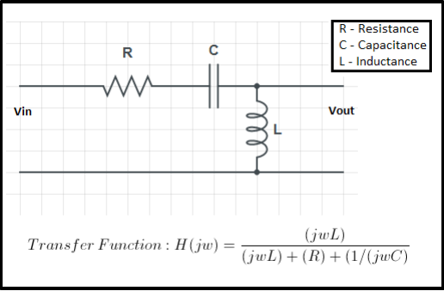

**Discussion:**

1. What are the applications of high pass filters?
2. In a first order high pass filter, frequencies higher than low cut-off frequencies are called ?
3. Determine the voltage Vo at f = 100 kHz and 1 MHz, and compare between them?