

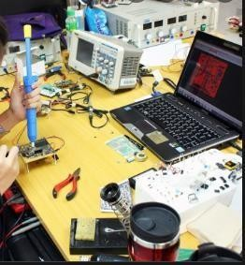

**Workshop**

# (Electronic components)

### For

Students of first class

Department of Electrical Engineering techniques

### By

#### Assistant lecturer ALI IMAD

**1/ Overview**



## 1 –Target population :-

For students of first class

Department of Electrical power techniques

## 2 –Rationale :-

This unit introduces principles of electronic components

## 3 –Central Idea :-

The major topics discussed in this unit are included in the following outline.

* **Battery**
* **Jumper**
* **Fuse**
* **Pushbutton**
* **Switch**
* **Rotary switch**

# 2/ Performance Objectives :-

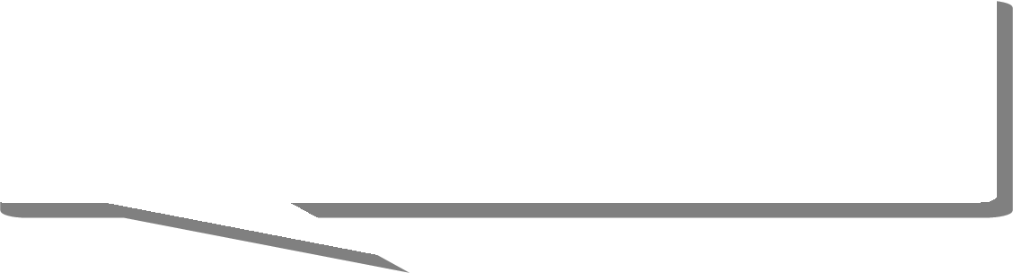

After studying the first modular unit, the student will be able to-

1. Know the principles of electronic components
2. Know how to test the electronic components

# 3/ Pre test :-

Circle the correct answer:-

1. **Protects an electrical circuit or device from excessive current when a metal element inside it melts to create an open circuit.**
   1. fuse
   2. jumper
   3. switch
   4. all above
2. **Contains at least two contacts, which close or open when an external lever or knob is flipped or moved.**

a- switch b- fuse

1. Rotary switch d- all above

# 4/ the text :-

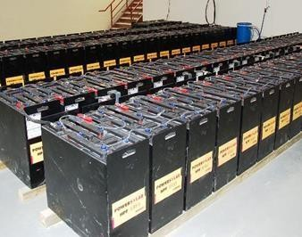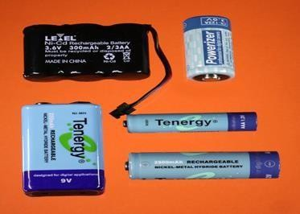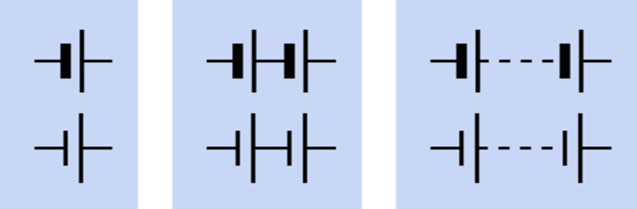

### Electronic components

1. **Battery**

A battery contains one or more electrochemical cells in which chemical reactions create an electrical potential between two immersed terminals. This potential can be discharged as current passing through a load.

The schematic symbols for a battery has shown below

**There are three types of batteries**

**a .Disposable batteries:** properly (but infrequently) referred to as primary cells. They are not reliably rechargeable because their chemical reactions are not easily reversible.

**b .Rechargeable batteries:** properly (but infrequently) known as secondary cells. They can be recharged by applying a voltage between the terminals from an external source such as a battery

charger. The materials used in the battery, and the care with which the battery is maintained, will affect the rate at which chemical degradation of the electrodes gradually occurs as it is recharged repeatedly. Either way, the number of charge/discharge cycles is limited.

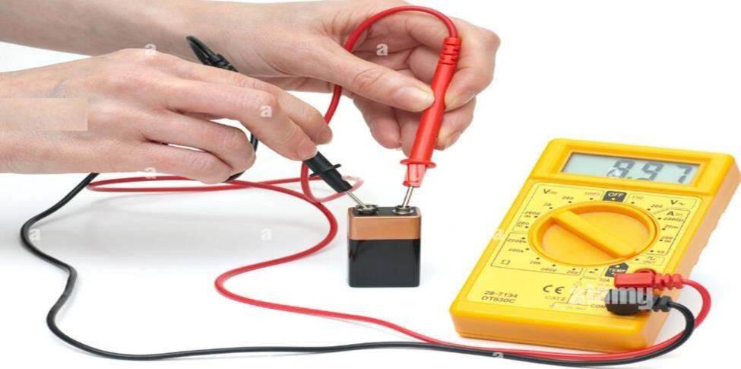

**c .Fuel Cells** require an inflow of a reactive gas such as hydrogen to maintain an electrochemical reaction over a long period.

**Test battery capacity has shown below**

1. **Jumper**

A jumper is a low-cost substitute for a switch, where a connection has to be made (or unmade) only a few times during the lifetime of a product. Typically, it allows a function or feature on a circuit board to be set on a semi-permanent basis, often at the time of manufacture.

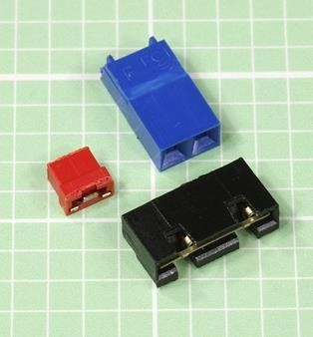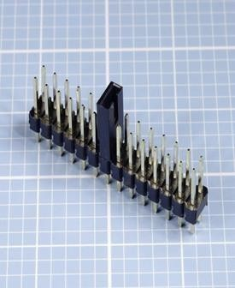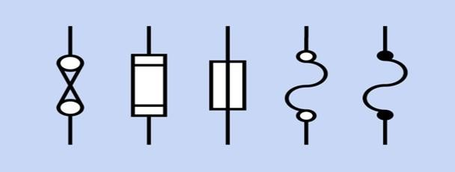

1. **Fuse**

A fuse protects an electrical circuit or device from excessive current when a metal element inside it melts to create an open circuit. With the exception of resettable fuses. A fuse must be discarded and replaced after it has fulfilled its function. When high current melts a fuse, it is said to blow or trip the fuse. A fuse can work with either AC or DC voltage, and can be designed for almost any current. In residential and commercial buildings, circuit breakers have become common, but a large cartridge fuse may still be used to protect the whole system from short-circuits or from overcurrent caused by lightning strikes on exposed power lines. In electronic devices, the power supply is almost always fused.

Alternate schematic symbols for a fuse has shown below

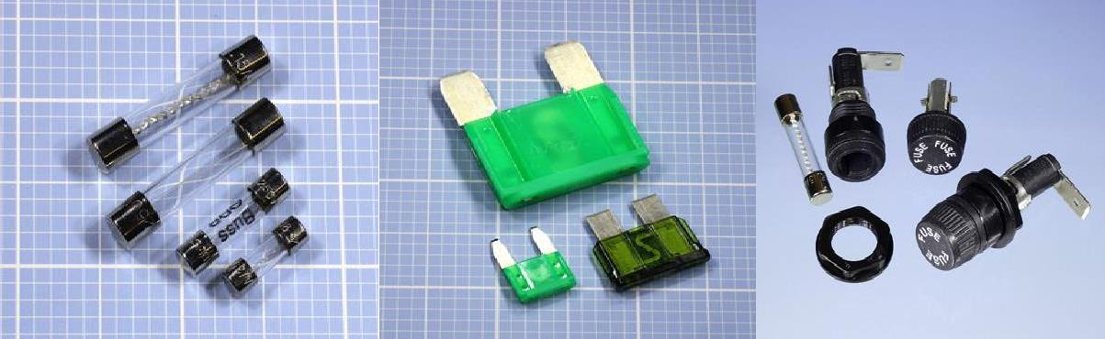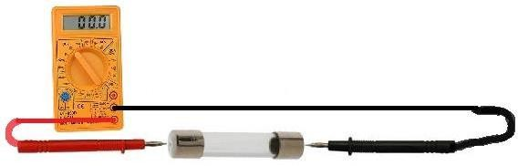

**Test fuse has shown below**

1. **Pushbutton switch**

Often referred to as a pushbutton switch and sometimes as a momentary switch. A pushbutton contains at least two contacts, which close or open when the button is pressed. Usually a spring restores the button to its original position when external pressure is released. Figure below shows schematic symbols for pushbuttons. The symbols that share each blue rectangle are functionally identical. At top is a normally-open single-throw pushbutton. At center is a normally-closed single-throw pushbutton. At bottom is a double-throw pushbutton. Unlike a switch, a basic pushbutton does not have a primary contact that can be identified as the pole. However, a single pushbutton may close or open two separate pairs

of contacts, in which case it can be referred to, a little misleadingly, as a double-pole pushbutton.

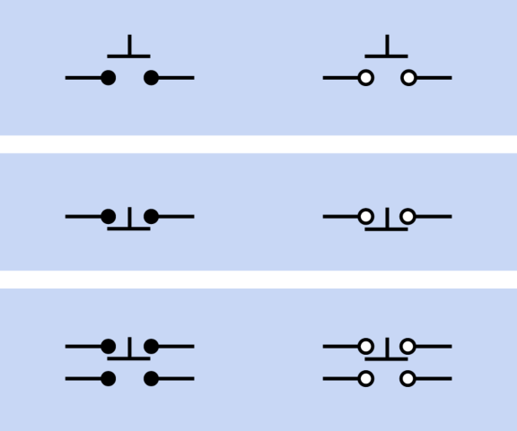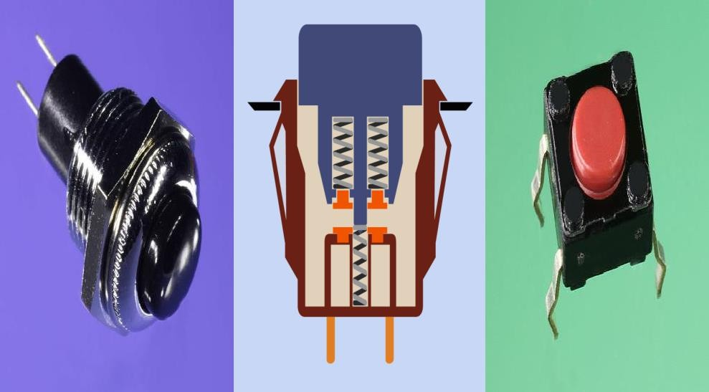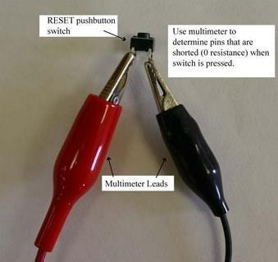

Commonly used schematic symbols to represent a simple pushbutton.

**Test Pushbutton has shown below**

1. **-Switch**

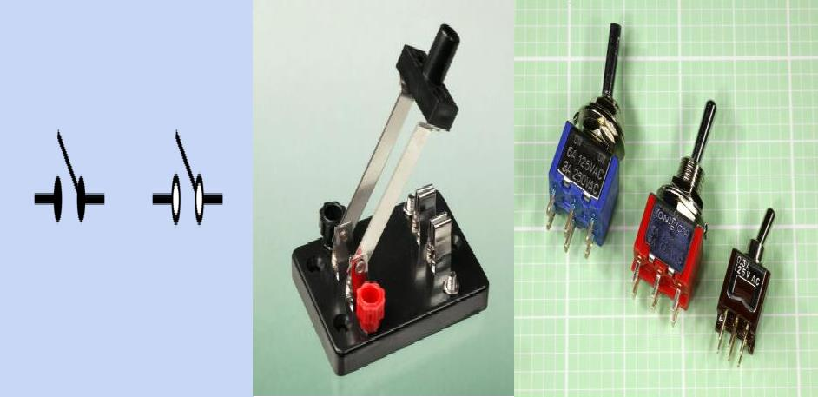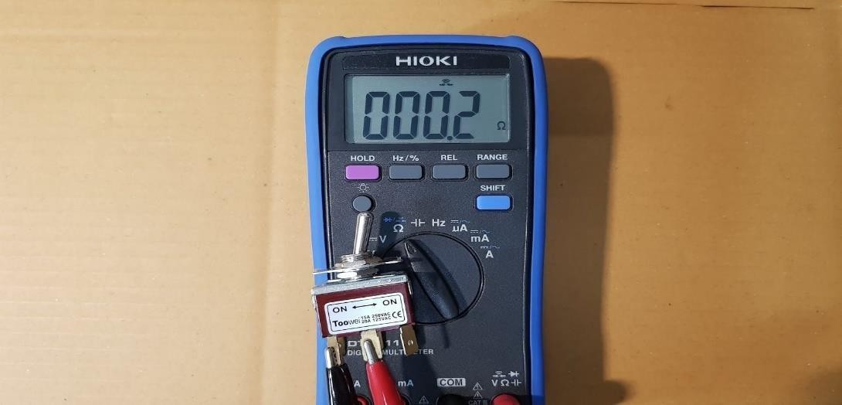

The term switch refers here to a physically operated mechanical switch, controlled by flipping a lever or sliding a knob. Although there is some overlap of function, rotary switches and pushbuttons have their own separate entries. Solid-state switching components are described in entries for bipolar transistor, unijunction transistor, and field-effect transistor.

A switch contains at least two contacts, which close or open when an external lever or knob is flipped or moved. Schematic symbols for the most basic type of on-off switch are shown in Figure below.

**Test Pushbutton has shown below**

### -Rotary switch

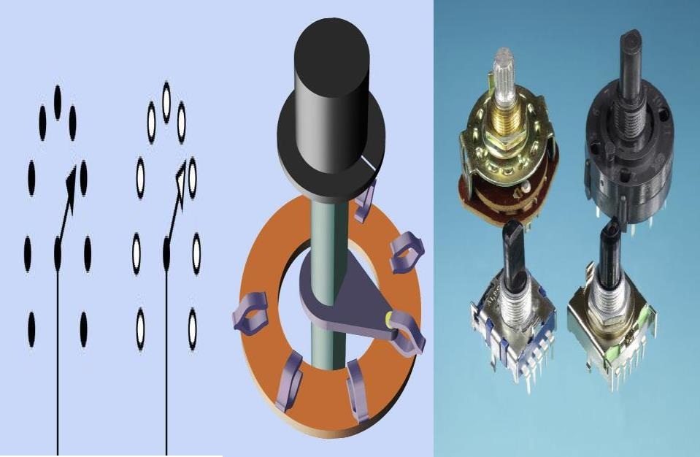

A rotary switch makes an electrical connection between rotors, mounted on a shaft that is turned by a knob, and one of two or more stationary contacts. Traditionally, it was the component of choice to select wavebands on a radio receiver, broadcast channels on a television or inputs on a stereo preamplifier.

# 5/ Post test :-



Circle the correct answer:-

### Makes an electrical connection between rotors, mounted on a shaft that is turned by a knob, and one of two or more stationary contacts.

* 1. Rotary switch
  2. fuse
  3. jumper
  4. All above.

### In electronic devices, the --------------- is almost always fused.

* 1. F.G.
  2. Avo meter.
  3. P.S.
  4. All above



# 7/References :-

1. Encyclopedia of Electronic Components Volume 1 (Charles Platt).