

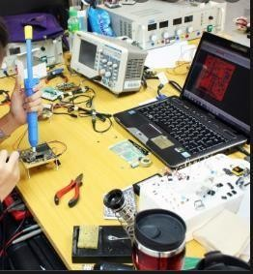

**Workshops**

# (How to use irons, types of soldering used, and how to use absorbent soldering irons)

### For

Students of first class

Department of Electrical Engineering techniques

### By

#### Assistant lecturer

#### ALI IMAD



**1/ Overview**

**1–Target population** :-

For students of first class

Department of Electrical power techniques

## 2 –Rationale :-

This unit introduces principles of how to use irons, types of soldering used, and how to use absorbent soldering irons

## 3 –Central Idea :-

The major topics discussed in this unit are included in the following outline.

#### Soldering iron

* **Solder**
* **Solder pumps**

# 2/ Performance Objectives :-



After studying the first modular unit, the student will be able to-

1. Know how to use Soldering iron
2. Know how to use the soldering
3. Know how to use absorbent soldering irons.
4. Soldering iron training

# 3/ Pre test :-

Circle the correct answer:-

#### A device used for electronic components that needs to be connected to the circuit boards.

* 1. Soldering iron
  2. Solder
  3. Solder pumps
  4. All above

#### A fusible alloy or metal, called

a- Solder pumps b- Soldering iron

1. Solder d- all above

# 4/ the text :-

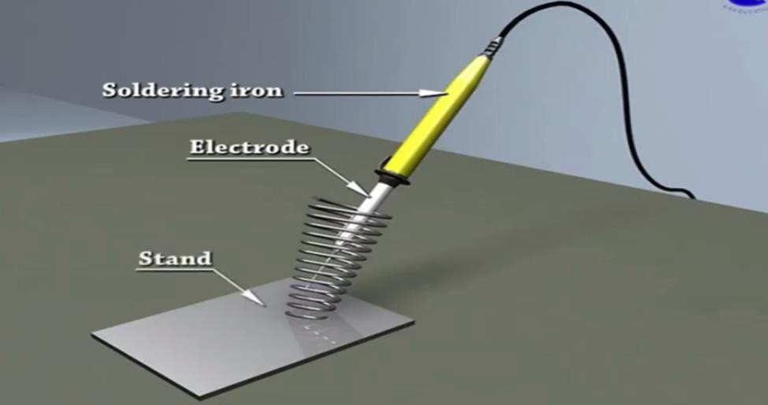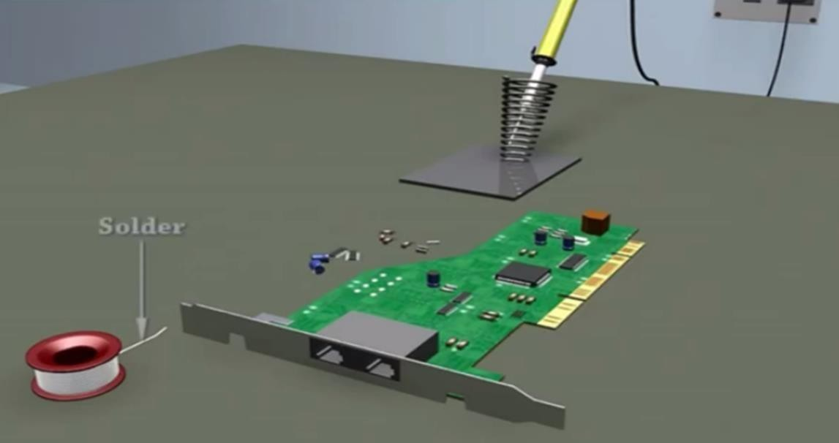

### Soldering iron training

#### Soldering iron

Soldering is mostly required wherever electronic components need to be connected to the circuit boards. Soldering is a method of uniting two or more piece of metal by means of fusible alloy or metal, called solder.

#### Solder

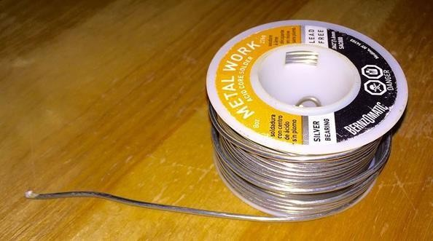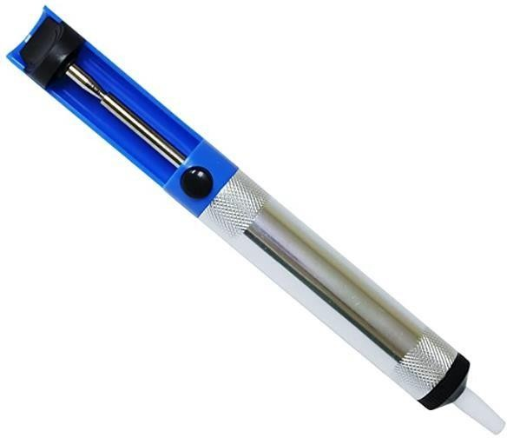

Solder is melted in order to wet the parts of the joint, where it adheres to and connects the pieces after cooling. Metals or alloys suitable for use as solder should have a lower melting point than the pieces to be joined. The solder should also be resistant to oxidative and corrosive effects that would degrade the joint over time. Solder used in making electrical connections also needs to have favorable electrical characteristics.

#### Solder pumps

Solder pumps are used to clean heated, molten solder out of solder joints and contact points. They are best used when removing solder from PCB through-hole solder joints.



# 5/ Post test :-

Circle the correct answer:-

1. **Used to clean heated, molten solder out of solder joints and contact points.**
2. Soldering iron
3. Solder
4. Solder pumps
5. All above

### Solder pumps used when removing solder from PCB through-hole solder joints.

* 1. True.
  2. False.



# 7/References :-

1. Encyclopedia of Electronic Components Volume 1 (Charles Platt).