|  |  |  |
| --- | --- | --- |
| **وزارة التعليم العالي والبحث العلمي**  **كلية المستقبل الجامعة**  **قسم/هندسة تقنيات الحاسوب**  **مختبر/أسس الاتصالات** | | **رمز السجل :**  **تاريخ الإصدار:**  **رقم الإصدار:** |
| **المرحلة : الثانية** |
| **سجل التجارب للعام الدراسي 2023-2024** | | |

**Experiment no. 3**

**Band – Pass Filter (integrator R.C. circuit)**

**OBJECT:**

To establish the pass-band characteristic.

**Apparatus Required**

a) Hardware Tools: Computer system

b) Software Tool: Multisim Program

**THEORY:**

Any combination of passive (R, L, and C) and/or active (transistors or operational amplifiers) elements designed to select or reject a band of frequencies is called a filter. In communication systems, filters are employed to pass those frequencies containing the desired information and to reject the remaining frequencies. In stereo systems, filters can be used to isolate particular bands of frequencies for increased or decreased emphasis by the output acoustical system (amplifier, speaker, etc.). Filters are employed to filter out any unwanted frequencies, commonly called noise, due to the nonlinear characteristics of some electronic Devices or signals picked up from the surrounding medium. In general, there are two classifications of filters: 1. Passive filters are those filters composed of series or parallel combinations of R, L, and C elements.

2. Active filters are filters that employ active devices such as transistors and Operational amplifiers in combination with R, L, and C elements. The analysis of this experiment will be limited to passive filters. All filters belong to the four broad categories of (low-pass, high-pass, pass-band, and stop-band), as depicted in fig. ( 1) For each form there are critical frequencies that define the regions of pass-bands and stop-bands (often called reject bands). Any frequency in the pass-band will pass through to the next stage with at least 70.7% of the maximum output voltage. Recall the use of the 0.707 level to define the bandwidth of a series or parallel resonant circuit (both with the general shape of the pass-band filter).

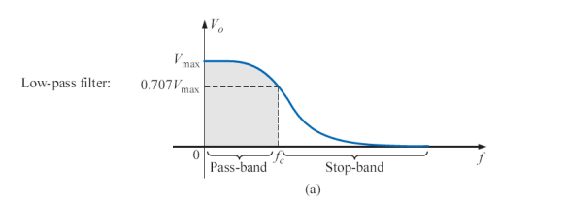

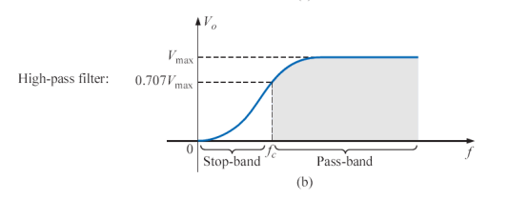

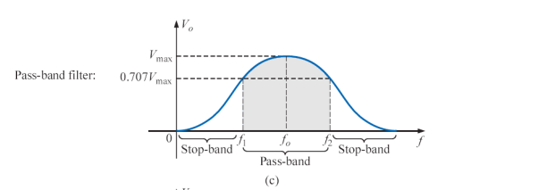

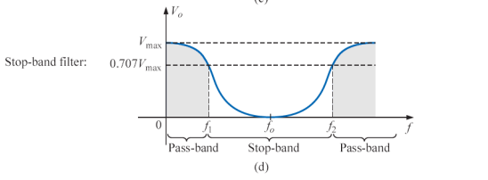

**Fig.1 (Defining the four broad categories of filters.)**

A number of methods are used to establish the pass-band characteristic of Fig. 1(c). One method employs both a low-pass and a high-pass filter in cascade, as shown in Fig.(2)

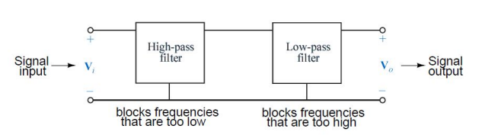

**Fig.(2) Pass-band filter.**

The components are chosen to establish a cutoff frequency for the high-pass filter that is lower than the critical frequency of the low-pass filter, as shown in Fig(3). A frequency f1 may pass through the low-pass filter but have little effect on Vo due to the reject characteristics of the high-pass filter. A frequency f2 may pass through the high-pass filter unmolested but be prohibited from reaching the high-pass filter by the low-pass characteristics. A frequency fo near the center of the pass band will pass through both filters with very little degeneration.

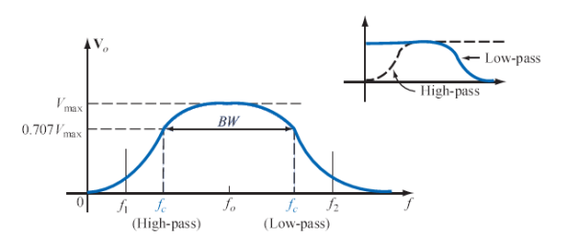

**Fig.(3) Pass-band characteristics.**

The network of fig (4) will generate the characteristics of Fig. (3). However, for a circuit such as the one shown in Fig.( 4), there is a loading between stages at each frequency that will affect the level of Vo. Through proper design, the level of Vo may be very near the level of Vi in the pass-band, but it will never equal it exactly. In addition, as the critical frequencies (f C) of each filter get closer and closer Together to increase the quality factor of the response curve, the peak values within the pass-band will continue to drop. For cases where Vo max ≠ Vi max the bandwidth is defined at 0.707 of the resulting Vo max.

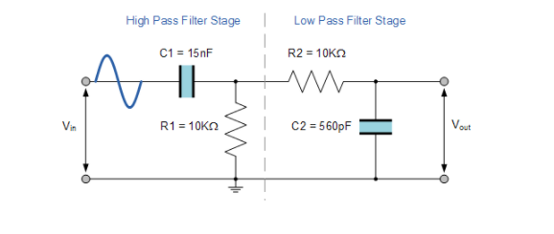

**Definitions:**

**Filter** Networks designed to either pass or reject the transfer of signals at certain frequencies to a load.

**Active filter** a filter that employs active devices such as transistors or operational amplifiers in combination with R, L, and C elements.

**High-pass filter** a filter designed to pass high frequencies and reject low frequencies.

**Low-pass filter** a filter designed to pass low frequencies and reject high frequencies.

**Pass-band (band-pass) filter** a network designed to pass signals within a particular frequency range. Band-pass filters can also be constructed using inductors, but as mentioned before, the reactive "purity" of capacitors gives them a design advantage. If we were to design a band -pass filter using inductors, it might look something like this fig(4):

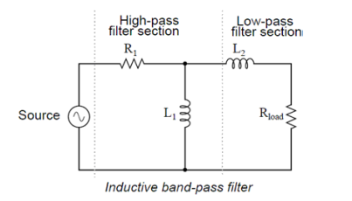

**fig (4)**

**Band Pass Filter Applications**

The application of band pass filter is as follows,

* Band pass filters are widely used in audio amplifier circuits. For example, the speaker is used to play only a desired range of frequencies and ignore the rest of the frequencies.
* It is used optics like [LASER](https://www.electrical4u.com/laser-types-and-components-of-laser/), LIDARS, etc.
* These filters are used in a communication system for choosing the signals with a particular bandwidth.
* It is used in audio signal processing.
* It is also used to optimize the signal to noise ratio and sensitivity of the receiver.

**Frequency Response of a 2nd Order Band Pass Filter:**

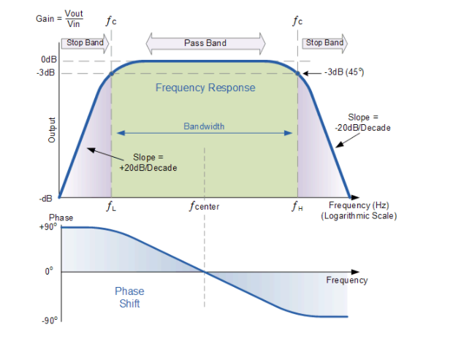

The Bode Plot or frequency response curve above shows the characteristics of the band pass filter. Here the signal is attenuated at low frequencies with the output increasing at a slope of +20dB/Decade (6dB/Octave) until the frequency reaches the “lower cut-off” point ƒL. At this frequency the output voltage is again 1/√2 = 70.7% of the input signal value or -3dB (20*log(VOUT/VIN)) of the input.

The output continues at maximum gain until it reaches the “upper cut-off” point ƒH where the output decreases at a rate of -20dB/Decade (6dB/Octave) attenuating any high frequency signals. The point of maximum output gain is generally the geometric mean of the two -3dB value between the lower and upper cut-off points and is called the “Centre Frequency” or “Resonant Peak” value ƒr. This geometric mean value is calculated as being ƒr2 = ƒ(UPPER) x ƒ(LOWER).

A band pass filter is regarded as a second-order (two-pole) type filter because it has “two” reactive components within its circuit structure, then the phase angle will be twice that of the previously seen first-order filters, ie, 180o. The phase angle of the output signal LEADS that of the input by +90o up to the centre or resonant frequency, ƒr point were it becomes “zero” degrees (0o) or “in-phase” and then changes to LAG the input by -90o as the output frequency increases.

The upper and lower cut-off frequency points for a band pass filter can be found using the same formula as that for both the low and high pass filters, For example.

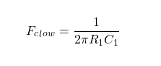

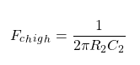

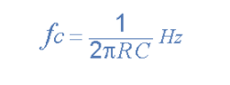

### Centre Frequency Equation :

* Where, ƒr is the resonant or centre frequency
* ƒL is the lower -3dB cut-off frequency point
* ƒH is the upper -3db cut-off frequency point

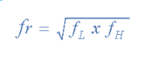



**PROCEDURE**

1-Connect the cct. Shown in fig. (5):  
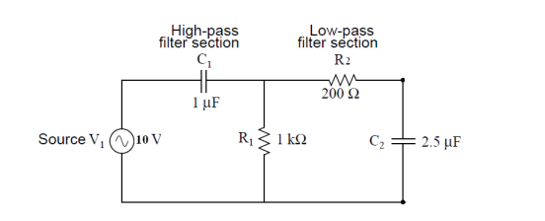

**Fig.(5) Capacitive band-pass filter**

1. Change the frequency and measure Vo for every setting of (f). Tabulate your result as in table (1)

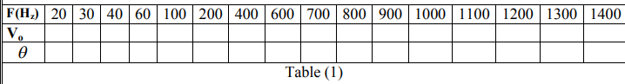

**REQUERMENTS:**

1. Draw a graph between the gain (Vo) versus frequency, find (fc) and Compare it with theoretical value. from the graph find f1 & f2 & B.W.
2. Draw a graph between (θ ) and (f).

**DISCUSSION:**

1. compare between the theoretical &experimental results
2. write some of application of band pass filter
3. For the pass-band filter of Fig. (6)

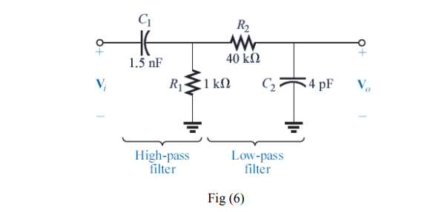

a. Determine the critical frequencies for the low- and high-pass filters

b. Using only the critical frequencies, sketch the response characteristics

c. Determine the actual value of Vo at the high-pass critical frequency calculated in part (a), and compare it to the level that will define the upper frequency for the Pass-band.