 

BONE

Prof. Dr.Muna Merza

Lecture 11

**Bone**

Bone is a living tissue, which makes up the body skeleton and is one of the hardest structures of the body.

**Function of bone**

1. It provides shape and support for the body.

2. It provides site of attachment for tendons and muscles.

3. It protects the vital organs of the body.

4. Bone serves as a storage site for minerals.

5. It provides the marrow for the development and storage of blood cells.

**CLASSIFICATION OF BONES**

1. **Mature bone which is classified into**

A. compact bone (cortical bone) consists of tightly, packed osteons or haversian systems, forming a solid mass ,it is also called lamellar bone

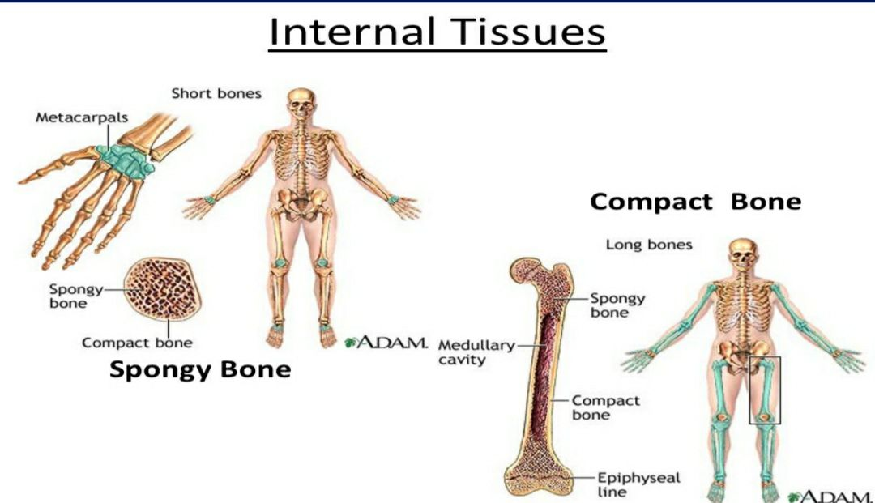

**B.Cancellous bone (spongy bone)** has ahoneycomb appearance, with large marrow cavities and sheets of trabeculae of bone in the form of bars and plates.

**2.Woven or immature bone** is the first formed bone with irregularly oriented collagen fibers of varying diameters. This type of bone is not usually seen after birth.

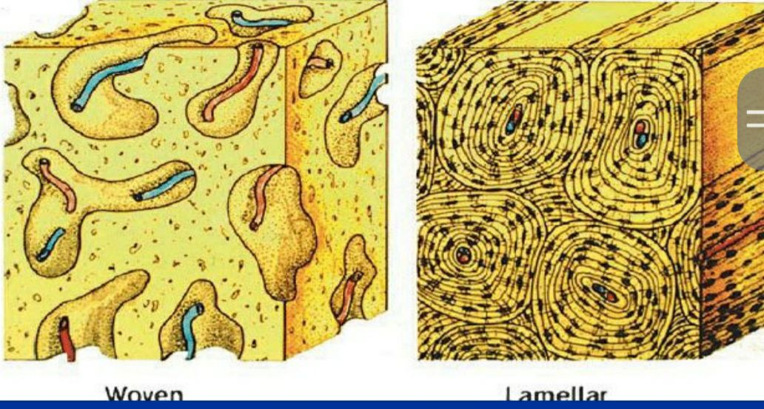

**COMPOSITION OF BONE**

Bone is a connective tissue composed of cells , fibers and ground substance. The intercellular substance of bone consists of organic and inorganic substances. The inorganic part of bone ( 2/3) is made of bone minerals which is composed of hydroxyapatite crystals, with carbonate content and low Ca/P ratio than the pure hydroxyapatite.

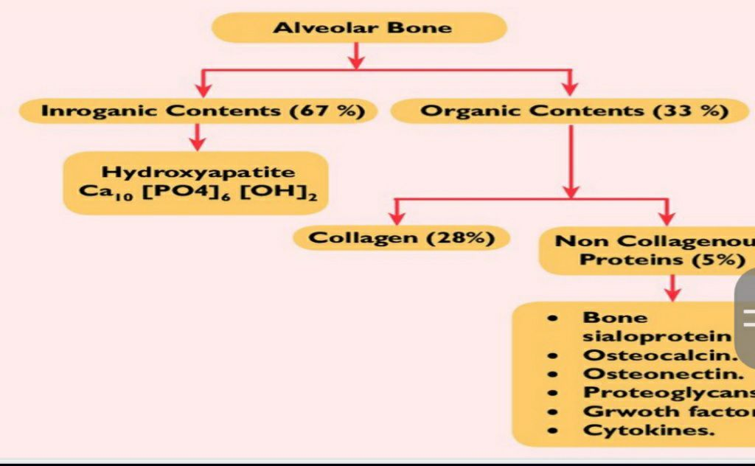

The organic matrix ( 1/3) is known as osteoid and is made up of collagen and non collagenous proteins.

Collagen is the major organic component in mineralized bone tissues.

**BONE HISTOLOGY**

*Osteoid* is an unmineralized bone matrix on the surface, where active bone formation is taking place. It is produced by osteoblast but not yet calcified to form bone.

All mature bones have a dense outer sheet of *compact bone* and a central medullary cavity. The cavity is filled with red or yellow bone marrow in living bone.

**PERIOSTEUM**

The outer aspect of compact bone is surrounded by a condensed fibrocollagen

layer, the periosteum which has two layers:

*1.outer layer* which is a dense, irregular connective tissue termed fibrous layer

2. *inner* osteogenic layer, next to the bone surface consisting of bone cells, their precursors and a rich vascular supply.

The periosteum is active during fetal development. It is also important in the repair of fractures.

The inner surfaces of compact and cancellous bone are covered by a thin cellular layer called **endosteum.**

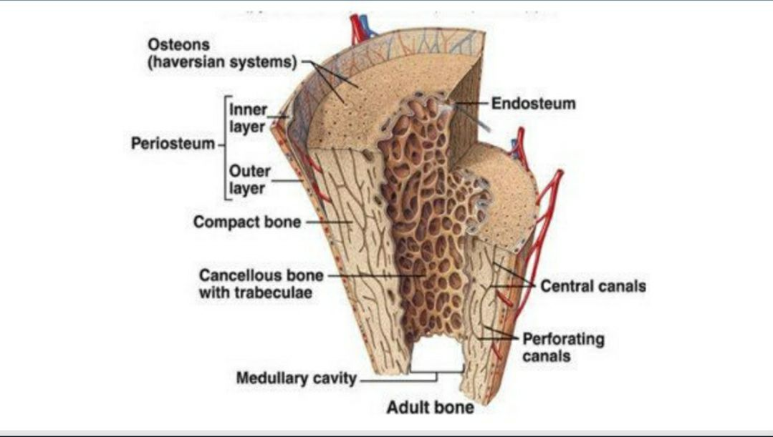

Spongy bone and compact bone have the same cells and intercellular matrix, but differ in the **arrangement of components**.

The bony substance consists of large slender spicules called ***trabeculae***.

**BONE CELLS**

Osteoblasts ; Osteoblasts are mononucleated basophilic, cuboidal or slightly flattened cells found on the forming surfaces of growing or remodeling bone, responsible for the synthesis and secretion of organic constituents of bone matrix and the regulation of bone remodeling and mineral metabolism.

**Osteocytes**

Osteoblasts produce the extracellular matrix, osteoid. As the osteoblasts form the bone matrix, they get entrapped within the matrix they secrete, and are called *osteocytes*.

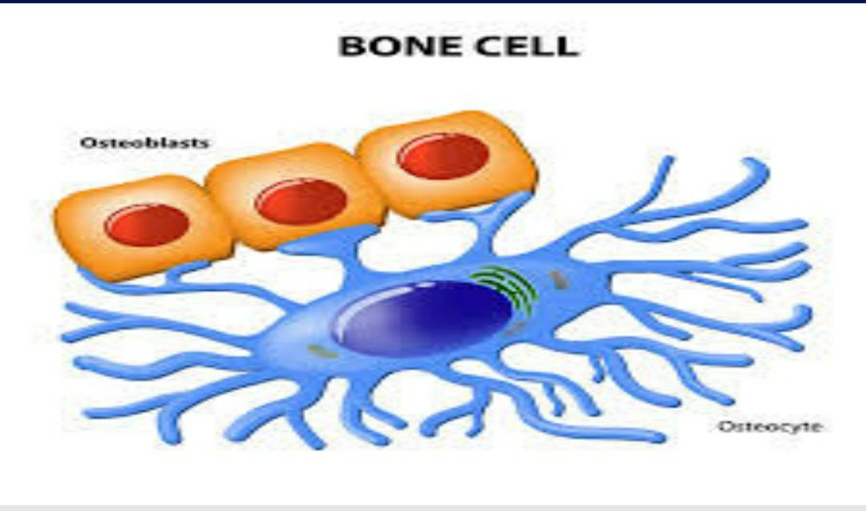

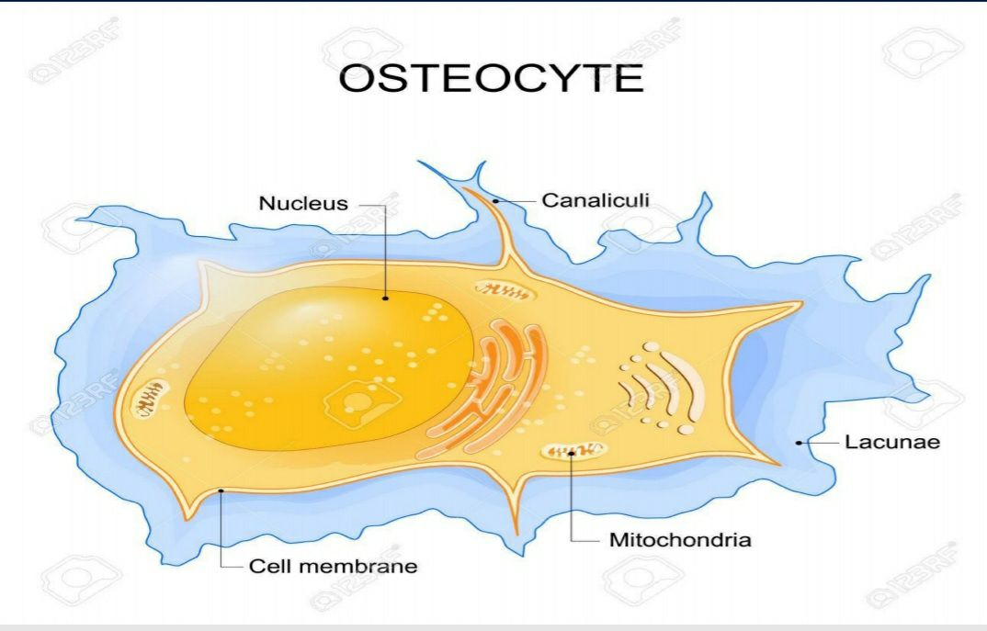

Within the bone matrix, the osteocyte reduces in size, creating a space around it, called the *osteocytic lacuna*. Narrow extensions of these lacunae form channels called *canaliculi*. *Osteocytic processes* are present within these canaliculi.

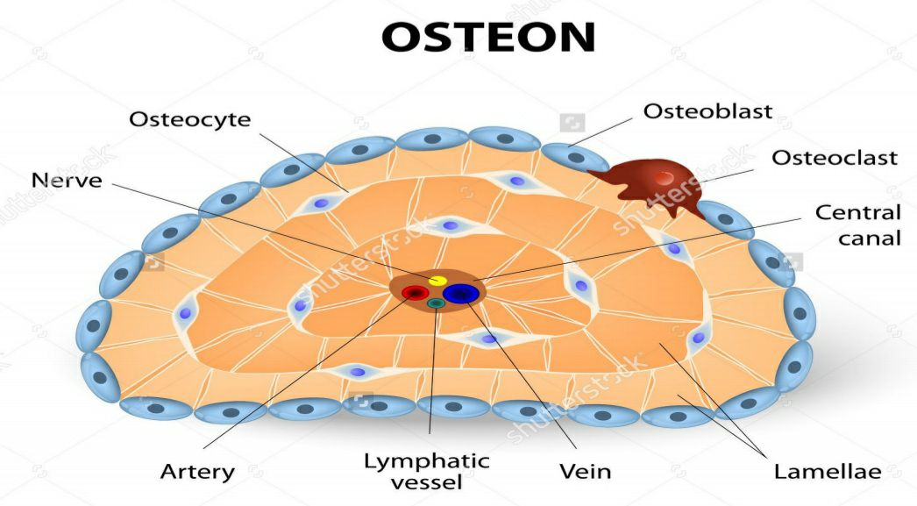

The canaliculi penetrate the bone matrix and permit diffusion of nutrients, gases and waste products between osteocytes and blood vessels. Failure of the interconnecting system between osteocytes and osteoblasts leads to sclerosis and death of bone.

**Osteoclast:** Is a large multinucleated cell approximately 40–100 Mm in diameter and may have as many as 200 nuclei, although most have only 5 to 20

responsible for the dissolution and absorption of bone. Bone is a dynamic tissue that is continuously being broken down and restructured in response to such influences as structural stress and the body’s requirement for calcium.

