**Indole Alkaloids**

*Harmala Alkaloids*

**Peganum harmala**  of the family Zygophyllaceae.

It is a woody, perennial, succulent shrub native to arid regions. The leaves are bright green, finely divided and about 1 cm long. Both the roots and seeds

contain significant quantities of Beta- carbolines (indole) alkaloids, which are absent in the rest of the plant.

***The Traditional and Medical Uses:***

The traditional uses including as ***the dye "turkey red",*** and as ***incense*** from ancient times.

**Peganum harmala** was claimed to be an important medical plant. Its seeds were known to possess hypothermic and essentially hallucinogenic properties since it is MAO inhibitor agent .

Various authors have under taken studies on the antibacterial, anti fungal and antiviral effects of **Peganum harmala** seeds. In Moroccan traditional medicine , seed powder is sometimes used on skin and subcutaneous tumors.

This work was designed to investigate some aspects of the anti neoplastic properties of **Peganum harmala** in that the active principle at a dose of 50 mg / kg given orally to mice for 40 days was found to have significant anti tumor activity. **Peganum harmala** alkaloids thus posses significant anti tumor potential, which could prove useful as novel anticancer therapy. The pharmacologically active compounds of  **Peganum harmala** are several alkaloids ,which are found especially in the seeds (2-7% total) and the roots.

These include beta-carbolines such as: **harmaine** , **harmaline** and **Harman**.

**Peganum harmala** also contains the quinazoline derivatives **vasicine** and **vasicinone.** It is believed that these quinazoline alkaloids are responsible for the abortifacient activity of **Peganum harmala** extracts. It has been reported that these chemicals have a uterine stimulatory effect, apparently through the release of prostaglandin. **Peganum harmala** alkaloids are characterized by the fluorescence property.

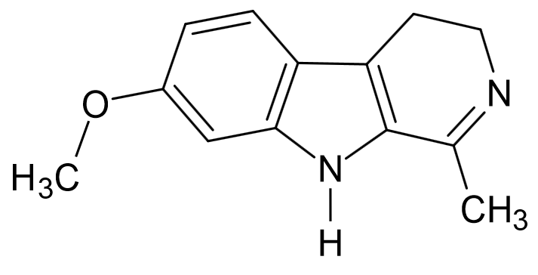 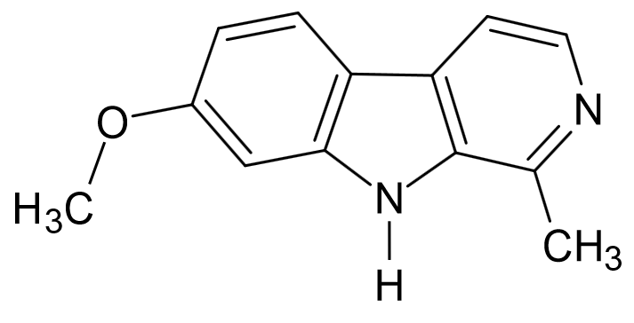

Harmaline Harmine

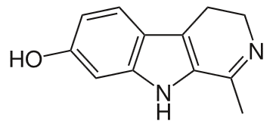

Harmalol

**Isolation of The Harmala Alkaloids:**

***Extraction:***

***Aim***: to isolate the Harmala Alkaloids.

***Equipments:***

* *Large beaker.*
* *Small conical flask.*
* *Reflux apparatus.*
* *Separatory funnel.*
* *Water bath.*
* *Litmus paper.*
* *Funnel.*
* *Filter paper.*

***Reagents:***

* *Petroleum ether.*
* *90 % Ethanol.*
* *Ammonium hydroxide solution.*
* *2%HCl.*
* *Chloroform.*
* *Methanol.*

***Procedure:***

***Method of extraction:*** Reflux.

***Plant used***: Peganum harmala

***Part used***: Seeds.

Maceration ***50 gm*** of the harmala seeds in ***500 ml*** of ***petroleum ether*** for **24 hrs (over night).**

Filter

Reflux with **90% *ethanol*** for **1 hr**.

Cool & Filter

Take ***20 ml*** of Extract in conical flask

Evaporate the filterate on water bath to about ***2 ml***

Add

***5ml*** of ***2% HCl***

(Filter if necessary**.)**

Partition with ***Chloroform*** (***10 ml*** x 2), take the acidic layer (upper layer)

Add

***Ammonium hydroxide*** solution (check by litmus paper)

Place the basic solution in the separatory funnel

Add

[***10 ml*** of ***Chloroform***] two times

(Shake & stand)

Take the organic lower layer and put it in the conical flask

Add

Small amount of ***Anhydrous sodium Sulphate*** & allow standing for few minutes untilget a clear solution , decant and concentrate by evaporation to give the product crude alkaloids.

***Identification of Harmala Alkaloids***

***Quantitative Analysis:***

By weighing the residue obtained.

***Qualitative Analysis:***

***The General Chemical Tests :***

The same as for other alkaloids.

The Identification of Harmala Alkaloids By Chromatography :

* By the use of thin layer chromatography **(T.L.C)**
* The stationary phase = *Silica gel GF254****.***
* The mobile phase = ***Chloroform : Methanol: Acetone (35:15:10)***

*Or*  ***Chloroform: Methanol: 10% Ammonium hydroxide (80:20:15).***

* The standard compound = any harmala alkaloids.
* The spray reagent = ***Dragendorff's reagent.***
* Mechanism of separation = *Adsorption*.
* Developing = *Ascending****.***
* ***Other mobile phases :***

***Chloroform: Acetone: Diethyl amine (50:40:10),***

***Chloroform: Diethyl amine (90:10).***

* **UV**instrument***.***

***Procedure:***

1. Prepare mobile phase, and place it in the glass jar.
2. Cover the jar with glass lid and allow standing for ***45 minutes*** before use.
3. Apply the sample and the standard spots on the silica gel plates, on the base line by the use of capillary tube.
4. Put the silica gel plate in the glass jar and allow the mobile phase to rise to about *two-third* the plate.
5. Remove the plate from the jar, dry and identified first by U.V. 254 ,366 nm**.**
6. Spray the plate with spraying reagent ***(Dragendorff's reagent)*** and then calculate the Rf values.

***Results:***

Fluorescence spot appears under the U.V. while an orange spots are seen when sprayed with the sprayer.

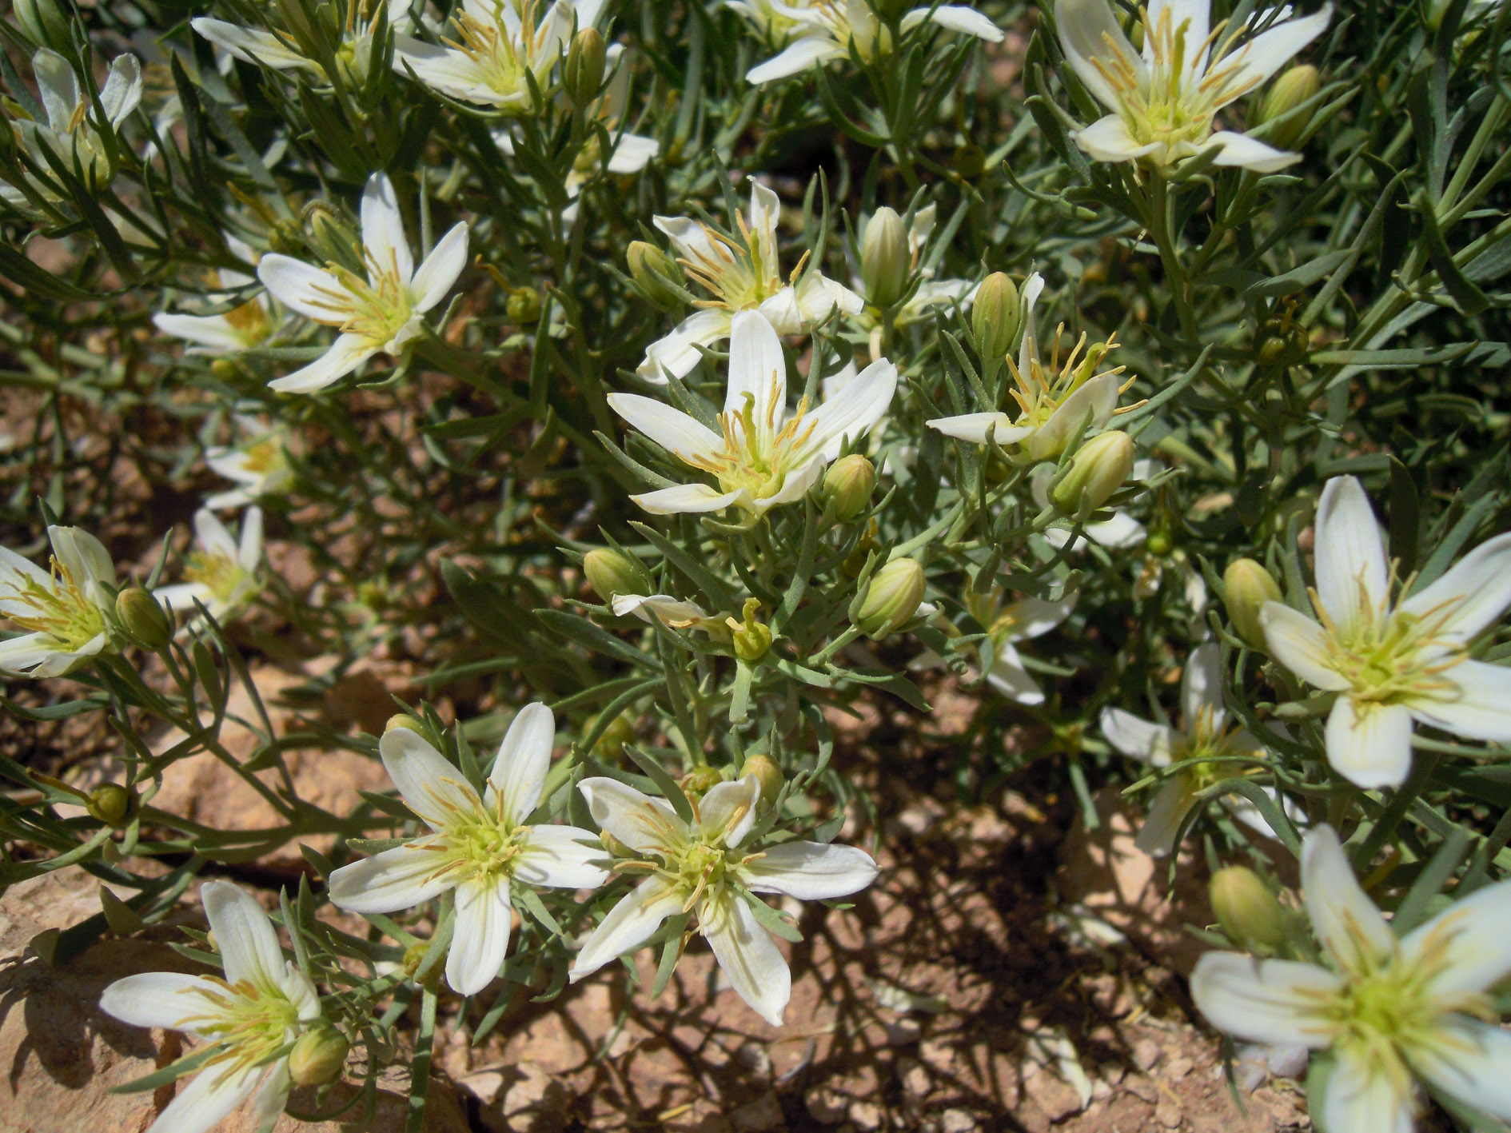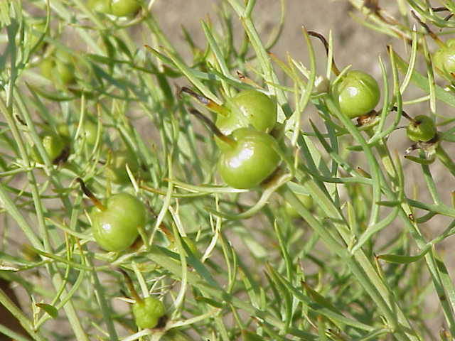[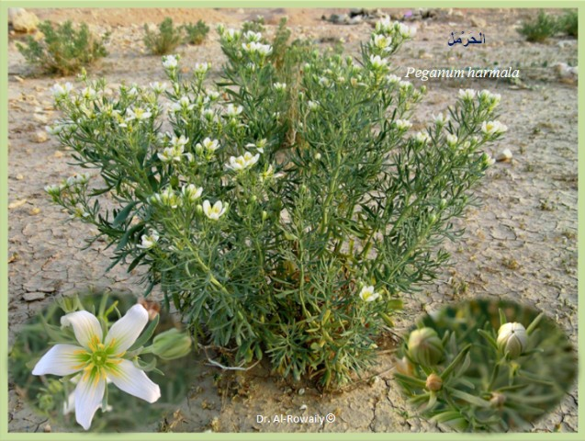](http://faculty.ksu.edu.sa/Al-Rowaily/Pictures%20Library/Rangeland%20Flora%20نباتات%20المراعي/Peganum%20harmala.bmp)