**Class: 2nd stage**

**Subject: Materials Science lab**

**Ministry of Higher Education and Scientific**

**Research**

**Al-Mustaqbal University College**

**Chemical engineering and petroleum industries**

**(Materials Science lab)**

**Experiment No.3**

**(Bending test)**

**Prepared by**

**Eng. Fatima Oday**

**Eng.Zainab Imad**

**Eng.Zainab Jwad**

**Class: 2nd stage**

**Subject: Materials Science lab**

**Aim of the experiment:**

-To study the behavior of materials subjected to loads to determine its mechanical properites.

- Calculate bending stress and draw a graph of bending stress σ vs deflection

**Theory:**

A **bending test** is a method of testing materials for their bending strength and other important properties by applying force to the specimen and seeing how it reacts under pressure. Typically, the bend test measures [**ductility**,](https://www.infobloom.com/what-is-ductility.htm) the ability of a material to change form under pressure and keep that form permanently. In certain cases the bending test can determine tensile strength. When using the bend test for this purpose, testers examine which side of the material breaks first to see what type of strength the material has. It also lets them know what kinds of pressure it holds up against and what kinds it doesn't.

**Ductility** describes how well a material, usually metal, can be stretched and keep itsnew shape. Steel, for example, is highly ductile. If pressure is applied that stretches the steel into a new shape, it will keep this shape even after the pressure has been removed. This characteristic is referred to as ductility and is a desirable characteristic for metals and other building materials.

To determine how ductile a material is, a bending test is used. Force is applied to a piece of the material at a specific angle and for a specific amount of time. The material is then bent to a certain diameter using force. After the bending test is over, the material is examined to see how well it held its shape once the pressure was removed, and whether or not the material cracked when pressure was applied.

**Class: 2nd stage**

**Subject: Materials Science lab**

**There are two common ways of bending test 3-point bending test**

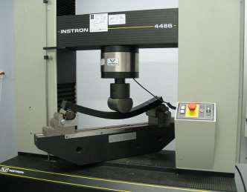

The 3-point description comes from the two points of support at the ends of the material and the one point of deflection brought down to the middle of the material. 3-Point bending involves placing the material across a span supported on either ends of the material and bringing down a point source to the center of the span and bending the material until failure while recording applied force and crosshead displacement

**4-point bending test**

4-point bending tests are conducted similarly to 3-point bending tests except that rather than one point source being brought down to the center of the span of material two points slightly separated from the center of the material are brought down in contact with the material. This separation of the two point sources spreads the region of bending out from the center such that a larger portion of the material is tested than with only one point of deflection.

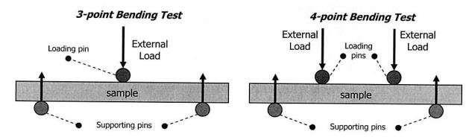

**Class: 2nd stage**

**Subject: Materials Science lab**

**Procedure:**

1- Measure the dimensions of the specimen ( beam) (height, width and length)

2- Put the specimen on the supports of the bending test machine

3- Start the loading process and note down the deflection and then calculate the bending stress

4- Repeat the process for other loadings

**Calculations**

**Bending stress :** is the stress that an object encounters when it is subjected to alarge load at a particular point that causes the object to bend and become fatigued.

* =  ×  …… (1)

**Bending moment**: a bending moment is a measure of the bending effect due toforces acting on a beam. It is measured in terms of force and distance.

|  |  |  |  |
| --- | --- | --- | --- |
| = | × | ……… (2) |  |
| 2 |  |
|  |  |  |

**Neutral axis (y):** the line in a beam or other member subjected to a bending actionin which the fibers are neither stretched nor compressed or where the longitudinal stress is zero.

= ℎ2 ………(3)

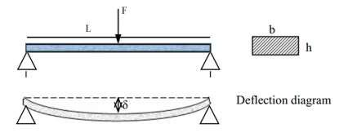

**Class: 2nd stage**

**Subject: Materials Science lab**

**Second moment of area (moment of inertia) (I):** The second moment of area is ameasure of the 'efficiency' of a shape to resist bending caused by loading.

=  ℎ3 …....(4)

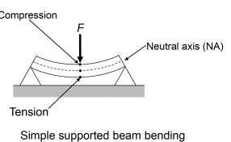

12

1. bending moment (N.m) h: height of beam = 2 cm b: width of beam = 6 cm
2. length of beam =40 cm
3. force (N)
4. second moment of area (m4)

**Discussion:**

1- What is bending test?

2- What is bending stress?

3- What does the bending test measure?

4- Describe briefly the 3-point bending test

**Class: 2nd stage**

**Subject: Materials Science lab**

|  |  |
| --- | --- |
| F(N) | (mm) |
|  |  |
| 1000 | 1.8 |
|  |  |
| 1500 | 2.1 |
|  |  |
| 2000 | 4.5 |
|  |  |

Use the force info to calculate the following:

=  × 2

ℎ

= 2

ℎ3

= 12

L= 40 cm

b = 6 cm

h = 2 cm

Then put the values you got in the following equation to calculate bending stress

* =  ×

Then draw a graph between σ vs.