**Class: 2nd stage**

**Subject: Materials Science lab**

**Ministry of Higher Education and Scientific Research Al-Mustaqbal University College**

**Chemical engineering and petroleum industries**

**(Materials Science lab)**

**Experiment No.2**

**(Hardness test)**

**Prepared by**

**Eng. Fatima Oday**

Eng. zainab Imad

Eng.zainab jwad

**Class: 2nd stage**

**Subject: Materials Science lab**

**Aim of the experiment**

To determine the Brinell hardness number of the given test specimen.

**Theory**

**Hardness** is a measure of how much a material resists changes in shape. Hardthings resist pressure. Hardness ranges from super hard materials such as diamond, boron-carbide to other ceramics and hard metals to soft metals and down to plastics and soft tissues.

The type of deformation under consideration when measuring hardness is plastic deformation. In other words, the object or material will not return to its original shape after being deformed, unlike elastic deformation.

The application of hardness testing enables you to evaluate a material’s properties, such as strength, ductility and wear resistance, and so helps you determine whether the material is suitable for the purpose you require.

**Brinell hardness test**

Brinell Hardness Testing is a testing method that determines the hardness of a metal by measuring the size of an indentation left by an indenter. At a defined ball diameter and test force, larger indents left in the surface by the Brinell Hardness Testing Machine indicate a softer material. The indenter on a Brinell Hardness Testing machine is spherical and leaves a rounded indent on the tested material. The indenter is usually made of tungsten carbide.

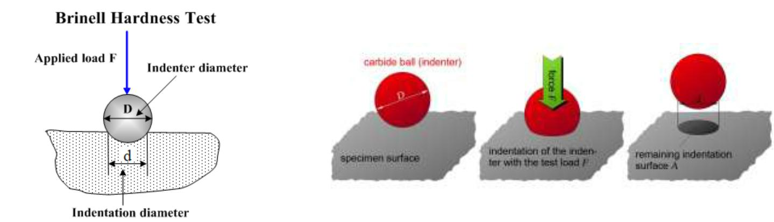

**Class: 2nd stage**

**Subject: Materials Science lab**

The Brinell hardness number (BHN) can be calculated from the following equation:

=

2

[ − √ 2 − 2]

BHN: Brinell hardness number (kgf/mm2)

1. Applied load in kilogram-force (kgf
2. Dimeter of indenter (mm) d: Dimeter of indentation (mm)

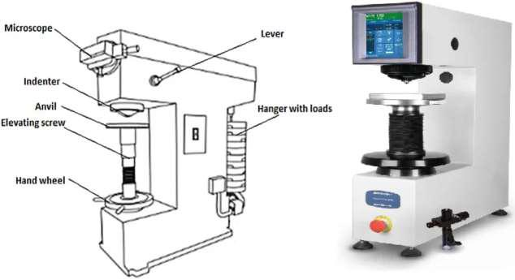

**Apparatus**:

Brinell hardness machine, test specimen. Brinell Microscope

**Class: 2nd stage**

**Subject: Materials Science lab**

**Procedure:**

1. Select the proper size of the ball and load to suit the material under test
2. Clean the test specimen to be free from any dirt and defects or blemishes.
3. Mount the test piece surface at right angles to the axis of the ball indenter plunger.
4. Turn the platform so that the bal is lifted up.
5. By shifting the lever apply the load and wait for some time.
6. Release the load by shifting the lever.
7. Take out the specimen and measure the diameter of indentation by means of the Brinell microscope.

**Discussion:**

1- What is hardness?

2- What is the type of deformation that occurs when measuring the hardness test?

3- What are the material’s properties that you evaluate from the application of hardness test?