**Class: 2nd stage**

**Subject: Materials Science lab**

**Ministry of Higher Education and Scientific Research Al-Mustaqbal University College**

**Chemical engineering and petroleum industries**

**(Materials Science lab)**

**Experiment No.4**

**(Creep test)**

**Prepared by**

***Eng. Fatima Oday***

***Eng.Rusul Ahmed***

**Class: 2nd stage**

**Subject: Materials Science lab**

**Aim of the experiment:** to study the mechanical behavior of materials duringcreep test

**Theory:**

**Creep** is the tendency of a solid material to deform permanently under theinfluence of persistent thermal and mechanical loads over time.

Creep is a type of deformation that is important and experienced in a wide range of industries ranging from nuclear power plants, jet engines and even heat exchangers.

Temperature has important effects on deformation phenomena. Microstructural defect rearrangements are often accelerated at high temperatures. Since these processes tend to soften the material, they counteract the strain hardening produced by plastic deformation.

There are three main stages of creep:

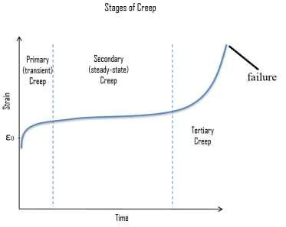

* **Primary Creep**: starts at a rapid rateand slows with time.
* **Secondary Creep**: has a relativelyuniform rate.
* **Tertiary Creep**: has an acceleratedcreep rate and terminates when the material breaks or ruptures. It is associated with both necking and formation of grain boundary voids.

**Class: 2nd stage**

**Subject: Materials Science lab**

Creep testing is conducted using a tensile specimen to which a constant stress is applied at a constant temperature, often by the simple method of suspending weights from it. The test is recorded on a graph of strain versus time.

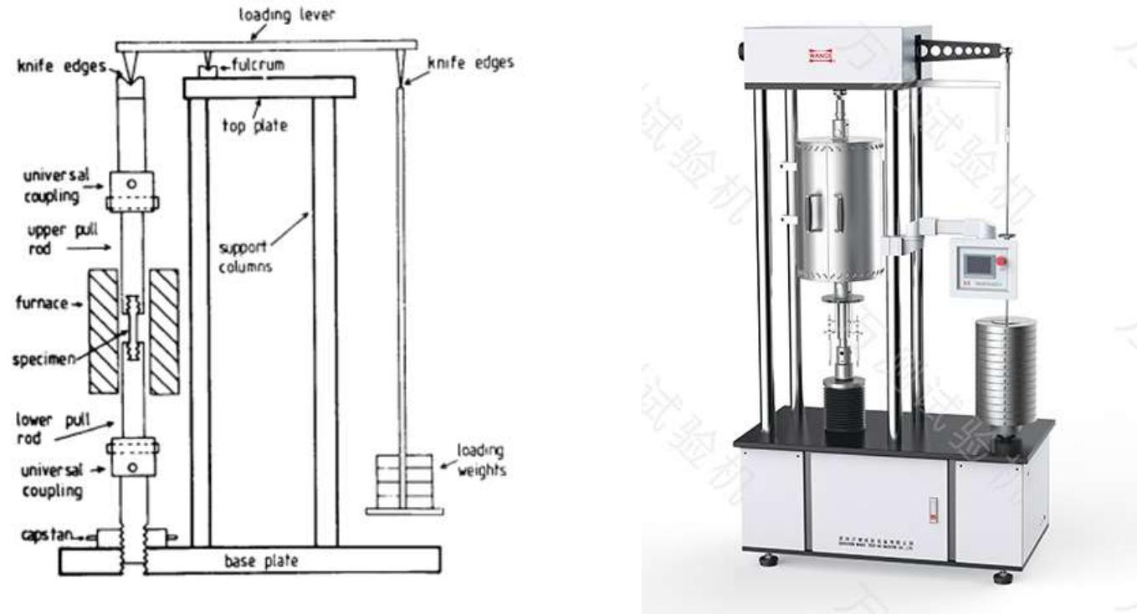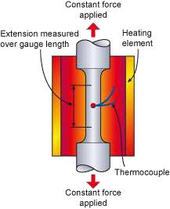

**Class: 2nd stage**

**Subject: Materials Science lab**

**Reducing creep in materials**

In general, there are three general ways to **prevent creep in metal**. One way is to **use higher melting point metals**, the second way is to **use materials with** **greater grain size** and the third way is to use **alloying.**

**Discussion:**

1- What is creep?

2- What are the stages of creep?

3- How can we reduce creep in materials?