

**Al-Mustaqbal University College**

**Optics Techniques Department**

**Lecture 7**

By : Duaa Abdulrida Raheem

Mustaf Mortada Kalihf

* 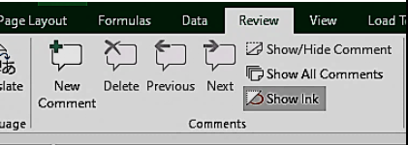**Comments**

Comments allow you to add Notes or more descriptive information to that cell in a popup message. A red triangle appears in the upper right corner of the cell.

* 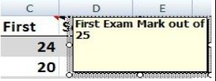**Adding Comments:**

1. Select the cell. Click **New Comment**, in

the **Comments** group on **Review** tab. Type the comment.

**Note:** Red triangle appears in the upper right- corner of the cell. The comment text appears when you place your mouse over the cell.

* **Editing Comments**

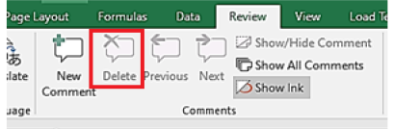Editing a comment allows you to change or add to the information you have placed within a cell as a comment.

1. Select the cell that contains the comment. Click Edit Comment in the Comments group on Review tab.

2. The Comment box appears, make your changes then click another cell.

* **Deleting Comments**

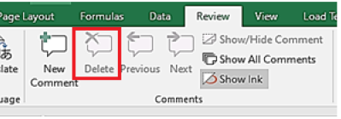1. Select the cell which contains the comment to be deleted.

2. Click **Delete Comment** in the **Comments** group, on **Review** tab. **Note:** you can delete a comment by **Clear** command in the **Editing** group, on **Home** tab. From the list choose **Clear Comments**.

* 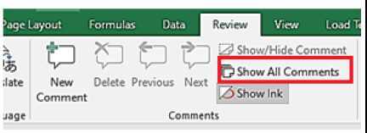**Show All Comments**

By default, the comments appear only when you hover over the cell that contains the comment to show all the comments at once.

- Click **Show All Comments**, in the **Comments** group On the **Review** tab.

* 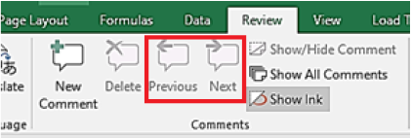**Navigate between Comments**

Click **Previous & Next**, in the **Comments** group On the **Review** tab to navigate through the comments.

* **Using AutoFill**

✓ **Copy** the same data to other adjacent cells in the row or column.

✓ Continue a **pattern (series)** for data like numbers, dates, and the days of a week or months.

* **Using auto fill to copy data**

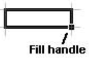1. Select the cell that you want to copy its contents and hover over the bottom right corner of the selected cell until the mouse pointer changes to a black cross .

2. Drag the *fill handle [small black square]* over the cells that you want to fill - either down a column or across a row.

* **Using auto fill to fill weekdays or months**

1. Enter the starting day into a cell (**Sunday, Monday, Tuesday**, or whatever…) or the starting month **(April, May, whatever…)**

2. Hover the mouse pointer over the lower-right corner of the cell until the mouse pointer changes to a black cross .

3. Drag the fill handle [small black square] over the cells you want to fill - either down a column or across a row.

**Example 1:**

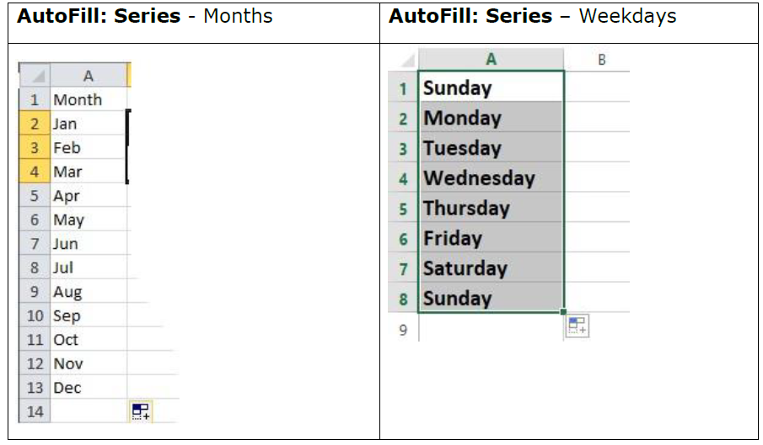**Example 2:**

✓ If you want to copy the value 1, just drag the fill handle to adjacent column or row.

✓ If you want to fill for a series like 1, 2, 3, 4, 5..., click Auto Fill Options and choose the option **Fill Series**.

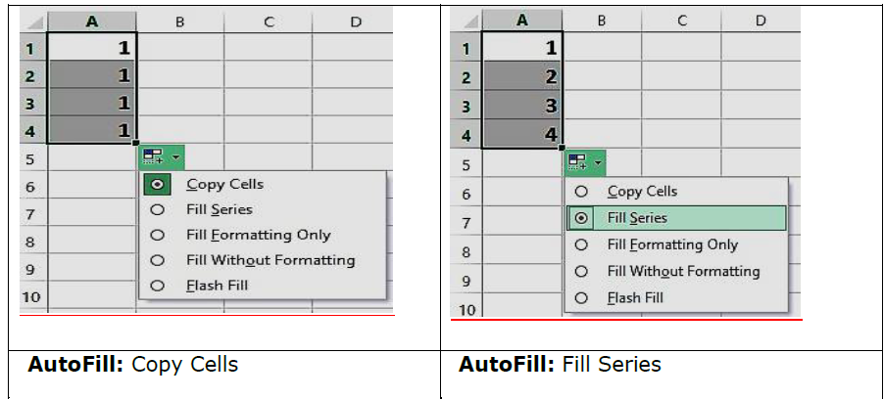

**Example 3:**

