|  |  |  |
| --- | --- | --- |
| **AL-Mustaqbal University College**  **Department of Medical Physics**  **The Second Stage**  **Thermodynamics and Heat**  **Dr. Rusul Abdul Ameer**  **MCs. Noor Raed Hadi** | **شعار المستقبل جديد فقط.jpg** | **كلية المستقبل الجامعة**  **قسم الفيزياء الطبية**  **المرحلة الثانية**  **الديناميكيا الحرارية** |

**Lecture .2**

**Temperature and Zeroth Law of Thermodynamics**

Thermodynamics is the branch of science which deals with the energy interactions. In order to find whether energy interactions are taking place or not some measurable mathematical parameters are needed. These parameters are called thermodynamic properties. Out of a number of thermodynamic properties discussed earlier the ‘temperature’ is one property.

Observations at the molecular level show that upon heating the molecular activity inside the bar gets increased. This may be attributed to the more agitated state of molecules as energy is given to them in the form of heating of the bar. From the physiological sensations it can be felt that this has resulted in an increase in the degree of hotness of the bar. This qualitative indication of the relative hotness can be exactly defined by using a thermodynamic property known as temperature.

Temperature is thus the intensive parameter and requires reference states. These acceptable known thermal states are such as the boiling point of water commonly called steam point, freezing point of water commonly called ice point etc. These easily reproducible and universally acceptable states of the substance are known as reference states and the temperature values assigned to them are called reference temperatures. Since these reference points and reference temperatures maintain their constant value, therefore these are also called fixed points and fixed temperatures respectively.

**The zeroth law of thermodynamics states that if two bodies are in thermal equilibrium with a third body, then they are in thermal equilibrium with each other.** Itmay seem silly that such an obvious fact is called one of the basic laws of thermodynamics. However, it cannot be concluded from the other laws of thermodynamics, and it serves as a basis for the validity of temperature measurement. By replacing the third body with a thermometer, the zeroth law can be restated as two bodies are in thermal equilibrium if both have the same temperature reading even if they are not in contact.

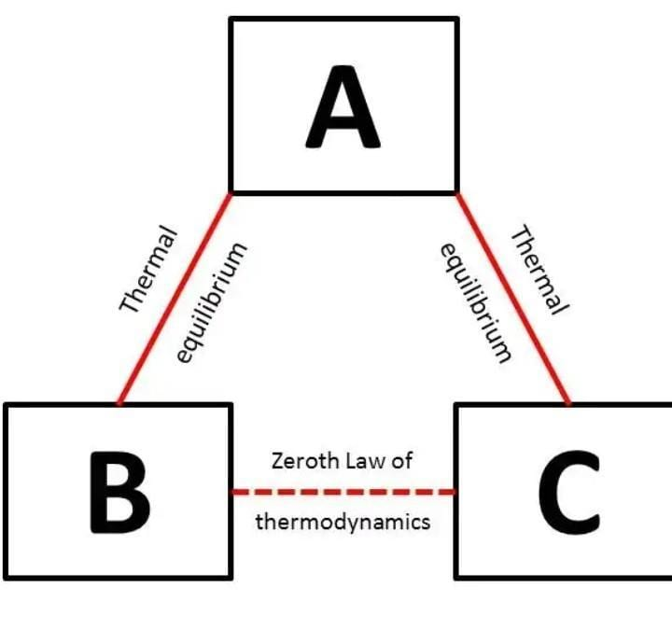

### **Applications of the Zeroth Law of Thermodynamics**

The zeroth law of thermodynamics is seen in many everyday situations.

* The [**thermometer**](https://www.thoughtco.com/the-history-of-the-thermometer-1992525) may be the most well-known example of the zeroth law in action. For example, say the thermostat in your bedroom reads 67 degrees Fahrenheit. This means that the thermostat is in thermal equilibrium with your bedroom. However, because of the zeroth law of the thermodynamics, you can assume that both the room and other objects in the room (say, a clock hanging in the wall) are also at 67 degrees Fahrenheit.
* Similar to the above example, if you take a glass of ice water and a glass of hot water and place them on the kitchen countertop for a few hours, they will eventually reach thermal equilibrium with the room, with all 3 reaching the same temperature.
* If you place a package of meat in your freezer and leave it overnight, you assume that the meat has reached the same temperature as the freezer and the other items in the freezer.

**Temperature Scales**

A number of temperature measuring scales came up from time to time. Different temperature scales have different names based on the names of persons who originated them and have different numerical values assigned to the reference states.

**1. Celsius Scale or Centigrade Scale**: Anders Celsius gave this Celsius or Centigrade scale using ice point of 0°C as the lower fixed point and steam point of 100ºC as upper fixed point for developing the scale. It is denoted by the letter C. Ice point refers to the temperature at which freezing of water takes place at standard atmospheric pressure. Steam point refers to the temperature of water at which its vaporization takes place at standard atmospheric pressure. The interval between the two fixed points was equally divided into 100 equal parts and each part represented 1ºC or 1 degree Celsius.

**2. Fahrenheit Scale:** Daniel Gabriel Fahrenheit gave another temperature scale known as Fahrenheit scale and has the lower fixed point as 32ºF and the upper fixed point as 212ºF. The interval between these two is equally divided into 180 parts. It is denoted by the letter F. Each part represents 1ºF. Fahrenheit Scale is related to Celsius scale as follows:

**𝑇F = 9 5 𝑇C + 32**

**3. Kelvin Scale:** Kelvin scale proposed by Lord Kelvin is very commonly used in thermodynamic analysis. It also defines the absolute zero temperature. Zero degree Kelvin or absolute zero temperature is taken as –273ºC. It is denoted by the letter K. It is related to Celsius scale as given below:

**𝑇K = 𝑇C + 273**

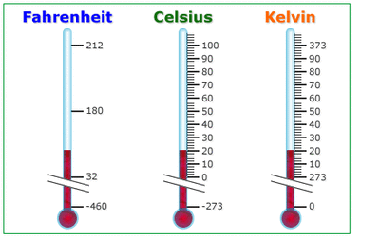

**4. Rankine Scale:** Rankine scale was developed by William John Macquorn Rankine, a Scottish engineer. It is denoted by the letter R. It is related to Fahrenheit scale as given below:

**𝑇R = 𝑇F + 460**

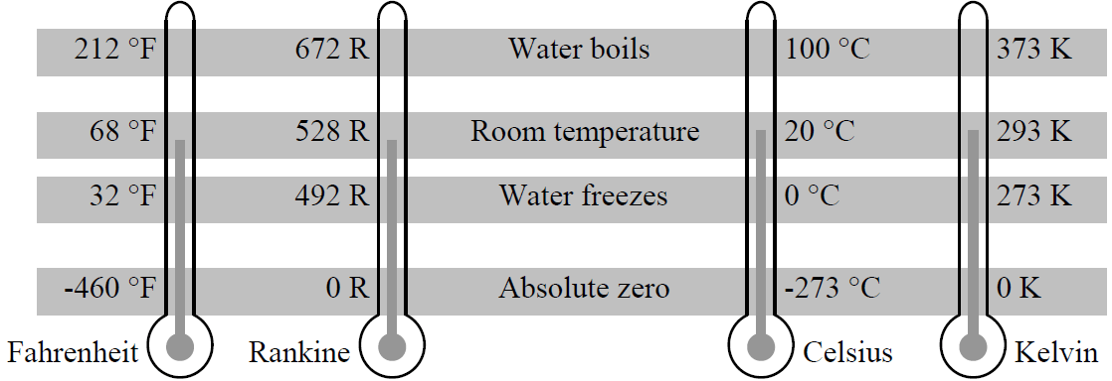

**Thermometers :**

A mechanical or electrical device for measuring temperature , most thermometers have these three parts:

a - **Sensor** : A material which is affected by the change in temperature

b- The sensor produces a **Signal** – information about the temperature , ex. water rising up/down the tube

c- The signal affects a **Responder** – light, pointer, or other mechanism that use the signal, ex. water is read on the scale.

**Four Types of Thermometers**

1. Thermocouple

2. Bimetallic Strips

3. Recording Thermometer

4. Infrared Thermograms

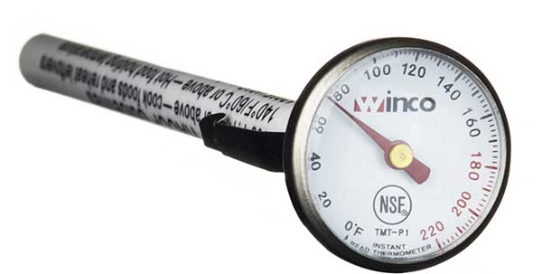

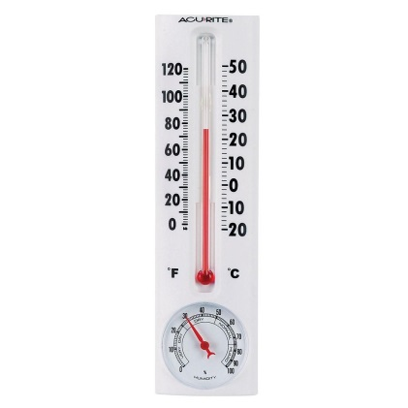**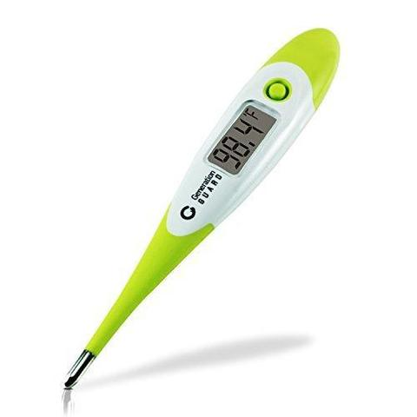  
Fig(a): Show some of thermometers devices**

**Ideal Gas**

A gas is made of molecules that move around with random motion. In the ideal gas, the molecules may collide but they have no tendency to stick together or repel each other. In reality, there is a slight force of attraction between gas molecules but this is so small that gas laws formulated for an ideal gas work quite well for a real gas.

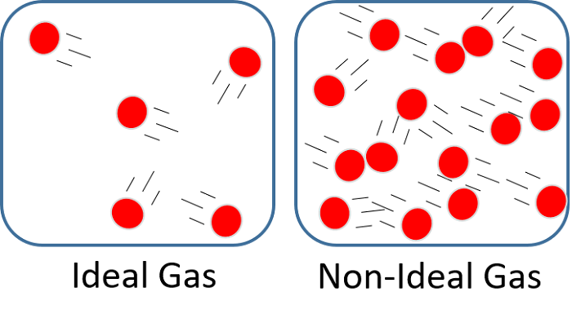

**Equation of State**

Any equation that relates the pressure, temperature and volume of a substance is called an equation of state. Property relations that involve other properties of a substance at equilibrium states are also referred to as equations of state. There are several equations of state, some simple and others very complex. The simplest and best known equation of state for substances in the gas phase is the ideal gas equation of state. This equation predicts the (P-V-T) behavior of a gas quite accurately within some properly selected region. The ideal gas equation of state is expressed as:

**𝑃𝑉 = n𝑅𝑇**

**or PV = 𝑅𝑇 (in terms of specific volume)**

where R is the gas constant, which has a different value for each gas. The equation of state can also be expressed in terms of the number of moles instead of the mass as follows:

**𝑃𝑉 = 𝑁𝑅𝑜𝑇**

where N is the number of moles, and 𝑅𝑜 is the universal gas constant which has a constant value for all gases:

**𝑅𝑜 = 8.314 kJ/kmol. K**

**𝑅𝑜 = 1545.37 ft. lbf/kmol. R**

**𝑅 = 𝑅𝑜 /𝑀 and 𝑀 = 𝑚 𝑁**

where M is the molar mass (also called molecular weight) of the gas.

For a constant mass, the properties of an ideal gas at two different states are related to each other by:

**𝑃1𝑉1 / 𝑇1 = 𝑃2𝑉2 /𝑇2**

Note: in these equations T is the absolute temperature (i.e. substituted in Kelvin or Rankine).

**Boyle’s law** states that the pressure of a given mass of an ideal gas is inversely proportional to its volume at a constant temperature. It is expressed as:

**𝑃𝑉 = 𝐶 or 𝑃1𝑉1 = 𝑃2𝑉2**

**Charles’s law** states that the volume of an ideal gas at constant pressure is directly proportional to the absolute temperature. It is expressed as:

**𝑉 𝑇 = 𝐶 or 𝑉1 𝑇1 = 𝑉2 𝑇2**

**Gay-Lussac’s law** states that, for a given mass and constant volume of an ideal gas, the pressure exerted on the sides of its container is directly proportional to its absolute temperature. It is expressed as:

**𝑃 𝑇 = 𝐶 or 𝑃1 𝑇1 = 𝑃2 𝑇2**

**Example**

An amount of gas has a pressure of 350 KPa, a volume of 0.03 m3 and a temperature of 35°C. If R = 0.29 kJ/kg .K, calculate the mass of the gas and the final temperature if the final pressure is 1.05 MPa and the volume remains constant?

**Solution**:

The absolute temperature: 𝑇1 = 35 + 273 = 308 K Applying the equation of state for the initial conditions: 𝑃1𝑉1 = 𝑚𝑅𝑇1

=350 × 0.03 = 𝑚 × 0.29 × 308 → 𝑚 = 350 × 0.03/ (0.29 × 308)

𝒎 = 𝟎. 𝟏𝟐 𝐤𝐠

Applying the equation of state between two conditions at constant volume:

𝑃1/ 𝑇1 = 𝑃2/ 𝑇2

=350 /308 = (1.05 × 103/ 𝑇2) → 𝑇2 = (1.05 × 103 × 308) / 350

𝑻𝟐 = 𝟗𝟐𝟒 𝐊

**Example**

A tank has a volume of 0.5 m3 and contains 10 kg of an ideal gas having a molecular weight of 24. The temperature is 25°C. What is the pressure of the gas?

**Solution**:

The absolute temperature:

𝑇 = 25 + 273 = 298 K

𝑅 = 𝑅𝑜 /𝑀 =( 8.314 /24) = 0.35 kJ/kg. K

Applying the equation of state:

𝑃𝑉 = 𝑚𝑅𝑇

𝑃 × 0.5 = 10 × 0.35 × 298 → 𝑃 = (10 × 0.35 × 298)/ 0.5

𝑷 = 𝟐𝟎𝟖𝟔 𝐤𝐏𝐚 .