|  |
| --- |
|  |

|  |
| --- |
| **Thermodynamics and Heat** |
| **Second Stage** |
| Dr. Rusul Abdul Ameer |
| MCs. Baraa Abd Alrda |
|  |
| 2023-2024 |

|  |  |  |
| --- | --- | --- |
| **AL-Mustaqbal University College**  **Department of Medical Physics**  **The Second Stage**  **Thermodynamics and Heat**  **Dr. Rusul Abdul Ameer**  **MCs. Baraa Abd Alrda** | **شعار المستقبل جديد فقط.jpg** | **كلية المستقبل الجامعة**  **قسم الفيزياء الطبية**  **المرحلة الثانية**  **الديناميكيا الحرارية** |

**Lecture .3**

**Real Gas**

A real gas is defined as a gas that does not obey gas laws at all standard pressure and temperature conditions. When the gas becomes massive and voluminous it deviates from its ideal behaviour. Real gases have velocity, volume and mass. When they are cooled to their boiling point, they liquefy.

 Oxygen, hydrogen, carbon dioxide, helium, and other gases are examples of real gas. Real gases exhibit modest attraction and repulsive forces between particles, but ideal gases do not. Real gas particles have a volume, but ideal gas particles do not. While the particles of an ideal gas are assumed to occupy no volume and experience no interparticle attractions, the particles of a real gas do have finite volumes and do attract one another.

**How do Real gases move**

The gas particles have negligible volume. The gas particles are equally sized and do not have intermolecular forces (attraction or repulsion) with other gas particles so the gas particles move randomly in agreement with Newton's Laws of Motion. The gas particles have perfect elastic collisions with no energy loss.

**Ideal Gas**

A gas is made of molecules that move around with random motion. In the ideal gas, the molecules may collide but they have no tendency to stick together or repel each other. In reality, there is a slight force of attraction between gas molecules but this is so small that gas laws formulated for an ideal gas work quite well for a real gas.

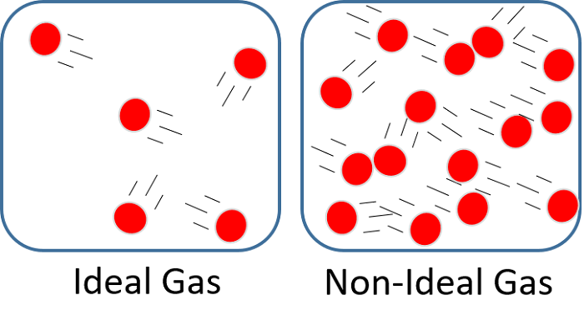

**Equation of State**

Any equation that relates the pressure, temperature and volume of a substance is called an equation of state. Property relations that involve other properties of a substance at equilibrium states are also referred to as equations of state. There are several equations of state, some simple and others very complex. The simplest and best known equation of state for substances in the gas phase is the ideal gas equation of state. This equation predicts the (P-V-T) behavior of a gas quite accurately within some properly selected region. The ideal gas equation of state is expressed as:

**𝑃𝑉 = n𝑅𝑇**

**or PV = 𝑅𝑇 (in terms of specific volume)**

where R is the gas constant, which has a different value for each gas. The equation of state can also be expressed in terms of the number of moles instead of the mass as follows:

**𝑃𝑉 = 𝑁𝑅𝑜𝑇**

where N is the number of moles, and 𝑅𝑜 is the universal gas constant which has a constant value for all gases:

**𝑅𝑜 = 8.314 kJ/kmol. K**

**𝑅𝑜 = 1545.37 ft. lbf/kmol. R**

**𝑅 = 𝑅𝑜 /𝑀 and 𝑀 = 𝑚 𝑁**

where M is the molar mass (also called molecular weight) of the gas.

For a constant mass, the properties of an ideal gas at two different states are related to each other by:

**𝑃1𝑉1 / 𝑇1 = 𝑃2𝑉2 /𝑇2**

Note: in these equations T is the absolute temperature (i.e. substituted in Kelvin or Rankine).

**Boyle’s law** states that the pressure of a given mass of an ideal gas is inversely proportional to its volume at a constant temperature. It is expressed as:

**𝑃𝑉 = 𝐶 or 𝑃1𝑉1 = 𝑃2𝑉2**

**Charles’s law** states that the volume of an ideal gas at constant pressure is directly proportional to the absolute temperature. It is expressed as:

**𝑉 𝑇 = 𝐶 or 𝑉1 𝑇1 = 𝑉2 𝑇2**

**Gay-Lussac’s law** states that, for a given mass and constant volume of an ideal gas, the pressure exerted on the sides of its container is directly proportional to its absolute temperature. It is expressed as:

**𝑃 𝑇 = 𝐶 or 𝑃1 𝑇1 = 𝑃2 𝑇2**

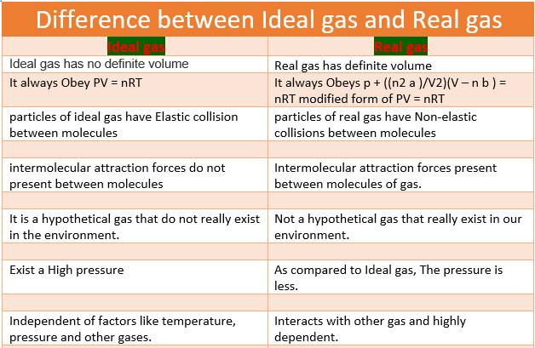

**Example1**

An amount of gas has a pressure of 350 KPa, a volume of 0.03 m3 and a temperature of 35°C. If R = 0.29 kJ/kg .K, calculate the mass of the gas and the final temperature if the final pressure is 1.05 MPa and the volume remains constant?

**Solution**:

The absolute temperature: 𝑇1 = 35 + 273 = 308 K Applying the equation of state for the initial conditions: 𝑃1𝑉1 = 𝑚𝑅𝑇1

=350 × 0.03 = 𝑚 × 0.29 × 308 → 𝑚 = 350 × 0.03/ (0.29 × 308)

𝒎 = 𝟎. 𝟏𝟐 𝐤𝐠

Applying the equation of state between two conditions at constant volume:

𝑃1/ 𝑇1 = 𝑃2/ 𝑇2

=350 /308 = (1.05 × 103/ 𝑇2) → 𝑇2 = (1.05 × 103 × 308) / 350

𝑻𝟐 = 𝟗𝟐𝟒 𝐊

**Example 2**

A tank has a volume of 0.5 m3 and contains 10 kg of an ideal gas having a molecular weight of 24. The temperature is 25°C. What is the pressure of the gas?

**Solution**:

The absolute temperature:

𝑇 = 25 + 273 = 298 K

𝑅 = 𝑅𝑜 /𝑀 =( 8.314 /24) = 0.35 kJ/kg. K

Applying the equation of state:

𝑃𝑉 = 𝑚𝑅𝑇

𝑃 × 0.5 = 10 × 0.35 × 298 → 𝑃 = (10 × 0.35 × 298)/ 0.5

𝑷 = 𝟐𝟎𝟖𝟔 𝐤𝐏𝐚 .

**Example 3**

5 moles of nitrogen gas is in a 100 liter fixed cylinder at 300 Kelvin. What is the pressure of the gas?

**Solution**:

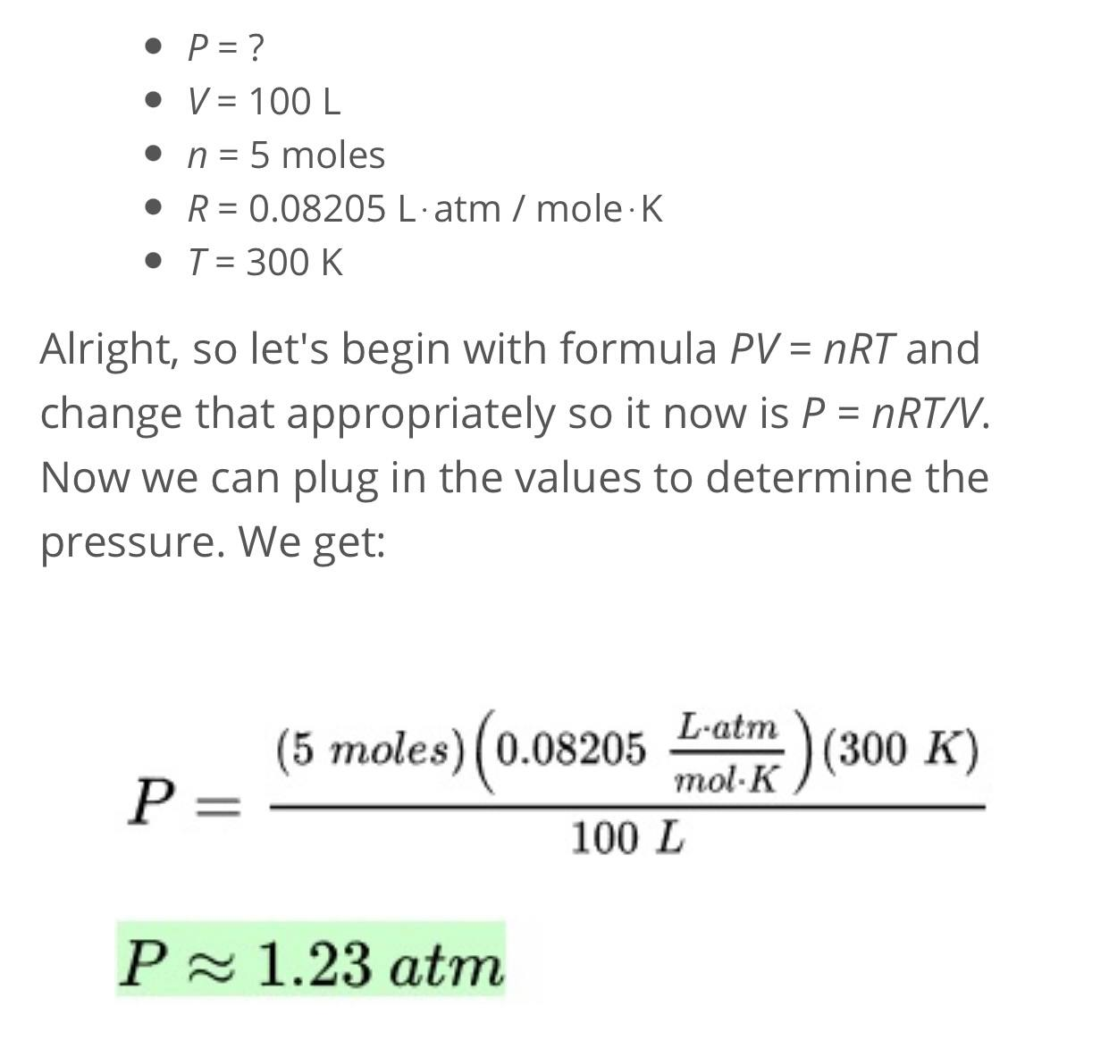

**H.W**

**1- What is the molar mass of a gas if 0.281 g of the gas occupies a volume of 125 mL at a temperature 126 °C and a pressure of 777 torr?**

**2-** Oxygen, hydrogen, carbon dioxide, helium, and other gases are examples of -----

**3-** The ------------- have perfect elastic collisions with no energy loss.

**4-**