Lecture 6 Dental Equipment Technologies Dr.Muna Merza

**Sandblast Machine**

This device is used to remove oxides & debris of investment from metal that is used in partial denture (chrome-cobalt) & in crown and bridge. Use a sandblast which project by compressor air through a fine nozzle (tube) to clean the alloy using abrasive (sandblast) abrasive particle showing compressive air in agent to remove particle of investment this particle with different

size.

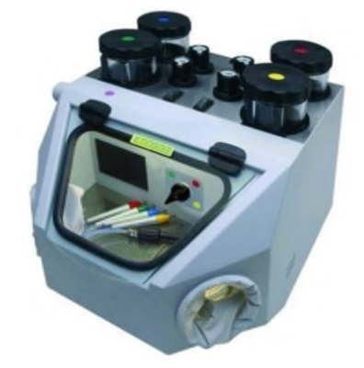

Parts:

A. Emery deposit vessel

B. Vessel pressure control

C. Booth light switch

D. External inlet tube

E. Rubber guard

F. Vessel heat system switch

G. Vessel selection switchgear

H. Fabric sleeve

I. Fine nozzle.

