Lecture 7 Dental Equipment Technologies Dr.Muna Merza

**Dental Ceramic Furnace**

**Dental Ceramic Furnace**

Used in crown & bridge laboratory for the firing of ceramics on metal-ceramic restoration, all ceramics, ceramic - zirconium, ceramic - aluminum, and ceramic - titanium restoration.

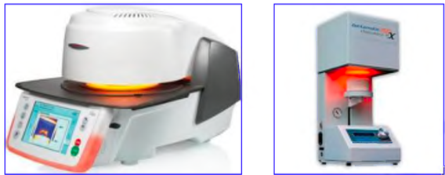

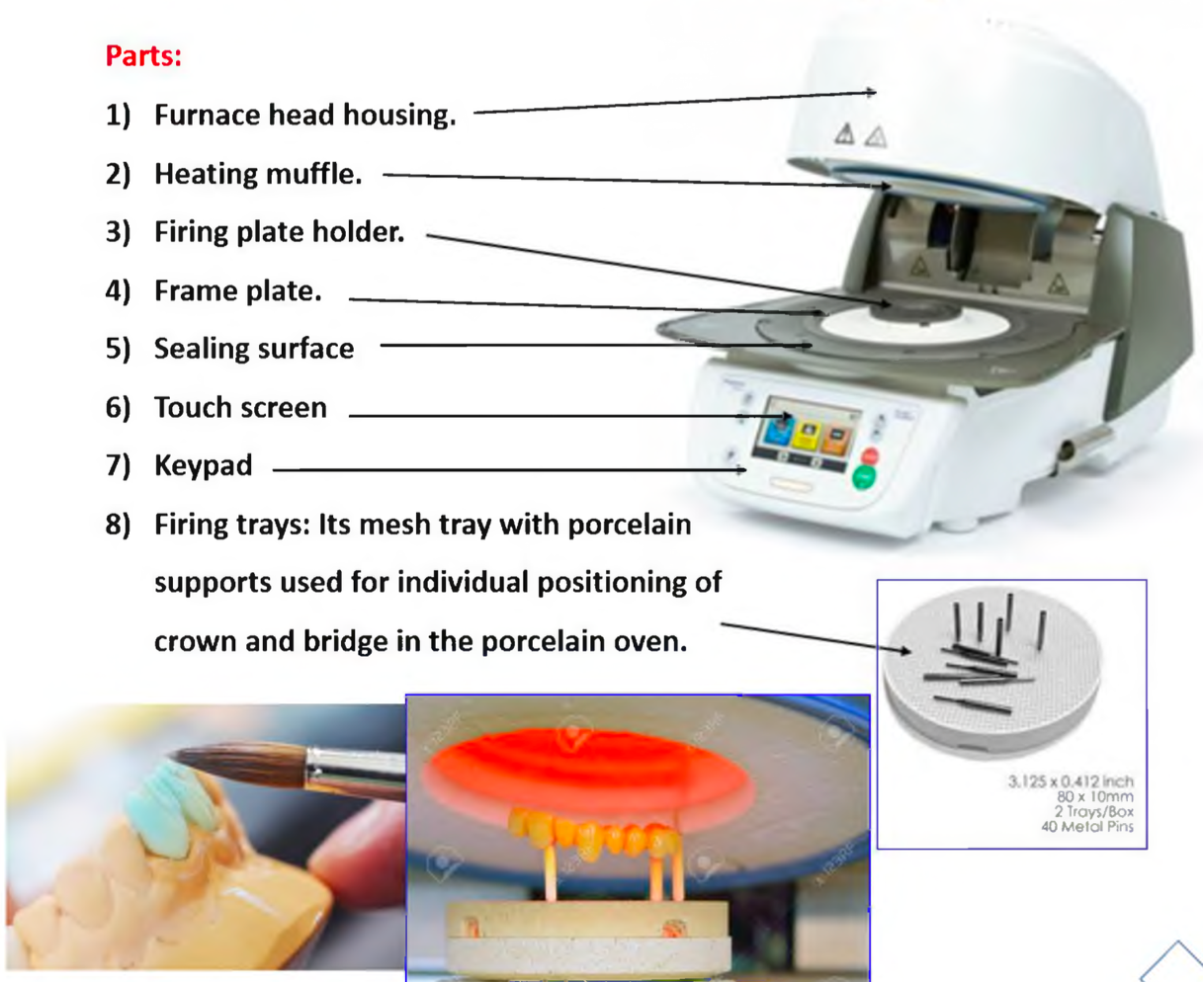

**Dental torch tool for soldering and casting.**

There are two types of torches tips.

**1. Multi orifice tip torch:** The tip most widely used in the casting procedure for metal-ceramic

alloys are probably the multi orifice type. Its main advantage is the distribution of heat over a wide area for more uniform heating of the alloy, which is particularly helpful in casting high-fusing base metal alloys. The Source of the flame torch is gas and air pressure or gas and oxygen.

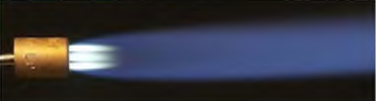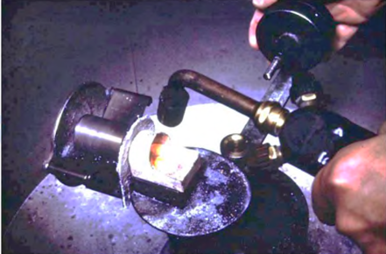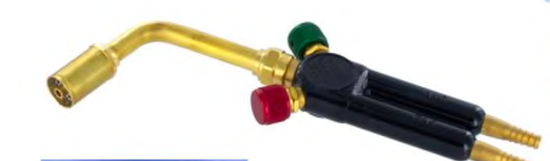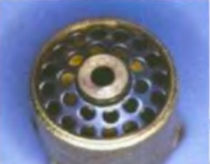

**2. Single orifice tip torch** may concentrate more heat in one area, but the area is smaller than

that produced by the multi orifice tip, used for the soldering procedure. The Source of the flame torch is gas and air pressure or gas and oxygen.

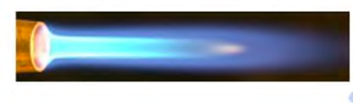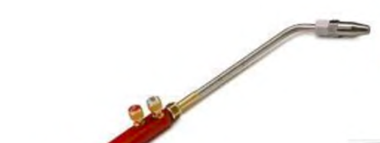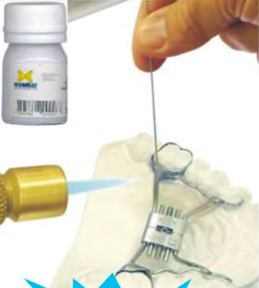

**Lecture 8 Soldering and Welding**

**• Soldering:**

Is defined as the joining of metals by the fusion of the filler metal between them, at a temperature below the solidus temperature of the metals being joined and below 450°C.

• Soldering is often used in the construction of dental appliances.

**• Components of solder joint:**

1. Parent metal

2. Flux

3. Anti flux4. Solder/filler metal

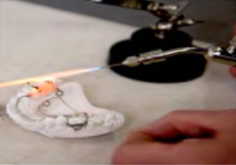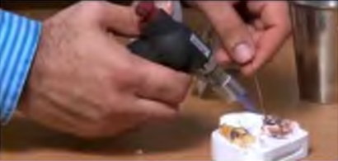

**1.Parent Metal**

• The parent metal is the metal or alloy to be joined. It is also known as substrate metal or base metal. Soldering operation is the same for any substrate metal.

•The composition of parent metal determines:

1. melting range

2. oxide that forms on the surface during heating wettability of the substrate by the molten solder.

**2.Flux**

• FLUX in Latin flux means "to flow".

• Purpose of flux is to remove any oxide coating on the substrate metal surface when the filler metal is fluid and ready to flow into place.

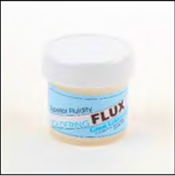

**3. Anti-Flux**

• Anti Flux Materials used to restrict the flow of solder are known as anti- flux.

• It is applied on the surface of a specific area where the solder should flow. It is applied before applying flux or solder.

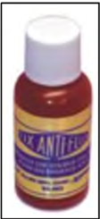

**3. Solder/filler metal**

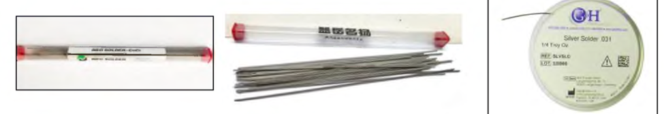

**• Soldering Applications in Pedodontics**

1. Wire to wire.

2. The tube can be soldered to the bridge of Adam's clasp.

3. Attachment of springs to arch wire,

4. Soldering lingual arch or palatal arch.

5. Soldering fracture bridge.

6. Soldering clasp from framework partial denture.

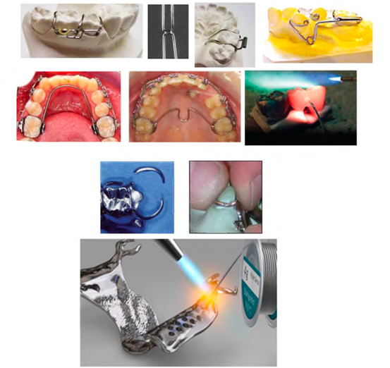

**Welding Machine**

Is the process by which the surfaces of metals are joined by mixing, with or without the use of heat.

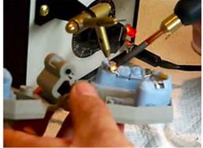

**Methods of welding:**

**1. Cold welding** is done by hammering or pressure. An example of cold welding is the gold foil filling.

**2. Hot welding** is using the heat of sufficient intensity to melt the metals being joined. The heat source is usually an oxyacetylene flame or high amperage electricity.

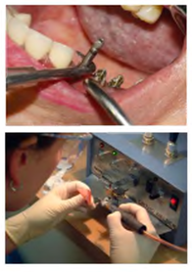

**Types of Welding Machine**

**1. Spot Welding 2. Pressure Welding 3. Laser Welding**

**1. Spot welding**: The two clean metal surfaces to be welded are placed together under pressure.

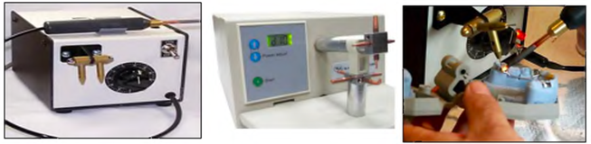

**2. Pressure welding**: If two metal parts are placed together and a sufficiently large force is applied perpendicular to the surface, pressure welding occurs.

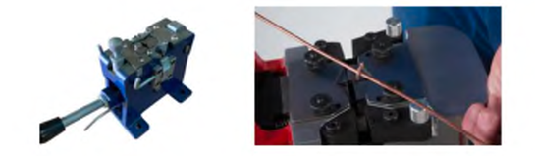

**3. Laser welding**: Laser generates a coherent, high-intensity pulse of light that can be focused.

