BIOCHEMISTRY LECTURE (1)

)**Introduction to Biochemistry**)

.

# Why should we study biochemistry?

We study biochemistry because it gives answers for mysterious questions. Questions like: -

How does coffee wake us up? Why does yeast make alcohol? Why do I get sleepy?

How come plants do not get sunburn? Why don't elephants get cancer?

Why do all animals age, yet bacteria do not?

**Historically**, Biochemistry is a new Science.

Separately, the subjects of chemistry and biology have been around since the time of the ancient Greeks and Egyptians, but the idea of combining them is much more recent.

**200 years ago**, there was no evidence that a science of biochemistry was even possible.

Even **100 years ago**, the word biochemistry was barely coming into use and the field had scarcely begun.

Biochemistry brings together the best of biology with the best of chemistry. Biochemistry is entirely grounded in the same rules as the rest of chemistry.

The earliest roots of biochemistry date from almost two centuries ago, when an experiment by **Friedrich Völler** accidentally created a compound. We now know as **urea**. It turned out to be identical to a crystal that appeared when he dried urine.

This demonstration made it clear for the very first time that ordinary chemistry had to be possible inside of cells.

1

BIOCHEMISTRY LECTURE (1)

)**Introduction to Biochemistry**)

.

Two discoveries at roughly the same time in the **1860s** were **inheritance**, and the existence of **DNA**. But the significance of these remained unrealized for decades.

# Watson and Crick in 1953 were found the structure of DNA. The importance of Biochemistry:

Classical biochemistry had been concerned with enzymes and other molecular reactions found inside and among cells.

Take the periodic table which has over 100 elements. With only a few exceptions, biochemistry is not concerned with those individual atoms at all, much less their internal structure of positively charged protons and neutrally charged neutrons. Biochemistry is mostly about molecules.

Moreover, the molecules of biochemistry are overwhelmingly built using primarily just six bonding elements.

They are **carbon**, **oxygen**, **nitrogen**, and **hydrogen** with supporting help from

**sulfur** and **phosphorus**.

What matters for joining these atoms together is electrons. And chemical bonds always involve electrons.

Electrons are negatively charged and located outside the nucleus of the Atom. The number and kinds of bonds an Atom can make is due to the number of electrons it can share, release or gain.

Cells are mostly water, which is just hydrogen covalently bonded with oxygen. (Dihydrogen oxide).

The oxygen can make two bonds, each hydrogen can only make one bond, but the more important fact is they share electrons with each other.

The other four elements that are of primary importance for making bonds in chemistry also like to share electrons.

The element whose atoms are arguably the most important for life is **carbon**. Carbon's importance is directly traced to its electrons.

2

BIOCHEMISTRY LECTURE (1)

)**Introduction to Biochemistry**)

It has four electrons that are involved in reactions and they all participate in sharing with other atoms, sometimes the sharing is 50:50 equal and sometimes it may be a bit unequal, but carbon never gives up its electrons entirely or takes those of another Atom.

Carbon's ability to make 4 bonds also makes it central to the construction of big and complicated molecules (carbohydrate molecules) for example, is a bunch of carbons that have been hydrated with a bunch of water.

Biochemistry is all about big carbon centered molecules and their relationships to the water of the cell.

# How molecules are stuck together?

In beginning chemistry, we might write letters or even full names for every single Atom with a short line in between to show the bond. Water is 2 hydrogen atoms linked to oxygen, 2 atoms of oxygen come together to make molecular oxygen by making two bonds, double bonds are shown by two lines between atoms.

Carbon molecules can have all their carbons written out, but we can make the same diagram simpler if the carbon atoms are not explicitly shown. Instead, the angled lines are used, and the carbon is assumed to be at the meeting point of angled lines depicting the bonds.

In such diagrams, hydrogens attached to the carbons are also emitted entirely. These simplifications help a lot when showing bigger carbon molecules. For example, a fatty acid drawn both ways.

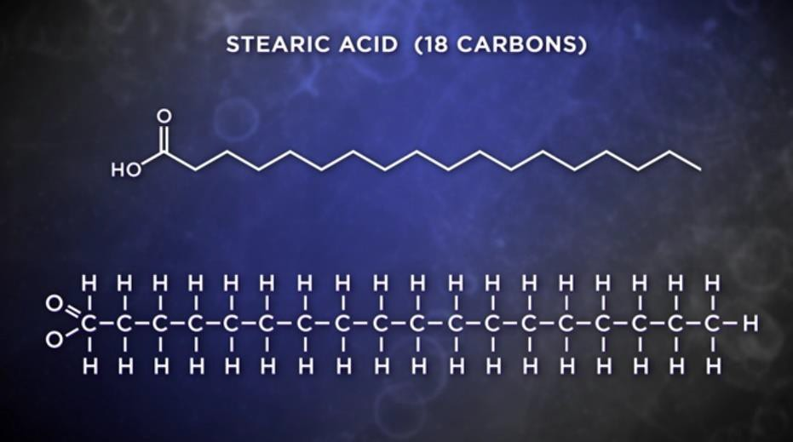

3

BIOCHEMISTRY LECTURE (1)

(**Introduction to Biochemistry**)

Besides carbon, hydrogen, and oxygen, the fourth most abundant element in our bodies, and the most abundant in our atmosphere, is **nitrogen**.

Nitrogen can make three bonds with its electrons. When nitrogen bonds to hydrogen as it commonly does, it forms what we call an **amine**, which is related to **ammonia**. Like the feel-good molecule **dopamine** has an amine group at one end.

Amines also give their name to amino acids, the simplest of which is **glycine**. Amino acids are the building blocks of **proteins**.

A fifth element that is important in many proteins is **sulfur**. As you know from the smell of eggs when their proteins start to breakdown. Sulfur can make two bonds and is found in two of the amino acids like **Cysteine**.

The 6th element important for building biomolecules is **phosphorus**. In cells we pretty much see phosphorus only when bound to four oxygen atoms. To create a unit known as **phosphate**. Phosphates are important for storing energy and activates or inactivates proteins

(The energy to power cells comes from a triphosphate called **ATP**. Phosphates are also part of the backbone of the structure of DNA as well).

There are some other atoms in biochemistry. Many of these are atoms and molecules we refer to as **minerals**. (8) minerals are most abundant in biochemistry, sodium, potassium, magnesium, calcium, iron, zinc, copper, and chlorine.

Minerals do not usually share electrons when they form bonds, chlorine steals (gain) electrons. Each of the other minerals is a supplier of electrons.

In the watery environment of the body, such molecules are broken up and become charged ions.

(Stealing electrons involves gaining a negative electric charge, while supplying electrons means a loss of negative charges by the Atom participating).

Since atoms start out with a charge of zero, we can tell the number of electrons an Atom has gained or lost by its charge.

4

BIOCHEMISTRY LECTURE (1)

)**Introduction to Biochemistry**)

Sodium, for example, is a supplier of 1 electron, so it typically has a charge of plus one, and chlorine steals electrons, so it has a charge of minus one. Put them together and you make sodium chloride known as table salt, but in the watery environment of our bodies the ionic bonds holding the salt are broken and we use the ions.

Iron and copper are two ions with some additional abilities. We find them in cells with two possible charges, each for iron it can exist as iron plus two or as iron plus three. Copper can exist as copper plus one or copper +2. What makes this so interesting is the ability of iron and copper to flip between the two states differing by one electron turns out to be important for handling energy in cells.

Copper plays two important roles in the body, one involves energy generation, it helps in respiration by transferring electrons to oxygen to make water, and this turns out to be the reason we breathe.

The second role of copper is in helping to protect cells from random damage actually caused by the oxygen that you breathe.

# Ionization

The process of making an ion is called ionization. Ions are important to cells., when minerals dissolve in water, they form ions and literally come apart.

Sodium chloride in our body splits into sodium ions and chloride ions. When they dissolve in water.

Since water is 70% of the weight of cells, interactions with water in the cell are crucially important.

Ions are not building blocks of cells, but ions perform critical tasks in and around the cells of our body.

Individual Atom ions like sodium and potassium are very tiny compared to proteins and other giant cell molecules with thousands of atoms.

The tiny size of these ions allows cells to regulate their movement using nanoscopic protein channels specific for each one.

5

BIOCHEMISTRY LECTURE (1)

(**Introduction to Biochemistry**)

And their tiny size allows them to move very rapidly, while their electrical charge gives them important roles in the electrical circuits of our nerve cells.

It is partly thanks to the small in charge characteristics of these mineral ions that nerve cells can communicate so rapidly in the body.

# Proteins

digestion process of proteins is to obtain their amino acids, and we use those amino acids to build our own proteins.

Proteins are polymers which are long strings of molecules joined end to end (chains of amino acids)

Proteins do not use a single building block repeated monotonously over and over. Instead, proteins have at their disposal and often use 20 different building blocks, all amino acids.

We say the proteins are assembled from building blocks because assembly implies a plan. The plan is needed because each of the thousands of proteins found in cells has a unique order of building blocks joined to each other, and unlike all other molecules, the plan for each of our proteins comes direct from a cell's DNA as written in the genetic code, and that sequence of building blocks determines the shape of the protein and what a protein does.

Many proteins are quite large, often with over 1000 amino acids in a single protein molecule. That is why we call them **macromolecules**.

Some proteins speed up reactions occurring inside of cells. A huge family of proteins responsible for speeding up all sorts of reactions are called **enzymes**.

Speeding reactions is cool but there are non protein molecules that speed reactions too. We call them **catalysts**.

In the absence of enzymes, some reactions can take millions of years to occur all by themselves.

Moreover, Enzymes are also very picky, we call this high specificity, so enzymes are a bit like a glove attempting to fit on a hand. If it does not fit, no reaction on it.

6

BIOCHEMISTRY LECTURE (1)

(**Introduction to Biochemistry**)

How do enzymes act so fast and so specifically this comes back to the protein polymer in the building blocks, the specificity of an enzyme is rooted in the very specific arrangement of the building blocks in its polymer change the order of amino acids and you change the shape of the enzyme shape.

Turns out to be one of the most important considerations in biochemistry. **A basic principle is that structure determines function.**

Enzymes have highly specific shapes and those specific shapes only allow molecules with corresponding shapes to fit in them.

Fitting into enzymes in a specific way is critical because that is where the enzymes catalyze reactions.

so, any given cell must have thousands of enzymes to catalyze the thousands of different reactions in that one cell.

# Cells

Cells are **the fundamental unit of life.**

Each cell has thousands of enzymes speeding up thousands of highly specific reactions. cells are the places for the molecular reactions. cells have surrounding walls in the form of a membrane.

Bacterial is a unicellular called **prokaryotes**. with no internal walls

Most other cells, like the ones in our body are more like houses or apartments subdivided into rooms, each room with a function.

Rooms in cells are called **organelles**.

There are several, including a **nucleus**, where the DNA is stored and **mitochondria**

where energy is made.

In plants there are also **chloroplasts** where energy from the light of the sun is captured in **photosynthesis** and the outer membrane of plants is wrapped in another layer called the **cell wall** cells with the organizational scheme of a house or apartment are called **eukaryotes**.

7

BIOCHEMISTRY LECTURE (1)

)**Introduction to Biochemistry**)

However, a few eukaryotes, such as yeast, an amoeba's happily maintained the rural life of a little house on the Prairie.

The molecules they contain are similar. The reactions their molecules undergo are similar and the ways they store information inside themselves are similar. In fact, the degree of similarity is almost shocking.

If we look at how a simple one celled bacterium breaks down sugar to get energy and compare it to how that happens in a human being, we see that the reactions are identical.

# The simplest molecular building blocks

These are the functional groups covered in any organic chemistry course, but here again, what we need for biochemistry is much simplified.

Carbon is the basis for all the nomenclature.

If our molecule has carbon bonded only with hydrogen, that makes a **hydrocarbon**. The simplest hydrocarbon is **methane**, a waste product where a single carbon makes

bonds with four hydrogens.

Methane is such a common byproduct of cellular respiration that scientists seeking evidence of life on other planets search for it in the atmosphere.

Methane gives up one of its four hydrogens and is called **methyl**.

A ring of carbons is **benzene**, a ring of carbons with three double bonds is **phenyl**. If we have carbon bonded to oxygen, and hydrogen many more biological

compounds are possible, including **alcohols**, **aldehydes**, **ketones**, and **acids**. Alcohols are the simplest with just an OH group. The thing to remember is that this. OH group is called a **hydroxyl group**.

The word is put together just like the atoms with the (YL) included, just like **methyl**.

**Ethanol** with two carbons and the hydroxyl group is the alcohol found in beer, wine, and spirits.

8

BIOCHEMISTRY LECTURE (1)

)**Introduction to Biochemistry**)

Although in everyday speech we use alcohol to refer only to ethanol, in chemistry the word refers to all molecules with a hydroxyl group linked to a carbon. Often there is an **OL** in the name. **Cholesterol**, for example, has a hydroxyl group. Dopamine, which besides its amine group, also has two hydroxyls.

And coming in with three hydroxyls is **glycerol**. This is the molecule that combines with **fatty acids** to make any of the **fats**.

If a OH hydroxyl group is bonded to a phenyl ring, then the phenyl ring is called

# Phenol.

Serotonin, the happiness molecule is a Phenol. There are also **polyphenols** by the hundreds found in plants that give us antioxidants and other exciting nutrients whose importance is increasingly understood.

When carbon makes a double bond with an oxygen that is a **carbonyl** group, also known as an **aldehyde**. Vitamin A in your eyes that gives you vision is an aldehyde called **retinal**.

**Acetaldehyde** is what your body makes if you drink alcohol and causes the misery known as a hangover. Notice that it has a carbon double bond with oxygen with the double bond at the end of the molecule.

If the location of the double bond is in the middle of the molecule instead of the end, then we call it a **ketone**. The keto diet, which is extremely high in fat, causes your body to make ketones. One of these called **Acetone** has three carbons, with the middle one double bonded to oxygen. Acetone is also found in nail Polish remover. Many sugars are ketones. We also see ketones as intermediates in the breakdown in synthesis of fatty acids in cells.

Carbon can also have the double bond of an aldehyde and the hydroxyl of an alcohol attached to the same carbon at the end of the molecule. That is all it takes to make a **carboxylic acid**.

**Acetic acid**, which is notable for giving vinegar its tang. The carbon double bond oxygen and the OH, which we call a. COOH group or a **carboxyl**. Anything with a carboxyl group goes under the general category of carboxylic acids.

9

BIOCHEMISTRY LECTURE (1)

)**Introduction to Biochemistry**)

When we talk about an acid in biochemistry, we are also usually talking about these carboxyl groups with a COOH group. These are weak acids, act as buffers to help stabilize acid levels in cells.

And we have a lot of acids built this way. We have **bile acids** that help with the digestion process. All the fatty acids have a carboxyl group, for example **myristic acid** found in coconut oil is 13 carbons plus a carboxyl. All the **amino acids** get the acid part of their name from having a carboxyl group.

When a carboxylic acid reacts with an alcohol, the resulting molecules are called

**esters** with a molecule of water released.

Simple esters often have a fruity smell. The smell of bananas, for example, comes from combining acetic acid with an alcohol called isoamyl alcohol to make a compound called **isoamyl acetate**.

When three fatty acids react with glycerol, the triple ester that results is a **fat**. This one molecular process, called **esterification** is what makes all the fats that help food taste so much better. Everything from olive oil to butter.

10