**AL-Mustaqbal university**

**College of Sciences**

**Department of Medical Biotechnology**

**Histology /2rd Stage**

**Lec.3\ The Muscle tissue**

**Dr. Sarah Kamil**

**Muscle tissue:**

Muscle tissue is composed predominantly of cells that are specialised to shorten in length by contraction. This contraction results in movement. It is in this way that virtually all movements within the body, or of the body in relation to the environment, are ultimately produced. Muscle tissue is made up basically of cells that are called **myocytes**. Myocytes are elongated in one direction and are, therefore, often referred to as **muscle fibers**. Myocytes are mesodermal in origin. Each muscle fiber is an elongated cell which contains contractile proteins actin and myosin. The cytoplasm of muscle cells is called **sarcoplasm**, and the smooth endoplasmic reticulum is called **sarcoplasmic** reticulum. The **sarcolemma** is the cell membrane, or plasmalemma. Each muscle fiber is closely invested by connective tissue that is continuous with that around other muscle fibers. Because of this fact the force generated by different muscle fibers gets added together. In some cases a movement may be the result of simultaneous contraction of thousands of muscle fibers. The connective tissue framework of muscle also provides pathways along which blood vessels and nerves reach muscle fibers.

**Three types of muscles are identified in mammals:**

1. **Skeletal muscle** is composed of bundles of very long, cylindrical, multinucleated cells that show cross-striations. Their contraction is quick, forceful, and usually under voluntary control.
2. **Cardiac muscle** also has cross-striations and is composed of elongated, branched individual cells that lie parallel to each other. At sites of end-to-end contact are the **intercalated disks**, seen only in the cardiac tissue. Contraction of cardiac muscle is involuntary, vigorous, and rhythmic.
3. **Smooth muscle** consists of collections of fusiform cells that do not show cross-striations. Their contraction process is slow and not subject to voluntary control.



**Figure 1: The three types of muscle.**

**Skeletal Muscle:**

**Skeletal muscle** is present mainly in the limbs and in relation to the body wall. Because of its close relationship to the bony skeleton, it is called **skeletal muscle**. When examined under a microscope, fibers of skeletal muscle show prominent transverse striations. Skeletal muscle is, therefore, also called **striated muscle**. Skeletal muscle can normally be made to contract under our will (to perform movements we desire). It is, therefore, also called **voluntary muscle**. Skeletal muscle is supplied by somatic motor nerves. Consist of muscle fibers bundles of very long (up to 30cm), cylindrical multinucleated cells with a diameter of 10-100μm. The oval nuclei are usually found at the periphery of the cell under the cell membrane. Masses of fibers are arranged in regular bundles surrounded by the **epimysium,** an external sheath of dense connective tissue surrounding the entire muscle. From the epimysium, thin septa of connective tissue extend inward, surrounding the bundles of fibers within a muscle, called the **perimysium.** Each muscle fiber is itself surrounded by a delicate layer of connective tissue, the **endomysium**, composed mainly of a basal lamina and reticular fibers (figure 2).

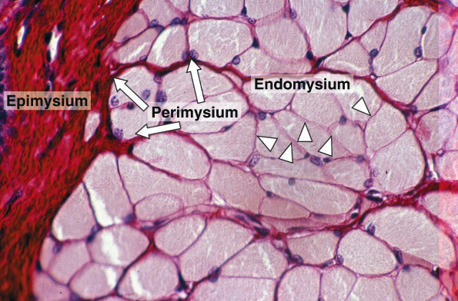

Skeletal muscles contain fibers that can be physiologically classified as the three main types: (1) **slow**, **oxidative** (type I); (2) **fast, intermediate** **oxidative-glycolytic** (type IIa); and (3) **fast**, **glycolytic** (type IIb).

**Organization with muscle fibers:**

Longitudinally sectioned skeletal muscle fibers show cross striations of alternating light and dark bands. The dark bands are called A bands; the light bands are called I bands. Each I band is seen to be bisected by a dark transverse line, the Z disc. The repetitive functional subunit of the contractile apparatus, the sarcomere, extends from Z disc to Z disc and is about 2.5μm long in resting muscle (figure 3).

The sarcoplasm has little RER and contains primarily long cylindrical filament bundles, called myofibrils, running parallel to the long axis of the fiber. Mitochondria and sarcoplasmic reticulum are found between the myofibrils, which have a diameter of 1 to 2μm. Myofibrils consist of an end-to end repetitive arrangement of sarcomeres; the lateral registration of sarcomeres in adjacent myofibrils causes the entire muscle fiber to exhibit a characteristic pattern of transverse striations. The A and I banding pattern in sarcomeres is due mainly to the regular arrangement of thick and thin myofilaments, composed of myosin and F-actin, respectively, organized within each myofibril in a symmetric pattern containing thousands of each filament type. The thick myosin filaments are 1.6μm long and 15nm wide; they occupy the A band at the middle region of the sarcomere. Myosin is a large complex (~500kDa) with two identical heavy chains and two pairs of light chains. Myosin heavy chains are thin, rod like motor proteins (150nm long and 2-3nm thick) twisted together as myosin tails. Globular projections containing the four myosin light chains form a head at one end of each heavy chain. The myosin heads bind both actin, forming transient crossbridges between the thick and thin filaments, and ATP, catalyzing energy release (actomyosin ATPase activity).

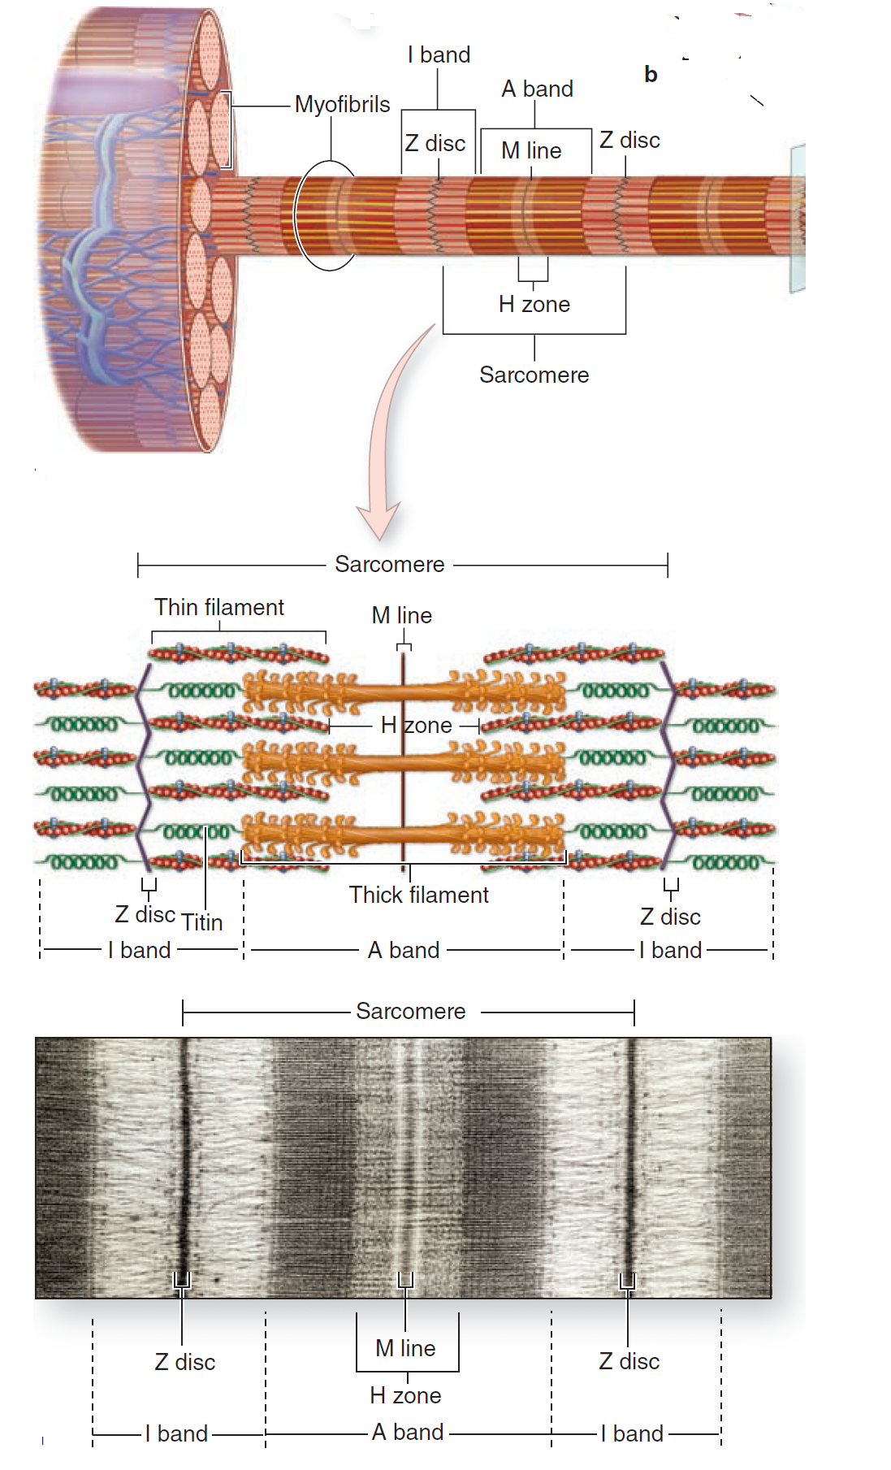

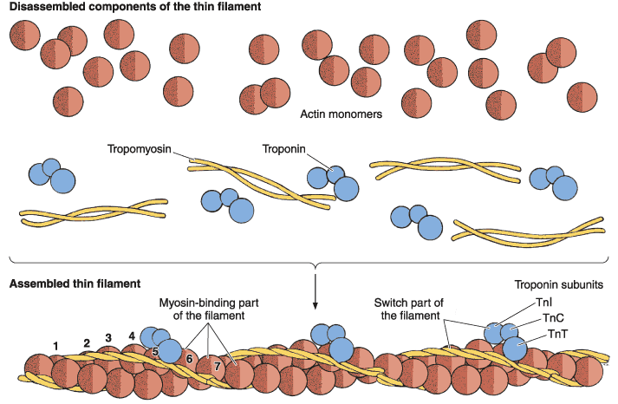

Several hundred myosin molecules are arranged within each thick filament with overlapping rod like portions and the globular heads directed toward either end. The thin, helical actin filaments are each 1.0μm long and 8nm wide and run between the thick filaments. Each G-actin monomer contains a binding site for myosin. Actin filaments are anchored perpendicularly on the Z disc by the actin-binding protein a-actinin and exhibit opposite polarity on each side of this disc. Thin filaments are also tightly associated with two regulatory proteins:

■Tropomyosin, a 40-nm-long coil of two polypeptide chains located in the groove between the two twisted actin strands.

■Troponin, a complex of three subunits: TnT, which attaches to tropomyosin; TnC, which binds Ca2+; and TnI, which regulates the actin-myosin interaction. Troponin complexes attach at specific sites regularly spaced along each tropomyosin molecule.

I bands, each bisected by a Z disc, consist of the portions of the thin filaments that do not overlap the thick filaments (which is why I bands stain more lightly). An important accessory protein in I bands is titin (3700 kDa), the largest protein in the body, with scaffolding and elastic properties, which supports the thick myofilaments and connects them to the Z disc.

The A bands contain both thick filaments and the overlapping portions of thin filaments. Close observation of the A band shows the presence of a lighter zone in its center, the H zone, corresponding to a region with only the rod like portions of the myosin molecule and no thin filaments. Bisecting the H zone is the M line, containing a myosin-binding protein myomesin that holds the thick filaments in place, and creatine kinase. This enzyme catalyzes transfer of phosphate groups from phosphocreatine, a storage form of high-energy phosphate groups, to ADP, helping to supply ATP for muscle contraction.

**Cardiac Muscle:**

**Cardiac muscle** is present exclusively in the heart. It resembles smooth muscle in being involuntary; but it resembles striated muscle in that the fibers of cardiac muscle also show transverse striations. Cardiac muscle has an inherent rhythmic contractility the rate of which can be modified by autonomic nerves that supply it. Mature cardiac muscle cells are approximately 15μm in diameter and from 85 to 100μm in length. They exhibit a cross-striated banding pattern identical to that of skeletal muscle. Each cardiac muscle cell possesses only one or two centrally located pale-staining nuclei. Surrounding the muscle cells is a delicate sheath of endomysial connective tissue containing a rich capillary network. There is the presence of dark-staining transverse lines that cross the chains of cardiac cells at irregular intervals called the **intercalated disks**, represent junctional complexes found at the interface between adjacent cardiac muscle cells, having transverse and lateral portions. Fasciae adherents are membrane specialization in transverse portions of the disk, serve as anchoring sites for actin filaments of the terminal sarcomeres, representing hemi-Z bands. Desmosomes are also present in the transverse portion and bind the cardiac cells together. In addition, zonula adherens present in the transverse portion too. On the lateral portions of the disk, **gap junctions** provide ionic continuity between adjacent cells.

**Smooth Muscles:**

**Smooth muscle** is present mainly in relation to viscera. It is seen most typically in the walls of hollow viscera. As fibers of this variety do not show transverse striations, it is called **smooth** **muscle**, or **non-striated muscle**. As a rule, contraction of smooth muscle is not under our control; and smooth muscle is, therefore, also called **involuntary muscle**. It is supplied by autonomic nerves. Smooth muscle is composed of elongated, nonstriated cells, each of which is enclosed by a basal lamina and a network of reticular fibers. Smooth muscle cells are fusiform, i.e. they are largest at their midpoints and taper toward their ends. They may range in size from 20 μm in small blood vessels to 500 μm in the pregnant uterus. The narrow part of one cell lies adjacent to the broad parts of neighboring cells.

Concentrated at the poles of the nucleus are mitochondria, polyribosomes, cisternae of rough endoplasmic reticulum, and the Golgi complex. Pinocytotic vesicles are frequent near the cell surface. Bundles of myofilaments crisscross obliquely through the cell, forming a network. These bundles consist of thin filaments (5-7nm) containing actin and tropomyosin and thick filaments (12-16nm) consisting of myosin. Smooth muscle actin and myosin contract by a sliding filament mechanism similar to what occurs in striated muscles. Smooth muscle occurring in large sheets such as those found in the walls of hollow viscera, e.g., the intestines, uterus, and ureters are called **visceral smooth muscles**. Their cells possess abundant gap junctions and a relatively poor nerve supply. In contrast, the **multiunit smooth muscles** have a rich innervation and can produce precise and graded contractions such as those occurring in the iris of the eye. Smooth muscle usually has spontaneous activity in the absence of nervous stimuli.