 

**Oral Pathology**

Prof. Dr.Muna Merza

Lecture 2

**Lec. 2 ORAL PATHOLOGY Dr. Muna**

**Biopsy**

**Definition:** removal and examination of apart or the whole of a lesion.

There are several types of biopsy techniques.

**Types of Biopsy:**

1_surgical biopsy: Is the most important type

A_ **Incisional biopsy**:-it is removal of part of lesion is used to determine the diagnosis before treatment.

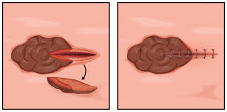

B_ **Excisional biopsy:**-it is removal of the whole lesion,it is used to confirm chemical diagnosis and it consider as treatment.

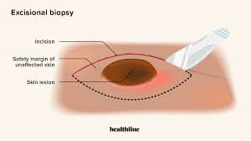

C_ **Frozen sections**:-allows stained slide to be examined within 10 min of taken the specimen but has some limitation the tissue is sent fresh to the laboratory to be quickly frozen.

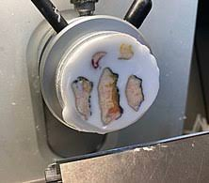

2_**Fine Needle Aspiration biopsy**(F.N.A): to differentiate between solid and cystic lesion e.g : heamingioma which is benign tumor of blood vessels.

3_**Thick needle core biopsy:** larger sample than F.N.A

4_ **Exfoliate cytology**: it is limited to the surface cells provide no information on deeper tissue. ***Technique:***

1_Anesthesia and incision done around the site of the lesion.

2_Biobsy provide tissue lesion and 2mm around from normal tissue.

3_Fix the tissue immediately in 10% formalin.

***Indication of biopsy:***

1_Any lesion persists for more than 2 week.

2_Any inflammatory lesion that not respond to local treatment.

3_Persist hyperkeratotic changes.

4_Any lesion that has the characteristic of malignancy.

Contraindication for biopsy:

1-uncorrectable bleeding

2-uncontroll sever hypertension

3-active renal infection

4-skin infection at biopsy site

***Technique:***

1_Anesthesia and incision done around the site of the lesion.

2_Biobsy provide tissue lesion and 2mm around from normal tissue.

3_Fix the tissue immediately in 10% formalin.

***Indication of biopsy:***

1_Any lesion persists for more than 2 week.

2_Any inflammatory lesion that not respond to local treatment.

3_Persist hyperkeratotic changes.

4_Any lesion that has the characteristic of malignancy.

Contraindication for biopsy:

1-uncorrectable bleeding

2-uncontrolled sever hypertension

3-active renal infection

4-skin infection at biopsy site