 

Oral Histology

**DEVELOPMENT OF ORAL CAVITY**

Lecture 3

Prof. Dr. Muna Merza

Face and structures of the oral cavity begin development early in the embryonic period. ALL three embryonic layers are involved in facial development (layers are discussed earlier). Depending on five facial processes (prominences) that form during fourth week and surround stomodeum (primitive mouth):

1) single frontonasal process.

(2 and 3) paired maxillary processes.

(and 5) paired mandibular processes.

In the future, the stomodeum will form the oral cavity.

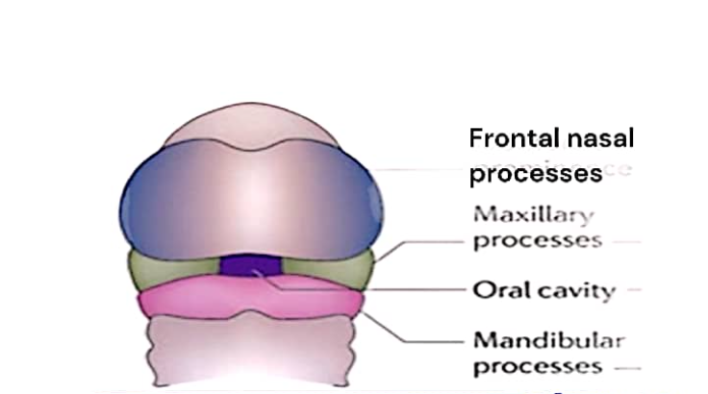

Facial processes are centres of growth for the face, If an adult's face is divided into thirds, these portions roughly correspond to centres of facial growth:

a. Upper face: from the frontonasal process.

b. Middle face (midface): from maxillary processes.

c. Lower face: from mandibular processes

Stomodeum and Oral Cavity Formation Before fourth week, stomodeum initially appears as a shallow depression in embryonic surface ectoderm at cephalic end, limited depth. Stomodeum is increased in depth, enlarging it to become oral cavity and lined by oral epithelium, which is derived from ectoderm, as a result of embryonic folding

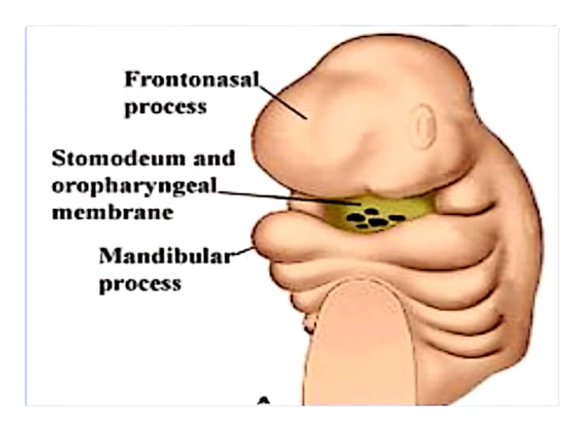

Oropharyngeal membrane disintegrates so that the stomodeum becomes deeper and gradually forms the oral cavity. Now there is access by way of stomodeum from internal primitive pharynx to outside fluids of the amniotic cavity surrounding the embryo.

Oral epithelium and underlying tissues will form teeth and associated tissues.

Mandibular Arch and Lower Face Formation During fourth week, two bulges of tissue appear inferior to stomodeum; these paired mandibular processes are formed in part by neural crest cells that migrated to the facial region, covered externally by ectoderm and internally by endoderm, Paired mandibular processes BOTH fuse at midline to form the mandibular arch.

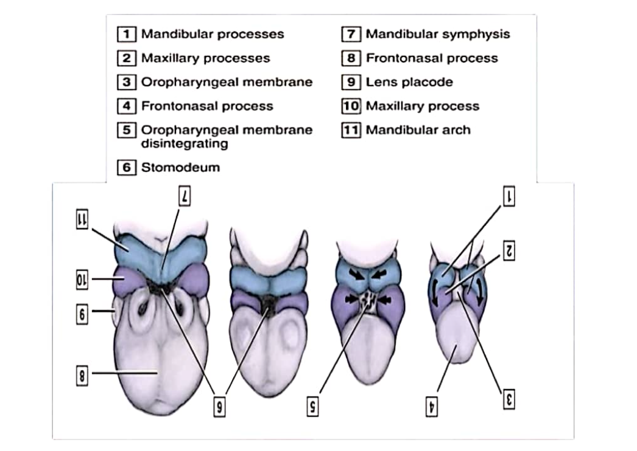

Mandibular arch and related tissues are first portions of the face to form after creation of stomodeum and directly forms lower face, including lower lip and will also form mandible, mandibular teeth, tissues, as well as tongue.

Meckel's cartilage forms within each side of mandibular arch, IMPORTANT in:

1. Alveolar bone development.
2. Makes contribution to the mandible, and a portion of cartilage participates in formation of middle ear bones.
3. Part of the perichondrium surrounding Meckel's cartilage becomes ligaments of the jaws and middle ear.

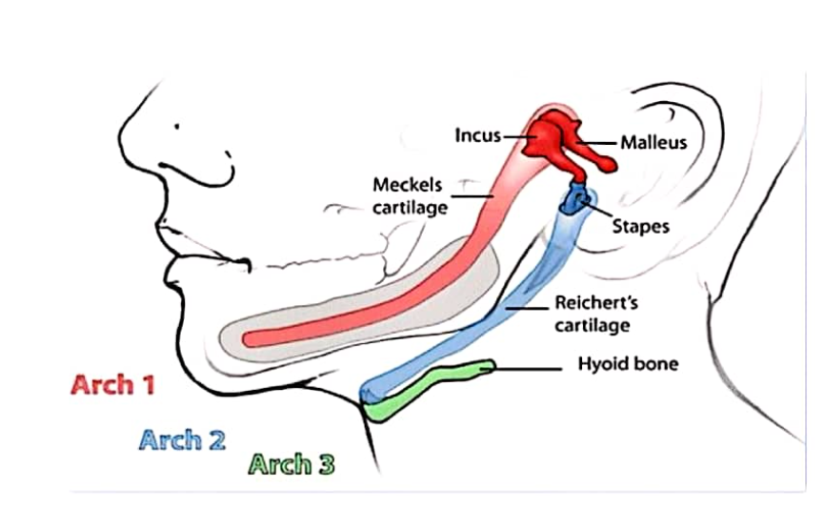

Mesoderm of the mandibular arch forms muscles of mastication, as well as some palatal muscles and suprahyoid muscles. Because these muscles are derived from mandibular arch, they are innervated by nerve of the first arch, fifth (V) cranial nerve (trigeminal nerve)