

**Electromagnetic waves**

**Lecture 2**

**System of Coordinates and Application**

**Msc. Ammar Karem**

**Tow stage**

**Department of medical physics**

**Al-Mustaqbal University-College**

* **Coordinate System**
* Used to describe the position of a point in space
* Coordinate System consists of
* A fixed reference point called the origin
* Specific axes with scales and labels
* Instruction on how to label a point relative to the origin and the axes
* **Types of Coordinate Systems**
* Number line. . A number line (also called a number axis) is an infinite line on which real numbers are designated: every point on the number line fits a real number, which may be a positive integer, a negative integer, zero, a fraction, or an irrational decimal number.
* Cartesian coordinate system.
* Polar coordinate system.
* 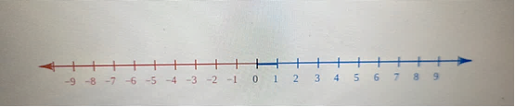Cylindrical and spherical coordinate systems.
* Homogeneous coordinate system.
* Other commonly used systems.
* Relativistic coordinate systems.
* 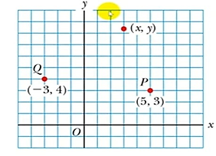 **Cartesian Coordinate System**
* Also called rectangular Coordinate System
* x- and y- axes intersect at the origin
* Points are labeled ( x , y )
* The plural of axis is axes
* Ordered pair (x , y) with x-value first

Example /Determine the following points

a.(2 ,3 )

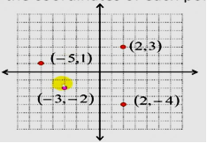 b.(-5 ,1)

c.(-3,-2)

d.(2,-4)

solution :

* **Polar coordinate system**
* Origin and reference line are noted.
* 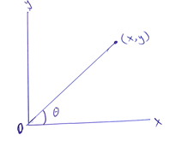Point is distance r from the origin in the direction of angle θ , from reference line .
* Points are labeled (r , θ) .
* **Polar to Cartesian coordinates**

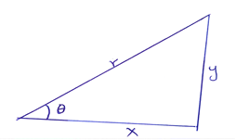 $sinθ=\frac{y}{r}$, $cosθ=\frac{x}{r}$, $tanθ=\frac{y}{x}$

* Based on forming a right triangle from r and θ .
$x=r\cos{θ}$

$y=r\sin{θ}$

* **Cartesian to Polar coordinates**
* If the Cartesian coordinates are known :
* r is the hypotenuse and θ an angle
$$tanθ=\frac{y}{x}$$

$$r=\sqrt{x^{2}+y^{2}}$$

* θ must be ccw from positive x axis for these equations to be valid

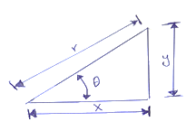**Example** : The Cartesian coordinates of a point in the xy Plane are (x,y)=(12 , 5 ) . Fined the polar coordinates of this point .

Solution : from equation

$r=\sqrt{x^{2}+y^{2}}$

$$r=\sqrt{{12}^{2}+5^{2}}$$

$$r=13$$

And from equation ,

$$tanθ=\frac{y}{x}$$

$$tanθ=\frac{5}{12}$$

$$θ=\tan^{-1}\left(\frac{5}{12}\right)$$

θ= ${22,6}^{°}$

* **Cylindrical coordinate systems**
* 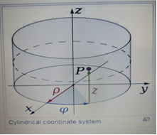There are two common methods for extending the polar coordinate system to three dimensions.
* In the cylindrical coordinate system, a z coordinate with the same meaning as in Cartesian coordinates is added to the r and θ polar coordinates giving a triple (r , θ , z).
* **Convert from Cartesian coordinates to cylindrical coordinates**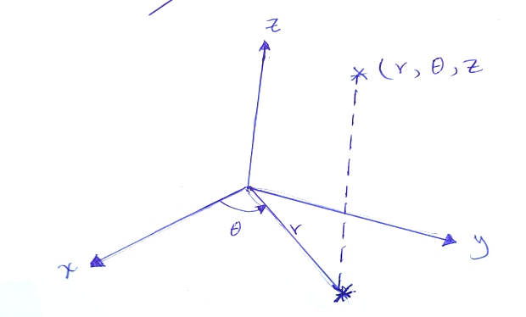

(x, y,z) $→$ (r,θ,z)

$θ=\tan^{-1}\left(\frac{y}{x}\right)$

$z=z$

* Convert from cylindrical coordinates to Cartesian coordinates

(r,θ,z) $→$ (x,y,z)

$x=rcosθ$

$y=rsinθ$

z=z

**Example**: Convert from cylindrical coordinates to Cartesian coordinates $(4, \frac{2π}{3}$,-2 )

Solution : $x=rcosθ$

$x=4\cos{\frac{2π}{3}}$

$x=-2$

$y=rsinθ$

$y=4sin\frac{2π}{3}$

$y=2\sqrt{3}$

z=z

z=-2

p=(-2,2 $\sqrt{3}$,-2)

**Example**: Convert from Cartesian coordinates to cylindrical coordinates $(1,-3, 5)$

Solution :

$r=\sqrt{x^{2}+y^{2}}$

$r=\sqrt{1^{2}+{-3}^{2}}$

$r=\sqrt{10}$

$θ=\tan^{-1} (\frac{y}{x})$

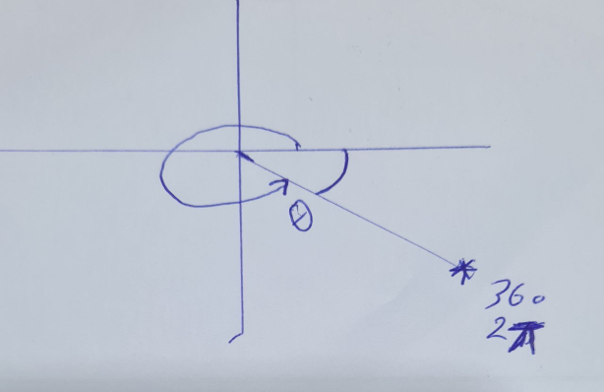 $θ=\tan^{-1} (\frac{-3}{1})$

$θ=-71.56$

$θ=2π+71.56$

$θ=431.56$

z = z

z = 5

(r,θ,z) = ( $\sqrt{10}$, 5.03 , 5 )

**Homework** :

Convert from Cartesian coordinates to polar coordinates (3,-3,-7) .

$r=\sqrt{x^{2}+y^{2}}$

$r=\sqrt{18}$

$θ=\tan^{-1} \left(\frac{y}{x}\right)$

$θ=\tan^{-1} \left(\frac{-3}{3}\right)$

$θ=\tan^{-1} (-1)$

$θ=-45$

$θ=-45+2π=….$

(r, $θ$) = ($\sqrt{18}, ….$)

* **Spherical Coordinate System**

In mathematics, a spherical coordinate system is a coordinate system for three-dimensional space where the position of a point is specified by three numbers: the radial distance of that point from a fixed origin, its polar angle measured from a fixed zenith direction, and the azimuthal angle of its orthogonal projection on a reference plane that passes through the origin and is orthogonal to the zenith, measured from a fixed reference direction on that plane. It can be seen as the three-dimensional version of the polar coordinate system.

* The radial distance is also called the radius or radial coordinate. The polar angle may be called colatitude, zenith angle, normal angle, or inclination angle.

**Definition**

To define a spherical coordinate system, one must choose two orthogonal directions, the zenith and the azimuth reference, and an origin point in space. These choices determine a reference plane that contains the origin and is perpendicular to the zenith. The spherical coordinates of a point P are then defined as follows:

1-The radius or radial distance is the Euclidean distance from the origin O to P.

2-The inclination (or polar angle) is the angle between the zenith direction and the line segment OP.

3-The azimuth (or azimuthal angle) is the signed angle measured from the azimuth reference direction to the orthogonal projection of the line segment OP on the reference plane.

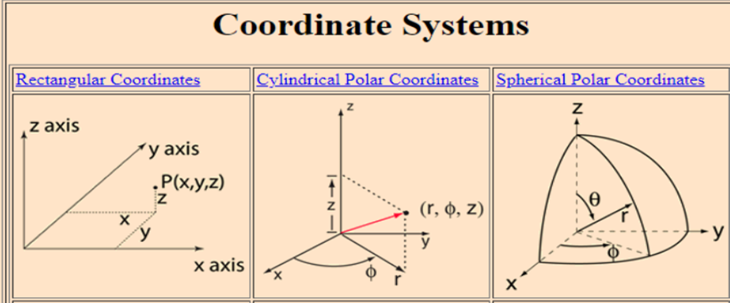

=r sin ɵ cos Φ

Y= r sin ɵ sin Φ

Z= r cos ɵ

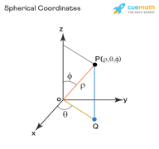**Example**: **Convert from Spherical coordinates to Cartesian** **Coordinate System (4,30,60)**

Solution:-

X=r sin ɵ cos Φ

X= 4sin(30 ) cos (60)

x=1

Y= 4sin( 30).sin (60)

Y= $\sqrt{3}$

Z= 4cos (30)

Z= 2

r=+z2

Φ = tan-1 (y/x)

ɵ = tan-1 ( )

* **Homogeneous coordinate system**

A point in the plane may be represented in homogeneous coordinates by a triple (x,y,z) where x/z and y/z are the Cartesian coordinates of the point. this introduces an extra coordinate since only two are needed to specify a point on the plane, but this system is useful in that it represents any point on the projective plane without the use of infinity . in general, a homogeneous coordinate system is one where only the ratios of the coordinates are significant and not the actual values.

* **Other commonly used systems**

Some other common coordinate systems are the following:

1- Curvilinear coordinates are a generalization of coordinate systems generally; the system is based on the intersection of curves.

* Orthogonal coordinates: coordinate surfaces meet at right angles
* Skew coordinates: coordinate surfaces are not orthogonal

2- The log-polar coordinate system represents a point in the plane by the logarithm of the distance from the origin and an angle measured from a reference line intersecting the origin.

3- Plücker coordinates are a way of representing lines in 3D Euclidean space using a six-tuple of numbers as homogeneous coordinates.

4- Generalized coordinates are used in the Lagrangian treatment of mechanics.

5- Trilinear coordinates are used in the context of triangles.

* **Applications**
* Just as the two-dimensional Cartesian coordinate system is useful on the plane, a two-dimensional spherical coordinate system is useful on the surface of a sphere. In this system, the sphere is taken as a unit sphere, so the radius is unity and can generally be ignored. This simplification can also be very useful when dealing with objects such as rotational matrices.

* Three dimensional modeling of loudspeaker output patterns can be used to predict their performance. A number of polar plots are required, taken at a wide selection of frequencies, as the pattern changes greatly with frequency. Polar plots help to show that many loudspeakers tend toward Omni directionality at lower frequencies.
* Spherical coordinates are useful in analyzing systems that have some degree of symmetry about a point, such as volume integrals inside a sphere, the potential energy field surrounding a concentrated mass or charge, or global weather simulation in a planet's atmosphere. A sphere that has the Cartesian equation x2 + y2 + z2 = c2 has the simple equation r = c in spherical coordinates.

**Homework:-**

**Convert from Spherical coordinates to Cartesian** **Coordinate System (8,30,60) .**