 

**Electromagnetic waves**

***Lecture( 3 -4 )***

**Static Electric Field with Coordinates**

**Msc. Ammar karem**

**Tow stage**

**Department of medical physics**

**Al-Mustaqbal University**

* **Electric field**

The electric field E at any point is defined as the amount of electrical force F acting on each unit of positive charge **q** at that point, that is, **E=F/q**. The strength of the electric field depends on the source of the charge and not on the opposite charge. The direction of the forces acting on the negative charge is opposite the direction of the forces acting on the positive charge.

* E-field is the physical field that surrounds electrically charged particles and exerts force on all other charged particles in the field, either attracting or repelling them.
* The electric field is represented by lines called lines of electric force or electric field lines.
* Electric fields originate from electric charges, or from time-varying magnetic fields.
* Electric fields and magnetic fields are both manifestations of the electromagnetic force.
* **Electric** fields are important in many areas of physics, and are exploited practically in electrical technology.
* **In** atomic physics and chemistry, for instance, the electric field is the attractive force holding the atomic nucleus and electrons together in atoms. It is also the force responsible for chemical bonding between atoms that result in molecules .
* **The** electric field is defined mathematically as a vector field that associates to each point in space the (electrostatic or Coulomb) force per unit of charge exerted on an infinitesimal positive test charge at rest at that point.
* The derived SI units for the electric field are volts per meter (V/m), exactly equivalent to newtons per coulomb (N/C).

The electric field is divided into

Non-uniform electric field It is the field whose magnitude changes between one point and another point such as the field generated around a charged conductive ball.

Uniform electric field It is a field of constant magnitude and direction at each of its points, and the lines of force are parallel and of uniform density.

* **Characteristics of electric field lines:**

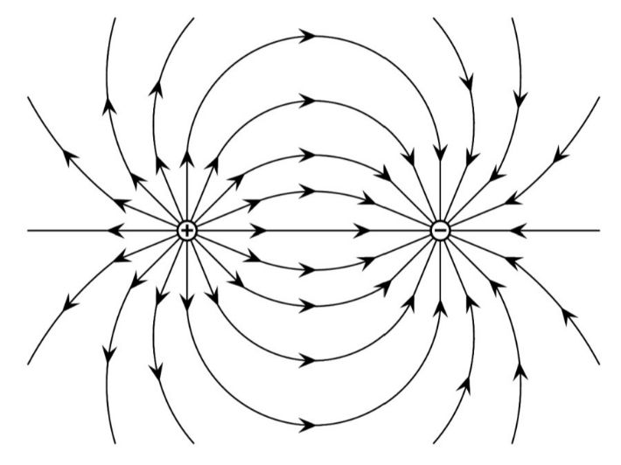

1**- It** originates from the positive charge and is perpendicular to the charged surface and is directed to wards the negative charge.

2-**The** tangent represents the direction of the electric field.

3-**Electric** field lines do not intersect with some of them.

4- **Electric** field lines are imaginary lines that are agreed to start from the positive charge and end to the negative charge.

5- The density of field lines is directly proportional to the amount of electric charge.

6- **The** lines end on the surface of the charge and do not penetrate it

7-The number of field lines that cut perpendicular to a unit area is directly proportional to the field strength.

**E=**

**E= K (q)/r2** The equation of the field for a single charge

**Example** :- Two parallel plates charged with equal amounts of charge and different in type, placed a charge of (2x10-6 C) at the point (a ) and was affected by an electric force of ( 6x10-4 N ) in the direction of the field lines.

1- What kind of shipment ?

2-Calculate the magnitude of the electric field at point ( a) ?

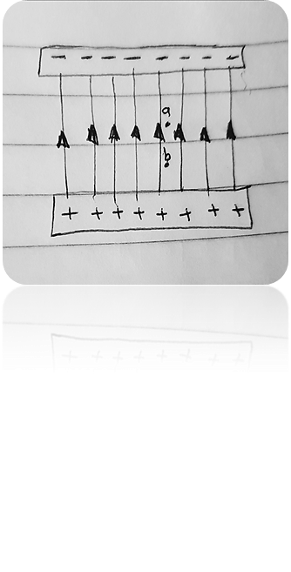Sol:-

1- positive charge.

2- E= F/q

E = 6X10-4/ 2X10-6

E = 3X10-4X106

E =3X102 N/C

Example: A charged conductive sphere has a charge (100 PC ) and a radius ( 1cm ).

Calculate:-

1-The electric field is at a point (50 cm ) away from its center?

2-The electric field on its surface? 3-Electric field at a point inside the sphere?

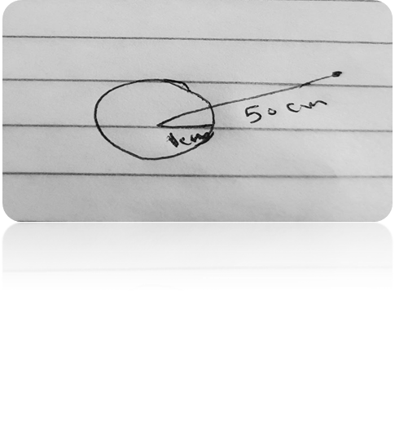Sol:-

1. E = K (q)/r2

E = 9X109X100X10-12 / (50X10-2)2

E= 9X109X100X10-12 /(5X10-1)2

E = 9X109X100X10-12 /25X10-2

E= N/C

1. E =K(q)/r2

E = 9X109X100X10-12/ (1X10-2 )2

E = 900X10-3/ 10-4

E= 900X10-3X10 4

E = 900 N/C

E =900 $N/C$

3 -E = 0

* **Electric Charge**
* 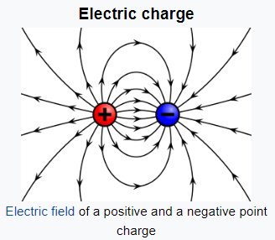Electric charge is the basic physical property of matter that causes it to experience a force when kept in an electric or magnetic field.
* Matter is composed of atoms, and atoms in turn are composed of electrons, protons, and neutrons. And for everyone
* **These** particles have distinctive properties. One of the properties of these particles is the mass property, which determines the inertia
* (**inertia**) (or the inability of these particles to move on their own. Here is another property of these particles:
* **Charge**. It is symbolized by the symbol q (or Q), and is measured in coulombs. The coulomb is symbolized by
* C. **Just** as the property of mass enables bodies to attract each other (such as the mutual attraction between the Earth and the Moon), so
* The first stage: electricity and magnetism
* Usually positive, the charge may be negative or it may be positive, and therefore the force resulting from the presence of the property of charge
* In matter, there may be a force of attraction or a force of repulsion. From here, the rule of attraction and repulsion can be deduced, which states:
* **Different charges attract and like charges repel each other**
* Electric charges are of two types: Positive and Negative, commonly carried by charge carriers protons and electrons.
* Examples of the types of charges are subatomic particles or the particles of matter: protons are positively charged , electrons are negatively charged , neutrons have zero charge.
* Negative Charge when an object has a negative charge it means that it has more electrons than protons.
* Positive Charge when an object has a positive charge it means that it has more protons than electrons.
* When there is an identical number of positive and negative charges, the negative and positive charges would cancel out each other and the object would become neutral.
* **Properties of Electric Charge**
* 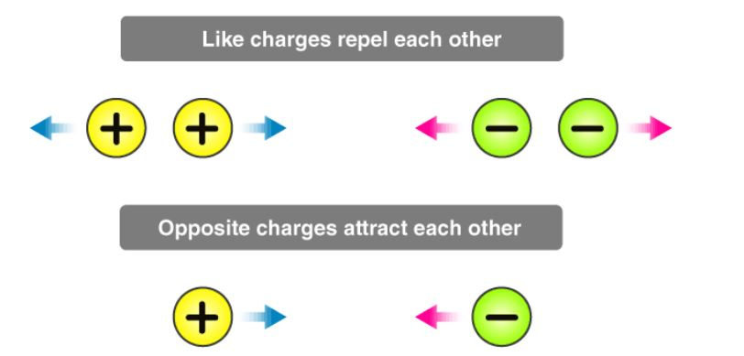Additively of Electric Charge

consider a system of charges containing q1, q2, and q3. The total charge of the system can be obtained by algebraically adding the three charges.

$$Q=q_{1}+q_{2}+q_{3}$$

These charges have magnitude but no

direction, are scalar quantities.

* Conservation of Electric Charge

We have two objects, one has some charge and the other having no charge are made to come in contact with each other, the charge is transferred from the object possessing some charge to the object possessing no charge until the charge is equally distributed over the whole system.

* Quantization of Electric Charge

According to the principle of quantization of [**electric charge**](https://byjus.com/physics/electric-charge/), all the free charges are integral multiples of a basic predefined unit, which we denote by *e*. Thus, the charge possessed by a system can be given as,

$$q=ne$$

Where n is an integer (zero, a positive or a negative number) and *e* is the basic unit of charge, that is, the charge carried by an electron or a proton. The value of *e* is 1.6 × 10-19C.

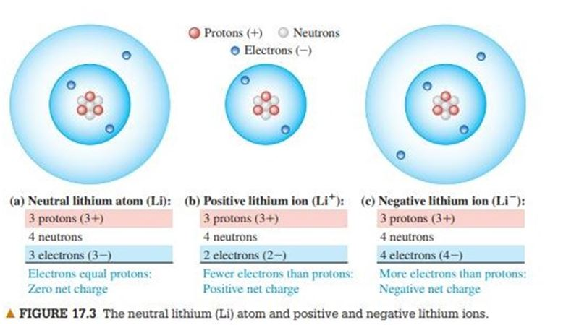An ion is an atom that has lost or gained one or more electrons. If one or more electrons are removed, the remaining positively charged structure is called a positive ion (Figure 17.3b).

A negative ion is an atom that has gained one or more electrons (Figure 17.3c).

This gaining or losing of electrons is called ionization. Ordinarily, when an ion is formed, the structure of the nucleus is unchanged.

experience

Conductors and Insulators Some materials permit electric charge to move from one region of the material to another; others do not. For example, Figure 17.4 shows a copper wire supported by a nylon thread. Suppose you touch one end of the wire to a charged plastic rod and touch the other

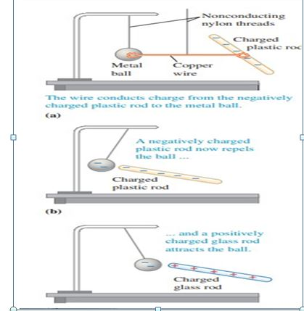end to a metal ball that is initially uncharged. When you remove the copper wire and bring another charged object near the ball, the ball is attracted or repelled, showing that it has become electrically charged. Electric charge has been transferred through the copper wire between the ball and the surface of the plastic rod. The wire is called a conductor of electricity. If you repeat the experiment, but this time using a rubber band or nylon thread in place of the wire, you find that no charge is transferred to the ball. These materials are called insulators. Conductors permit charge to move through them; insulators do not. Carpet fibers on a dry day are good insulators and allow charge to build up on us as we walk across the carpet. Coating the fibers with an antistatic layer that does not easily transfer electrons to or from our shoes is one solution to the charge-buildup problem; another is to wind some of the fibers around conducting cores. Most of the materials we call metals are good conductors, and most nonmetals are insulators. Within a solid metal such as copper, one or more outer electrons in each atom become detached and can move freely throughout the material, just as the molecules of a gas can move through the spaces between the grains in a bucket of sand. The other electrons remain bound to the positively charged nuclei, which themselves are bound in fixed positions within the material. In an insulator, there are no, or at most very few, free electrons, and electric charge cannot move freely through the material. Some materials called semiconductors are intermediate in their properties between good conductors and good insulators. Unlike copper, which is always a good conductor, no matter what you do to it, or rubber, which is always a bad conductor, no matter what you do to it, a semiconductor such as silicon can be engineered to have a controllable conductivity.

▲ Figure 17.4 Charging by conduction. A copper wire is a good conductor. (a) The wire conducts charge between the plastic rod and the metal ball, giving the ball a negative charge. The charged ball is then (b) repelled by a like charge and (c) attracted by an unlike charge.

* The earth acquires a negative charge that is equal in magnitude to the induced positive charge remaining on the sphere.
* In fact, when we study electric currents, we will find that, for historical reasons, currents in wires are described as though the moving charges were positive. When excess charge is placed on a solid conductor and is at rest (i.e., an electrostatic situation), the excess charge rests entirely on the surface of the conductor. If there were excess charge in the interior of the conductor, there would be electric forces among the excess charges that would cause them to move
* **Coulomb's law**
* The law states that the magnitude of the electrostatic [force](https://en.wikipedia.org/wiki/Force) of attraction or repulsion between two point [charges](https://en.wikipedia.org/wiki/Electric_charge) is directly proportional to the product of the magnitudes of charges and inversely proportional to the square of the distance between them
* Coulomb's law was essential to the development of the [theory of electromagnetism](https://en.wikipedia.org/wiki/Classical_electromagnetism), maybe even its starting point, as it made it possible to discuss the quantity of electric charge in a meaningful way.
* The Coulomb’s Law is given by the expression:

$$\left|F\right|=K\frac{\left|q_{1}q_{2}\right|}{r^{2}}$$

where Fe is the electric force

q1 and q2 are electric charges,

k is the Coulomb’s constant 8.988×109 N⋅m2/C2 or

r is the distance of separation.

## Coulomb’s Law in Vector Form

## C:\Users\Naruto Center\Desktop\Capture.JPG7.JPG

Here F12 is the force exerted by q1 on q2 and F21 is the force exerted by q2 on q1.

Coulomb’s law holds for stationary charges only, which are point sized. This law obeys [Newton’s third law](https://byjus.com/physics/laws-of-motion/)

The value of 1/4πε0 is equal to 9 × 109 Nm2/C2.

**Limitations of Coulomb’s Law**

* The law is applicable only for the point charges at rest.
* Coulomb’s Law can only be applied in those cases where the [inverse square law](https://byjus.com/inverse-square-law-formula/) is obeyed.
* It is difficult to implement Coulomb’s law where charges are in arbitrary shape because in such cases, we cannot determine the distance between the charges.
* The law can’t be used directly to calculate the charge on the big planets.

Example :- The figure shows three point charges $q_{1}, q_{2 ,}q_{3}$ calculate the force acting on the charge $q_{1}$

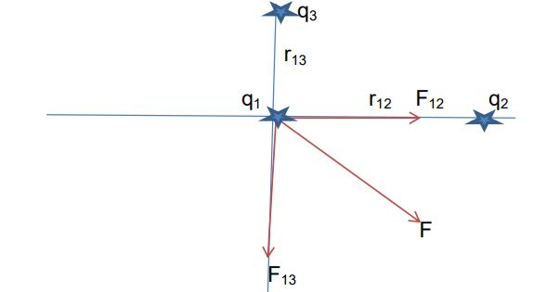 $q_{1}=1×{10}^{-6} C$ $q_{2}=-3.6×{10}^{-6}C$, $q_{3}=4.8×{10}^{-6}C$, $r_{13}=4m$, $r_{12}=3m$

Solution :-

$$F_{12}=9×{10}^{9}\frac{\left(1×{10}^{-6}\right)\left(3.6×{10}^{-6}\right)}{9}=36×{10}^{-4} N$$

$$F_{13}=9×{10}^{9}\frac{\left(1×{10}^{-6}\right)\left(4.8×{10}^{-6}\right)}{16}=27×{10}^{-4} N$$

$$F=\sqrt{{F_{12}}^{2}+{F_{13}}^{2}}=\sqrt{{\left(36×{10}^{-4}\right)}^{2}{\left(27×{10}^{-4}\right)}^{2}}$$

$=45 ×{10}^{-4}$ N

**Example**:-

What distance must separate two charges of $+5.6×{10}^{-4}$ C and $-6.3×{10}^{-4}$ C in order to have an electric potential energy with a magnitude of 5.0 J in the system of the two charges ?

Solution :-

The magnitude of the electric Potential energy E p of a system of two charges q1 and q2

Separated by a distance r is given by

E p

Solve for r

r = k q1 q2 /Ep = 9.00x109 ×5.6 x10-4 ×6.3 x10 -4 /5.0=6.35×102 m

**Example:-**

A Positive charge q exerts a force of magnitude -0.20 N on another charge -2q . Find the magnitude of each charge if the distance separating them is equal to 50 cm .

Solution :-

The force that q exert on 2q is given by Coulomb’s law

F=k(q) (-2q) /r2 , r= 0.5m , F=-0.20 N ,

-0.2= -2q2 k/

q2 = 0.2 × 0.52/ (2k)

q == 1.66x10-6 C

q = 1.66x10-6 C

-2q = -3.23 x10-6 C

**Example**:- in the radioactive decay of uranium ${}_{92}^{238}U$ it was the alpha minute (the nucleus of a helium atom) ${}_{2}^{4}{He}$ emitted on a distance $\left(9×{10}^{-15}m\right)$ from the center of the remaining nucleus of thorium ${}_{90}^{234}{Th}$ calculate :-

1-The force acting on the alpha minute, which is at this aforementioned dimension

2-Acceleration of an alpha minute at the same distance

Solution:-

1- $F=K\frac{q_{1}q_{2}}{r_{12}^{2}}$

$q_{1}=2×1.6×{10}^{-19}C$, $q_{2}=90×1.6×{10}^{-19}C$

$F=9×{10}^{9}\frac{2×1.6×{10}^{-19} ×90×1.6×{10}^{-19} }{{\left(9×{10}^{-15}\right)}^{2}}$

$F=5.12×{10}^{2}$ N

2- $m_{p}=1.6×{10}^{-27}Kg$

$F=ma$

$a=\frac{F}{m}=\frac{5.12×{10}^{2}}{2×1.67×{10}^{-27}} m/{\sec^{2}}$

**Real life examples showing how static electricity is generated**

* **If** you try to walk on a carpet and then hold the door handle, you will feel an electric shock.
* **If** you are walking in cold weather and wearing a woolen hat, as soon as you take off the hat, you will see that the hair on your head has stood up. These are two examples of the uncommon effect of static electricity.

**Contact electricity**

Each atom usually contains the same number of particles called protons and electrons. Protons are particles with a positive charge, while electrons are particles with a negative charge.

Protons and electrons balance each other, but electrons can sometimes be removed from atoms. For example, when you rub a balloon on your hair.

Electrons jump from your hair to the balloon, and in this case the balloon contains an excess number of electrons and we then say that it has a charge of static electricity.

Because the balloon now has more electrons than protons, it has a negative charge. As for your hair, the number of protons in it now exceeds the number of electrons, and thus it has a positive charge.

The negatively charged balloon is attracted to any positively charged object, such as clothes or a wall, and sticks to it.

* :- **A** small metal ball bearing a charge of (+2C) is placed (20 cm) away from a similar ball bearing a charge of (-1C). At any point on the straight line connecting two charges, another ball of positive charge must be placed, so that the force acting on it is zero.

