# Example

Notice that the centroid changes from 9.47 in. to

5.62 in. and the moment of inertia decreases from

6491 in4 to 2584 in4 . The cracked section loses

more than half of its’ strength.

# Flexural Stress

### Basic Assumptions in Flexure Theory

* Plane sections remain plane ( not true for deep beams h > 4b)
* The strain in the reinforcement is equal to the strain in the concrete at the same level,

i.e. es = ec at same level.

* Stress in concrete & reinforcement may be calculated from the strains using s-e curves for concrete & steel.

# Flexural Stress

### Additional Assumptions for design (for simplification)

* Tensile strength of concrete is neglected for

calculation of flexural strength.

* Concrete is assumed to fail in compression, when

ec (concrete strain) = ecu (limit state) = 0.003

* Compressive s-e relationship for concrete may be assumed to be any shape that results in an acceptable prediction of strength.

# Flexural Stress

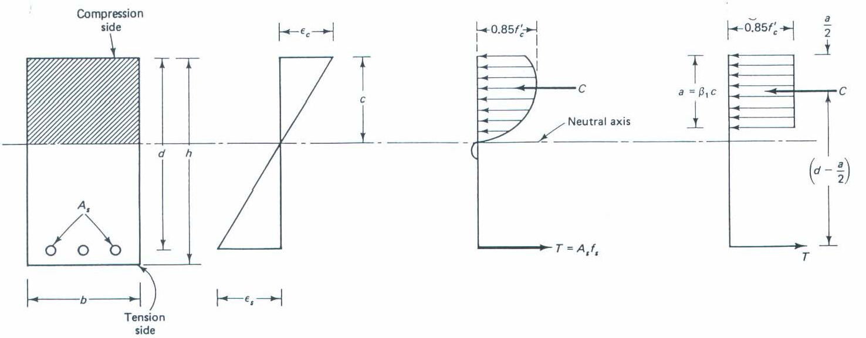

The concrete may exceed the ec

of the compressive zone**.**

at the outside edge

# Flexural Stress

The compressive force is modeled as Cc = k1k3f’c b*c at the location x = k2*c

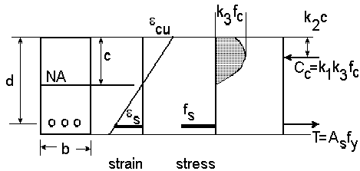

# Flexural Stress

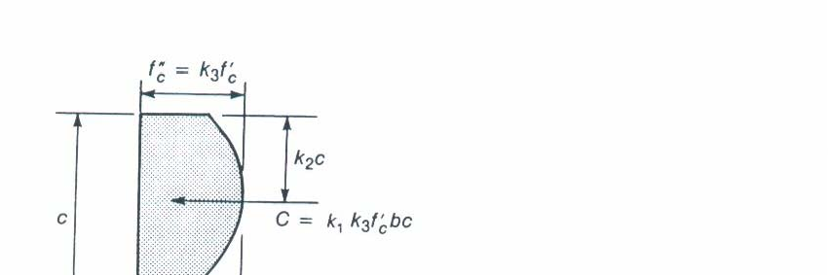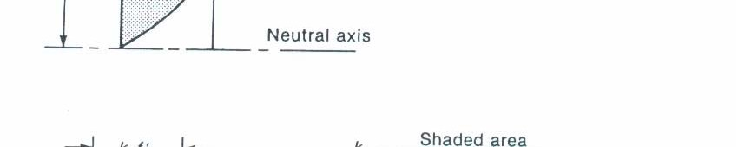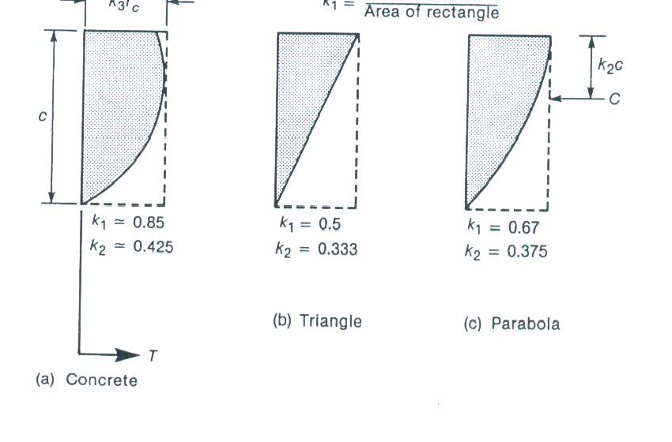

The compressive coefficients of the stress block at given for the following shapes.

k3 is ratio of maximum stress at fc in the compressive zone of a beam to the cylinder strength, fc’ (0.85 is a typical value for common concrete)

The compressive zone is modeled with a equivalent stress block.

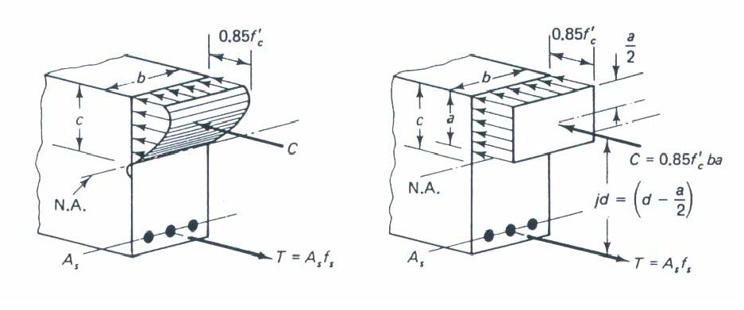

The equivalent rectangular concrete stress distribution has what is known as a b1 coefficient is proportion of average stress distribution covers.

b1 =

#### for

*f*c £

#### 4000

psi

Requirements for analysis of reinforced concrete beams

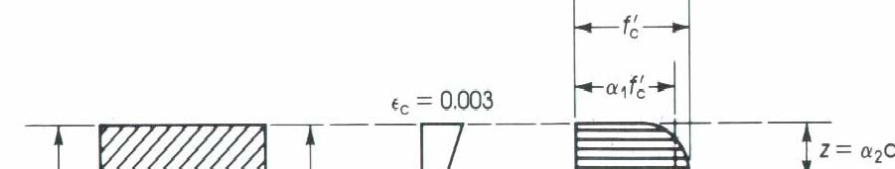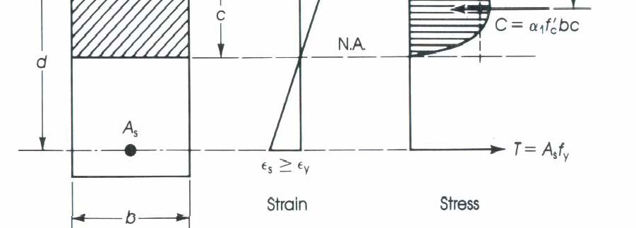

1. Stress-Strain Compatibility – Stress at a point in member must correspond to strain at a point.
2. Equilibrium – Internal forces balances with external forces

# Flexural Stress

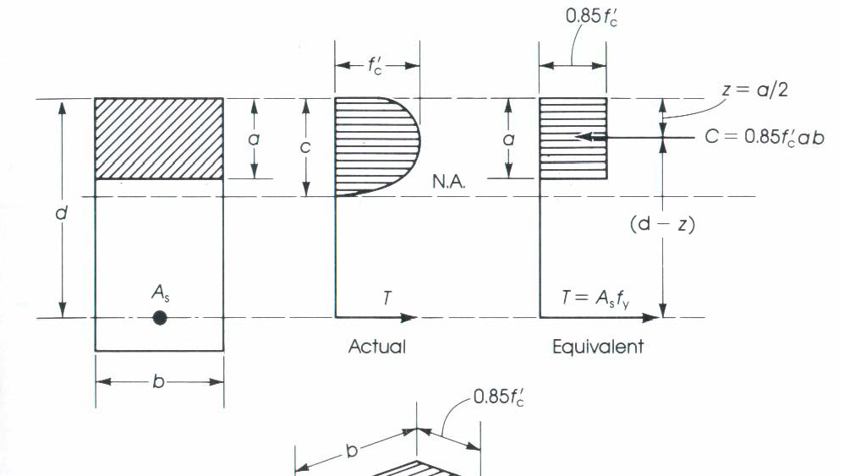

Example of rectangular reinforced concrete beam.

* 1. Setup equilibrium.

å *F*x = 0 Þ

T = C

*A*s *f*s = 0.85 *f*c *ab*

å *M* = 0 Þ

æ *a* ö

è ÷

ç

2

-

=

M

T *d*

ø

# Flexural Stress

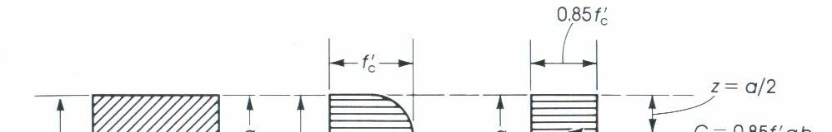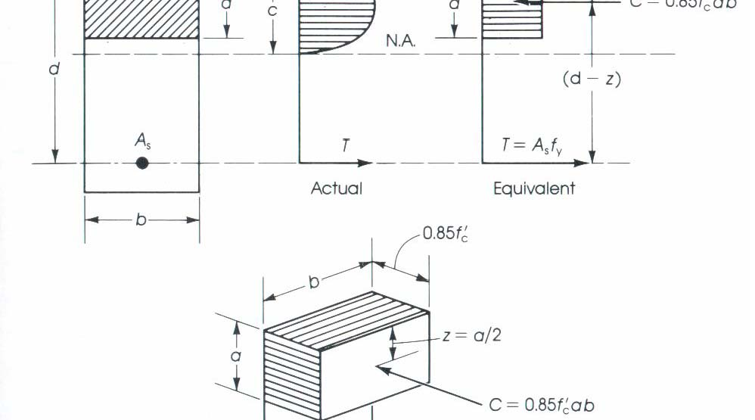

Example of rectangular reinforced concrete beam.

* 1. Find flexural capacity.

*T* = *A*s *f*s

*C* = 0.85

*a* = *A*s

*f*c *ab f*y

# Flexural Stress

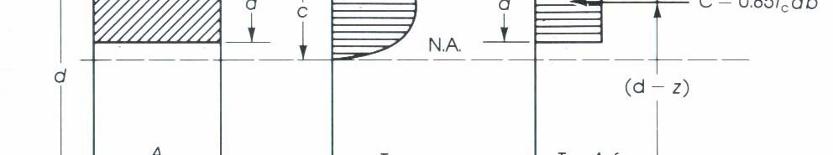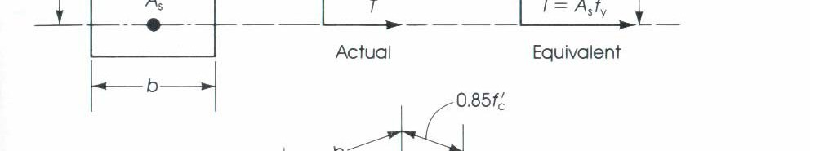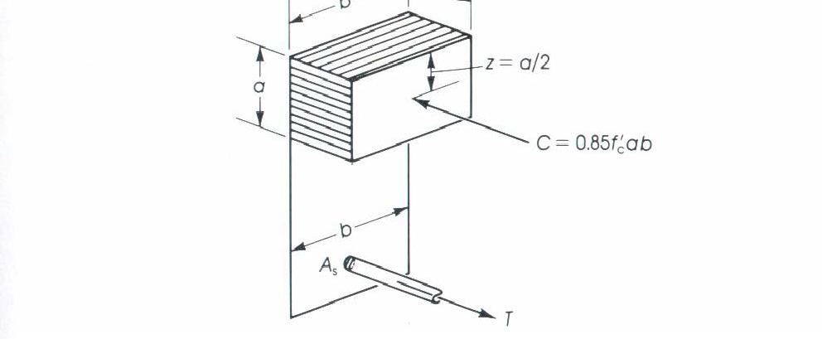

Example of rectangular reinforced concrete beam.

1. Find flexural capacity.

Mn = *T*

(moment arm)

= *A*s *f*y ç 2 ÷

*d*

æ

-

*a* ö

è ø

# Flexural Stress

Example of rectangular reinforced concrete beam.

1. Need to confirm es > ey

e = s y

y

*E*s

*c* = *a*

b1

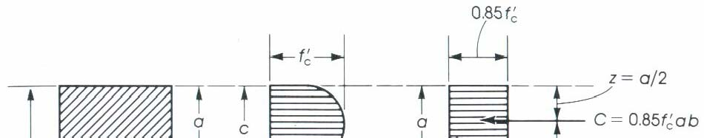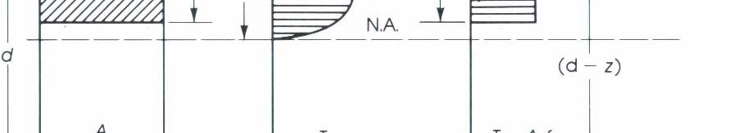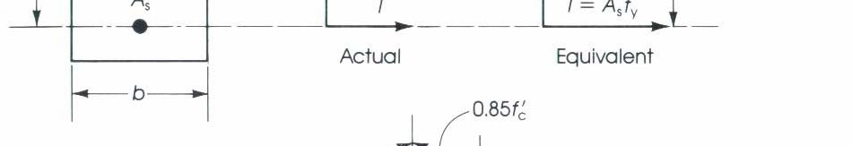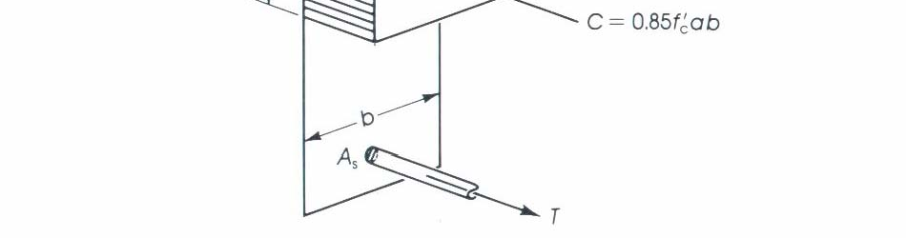

es =

(*d* - *c*)e

*c* c

* e y

# 

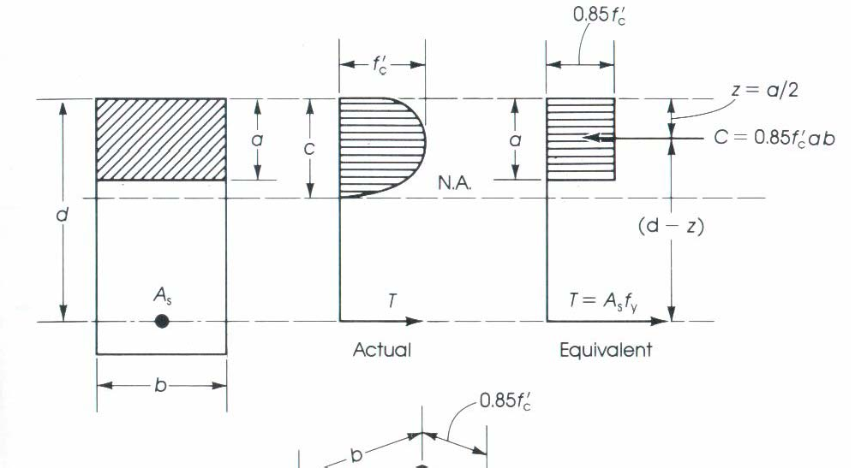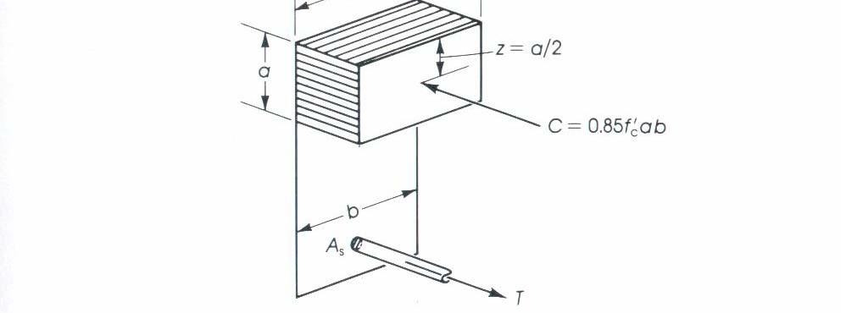

# Flexural Stress Example

Example of rectangular reinforced concrete beam.

Given a rectangular beam fc = 4000 psi

fy = 60 ksi (4 #7 bars)

b = 12 in. d = 15.5 in. h= 18 in. Find the neutral axis.

Find the moment capacity of the beam.