**Lecture Goals**

### Loading (continued)

* Concrete Mixing and Proportioning

### Concrete Properties

* Steel Reinforcement

# Earthquake Load

Inertia forces caused by earthquake motion

### F = m * a

* Distribution of forces can be found using equivalent

static force procedure (code, not allowed for every

building) or using dynamic analysis procedures

# Earthquake Load

Inertia forces caused by earthquake motion. Equivalent Static Force Procedure for example, in ASCE 7-95:

where

V = Cs * W

V = Total lateral base shear

Cs = Seismic response coefficient W = Total dead load

# Earthquake Load

### Total Dead Load, W:

1.0 * Dead Load

### + 0.25 * Storage Loads

+ larger of partition loads or 10 psf

### + Weight of permanent equipment

+ contents of vessels

+ 20% or more of snow load

# Earthquake Load

1.2 *C*

2.5 *C*

*C*  *smaller of*

 *v*

*and a*

*s*  *R T*

2 / 3 *R*

where

Cv = Seismic coefficient based on soil profile and Av Ca = Seismic coefficient based on soil profiled and Aa

R = Response modification factor (ability to deform in inelastic range)

T = Fundamental period of the structure

# Earthquake Load

1.2 *C*

2.5 *C*

*C*  *smaller of*

 *v*

*and a*

*s*

where

 *R T*

2 / 3 *R*

T = Fundamental period of the structure

T = CT hn 3/4

where CT = 0.030 for MRF of concrete

0.020 for other concrete buildings. hn = Building height

# Earthquake Map

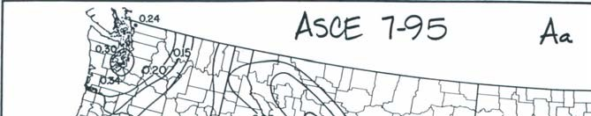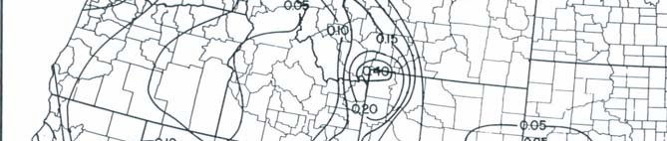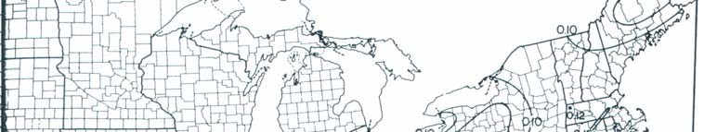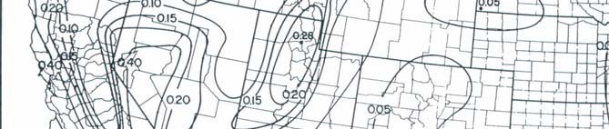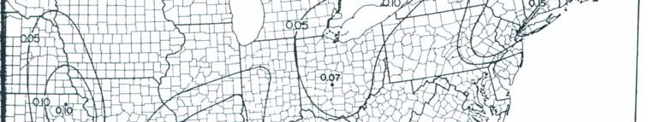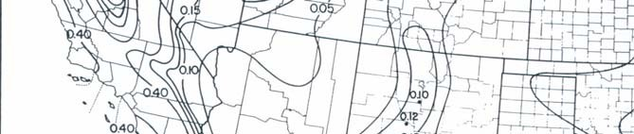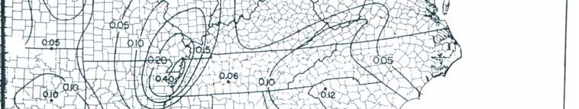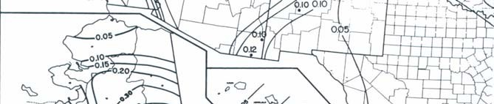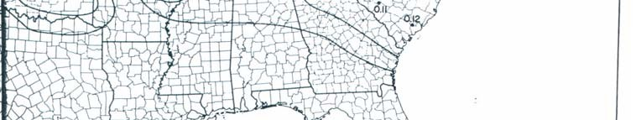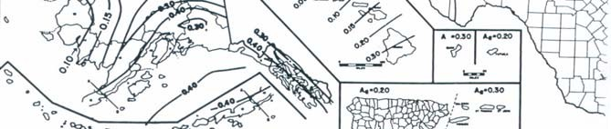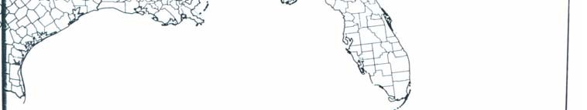

**Roof Load**

* Ponding of rainwater
  + Roof must be able to support all rainwater that could accumulate in an area if primary drains were blocked.
  + Ponding Failure:

→ Rain water ponds in area of maximum deflection

→ increases deflection

→ allows more accumulation of water  cycle continues… potential failure

# Roof Load

* + - Roof loads are in addition to snow loads
    - Minimum loads for workers and construction materials during erection and repair

# Construction Loads

### Construction materials

* + - Weight of formwork supporting weight of fresh concrete

## Proportioning

Failure Mechanism of Concrete

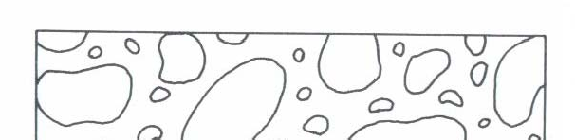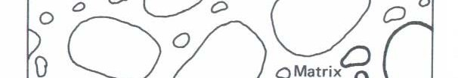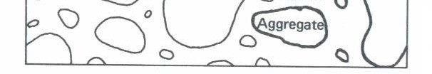

Shrinkage Microcracks are the initial shrinkage cracks due to carbonation shrinkage, hydration shrinkage, and drying shrinkage.

## Proportioning

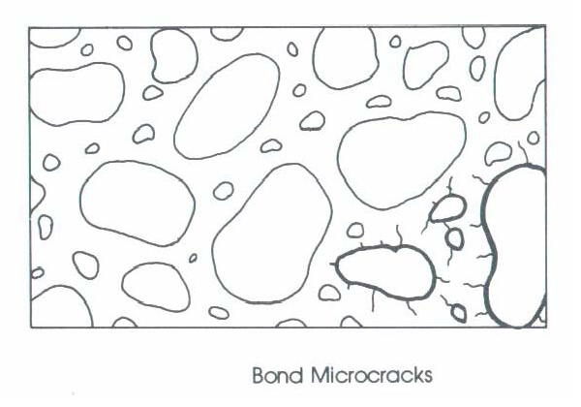

Failure Mechanism of Concrete

Bond Microcracks are extensions of shrinkage microcracks, as the compression stress field increases, the shrinkage microcracks widen but do not propagates into the matrix. Occur at 15- 20 % ultimate strength of concrete.

## Proportioning

Failure Mechanism of Concrete

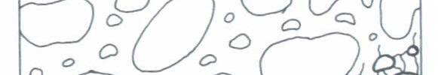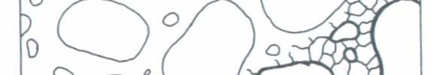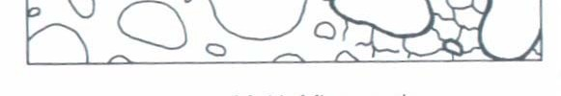

Matrix Microcracks - are microcracks that occur in the matrix. The propagate

from 20% fc. Occur up to

30-45 % ultimate strength

of concrete. Matrix

microcracks start bridge one another at 75%.

Aggregate microcracks occur just before failure (90%).



**Concrete Properties**

1. Uniaxial Stress versus Strain Behavior in Compression

fc

f’c

Ec

12”

0.45f’c

6”

o u 

c

# Concrete Propertie

The standard strength test generally uses a cylindrical sample. It is tested after 28 days to test for strength, fc.

The concrete will continue to harden with time and for a

normal Portland cement will increase with time as follows:

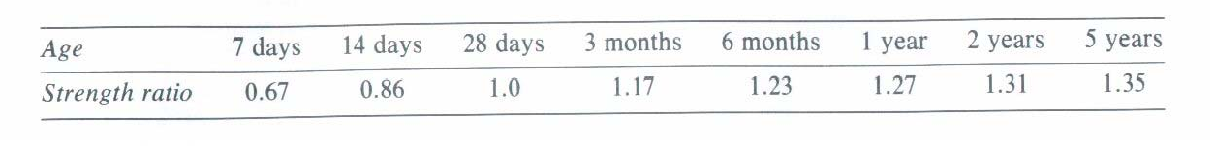

# Concrete Propertie

* Compressive Strength, f’c
  + Normally use 28-day strength for design strength



* Poisson’s Ratio, 
  +  ~ 0.15 to 0.20

f’c

fc

Ec

* Usually use   0.17 0.45f’c

o u 

c

# Concrete Properties

* Modulus of Elasticity, Ec
  + Corresponds to secant modulus at 0.45 f’c
  + ACI 318-02 (Sec. 8.5.1):

*E c* (

*psi*

)  33

*w* 1 . 5

where w = unit weight (pcf) 90 pcf < wc <155 pcf

*f* ' *c*

( *psi*

)

*E c* (

*psi*

)  57

, 000

For normal weight concrete (wc  145 pcf)

*f* ' *c*

( *psi*

)

# Concrete Propertie

* In-Class Exercise:

Compute Ec for f’c = 4500 psi for normal weight (145 pcf) concrete using both ACI equations:

*E*

*c*

( *psi*

) 

33

*w*

1 . 5

*f* '

*c*

( *psi*

)

*E c* (

*f* ' *c*

( *psi*

)

*psi*

)  57

, 000

# Concrete Properties

* + Concrete strain at max. compressive stress, o
    - For typical  curves in compression
    - o varies between 0.0015-0.003
    - For normal strength concrete, o ~ 0.002

fc

Ec

f’c

0.45f’c

o u

# Concrete Properties



* + Maximum useable strain, u
    - ACI Code: u = 0.003
    - Used for flexural and axial compression

fc Ec

f’c

0.45f’c

o u

# Concrete Propertie

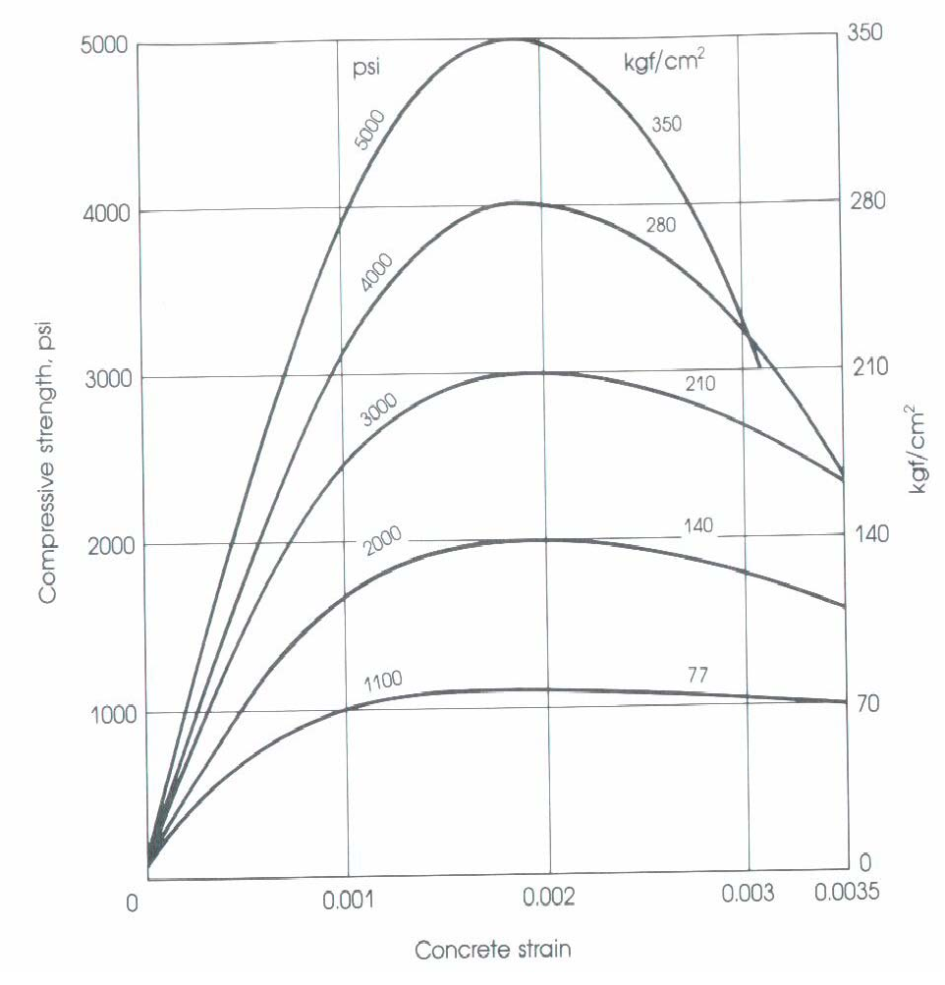

Typical Concrete Stress-Strain Curves in Compression

# Concrete Propertie

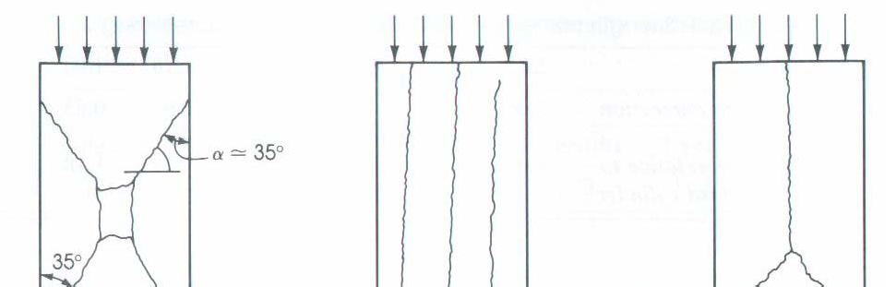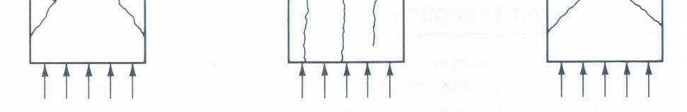

### Types of compression failure

There are three modes of failure.

1. Under axial compression concrete fails in shear.
2. the separation of the specimen into columnar pieces by what is known as splitting or columnar fracture.
3. Combination of shear and splitting failure.

# Concrete Properties

1. Tensile Strength
   * Tensile strength ~ 8% to 15% of f’c
   * Modulus of Rupture, fr
     + For deflection calculations, use:

fr



*f*

– Test:

*r*



7 . 5

*f* ' *c*

( *psi*

)

ACI Eq. 9-10

P

unreinforced

concrete beam

*f r* 

*Mc*

*I*



6*M*

*bh*2

Mmax = P/2*a

# Concrete Propertie

### Tensile Strength (cont.)

* + Splitting Tensile Strength, fct
  + Split Cylinder Test

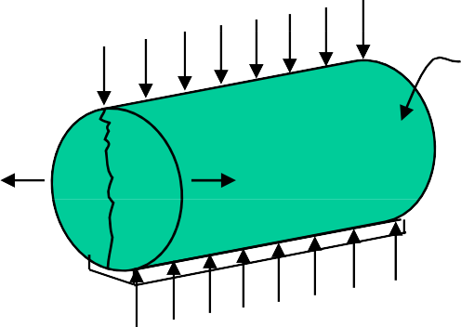P

Concrete Cylinder

Poisson’s Effect

# Concrete Propertie

1. Tensile Strength (cont.)

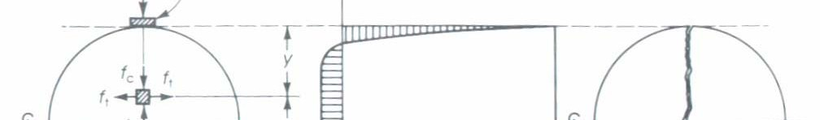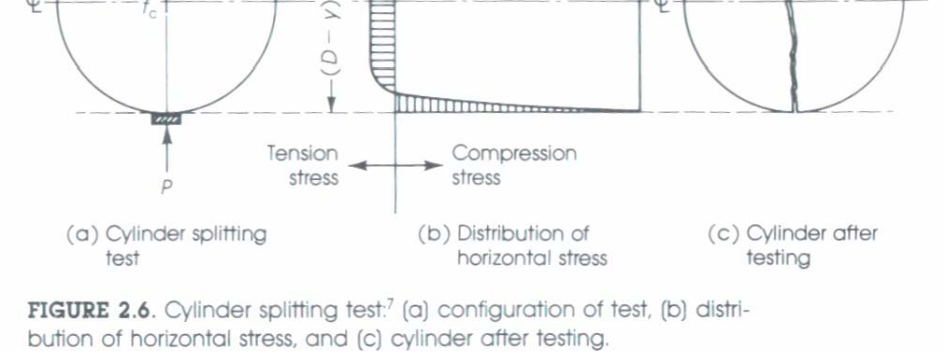

*f*

*ct*

 2*P*

*ld*

*fct*  (5 *to* 7)

*f* '*c* ( *psi*)

(Not given in ACI Code)

# concrete Properties

1. Shrinkage and Creep
   * **Shrinkage:** Due to water loss to atmosphere (volume loss).
     + Plastic shrinkage occurs while concrete is still “wet” (hot day, flat work, etc.)
     + Drying shrinkage occurs after concrete has set
     + Most shrinkage occurs in first few months (~80% within one year).
     + Cycles of shrinking and swelling may occur as environment changes.
     + Reinforcement restrains the development of shrinkage.

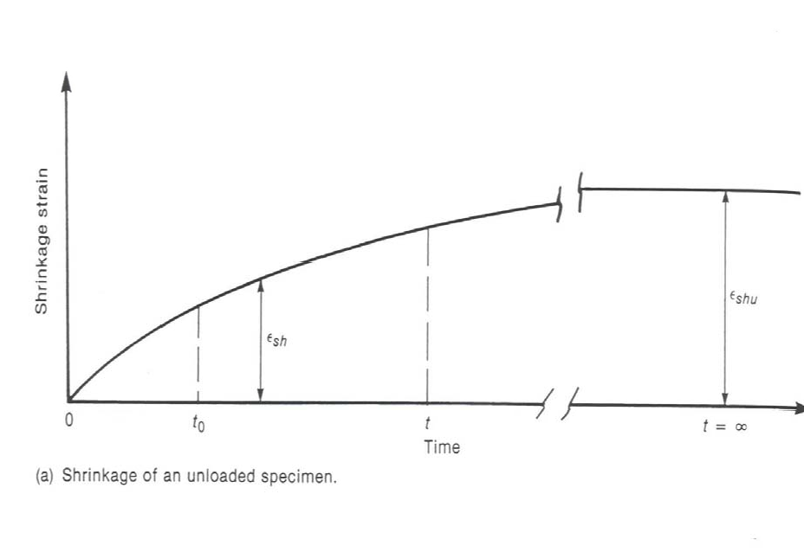

**Concrete Properties**

Shrinkage of an Unloaded Specimen

Fig. 3-21, MacGregor (1997)

* 80% of shrinkage occurs in first year

# Concrete Properties

### Shrinkage is a function of

* + - W/C ratio (high water content reduces amount of aggregate which restrains shrinkage)
    - Aggregate type & content (modulus of Elasticity)
    - Volume/Surface Ratio

# Concrete Properties

### Shrinkage is a function of

* + Type of cement (finely ground…)
  + Admixtures
  + Relative humidity (largest for relative humidity of 40% or less).
  + Typical magnitude of strain: (200 to 600) * 10-6 (200 to 600 microstrain)

train