* **Creep**

# Concrete Propertie

* + Deformations (strains) under sustained loads.
  + Like shrinkage, creep is not completely

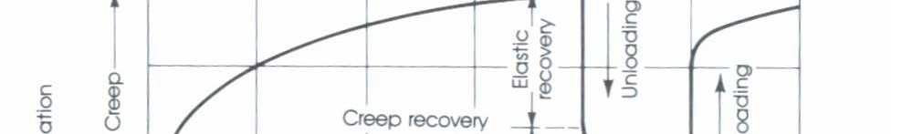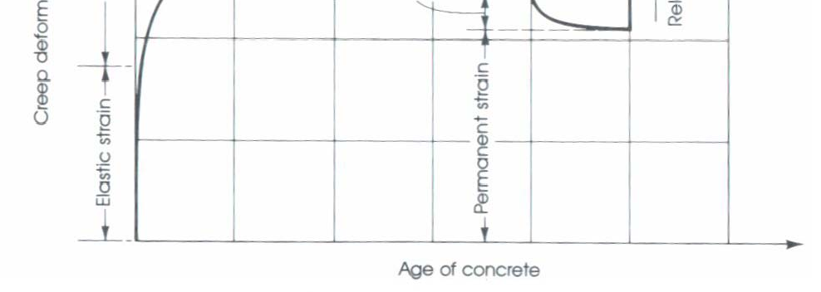

P

L

L, elastic

L, creep

P

=L/L

* Magnitude of creep strain is a function of all the above that affect shrinkage, plus
  + magnitude of stress
  + age at loading
* Creep strain develops over time…
  + Absorbed water layers tend to become thinner between gel particles that are transmitting compressive stresses
  + Bonds form between gel particles in their deformed position.

# Concrete Propertie

where,

* Tri-axial Compression
  + Confined Cylinder
  + Improved strength and ductility versus uniaxial compression F



* Example: spiral reinforced

1

1  *f* '*c*  4.1 3

F1 = longitudinal stress at failure F3 = lateral pressure

F

3

F1

# concrete Propertie

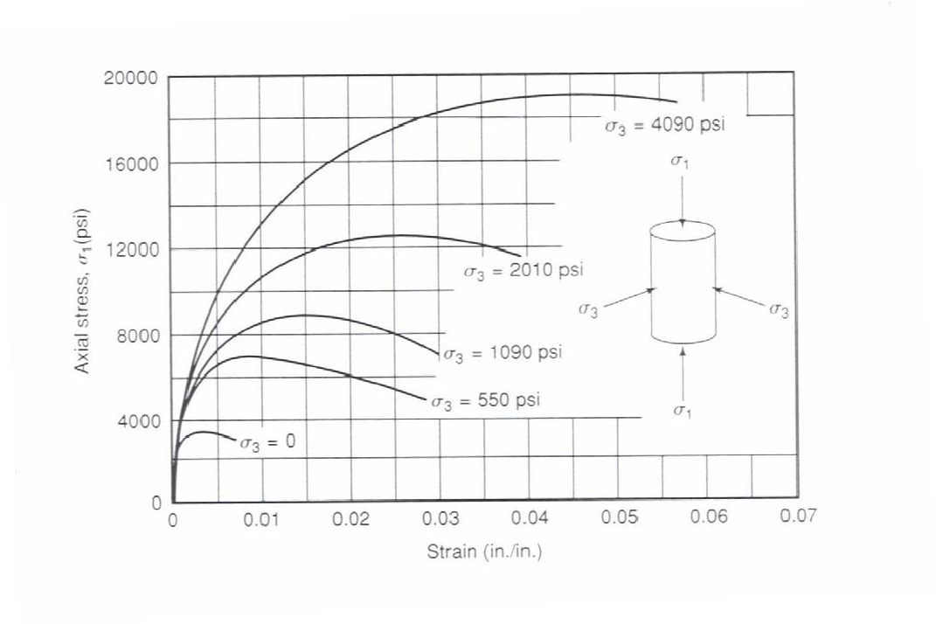

* Tri-axial Compression

Fig. 3-15, MacGregor (1997)

# Steel Reinforcement

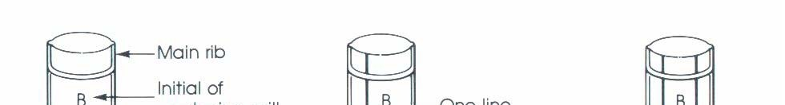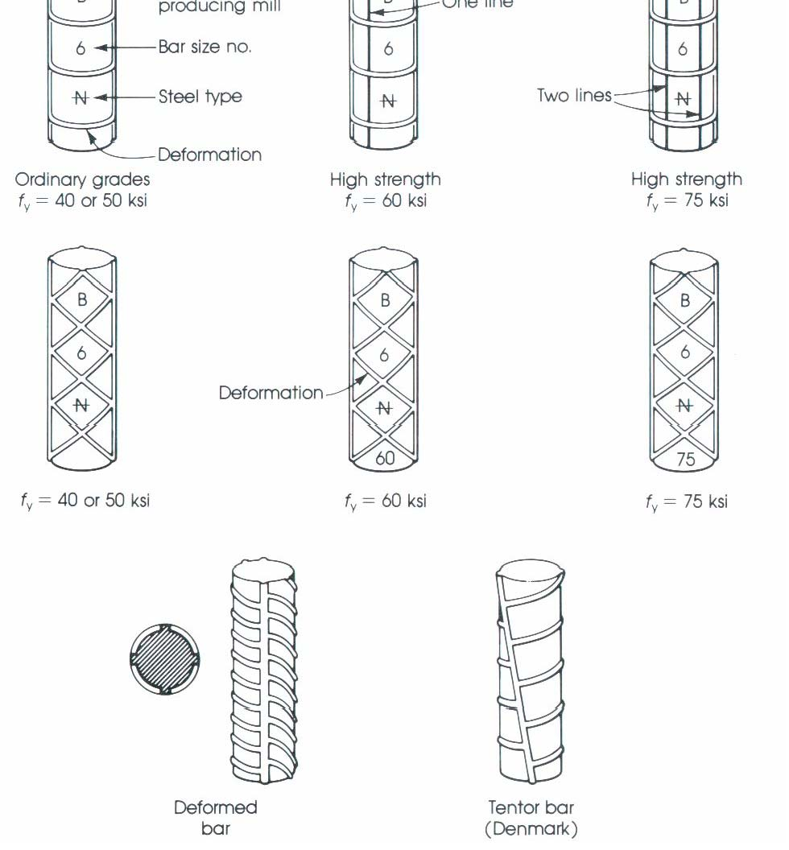

* 1. General

– Standard Reinforcing Bar Markings

* + 1. General

# Steel Reinforcement

* + - * Most common types for non-prestressed members:
        + hot-rolled deformed bars
        + welded wire fabric

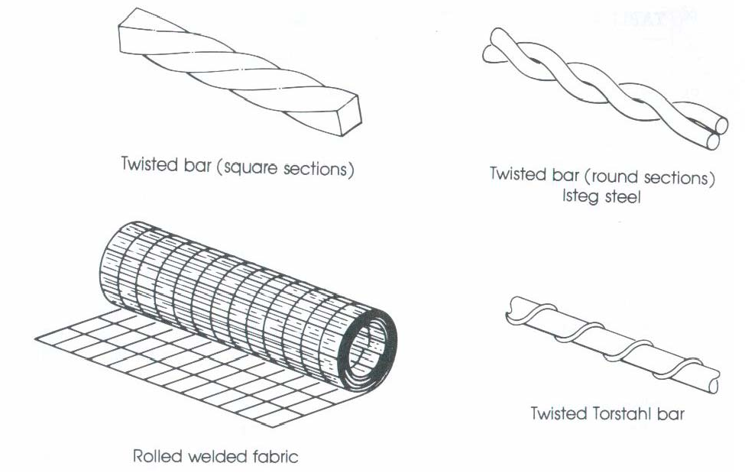

# Steel Reinforcement

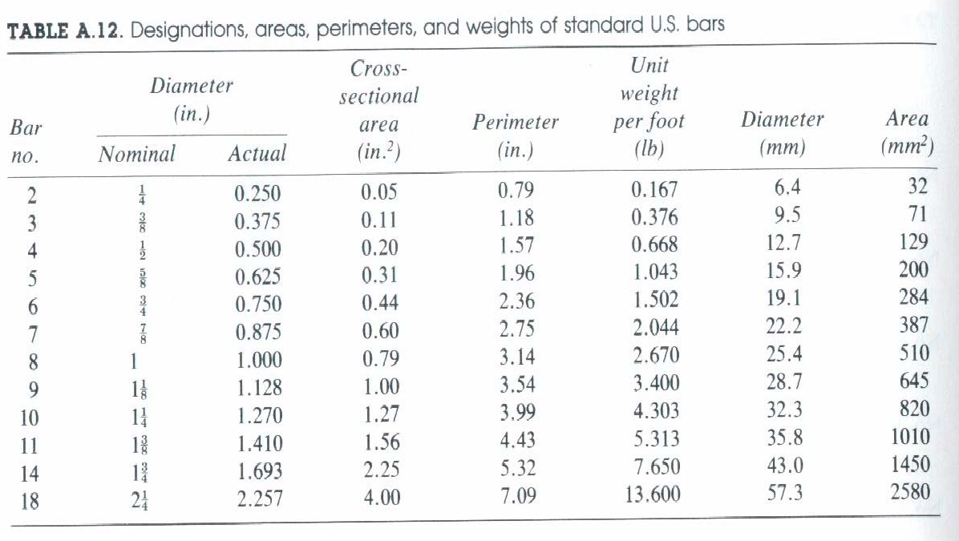

* + - * Areas, Weights, Dimensions

# Steel Reinforcemen

* + 1. Types
       - ASTM A615 - Standard Specification for Deformed and Plain-Billet Steel Bars
         * Grade 60: fy = 60 ksi, #3 to #18

most common in buildings and bridges

* + - * + Grade 40: fy = 40 ksi, #3 to #6

most ductile

* + - * + Grade 75: fy = 75 ksi, #6 to #18

# Steel Reinforcement

1. Types
   * ASTM A616 - Rail-Steel Bars
   * ASTM A617 - Axle-Steel Bars
   * ASTM A706 - Low-Alloy-Steel Bars
     + more ductile GR60 steel
     + min. length of yield plateau = sh/y = 5

# Steel Reinforcement

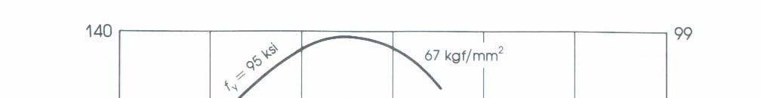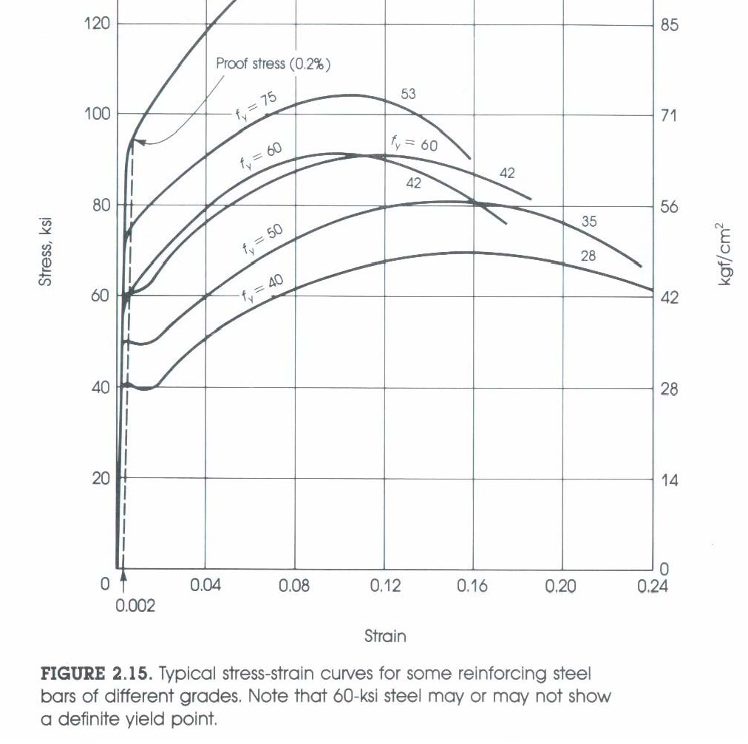

1. Stress versus Strain

– Stress-Strain curve for various types of steel reinforcement bar.

# Steel Reinforcemen

* Es = Initial tangent modulus

= 29,000 ksi (all grades)

Stress

* **Note:** Es

GR40 has a longer 1

yield plateau

GR 60 (less ductile) GR 40

0.20

S